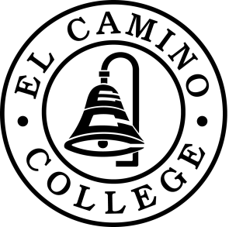

**Online LGBTQIA+ training for Students**

Learn to create a more supportive campus culture for LGBTQ Students. In this virtual environment you’ll engage in a series of game-based exercises, including a role-play conversation with fully animated and emotionally responsive virtual students to better understand how to:

* address discriminatory language;
* respond supportively when a peer comes out as LGBTQ;
* approach and refer a peer who may be distressed and need additional support.

To access the free training:

1. Begin at **ccc.kognito.com**
2. Create an account when prompted: “Don’ have an account? **Click here**.”
3. Enter your information and under Choose your Training POV, select **Student/RA**
4. After creating an account, click on **LGBTQ on Campus for Students** to begin the training. Other trainings are also available!

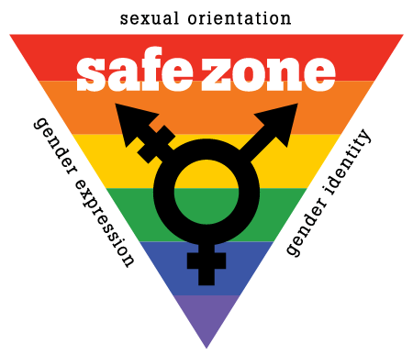

Online training courses are made available to all California community colleges through the CCC Student Mental Health Program, a partnership between the Chancellor's Office and the Foundation for California Community Colleges (FCCC) funded through a grant from the California Mental Health Services Authority (CalMHSA).