**El Camino Community College**

**PROGRAM REVIEW 2022-23**

**BEHAVIORAL AND SOCIAL SCIENCES DIVISION**

**PSYCHOLOGY DEPARTMENT**

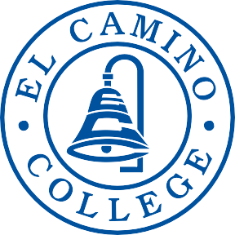

**DEAN:**

DR. CHRISTINA GOLD

**CONTRIBUTOR(S):**

DR. AMY HIMSEL

DR. RENEE GALBAVY

DR. YUN CHU

DR. ANGELA SIMON

DR. MICHAEL WYNNE

**TABLE OF CONTENTS**

**Contents**

SECTION 1 Program Overview 3

SECTION 2 Program Assessment 11

Program Contribution to Student Success and Equity 11

Curriculum and Outcomes Assessment 24

SECTION 3 Program Vision and Future Planning 30

Program Vision 30

Future Planning 31

Program Resources 33

# SECTION 1 Program Overview

1. **Provide a brief narrative description of the current program, (e.g., the program’s mission statement, a description of the students it serves) and any highlights of the program’s previous success, future vision, and related needs.**

The Psychology Program emphasizes scientific inquiry into human behavior and mental processes. Our psychology students develop skills such as evaluating theories critically, studying the key areas of psychology, utilizing statistical analysis, designing and conducting research, writing reports in proper psychological style with analysis and argumentation, and applying psychological principles to practical situations. Courses prepare students for pursuing psychology at both the undergraduate and graduate levels, as well as for various job opportunities in teaching, research, and clinical settings.

The Psychology Department serves many students. In fact, rates of Psychology AA-T degree completion have increased from 168 students in 2018-19 to 250 students in 2021-22. Our department is the second highest degree awarding department at El Camino College.

Despite these achievements, we could do so much more with additional full-time faculty. We currently have only 6 full-time faculty, and we have no full-time faculty teaching two of our most in-demand courses: PSYC 103 and PSYC 109A. We are almost certainly losing enrollment due to our inability to offer more sections of these courses. For example, students who can’t get into PSYC 103 may opt to take one of the numerous sections of English 1C instead, as it fulfills the same critical thinking requirement as PSYC 103. Data from 2019-2022 shows that English 1C averages an enrollment of 1452 per semester, in contrast to the average PSYC 103 enrollment of 195 per semester. Similarly, students who are not able to get into the limited number of 109A sections currently offered often opt to take Math 150 instead. Data from 2019-2022 shows that Math 150 averages an enrollment of 1796 per semester, in contrast to the average PSYC 109A enrollment of 60. In both cases, our department is losing out on opportunities to increase FTES. Given that the PSYC 109 A/B sequence is required for the AA-T major, we are likely missing opportunities to increase psychology AA-T completion as well.

Our in-demand psychology courses fulfill important requirements for all students, not just psychology majors. For example, PSYC 103 fulfills the CSU-GEB requirement in category A3 (Critical Thinking), and PSYC 109A is included in IGETC Area 2 (Mathematical Concepts and Quantitative Reasoning). Hiring additional full-time faculty so that more of these sections can be taught would benefit the college beyond our department.

Another contributor to the urgency of our department hiring more full-time faculty is that we have at least two current full-time faculty who may retire within the next few years. And finally, the turnover rate of adjunct instructors is higher than that of full-time faculty, creating challenges for maintaining a consistent approach to these important courses over the years.

The Psychology Department offers the following courses, reflecting a wide range of dominant subfields of empirical study in psychology.

Psychology 101 General Psychology

Psychology 101H Honors General Psychology

Psychology 102 Psychology for Effective Living

Psychology 103 Critical Thinking and Psychology

Psychology 103H Honors Critical Thinking and Psychology

Psychology 107 Physiological Psychology

Psychology 108 Social Psychology

Psychology 109A Introduction to Elementary Statistical Methods for the Study of Behavior

Psychology 109B Experimental Methods in the Study of Behavior

Psychology 110 African American Psychology

Psychology 112 Human Sexuality

Psychology 115 Abnormal Psychology

Psychology 116 Lifespan Development

Psychology 117 Cultural Psychology

Psychology 119 LGBTQ+ Psychology

Psychology 125 The Psychology of Gender

Two additional courses will be offered starting in the Fall of 2023:

Psychology 116H Honors Lifespan Development

Psychology 378 The Psychology of Stress, Illness, and Trauma

Our department’s previous successes include the creation of new courses, expanding the range of content taught. These courses include topics directly related to matters of equity and the experiences of marginalized students, such as PSYC 119 (LGBTQ+ Psychology) and PSYC 125 (The Psychology of Gender). In the Fall of 2022, PSYC 119 was included in learning community with a history class. The plan is to continue this learning community for the 2023-24 academic year as well.

For the future, our department is excited to offer a new class on stress, illness and trauma, topics that apply to all humans but are especially relevant to our marginalized students (PSYC 378 - The Psychology of Stress, Illness, and Trauma, offered starting in the fall of 2023).

Our previous successes also include the campus involvement and professional development of our full-time faculty. These are individual faculty efforts, but faculty share their growing knowledge with each other and sometimes collaborate on these efforts.

Attendance, presentations, and representation at regional, and local professional conferences/meetings

* Extreme Imagination Conference, University of Exeter
* 42nd Annual Conference on the First-Year Experience, University of South Carolina
* Western Psychological Association (WPA) ECC Representative, WPA Council of Representatives
* Academic Senate for California Community Colleges Faculty Leadership Institute

Completion of Teaching-Specific Training

* The Flipped Learning Certification Level - 1, offered by the Flipped Learning Global Initiative (FLGI).
* LOGIC training
* @One Training Course - Introduction to Canvas
* IMPACT Training
* Teaching with Technology Workshops offered outside of ECC

Organization of and participation in El Camino College sponsored events

* Guest Speakers
  + - University of Hawaii, Kapi’olani Community College, Nursing Department Counselor Crystalyn Hottenstein, Career Conversations
* Flex Day and Professional Development Presentations
  + - *Getting the Job Part I: The Application Process*
    - *Getting the Job Part II: The Interview*
    - *Canvas Training* for Behavioral and Social Sciences Division Faculty
    - *Engagement Opportunities: Practical Ideas for Faculty Involvement*
    - *Creation, Planning, and Presentation of numerous SAFE Zone Training Workshops*
* Presentations to Students
  + - *Career Paths in the Behavioral and Social Sciences*
    - *Monster or Mastermind? Inside the Mind of the Psychopath*
    - *Sexual Aggression and Violence - ECC Police Department*
    - *Sexual Aggression and Violence - YWCA*
    - *Movies for Mental Health - Art with Impact*
    - *Mental Illness - NAMI (The National Alliance on Mental Illness)*
* Beyond the Breast Panel for Women’s History Month on 3/24/22
* Participation in ECC study: Evidence-based best teaching-learning practices

El Camino Club Sponsors

* Psychology Club
* Gender Sexuality Alliance
* Psi Beta (psychology honors society for community college students)

El Camino Committees and Programs

* Academic Senate
* Faculty Development Committee
* Project Success
* Accreditation Subcommittees
* Assessment, Intervention, & Management for Safety Team (AIMS)
* Area Council
* Division Council
* Facilities Steering Committee
* Academic Technology Committee
* Equal Employment Representative (EER) for FT hiring committees
* Online and Distance Education Advisory Committee (ODEAC)
* Online Education Initiative Implementation Team
* Faculty Position Identification Committee
* Faculty Innovation Task Force
* Student Discipline Task Force
* Student Equity Program: MyPATH, Peer Assisted Support Sessions (PASS)
* Load Committee
* ECC Safe Zone LGBTQIA+ Planning Committee
* Women’s History Month Committee

1. **Describe the degrees and/or certificates offered by the program.**

In addition to the basic AA requirements, students pursuing the Associate in Arts for Transfer (AA-T) psychology degree will complete 20-21 units in psychology. After finishing the psychology AA-T degree, students will have a robust academic background in the field of psychology and will be ready to pursue higher-level studies at the undergraduate level. The diversity of our students is shown below. **A picture containing text, diagram, font, screenshot
**

1. **Explain how the program fulfills the college’s mission.**

*The mission of El Camino College is to make a positive difference in people’s lives by providing comprehensive educational programs and services that promote student learning and success in collaboration with our diverse communities.*

The Psychology Program provides opportunities for all students, including those who are not majoring in psychology, to gain knowledge that can be used to enhance their own and others' lives. Students majoring in psychology can earn an AA-T degree as a step toward obtaining a bachelor's degree in psychology. A bachelor's degree in psychology is a versatile degree that is attractive to many employers in both psychology and non-psychology related fields. Moreover, the psychology major equips students with the skills and knowledge necessary for graduate study and future careers in psychology. People who hold advanced degrees can find employment in various areas, such as teaching, research, and clinical practice.

1. **Discuss the status of recommendations from your previous program review.**

*If more than ten recommendations were presented in the previous program review, expand the enumerated list below as needed.*

1. **Recommendation:** Continue working on the following 2008 recommendation:

Increase the full-time faculty from 7 to 10 in 3-5 years.

**Status:** Active.

**Notes/Comment:** As stated earlier, we currently have only 6 full-time faculty. We have no current full-time faculty teaching two of our most in-demand courses: PSYC 3 and PSYC 109A. We are losing out on opportunities to increase FTES and rates of psychology AA-T completion because of this need. We are likely to have two retirements in the upcoming years as well, further increasing the need to add to our full-time faculty.

1. **Recommendation:** Coordinate with the library to add American Psychological

Association databases to library offerings.

**Status:** Completed.

**Notes/Comments:** The Library currently offers the APA database PsycARTICLES, as well as 16 other databases containing Psychology material.

1. **Recommendation:** In 2008, an update to computer facilities, software, and other research-related upgrades for the formal Psychology Lab was recommended. The Psychology Lab no longer exists, but there is still a great need for a dedicated computer classroom laboratory for psychology students and faculty. The computer laboratory could be used by students, faculty, and staff of the Behavioral and Social Sciences Division.

**Status:** Active.

**Notes/Comments:** The new building for the B&SS Division will not have a computer lab, but there is still a need for such a lab since many departments in the Division have courses where student access to computers is essential. Currently, the best option is to convert a room in the Social Sciences building into a computer lab with a dedicated IT technician. This lab would have desktop computer preloaded with the industry-standard software program SPSS (Statistical Package for the Social Sciences) for PSYC 109A/B students. Current instructors have found creative ways around our lack of SPSS, such as using “freeware” instead. However, given our high rates of AA-T completion and transfers, it is particularly unfortunate (and suggests an articulation challenge) that our students will not be fully prepared to use this software upon transferring. Our lack of SPSS creates unnecessary hurdles for our transfer students.

1. **Recommendation:** Hire an IT technician to maintain the equipment for the Behavioral and Social Sciences Division only.

**Status:** Active.

**Notes/Comments:** If a room in the Social Sciences building is converted into a computer lab, we would also need to hire a dedicated IT technician.

1. **Recommendation:** Previously, we recommended purchasing Chromebooks with a charging cart and printer. Changed circumstances require a modification: We now recommend two sets of laptops preloaded with the industry-standard SPSS program, to be loaned to online students.

**Status:** Active.

**Notes/Comments:** We have increased our online offerings of the PSYC 109A/B series in recent years. Students need the resources to complete coursework at home, using industry-standard software. To meet this need, we recommend two class sets of laptops preloaded with SPSS that are loaned to online PSYC 109A/B students.

1. **Recommendation:** Seek additional support for Psychology 110 students, such as the [Student Equity Program](https://www.elcamino.edu/support/resources/student-equity-program/index.aspx). This could include incorporating other forms of student support into the course.

**Status:** Active.

**Notes/Comments:** Attempting to hire a peer mentor-tutor with the MyPATH program.

1. **Recommendation:** Encourage faculty teaching online to pursue opportunities for enhancing their knowledge of “best practices” in online pedagogy. Faculty new to online teaching should have a seasoned online instructor advise them on creating their syllabi and designing their classrooms.

**Status:** Completed.

**Notes/Comments:** This has been completed, but not by the Department. The campus Department of Online and Digital Education (ODE) requires online faculty to maintain their online certification via various options, including participating in “best practices” workshops. Faculty new to online teaching are instructed and advised by ODE staff.

1. **Recommendation:** Consider adding more weekend sections of courses that are high in demand, such as Psychology 101.

**Status:** Abandoned.

**Notes/Comments:** The Division Dean regularly makes recommendations to all departments regarding the details of course offerings. Most recently, the need has been to add online sections. Our online courses have shown excellent enrollment, suggesting that students’ needs for more flexibility in scheduling is being met.

1. **Recommendation:** Encourage faculty to increase both interdisciplinary collaboration (e.g. lecture exchanges, learning communities/linked courses, professional development presentations, TEDx presentations) and intradepartmental collaboration (e.g. presentations/psychology department brown bags, information/material sharing, professional expertise/lecture sharing, curriculum development, career advising, Psychology Club advocacy).

**Status:** On Hold.

**Notes/Comments:** There has been substantial interdisciplinary and intradepartmental collaboration since the last Program Review in the form of learning communities/linked classes, professional development presentations, and curriculum development. It would be beneficial to the program to have more intradepartmental collaboration, but with so few full-time faculty, most of whom have other campus-related obligations, this is impossible. Faculty simply do not have enough time in their workday to plan and implement such collaborations.

1. **Recommendation:** To provide research opportunities for psychology students and majors, reactivate Psychology 199abc as Psychology 199, Independent Study.

**Status:** On Hold.

**Notes/Comments:** As mentioned above in #9, because there are so few full-time faculty in our department keeping the program running, any faculty member who has the motivation to do this simply does not have the time.

11. **Recommendation:** Encourage faculty to explore increasing the number of courses which include service-learning activities. Also, remain committed to the Completed Recommendation from 2013 (#3) to continue with Supplemental Instruction and with exploring other innovative additions to current courses.

**Status:** Active.

**Notes/Comments:** Since the last Program Review,at least two full-time faculty members have implemented service-learning activities as part of some of their courses, but this is not necessarily on an on-going basis. Several faculty members are participating in the MyPATH program, which provides intensive support for students enrolled in MyPATH courses. The support includes an embedded peer mentor-tutor and an academic counselor for each course, as well as a host of services offered through the Student Equity and Advancement Center on campus.

12. **Recommendation:**  To continue the upward trend in the number of psychology AA-T degrees awarded, more efficiently publicize the AA-T degree in psychology.

**Status:** Active.

**Notes/Comments:** Information about the AA-T major is easily accessible to students in the form of a display (with handouts) outside one of the suites which house Psychology faculty members; this information is also available outside of the Division office. The AA-T major is also publicized by the Division’s Guided Pathways team at various campus functions, which are also often attended by faculty from the Department.

13. **Recommendation:** Professional development for increased curriculum development validity: (1) Encourage individual faculty members who are preparing course reviews to request input from all other psychology faculty members regarding the course coverage of changing trends in psychology. (2) At least once per year, present a workshop for psychology students which covers the following areas: (a) Employment opportunities in psychology with two- and four-year degrees, (b) Graduate work in psychology, (c) Research and presentation opportunities for our psychology majors

**Status:** 13(1) has been abandoned and 13(2) is on hold.

**Notes/Comments:** (1) We have decided that our standard Division Curriculum Committee process already provides the best opportunity for faculty to update course outlines with changing trends. (2) Workshops have been offered to students since the last Program Review, but again, given the inadequate number of full-time faculty in our Department, nobody has the time to devote to this important activity on a regular basis.

14. **Recommendation:** Encourage faculty to include course guidelines that explicitly outline valid and reliable online resources, highlighting the difference between scientific and pseudoscientific (or faulty) reference sites.

**Status:** Completed.

**Notes/Comments:** Dr. Renee Galbavy’s recent sabbatical was focused on media literacy in psychology, which includes a consideration of the difference between scientific and pseudoscientific reference sites. She shared her report, titled [“*Digital (Information) Literacy: Credibility and Accountability in The Age of Misinformation*,”](https://www.dropbox.com/s/3ax4m99lys73p00/Digital%20Information%20Literacy%20-%20Credibility%20and%20Accountability%20in%20The%20Age%20of%20Misinformation.pdf?dl=0) with the rest of our faculty.

**15. Recommendation:** Continue departmental discussion regarding the merits of different methods of assessing SLOs and PLOs.

**Status:** Abandoned.

**Notes/Comments:** We have decided that our department SLO assessments work best when we encourage autonomy regarding assessment methods. When data for assessments are collected from multiple sections of a course, the faculty members involved decide whether to use one, standardized measure for all sections, or whether faculty teaching each section will each use their own, course-specific measure. For example, all faculty members assessing PSYC-101 use the same quiz, whereas faculty assessing PSYC-116 have used course-specific quizzes.

**16. Recommendation:**  Faculty should explore additional avenues for students to gain research and presentation experience.

**Status:** On Hold.

**Notes/Comments:** As noted several times previously, the low number of full-time Psychology faculty make this additional task difficult to complete. Some faculty members are doing this with their own students on an individual basis and/or advertise to the Department as opportunities for students arise.

**17. Recommendation:** Add a supplementary questionnaire to collect data on the specific needs and interests of students in our department for the next Program Review.

**Status:** On Hold.

**Notes/Comments:** Although we believe this is important for the growth and vitality of our program, we have yet to do this. This would take a full-time faculty member to devote considerable time to the creation, implementation, and analysis of such a questionnaire; however, the Department should explore possibilities with the campus office of Institutional Research and Planning.

**18. Recommendation:**  Collect descriptive data on students taking psychology courses. For example, identify the majors of students taking a Psychology 101 course versus a psychology course which requires Psychology 101 as a prerequisite. As another example, track the number of majors who graduate with the AA degree, the number of students with the AA degree who continue on to graduate school, etc.

**Status:** Completed.

**Notes/Comments:** The Institutional Research and Planning Program Review Dashboard has been expanded to include some of the data we were interested in collecting. Any additional data we wish to obtain can be included in the supplementary questionnaire we conduct in preparation for the next Program Review (see #17 above).

**19. Recommendation:** In order to further the program’s recommendations regarding facilities, equipment, technology, and software, a psychology faculty member should serve on the Users’ Group for the new Behavioral and Social Sciences building.

**Status:** Completed.

**Notes/Comments:** Unfortunately, even with representation, we were unable to guarantee a dedicated Computer Lab for Psychology and the Division.

# 

# SECTION 2 Program Assessment

# Program Contribution to Student Success and Equity

The following data were retrieved from the El Camino College Institutional Research and

Planning Program Review Dashboard.

1. **Degree Completion: Number/percent of students earning a program degree**

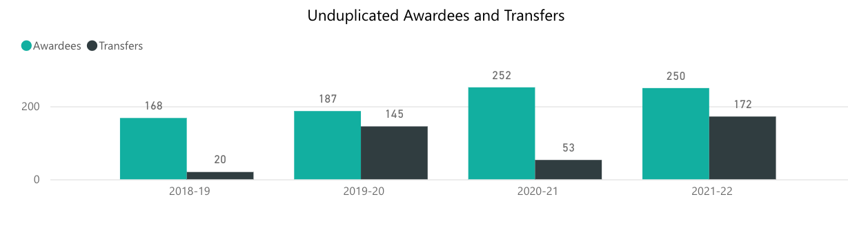

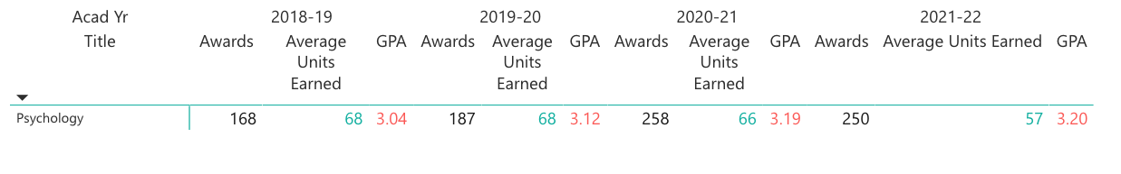

Psychology is the second highest degree awarding department at the college, behind Business. The Psychology Department experienced a significant increase in its number of degree conferrals from the 2018-19/2019-20 (N = 168-187) compared to 2020-21/2021-22 (N = 250-252) academic years.

1. **Certificate Completion: Number/percent of students earning a program certificate**

The Psychology Department does not currently confer program certificates.

1. **Transfer to a four-year institution: Number/percent of students transferring to a four-year institution**

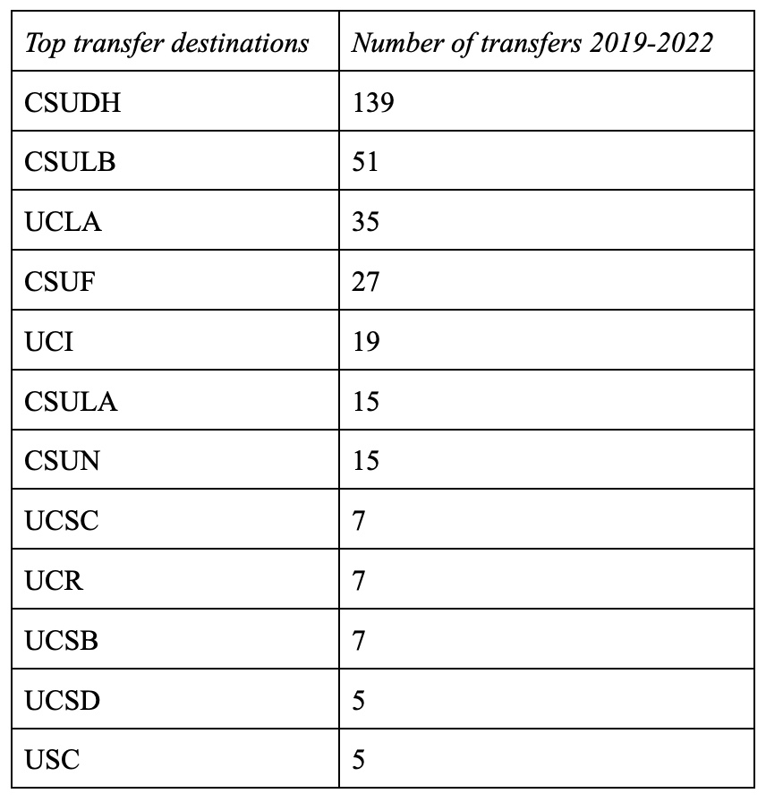Transfers have also increased from 2018-19 (N = 20) to 2019-20/2021-22 (N = 145-172). The one exception was the start of COVID during the 2020-21 academic year at N = 53. This is likely due to the uncertainty of the COVID situation. No data were available to disaggregate by race/ethnicity, gender, and age to determine the extent to which equity gaps existed in the rates of transfers to four-year institutions.

1. **Scheduling of courses: Percentage of students enrolled in day/evening courses, on campus/online/hybrid courses, days of the week**

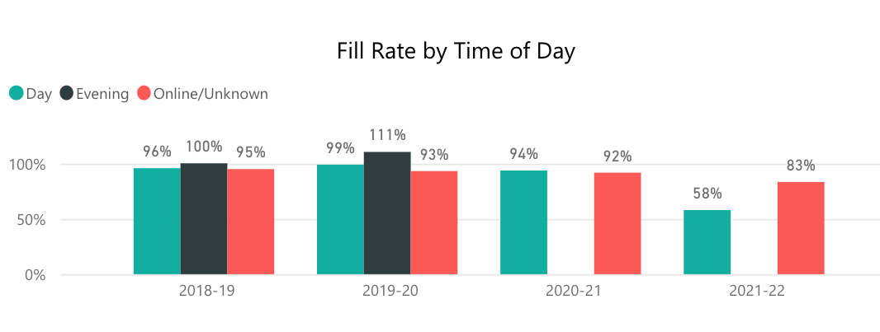

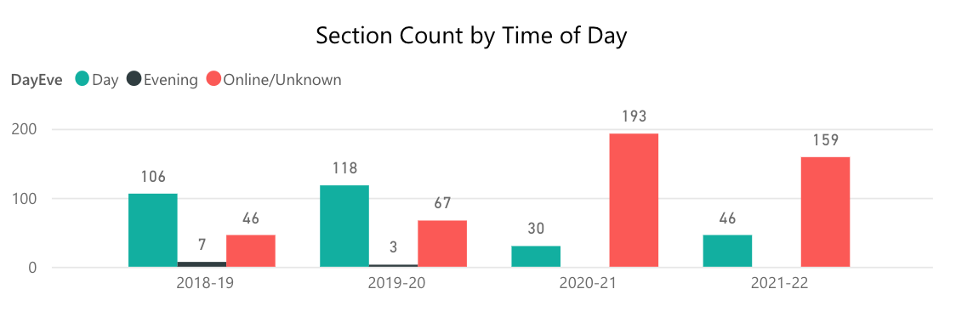

Based on the available data regarding fill rates, the times and frequencies that courses are

scheduled seemed to fulfill student demand for courses. All sections offered by the psychology program (day, evening, and online) had greater fill rates than the averages for the campus for each year. It is possible that this increase was due to most psychology courses being conducive to the online platform as they do not require labs. Lectures, discussions, and papers online are commonly used in-person and online sections. While some students waited to take lab courses until the college was back in person, they chose to take online psychology classes instead. Another explanation for the increased enrollment in the middle of the pandemic is that students were experiencing some mental health and social justice issues during this time. They wanted to learn more about these topics in psychology courses that addressed depression, anxiety, and other interpersonal issues.

Enrollment and the number of sections offered were highest during the 2020-21 academic year, in contrast to most other departments on campus. This was during the COVID-19 pandemic, when all courses were delivered online. It is possible that this increase was due to most psychology courses being conducive to the online platform as they do not require labs. Lectures, discussions, and papers submitted online are commonly used in both in-person and online sections. While some students waited to take lab courses until the college was back in person, they may have chosen to take online psychology classes instead. Another explanation for the increased enrollment in the middle of the pandemic is that students were experiencing some mental health and social justice issues during this time. Perhaps they wanted to learn more about these topics in psychology courses that addressed depression, anxiety, and other interpersonal issues.

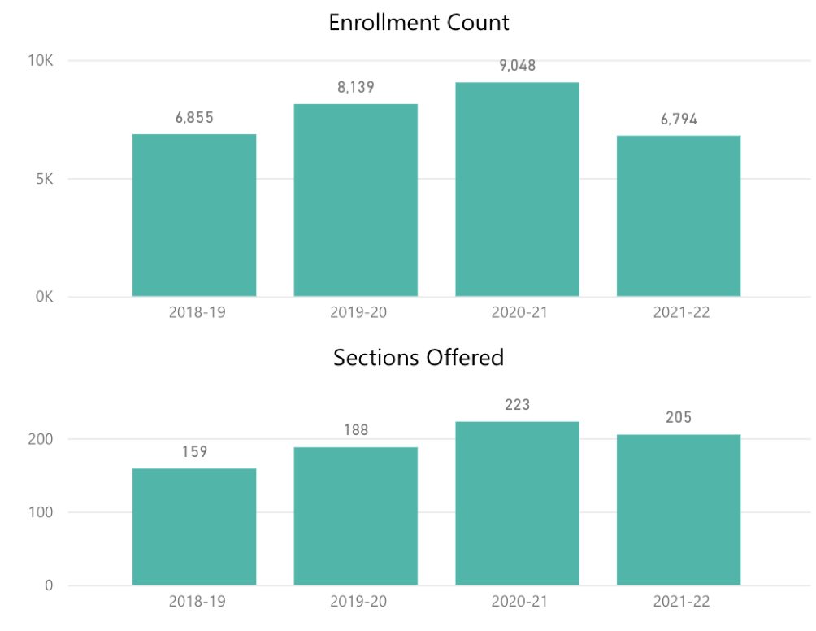

1. **Fill rate: Percentage of actual students enrolled in a term in relation to total seats offered**

Fill rate ranged from 78-97%. The fill rate declined in 2020-21/2021-22 in part due to the increased number of sections offered. See graph above in section D. Not as many students had to be waitlisted or turned away due to being full, because more sections were available to accommodate them. No data were available to disaggregate by race/ethnicity, gender, and age to determine the extent to which equity gaps existed in fill rates for psychology courses.

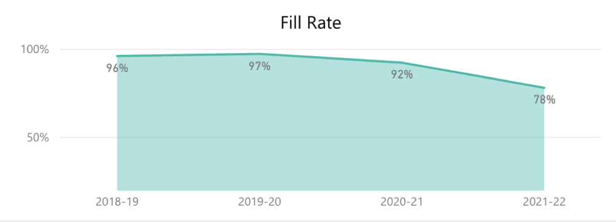

1. **Grade Distribution: Percentage of students in a course receiving each of the possible grades that can be awarded**

The following information was obtained from the El Camino College Institutional Research and

Planning Program Review Dashboard. We requested the data in database format and aggregated ita. For these percentages, we used the total number of students who earned a grade in the class as the denominator. In other words, students who withdrew were not included. In addition, we noticed that Spring 2020 courses were still coded in pre-pandemic terms: we recoded those listed as On Campus to Online, as all courses were moved online a few weeks after the semester began.

Grade Distribution – On Campus Courses

|  |  |  |  |  |  |  |  |  |  |  |  |
| --- | --- | --- | --- | --- | --- | --- | --- | --- | --- | --- | --- |
|  | **A** | | **B** | | **C** | | **D** | | **F** | | **TOTAL** |
| **COURSE** | **n** | **%** | **n** | **%** | **n** | **%** | **n** | **%** | **n** | **%** | **n** |
| **PSYC-101** | 1067 | **38%** | 872 | **25%** | 673 | **17%** | 181 | **6%** | 410 | **14%** | 3203 |
| **PSYC-101H** | 56 | **59%** | 26 | **29%** | 9 | **9%** | 0 | **0%** | 3 | **3%** | 94 |
| **PSYC-102** | 195 | **39%** | 74 | **17%** | 66 | **15%** | 16 | **4%** | 100 | **25%** | 451 |
| **PSYC-103** | 190 | **32%** | 159 | **38%** | 82 | **20%** | 40 | **6%** | 29 | **4%** | 500 |
| **PSYC-103H** | 5 | **63%** | 1 | **13%** | 2 | **25%** | 0 | **0%** | 0 | **0%** | 8 |
| **PSYC-107** | 103 | **30%** | 125 | **28%** | 126 | **27%** | 17 | **4%** | 43 | **11%** | 414 |
| **PSYC-108** | 98 | **28%** | 134 | **37%** | 79 | **22%** | 23 | **6%** | 25 | **8%** | 359 |
| **PSYC-109A** | 37 | **29%** | 36 | **26%** | 39 | **29%** | 1 | **1%** | 21 | **15%** | 134 |
| **PSYC-109B** | 90 | **45%** | 90 | **28%** | 74 | **22%** | 7 | **2%** | 8 | **3%** | 269 |
| **PSYC-110** | 64 | **42%** | 27 | **16%** | 18 | **13%** | 6 | **5%** | 40 | **25%** | 155 |
| **PSYC-112** | 53 | **25%** | 76 | **34%** | 58 | **24%** | 17 | **7%** | 22 | **10%** | 226 |
| **PSYC-115** | 82 | **40%** | 72 | **32%** | 40 | **17%** | 11 | **4%** | 15 | **7%** | 220 |
| **PSYC-116** | 152 | **51%** | 112 | **29%** | 59 | **13%** | 12 | **2%** | 17 | **4%** | 352 |
| **PSYC-117** | 11 | **46%** | 8 | **33%** | 4 | **17%** | 0 | **0%** | 1 | **4%** | 24 |
| **PSYC-119** | 10 | **20%** | 21 | **39%** | 17 | **26%** | 2 | **3%** | 8 | **12%** | 58 |
| **PSYC-125** | 8 | **26%** | 5 | **16%** | 2 | **6%** | 1 | **3%** | 15 | **48%** | 31 |
|  |  |  |  |  |  |  |  |  |  |  |  |
| **TOTAL** | 2221 | **37%** | 1838 | **28%** | 1348 | **19%** | 334 | **4%** | 757 | **12%** | 6498 |

Grade Distribution – Online Courses

|  |  |  |  |  |  |  |  |  |  |  |  |
| --- | --- | --- | --- | --- | --- | --- | --- | --- | --- | --- | --- |
|  | **A** | | **B** | | **C** | | **D** | | **F** | | **TOTAL** |
| **COURSE** | **n** | **%** | **n** | **%** | **n** | **%** | **n** | **%** | **n** | **%** | **n** |
| **PSYC-101** | 1949 | **33%** | 1391 | **25%** | 938 | **18%** | 204 | **4%** | 1054 | **21%** | 5546 |
| **PSYC-101H** | 120 | **85%** | 14 | **10%** | 4 | **3%** | 0 | **0%** | 3 | **2%** | 141 |
| **PSYC-102** | 346 | **58%** | 114 | **21%** | 74 | **13%** | 8 | **1%** | 57 | **7%** | 602 |
| **PSYC-103** | 365 | **40%** | 223 | **26%** | 137 | **19%** | 41 | **5%** | 105 | **10%** | 874 |
| **PSYC-103H** | 62 | **61%** | 20 | **21%** | 7 | **7%** | 3 | **3%** | 8 | **8%** | 100 |
| **PSYC-107** | 508 | **40%** | 320 | **30%** | 159 | **15%** | 36 | **3%** | 114 | **11%** | 1143 |
| **PSYC-108** | 187 | **53%** | 86 | **25%** | 42 | **12%** | 10 | **3%** | 30 | **7%** | 357 |
| **PSYC-109A** | 70 | **24%** | 87 | **32%** | 55 | **20%** | 15 | **6%** | 51 | **18%** | 279 |
| **PSYC-109B** | 402 | **51%** | 214 | **26%** | 114 | **14%** | 19 | **2%** | 42 | **5%** | 795 |
| **PSYC-110** | 15 | **36%** | 8 | **19%** | 6 | **14%** | 1 | **2%** | 11 | **26%** | 42 |
| **PSYC-112** | 192 | **46%** | 82 | **22%** | 41 | **11%** | 14 | **4%** | 69 | **16%** | 400 |
| **PSYC-115** | 453 | **59%** | 175 | **23%** | 69 | **8%** | 16 | **2%** | 67 | **8%** | 780 |
| **PSYC-116** | 1187 | **55%** | 532 | **23%** | 270 | **12%** | 49 | **2%** | 198 | **8%** | 2244 |
| **PSYC-117** |  |  |  |  |  |  |  |  |  |  |  |
| **PSYC-119** | 12 | **26%** | 11 | **23%** | 10 | **21%** | 4 | **9%** | 10 | **21%** | 47 |
| **PSYC-125** | 44 | **50%** | 18 | **19%** | 5 | **6%** | 0 | **0%** | 25 | **25%** | 92 |
|  |  |  |  |  |  |  |  |  |  |  |  |
| **TOTAL** | 5912 | **49%** | 3295 | **24%** | 1931 | **13%** | 420 | **3%** | 1844 | **11%** | **13442** |

Grade Distribution – Total: Online and On Campus Courses

|  |  |  |  |  |  |  |  |  |  |  |  |
| --- | --- | --- | --- | --- | --- | --- | --- | --- | --- | --- | --- |
|  | **A** | | **B** | | **C** | | **D** | | **F** | | **TOTAL** |
| **Course** | **n** | **%** | **n** | **%** | **n** | **%** | **n** | **%** | **n** | **%** | **n** |
| **PSYC-101** | 3016 | **35%** | 2263 | **25%** | 1611 | **17%** | 385 | **5%** | 1464 | **18%** | 8749 |
| **PSYC-101H** | 176 | **75%** | 40 | **17%** | 13 | **5%** | 0 | **0%** | 6 | **3%** | 235 |
| **PSYC-102** | 541 | **51%** | 188 | **19%** | 140 | **14%** | 24 | **2%** | 157 | **14%** | 1053 |
| **PSYC-103** | 555 | **37%** | 382 | **30%** | 219 | **19%** | 81 | **5%** | 134 | **8%** | 1374 |
| **PSYC-103H** | 67 | **62%** | 21 | **19%** | 9 | **10%** | 3 | **2%** | 8 | **6%** | 108 |
| **PSYC-107** | 611 | **37%** | 445 | **29%** | 285 | **19%** | 53 | **4%** | 157 | **11%** | 1557 |
| **PSYC-108** | 285 | **40%** | 220 | **31%** | 121 | **17%** | 33 | **4%** | 55 | **7%** | 716 |
| **PSYC-109A** | 107 | **26%** | 123 | **29%** | 94 | **24%** | 16 | **3%** | 72 | **17%** | 413 |
| **PSYC-109B** | 492 | **48%** | 304 | **27%** | 188 | **18%** | 26 | **2%** | 50 | **4%** | 1064 |
| **PSYC-110** | 79 | **41%** | 35 | **16%** | 24 | **13%** | 7 | **4%** | 51 | **25%** | 197 |
| **PSYC-112** | 245 | **38%** | 158 | **27%** | 99 | **16%** | 31 | **5%** | 91 | **14%** | 626 |
| **PSYC-115** | 535 | **52%** | 247 | **26%** | 109 | **12%** | 27 | **3%** | 82 | **8%** | 1000 |
| **PSYC-116** | 1339 | **54%** | 644 | **25%** | 329 | **12%** | 61 | **2%** | 215 | **7%** | 2596 |
| **PSYC-117** | 11 | **46%** | 8 | **33%** | 4 | **17%** | 0 | **0%** | 1 | **4%** | 24 |
| **PSYC-119** | 22 | **22%** | 32 | **35%** | 27 | **25%** | 6 | **4%** | 18 | **14%** | 105 |
| **PSYC-125** | 52 | **44%** | 23 | **19%** | 7 | **6%** | 1 | **1%** | 40 | **31%** | 123 |
|  |  |  |  |  |  |  |  |  |  |  |  |
| **TOTAL** | 8133 | **44%** | 5133 | **25%** | 3279 | **15%** | 754 | **3%** | 2601 | **12%** | 19940 |

General Psychology (PSYC-101) enrolls our largest number of students as it is a prerequisite for other psychology courses and many non-majors take it. Most students earn an A or a B grade in PSYC 101. Our 4-unit courses - Introduction to Elementary Statistical Methods for the Study of Behavior (PSYC-109A) and Experimental Methods in the Study of Behavior (PSYC-109B) - tend to have higher variability of grades with more students falling into the C and D grades. These courses have been historically more challenging for students. Physiological Psychology (PSYC-107) also tends to see more C grades and below than other psychology courses. A surprising data point is the relatively high percentage of Fs awarded for The Psychology of Gender (PSYC-125); however, this number is skewed by the instructor’s choice for the first two offerings of the course not to drop those who had stopped participating. Since then, the course has been taught two more times, with 13-15% of students earning an F.

1. **Course Success: Percentage of students enrolled at census who complete the course with a grade of A, B, C, or P**

**COURSE COMPLETION**

The course completion rate in the psychology department (89.8%) is higher than the college’s course completion of 83.6%.

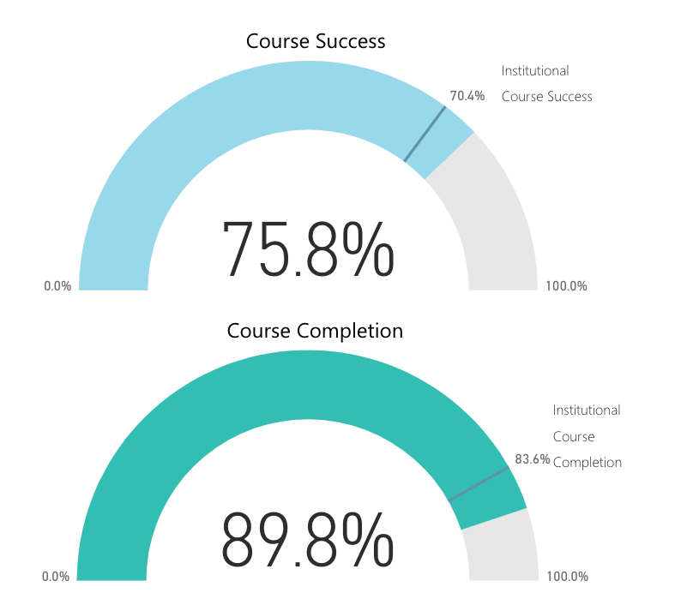

**Course-Level Data for Course Completion**

* General Psychology (PSYC-101): 83-100%
  + The highest completion rates come from the honors sections of the course.
* Psychology for Effective Living (PSYC-102): 87-100%
* Critical Thinking and Psychology (PSYC-103): 80-100% range.
  + A few sections are in the 70% range, but the samples are quite small; one student not completing the class severely affects the completion rate of the section.
* Physiological Psychology (PSYC-107): 72-100%.
  + This class fulfills the life science requirement for GE with biology content that some students find more challenging than other psychology courses.
* Social Psychology (PSYC-108): 90% range
* Intro. to Elementary Stat. Methods for the Study of Behavior (PSYC-109A): 74-94%
  + This lower rate is to be expected, as this math-focused course encounters some of the same challenges with the material as Physiological Psychology (PSYC-107).
* Experimental Methods in the Study of Behavior (PSYC-109B): 88-100%.
* African American Psychology (PSYC-110): 46-97%.
  + This course does not reach capacity, so the performance of a few students sways the completion rate significantly.
* Human Sexuality (PSYC-112): 85-100%
* Abnormal Psychology (PSYC-115): 83-100%
* Lifespan Development (PSYC-116): 82-100%.
* Cultural Psychology(PSYC-117): 96%
  + There was only one section that was offered during this period.
* LGBTQ+ Psychology (PSYC-119): 68-92%.
  + The sections were not filled leading to a smaller sample for these descriptive statistics.
* The Psychology of Gender (PSYC-125): 88-100%.

**COURSE SUCCESS - OVERALL**

The course success in the psychology department (75.8%) is higher than the college’s course success of 70.4%.



Over the last four years, course success ranged from 75-80%.

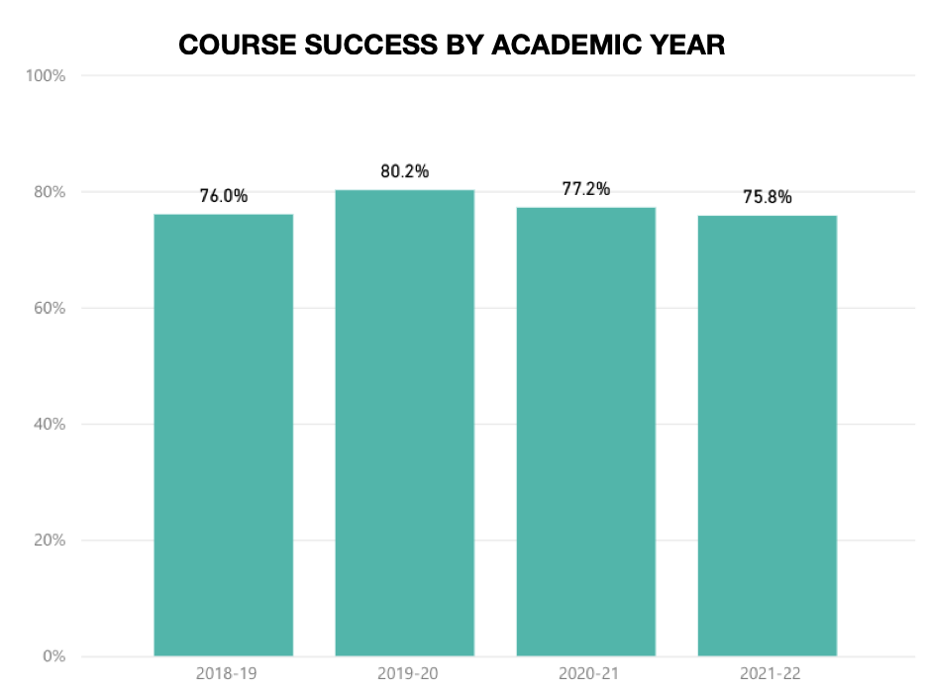

**COURSE SUCCESS BY SEX**

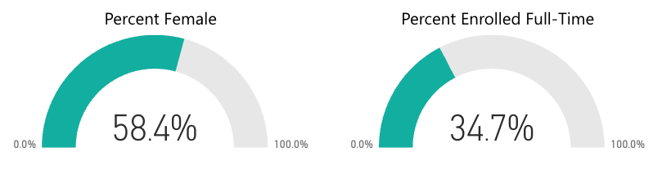

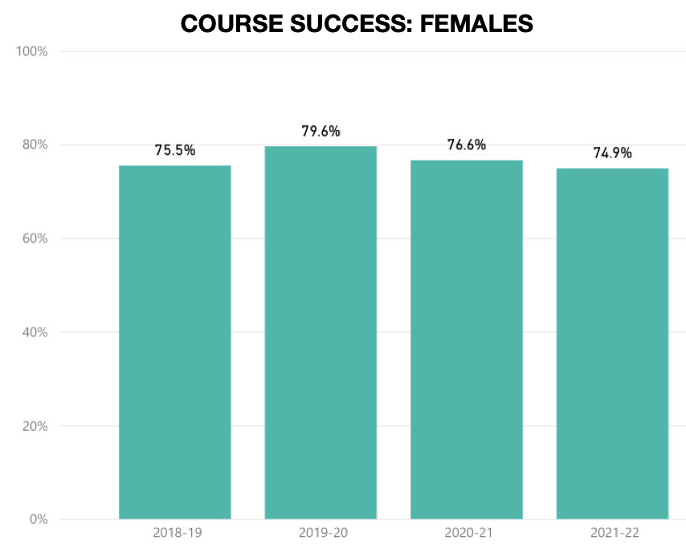Most psychology program students are female. Disaggregated by sex, we see that male and female students have very similar success rates. The sex differences that exist are small and are likely statistically insignificant, but males’ success rates (77-81%) are slightly higher than females’ success rates (74-79%).

There are notable differences in success rates among students who identify as nonbinary, or mark unknown, or decline to answer. While such students showed a very high success rate in 2018-2019 (92.3%), we see a sharp decline as the pandemic progresses (75% and 63.6%, respectively). Two main factors may help explain this change: 1) Some members of the LGBTQIA+ community self-identify into this 3rd group. They are a marginalized community that was disproportionately affected by the pandemic. Many of them lost their homes or jobs affecting their academic performance. 2) This 3rd group is a smaller sample, thus possibly skewing the descriptive statistics presented.

**COURSE SUCCESS BY ETHNICITY**

Psychology students at El Camino College represent a wide range of ethnic backgrounds. The largest group is Hispanic students at 45%, followed by African American students at 13.7%.

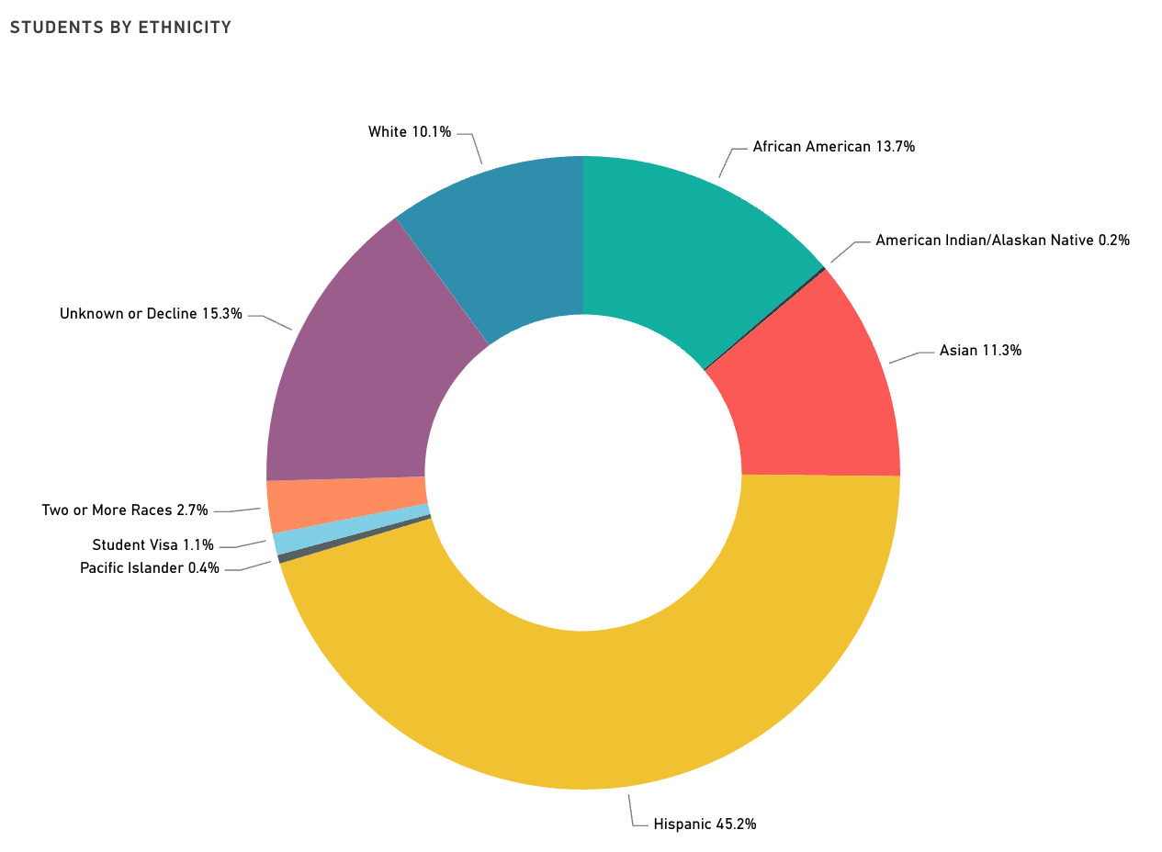

As reported earlier, the overall course success rate in the psychology department is 75.8%. Disaggregating by ethnicity reveals notable differences, however.

The highest success rates are shown among Asian students (85-90%) and White students (83-86%).

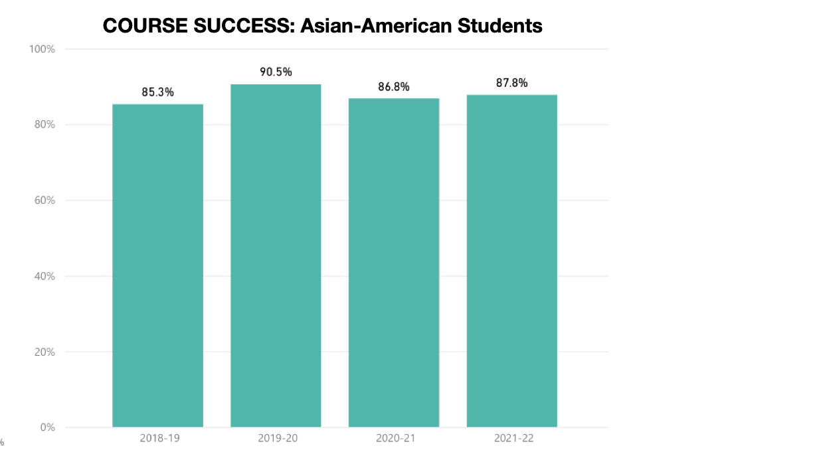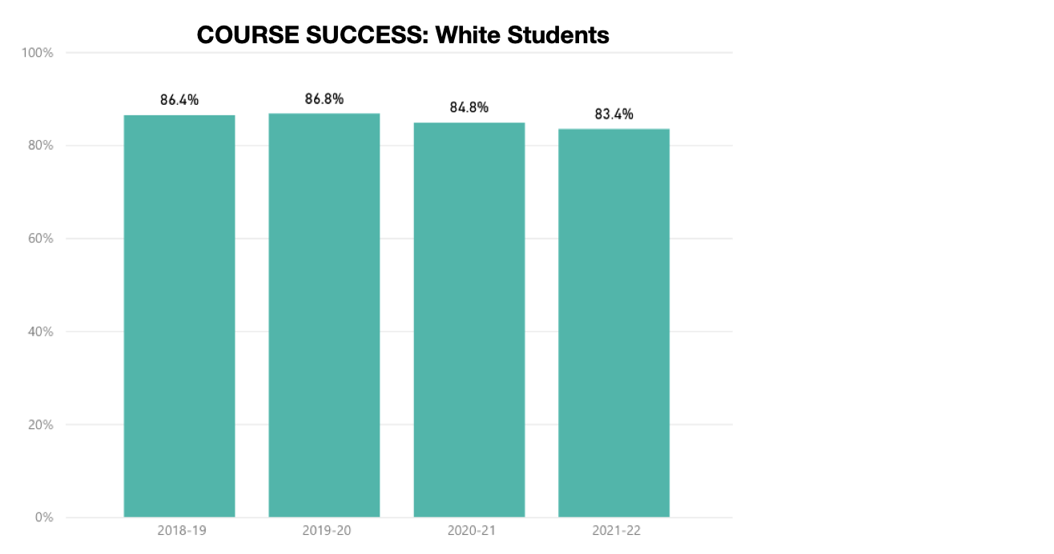

Ethnic groups with success rates below the psychology department average suggest equity gaps.

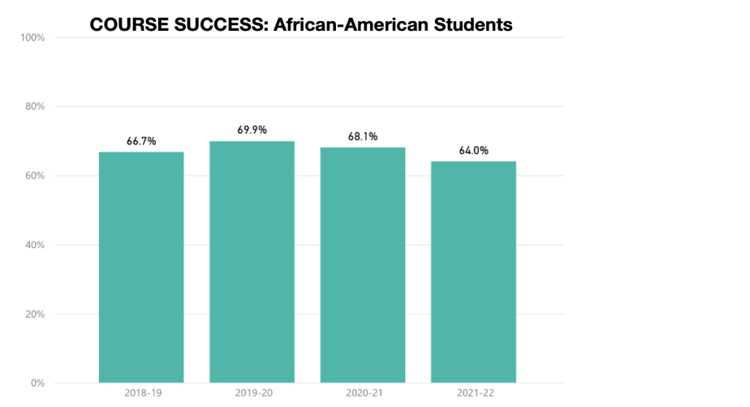African-American students’ success rates range from 64-69%, indicating the largest equity gap for ethnicity. The equity gap is smaller for Hispanic students, whose success rates range from 73-78%.

Other trends emerge from ethnic groups with much smaller populations. American Indian/Alaskan Native students, who make up 0.2% of the psychology student population at El Camino College, showed considerable variability across the years in success rates (62%, 81%, 53%, and 76%, respectively). The very small number of people in this category make it very hard to make meaningful interpretations of these results.

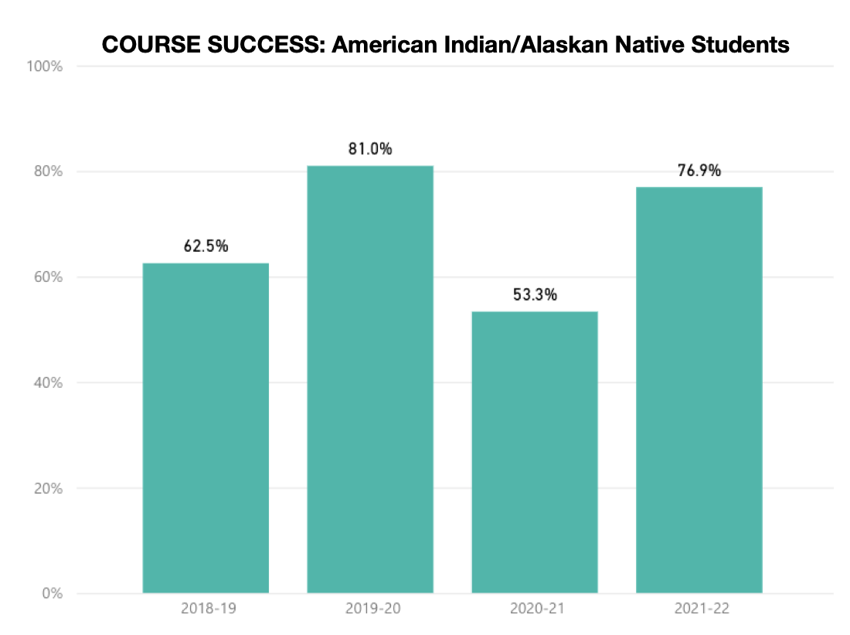

Pacific Islander students comprise 0.4% of our psychology students. Their course success rates also showed great variability, including a dip during the start of the pandemic and a recovery in 2021-22. The small sample size makes it difficult to make meaningful interpretations.

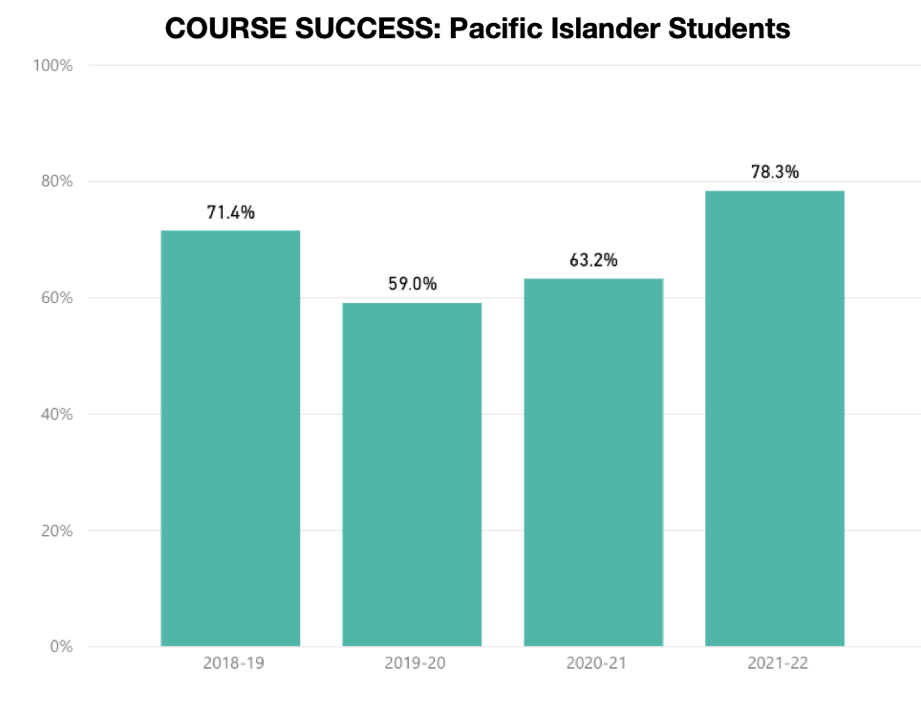

**Preliminary MyPath Course Success**

As previously mentioned, the Psychology Department has been active in [MyPath](https://www.elcamino.edu/support/resources/student-equity-program/mypath.aspx), which promotes “*equity-minded and culturally responsive instruction and embeds support services and PASS Mentors,”* Preliminary MyPath data on course success by ethnicity is shown below. With a total sample size of only 181 students and many students categorized as unknown/decline in the fall of 2021, it is difficult to interpret these data. We provide them here as a baseline against which to compare future MyPath data.

**COURSE SUCCESS BY AGE**

El Camino College psychology students represent a wide range of ages. Ages 17-19 comprised 32% of the population, while ages 20-24 comprised 36%. We do not have data to investigate whether course success rates vary by age.

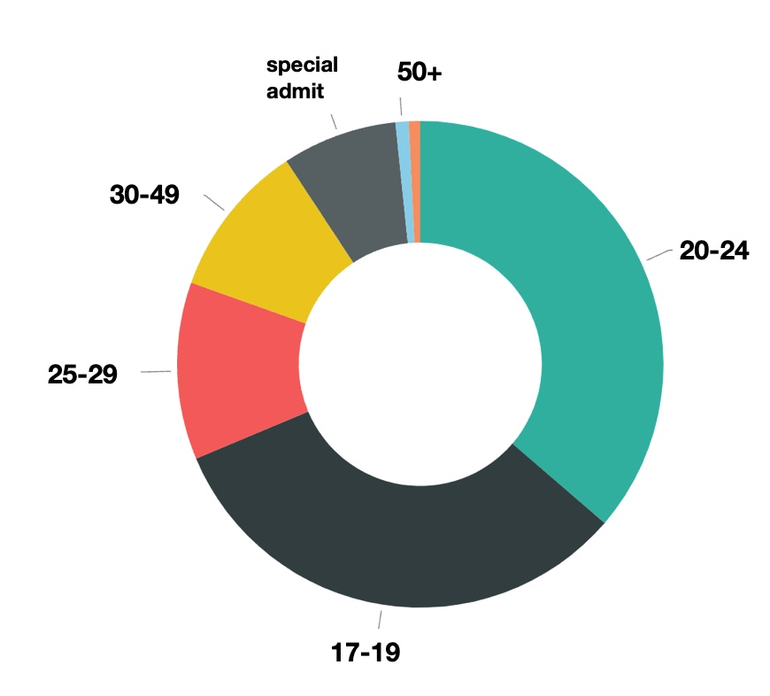

**COURSE SUCCESS BY PART-TIME AND FULL-TIME STATUS**

Approximately ⅓ of the students are full-time. We do not have data to analyze whether their course completion rates differ from those of full-time students.

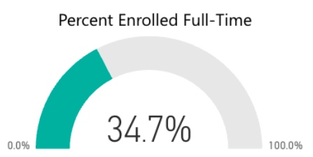

1. **Unit Accumulation: Number of units accumulated by students working towards a program degree/certificate. Discuss whether students who take units beyond the requirements for their educational goals serve educational purposes or not. Focus on general trends, not on particular courses within the program.**

Earning the AA-T requires 20-21 units from specific psychology courses. For both CSU-GEB and IGETC, the requirement is for 60 transferable units. Psychology majors average between 57-68 units, suggesting they are not taking many courses beyond what is needed for their transfer goals.

# Curriculum and Outcomes Assessment

1. **Examine the program curriculum using an equity lens by responding to the following questions: To what extent does the curriculum:**

**a1) Prepare students to actively engage in a diverse society? Include multicultural content? Encourage instructors and students to investigate their own views, biases and values and discuss multiple perspectives different from their own?**

Many of the psychology courses that we offer include content that is useful in preparing students to actively engage in a diverse society and includes a multicultural content. For example, General Psychology (PSYC-101) offers an overview of psychology with an emphasis on cultural diversity; Psychology of Effective Living (PSYC-102) explores *“personal development and adjustment in society as well as the psychosocial and cultural influences on childhood, adolescence, and adulthood”;* African American Psychology (PSYC-110) includes investigation of the *“relationship between the African American experience and social perception, social cognition, and identity and attitude formation,”* Human Sexuality (PSYC -112) studies topics related to human sexuality, sexual behavior and relationships, and sex as a social and health issue; Abnormal Psychology (PSYC-115) explores psychopathology through a cultural lens, with an emphasis on how mental disorders are perceived, diagnosed, and treated in a diverse society; Lifespan Development (PSYC-116) examines development throughout the lifespan, with a special emphasis on culture and family relationships; Cultural Psychology (PSYC-117) studies *“psychological principles, theory, and research through exploration of cultural differences and similarities, both within and across cultures”;* LGBTQ+ Psychology (PSYC-119) provides *“an introduction to psychological, social, and cultural aspects of sexual orientation and gender identity”;* and The Psychology of Gender (PSYC-125) explores the *“influence of gender in such areas as relationships, communication, health, and work.”* [(Course description citations from ECC Course Catalog.)](http://catalog.elcamino.edu/content.php?filter%5B27%5D=PSYC&filter%5B29%5D=&filter%5Bcourse_type%5D=-1&filter%5Bkeyword%5D=&filter%5B32%5D=1&filter%5Bcpage%5D=1&cur_cat_oid=7&expand=&navoid=362&search_database=Filter&filter%5Bexact_match%5D=1#acalog_template_course_filter)

The psychology department endeavors to promote a pedagogy which facilitates an understanding of how psychological theory and principles can be applied to the everyday lives (past, present, and future) of our diverse student population. As such, the psychology faculty are focused on promoting a learning environment that effectively navigates culturally sensitive topics, integrates cultural diversity, and facilitates responsible and sensitive discussions around individual and cultural differences and similarities. Psychology faculty are achieving these goals through incorporating inclusive content, which is culturally relevant for learning and cognitive consolidation, and allows for personal application and promotion of active learning.

**a2) Use critical/equity-oriented pedagogy? Respond to diverse students’ learning needs? Use multiple evaluation techniques sensitive to the diverse ways students can demonstrate understanding? Ensure creating an empowering classroom environment? Support student learning using a variety of instructional methods, educational technologies, and college resources.**

Psychology is a science, and one key goal of the Psychology Department is to train students to be adept at the basics of empirical research. This includes not only the ability to interpret and critique scientific research, but also the skills to conduct their own scientific research. Our PSYC 109 A/B series, which focuses on statistics and research methods, provides a critical foundation in empirical research. We have previously discussed the urgent need to increase full-time faculty to fulfill the demand for this course. Also previously mentioned is a need to bolster our computer and software resources (SPSS) so that students do not miss out on this important aspect of their scientific education. The lack of these resources may also impinge upon SLO success, course success, and successful articulation.

The Psychology Department has added courses that address matters of equity and inclusion, such as LGBTQ+ Psychology (PSYC-119), The Psychology of Gender (PSYC-125), and General Psychology (PSYC-101) with First Year Experience (FYE) cohorts. In addition, the Psychology Department has been active in [MyPath](https://www.elcamino.edu/support/resources/student-equity-program/mypath.aspx), which promotes “*equity-minded and culturally responsive instruction and embeds support services and PASS Mentors,”* Students in these courses who have opted to participate in the PASS mentoring program have consistently given encouraging feedback, with many crediting these sessions with positively influencing their grades. These courses also utilize *ECC Connect* to flag students that are struggling with submitting assignments, and the equity-minded course counselor then follows-up on these flags. El Camino College has found that students referred to *ECC Connect* have higher rates of success and retention. In addition to the MyPATH PSYC 101 courses, the psychology department has also linked courses with Human Development, designing and teaching equity-minded learning communities. These linked courses, which included Strategies for Creating Success in College and in Life (HDEV-110) and PSYC-101 were taught in Fall 2017, 2018, & 2019. In Fall 2022, psychology again collaborated with HDEV in developing an equity-minded learning community (PSYC-101 and HDEV-110) with an LGBTQIA+ and allies theme. Likewise, in Spring 2023 we expanded to collaborate with the History department in the same manner (HIST-101 and PSYC-119). The Psychology Department plans on continuing to offer MyPath courses in the future.

Providing zero-cost textbooks (ZTC) or low-cost texts (LTC) textbooks is another way that the psychology program has responded to the needs of students in its efforts to improve student equity and success. Many students do not have the funds to purchase textbooks, so several of our instructors have switched to ZTC or LTC. For example, in the spring semester of 2023, at least one section of the following courses was offered with Zero Textbook Cost (ZTC) materials: General Psychology (PSYC-101); Honors General Psychology (PSYC-101H); Critical Thinking and Psychology (PSYC-103); Introduction to Elementary Statistical Methods for the Study of Behavior (PSYC-109A); Experimental Methods in the Study of Behavior (PSYC-109B); Abnormal Psychology (PSYC-115); Lifespan Development (PSYC-116); LGBTQ+ Psychology (PSYC-119); The Psychology of Gender (PSYC-125). The Psychology of Stress, Illness, and Trauma (PSYC 378), which will be taught for the first time in the Fall of 2023, will also use ZTC materials. In addition, two courses – Physiological Psychology (PSYC-107), and Cultural Psychology (PSYC-117) – were offered with Low Text Cost (LTC) materials.

Other strategies that are being used to provide supportive and empowering equity-oriented pedagogy and respond to diverse students’ learning needs include the following:

1. Integration of culturally diverse teaching materials (e.g., readings, podcasts, videos, exercises/activities) and accommodation of varied learning modalities (e.g., visual, auditory, reading/writing);
2. Teaching in “smart classrooms,” which allows instructors multimedia access - e.g., internet, streaming, DVD, computers, PPT, document viewers, clickers, internet response systems such as “Poll Everywhere” and “Kahoot.” (Instructors can still present material on classroom whiteboards.)
3. Utilization of ECC’s Learning Management system (i.e., Canvas) and/or faculty websites for both online instruction and to supplement on-campus lectures, with the goal of enhancing student learning. (Some psychology instructors have created podcasts and short informational video clips with this goal in mind.)
4. Ensuring that psychology courses are compliant with the Americans with Disabilities Act (ADA). For example, some psychology faculty have successfully closed-captioned all of their course videos through Panopto.
5. Enhancement of psychological knowledge beyond the scope of course material (e.g., provide website information, articles, videos, podcasts, references, etc.).
6. Advisement of career alternatives/opportunities related to the psychology discipline (e.g., presentations that focus on careers in psychology, handouts such as the APA publication Careers for the 21st Century.
7. Ensuring that students are provided with information regarding [student support services and resources](http://catalog.elcamino.edu/content.php?catoid=6&navoid=280) - e.g., Student Health Center (including psychological counseling), the Counseling Center (including academic guidance, transfer services, and career services), the Writing Center, the Reading Center, the Special Resource Center, the Library, the Learning Resources Center, Financial Aid and Scholarships, Veterans Services, and Student Activities. Psychology faculty also refer students to Human Development and to Academic Strategies courses to increase students’ chances of succeeding in college.
8. **Summarize SLO and PLO assessment results over the past four years for key/gateway courses. Gateway courses are determined by your department & division – contact your Dean.**

Gateway courses for psychology are General Psychology (PSYC-101) and Lifespan Development (PSYC-116).

**GENERAL PSYCHOLOGY - PSYC-101**

SLOs: 1) Identify key elements of the scientific method (e.g., sampling of participants, measurement/manipulation of variables) as applied to mental processes and behavior; 2) Explain, differentiate, and critique the major theoretical perspectives in psychology (e.g., psychoanalytic, behavioral, cognitive); 3) Describe the historical events leading to the establishment of psychology as a science; apply fundamental psychological principles (e.g., perception, development, memory, conditioning, clinical, group) in their efforts to understand everyday life experiences (e.g., child discipline, eyewitness testimony).

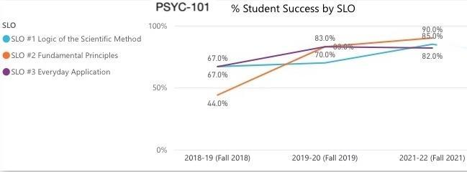

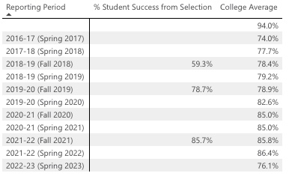

SLO ASSESSMENT RESULTS: For two of the three assessment cycles, the standard and target for success for each of the SLOs has been met – i.e., at least 66% of students completed the SLO assessment with 67% or higher. One exception is for SLO #2 in the fall of 2018, where 44% met the standard. The results for PSYC-101 were nearly identical to the college average for all but the Fall 2018 assessment, where the PSYC-101 average was 59.3% compared to the college average of 78.4%.

| **PLO ASSESSMENT RESULTS FOR PSYC-101: GENERAL PSYCHOLOGY** | | | |
| --- | --- | --- | --- |
| PLO | Assessment Conducted | Standard Met? | % of Success |
| PLO #1 Logic of the Scientific Method  SLO #1 Logic of the Scientific Method | Fall 2018 | met | 67.0% |
| Fall 2019 | met | 70.0% |
| PLO #2 Fundamental Principles  SLO #2 Fundamental Principles | Fall 2018 | not met | 44.0% |
| Fall 2019 | met | 83.0% |
| PLO #3 Everyday Application  SLO #3 Everyday Application | Fall 2018 | met | 67.0% |
| Fall 2019 | met | 83.0% |

PLO ASSESSMENT RESULTS: PLO assessments were conducted in the Fall of 2018 and 2019. These data show the same rates of success across two of the three assessment cycles, except for SLO #2 in the Fall of 2018.

**LIFESPAN DEVELOPMENT - PSYC-116**

SLOs: (1) Describe and contrast specific research methods in the study of lifespan development (e.g., longitudinal, cross-sectional, sequential designs) as well as assess the strengths and weaknesses of each. Students will be assessed through essay exam questions, multiple choice exam questions, or writing assignments. (2) Identify, explain, and compare these aspects of the major theoretical perspectives of lifespan development: main focus, key concepts, and basic assumptions. Students will be assessed by multiple choice exams, essay exams, oral presentations, or research-based papers. (3) Apply fundamental lifespan principles (e.g., temperament, attachment, personality, parental style, milestones, interpersonal and familial relationship) in their efforts to understand everyday life experiences (e.g., child rearing, bereavement). Students will be assessed by written exams, essay exams, research-based argumentative papers, or oral presentations of arguments.

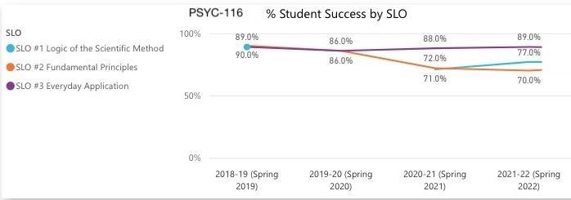

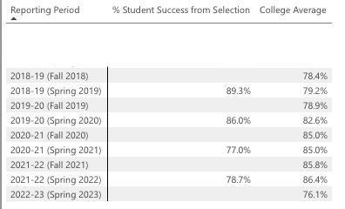

SLO ASSESSMENT RESULTS: The standard and target for success for each of the SLOs over the past four cycles has been met – i.e., at least 70% of students completed the SLO assessment with 70% or higher. The results for PSYC-116 varied in how they compared to the college average, sometimes exceeding the college average (Spring 2019, 2020) and sometimes falling below the college average (Spring 2021, 2022).

|  |  |  |  |
| --- | --- | --- | --- |
| **PLO ASSESSMENT RESULTS FOR PSYC-116: LIFESPAN DEVELOPMENT** | | | |
| PLO | Assessment Conducted | Standard Met? | % of Success |
| PLO #1 Logic of the Scientific Method  SLO #1 Logic of the Scientific Method | Spring 2019 | met | 89.0% |
| Spring 2020 | met | 98.0% |
| PLO #2 Fundamental Principles  SLO #2 Fundamental Principles | Spring 2019 | met | 90.0% |
| Spring 2020 | met | 86.0% |
| PLO #3 Everyday Application  SLO #3 Everyday Application | Spring 2019 | met | 89.0% |
| Spring 2020 | met | 86.0% |

PLO ASSESSMENT RESULTS: PLO assessments were conducted in the Spring of 2019 and 2020. These data show that the standard was met across all assessments – i.e., at least 70% of students completed the SLO assessment with 70% or higher.

1. **Discuss programmatic factors contributing to constant, increasing or decreasing trends in the results for SLO and PLO assessment within the previously examined courses.**

The largest deviation from target success rates occurred for PSYC-101 in the Fall of 2018. The overall success rate was 59.3%, which did not meet the standard of 70%. The psychology faculty do not have an explanation for this outlier. Given that following assessments rebounded to 78.7% (Fall 2019) and 85.7% (Fall 2021), there is reason to believe that the Fall 2018 semester was simply an aberration.

In general, disruption to academic routine and protocol related to the COVID pandemic complicates efforts to make meaningful interpretations of trends in SLO and PLO assessment results. Creating supportive, enriching, dynamic, and inspirational learning environments has been a challenge over the last couple years, as we transitioned the college and student body to a fully online curriculum, and now adapt to the ongoing academic realities that the pandemic has fostered. Online classes are in popular demand, face-to-face classes struggle for enrollment, and hybrid and live online classes have become a regular part of the curriculum. Nevertheless, even with this major disruption to “normal” pre-pandemic learning, the PSYC-101 and PSYC-116 SLOs have still met their standards and targets for success over the pandemic period.

1. **Highlight equity gaps found in SLO and PLO assessment results among different groups of students.**

Our department is unable to determine whether equity gaps exist in assessment results for SLOs and PLOs because only aggregated data were available. Starting in the Fall of 2022, we began using Canvas Outcomes for assessments of PSYC-101. We will do the same for PSYC-116 in the Spring of 2023. Thus, we will be able to analyze disaggregated data and examine possible equity gaps for Program Reviews in the future.

# 

# SECTION 3 Program Vision and Future Planning

# Program Vision

1. **Describe the vision of the program for the next four years considering the assessment reported in the previous section, student groups that are underrepresented in the program’s field, and any relevant changes within the program field/industry. A vision statement describes the desired future state of the program.**

The Psychology Department will continue to emphasize teaching methods that help students from different backgrounds understand how psychological theories and concepts can be useful in their daily lives, both now and in the future.

Faculty are committed to creating a safe and respectful environment for discussing culturally sensitive topics, recognizing and embracing cultural diversity, and fostering discussions about individual and cultural differences and similarities. To achieve these objectives, the psychology faculty will continue to incorporate inclusive content that is relevant to diverse learners and promotes active learning, enabling students to apply these ideas to their own lives.

Our department will also maintain its long-term goal of teaching scientific literacy, a need that has only grown stronger with the continued expansion of online sources of misinformation.

# Future Planning

**A) Based on the assessment reported in the previous section, develop program goals to be completed during the next four years in relation to:**

* **Adjusting the curriculum for coherence and alignment with students’ workforce needs**
* **Advancing towards a more equitable program to close equity gaps among groups of students**
* **Clarifying students’ paths to completion, further education and employment**
* **Helping students explore options and build foundation skills**
* **Helping students stay on the path**
* **Integrating applied learning experiences**

1. **What projects will the program complete to achieve the desired goals? Please specify at least two for each goal.**
2. **When the next program review is due, how will the program determine if the goals have been met? Please specify at least one quantitative target or qualitative accomplishment for each goal.**

|  |  |  |
| --- | --- | --- |
| **Program Goals** | **Projects** | **Targets/Accomplishments** |
| Adjusting the curriculum for coherence and alignment with students’ workforce needs | 1. Offer additional course resources that cover topics related to professions within the field of psychology 2. Add and promote courses that reflect subfields in psychology that are growing in importance | Create and/or update handouts about careers in psychology. These can be distributed during class and/or on Canvas.  PSYC-378: The Psychology of Stress, Illness, and Trauma will be taught for the first time in the Fall of 2023. We will also promote the class to enhance enrollment. |
| Advancing towards a more equitable program to close equity gaps among groups of students | 1. Investigate the extent to which there are equity gaps in student academic performance. 2. Continue to learn about and implement equity-minded teaching strategies and assessments. | Evaluate SLO results to determine whether equity gaps exist in gateway courses.  Seek additional support for PSYC-110 (African American Psychology) students, such as the Student Equity Program.  Hire a peer mentor-tutor for PSYC-110 with the MyPATH program |
| Clarifying students’ paths to completion, further education and employment | 1. Create opportunities for students to learn how others have navigated a path from college to careers in psychology. 2. Educate students about important transfer-related matters for psychology majors, focusing on the schools to which most of our students transfer. | Invite former ECC students back to campus, specifically those who have pursued further education in psychology and/or currently work in the field. These events could be hosted by the Psychology Club.  Invite ECC counselors to speak at a Psychology Club meeting about psychology transfer requirements. |
| Helping students explore options and build foundation skills | 1. Continue to emphasize scientific literacy in the teaching of psychology. 2. Continue to provide information to students about careers in psychology and related fields. | Encourage faculty to distribute faculty-produced resources about scientific literacy specific to the field of psychology and information about careers in psychology. |
| Helping students stay on the path | 1. Provide technological resources to support psychology students in their learning. 2. Continue the upward trend in the number of psychology majors by more efficiently publicizing the AA-T degree in psychology | Establish a dedicated computer classroom laboratory for psychology students and faculty. There is an ongoing discussion about converting a room in the Social Sciences building into a computer lab.  In addition to the AA-T handouts outside of the Division Office and the promotion of the major through the Division’s Guided Pathways team at campus events, encourage faculty to distribute information about the major in their classes (e.g., post information on Canvas). |
| Integrating applied learning experiences | 1. Increase service-learning activities in psychology classes. 2. Continue to create assignments that require the application of psychological science. | Encourage faculty to explore increasing the number of courses which include service-learning activities.  Use available audio-visual resources to create assignments where students must apply course material to examples from real life (e.g., documentary film analysis, interview analysis of people whose work involves knowledge of psychological science). |

# 

# Program Resources

**In the following areas, what are the resources needed by the program to meet the goals for the next four years?**

* **List resources in order of priority. You might want to prioritize them within each category and/or develop an overall prioritized list of resources.** 
  1. Add two full-time faculty to the department.

We have a pressing need to increase the number of full-time faculty in our department. We currently have only 6, which is quite small considering we are the second-highest degree granting department on campus. The loss of FTES to other departments offering courses that can be substituted for PSYC 103 and 109A, which are currently taught only by adjuncts, is another reason why more faculty are needed. Additional full-time faculty will also contribute to the stability and consistency of these courses over time, which will ultimately benefit the success of our students. And finally, there are at least two retirements on the horizon for current full-time faculty.

* 1. Improve educational technology for PSYC 109 A and B students.
     1. Convert a classroom in the current Social Sciences building into a computer lab with desktop computers preloaded with SPSS (Statistical Package for the Social Sciences) software .
     2. Hire an IT technician to staff the computer lab.
     3. To meet the needs of online students, purchase two class sets of laptops preloaded with SPSS software to be loaned to students enrolled in online sections of PSYC 109 A and B.

Many students find statistics to be the most challenging aspect of an education in the social sciences. Our present inability to provide opportunities to master industry-standard statistics software creates a significant disadvantage for our students upon transfer. Although we can feel proud of our high rates of AA-T completion and transfers, these achievements are diminished by the reality that our students face at their transfer institution: Their lack of experience with SPSS places them at a disadvantage in comparison to their peers.

* **Explain how these resources contribute to the** [**College’s equity goals**](https://www.elcamino.edu/about/depts/ir/docs/research/outcomes/Local%20Vision%20Goals%20Infographic%202017-18.pdf)**.**

**a) Staffing**

The Psychology Department needs to add two equity-minded and student-centered full-time instructors. At least one of these future instructors must have expertise in statistics and research methods, to address our pressing need to staff the PSYC 109 A/B series. It is essential for the continued vitality of the department.

**b, c, and d) Facilities and Equipment & Technology/Software & Contracts/Services**

The Psychology Department needs a dedicated computer classroom laboratory in the Social Sciences building. The computer laboratory could be used by students, faculty, and staff of the BSS division. In addition, two sets of laptops that are preloaded with SPSS are needed to loan to students enrolled in online sections of PSYC 109 A and B. Without access to SPSS, students will have to rely on “freeware,” which is far less preferable for their learning at El Camino and their articulation to their transfer institution. Our students already face many equity-related challenges to their education, and statistics is often the most challenging topic our students must master. It is our responsibility to remove as many obstacles as we can, which is why it is so important to give them the technological resources they need to be fully successful.