**El Camino Community College**

**PROGRAM REVIEW 2022-23**

**Humanities**

**Foreign Languages**

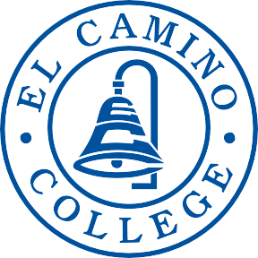

**DEAN:**

Debra Breckheimer

**CONTRIBUTORS:**

Andrew Gard, Alicia Class, Argelia Andrade, Maria Barrio de Mendoza, Donna Factor, Andrés Moina, Nina Yoshida, Scott Kushigemachi

**TABLE OF CONTENTS**

Contents

SECTION 1 Program Overview 3

SECTION 2 Program Assessment 5

Program Contribution to Student Success and Equity 5

Curriculum and Outcomes Assessment 6

SECTION 3 Program Vision and Future Planning 8

Program Vision 8

Future Planning 8

Program Resources 9

Appendix A 10

CAREER EDUCATION (CE) SUPPLEMENTAL QUESTIONS 10

# SECTION 1 Program Overview

1. **Provide an abstract of what your program does, who you serve, your previous successes, and where your program is moving in the next four years. Highlight the most interesting, compelling aspects of your program – your recent achievements and needs.**

The El Camino College Foreign Languages faculty is committed to the College’s mission: “[to] provide innovative and excellent comprehensive educational programs and services that promote student learning, equity, and success in collaboration with our diverse communities.” The El Camino College Foreign Languages faculty’s mission is to promote academic excellence and global citizenship in our students by providing rigorous courses that create a strong academic foundation in our students’ foreign language(s) of choice as well as in the English language. The study of a foreign language can provide a solid linguistic foundation that students can use in every college class and in the workplace as meta-linguistic awareness strengthens general analytic reading, improves writing, and promotes critical thinking.

As decided by our faculty, the name of our department will change in Fall 2023 from *Foreign Languages* to *World Languages and Cultures* in order to reflect the intended direction of the program. This change summarizes what our vision of the program is in the next four years: to promote values of diversity and inclusion, to continuously evaluate our teaching practices and courses to promote equity and access, and to address the needs of our community by designing courses that help students on a transfer track as well as community members wanting to add multilingualism and cultural awareness to their professional toolkit.

Our program provides a variety of courses in Chinese, French, German, Italian, Japanese, and Spanish, most of which are integral to students’ goals of matriculation, certification, and transfer. Our programs include courses in the following areas:

* elementary, intermediate, advanced, conversational, professional, and native Spanish;
* elementary, intermediate, advanced, and conversational French;
* elementary, intermediate, and conversational Japanese;
* elementary courses in Chinese, Italian, and German;
* the Spanish program includes one honors level course (Spanish 1) and a “Spanish for Professionals” course that awards a Certificate of Accomplishment;
* Chinese, Italian, and Japanese have active culture courses;
* a Linguistics major was added locally back in 2021 and is currently awaiting CSU and UC articulation in order to offer two new courses: Linguistics 1A and Linguistics 1B

Associate of Arts Degrees are offered in French, Japanese, and Spanish. Spanish also offers an AA-T degree and a Certificate of Accomplishment. The El Camino College Foreign Languages faculty is committed to implementing effective methodologies to prepare our students to be conversationally proficient by semester two of the language of study, and to be prepared to become proficient in reading and writing by their second year of study. We are passionate about preparing our students to pursue related and non-related majors at the UC, CSU, and independent colleges and universities as well as to excel in all university coursework.

The faculty holds active membership and leadership roles as well as presents work in local, state, national, and international language organizations such as MCLASC, CLTA, ACTFL, SCOLT,

AATSP, AATF, CCCFLC, ATA, AATJ, and TJSC. The College Foreign Languages faculty is engaged at regular faculty meetings, has developed online and hybrid courses, and has organized Consistency Project efforts and cultural symposiums, including:

* MICASA (Mexican, Indigenous, Chicano/a/x, Caribbean, Central American, South American Alliance) (serves as a comprehensive support program that provides mentoring, college preparation seminars, tutoring, community service and cultural enrichment for students of varied Latinx/Hispanic backgrounds)
* PUENTE (helps students of underserved Latinx/Hispanic communities succeed academically, graduate from four-year colleges and universities, belong to a statewide and national network of leaders and professionals, and receive priority registration)
* “A Celebration of Chicano Culture” (yearly event that invites various noted Chicano speakers, performers, scholars, and artists to campus to share their perspectives and cultural practices)
* “Music from Puerto Rico” (invited students to attend a concert and then work on related projects and papers)
* “Cuba on the Cusp Symposium” (invited students to attend a series of events including academic lectures from professors, musical and dance performances, and many more culturally-affirming events. Students in turn completed related class projects and papers)

There is more detailed information on these events and others on pp. 39-40.

In summary, the members of our department collaborate with one another and other experts in the field and undertake these projects in an effort “[to] provide innovative and excellent comprehensive educational programs and services that promote student learning, equity, and success in collaboration with our diverse communities.”

1. **Describe the degrees and/or certificates offered by the program. Consider addressing what makes your program unique to the college and region.**

Associate of Arts Degrees are offered in French, Japanese, and Spanish. Spanish offers an AA-T. During the latest Program Review cycle, our department awarded a strong number of degrees (especially relative to the size of our enrollments and given the difficulties of the Covid-19 pandemic):

* 23 in 2017-2018
* 29 in 2018-2019
* 21 in 2019-2020
* 28 in 2020-2021

Also, as mentioned earlier, the department now offers a Certificate of Accomplishment that can be earned in a “Spanish for Professionals” course, which provides degree-seeking and non-degree-seeking students the necessary language skills for designated professional purposes such as business, healthcare, hospitality, and translation.

1. **Explain how the program fulfills the college’s mission. Address the work your program is doing to help the college fulfill its stated mission.**

The Foreign Languages faculty understands that its courses are significant components of other comprehensive educational programs at El Camino College and beyond. In addition to providing academic opportunities for students to fulfill their foreign language requirements, our courses cultivate language skills and critical thinking. Our faculty acknowledges our diverse students' educational needs by bridging learning gaps to ensure equitable learning and equip them with the necessary tools to be successful global citizens and to realize their future academic endeavors. As instructors of world languages, our pedagogy is centered around equity and interculturalism that promotes inclusiveness and cultural fluency.

1. **Discuss the status of recommendations from your previous program review. In the “Notes/Comments” section, please discuss the known impact of a completed recommendation or the rationale for recommendations that are on active, on hold, and/or abandoned.**
2. **Recommendation:** **Program Growth Self-Study [The Faculty will engage in an informed and meaningful (taking this Program Review into account) discussion of how to secure program growth. This is critical and should be central to all programmatic planning in the next five years.]**

**Status:** **Active**

**Notes/Comments:** Program growth requires continuous discussions and analyses: they are central to all critical elements of growth mentioned hereafter. We wish to focus on increasing student success and retention in our classes but in turn this means the college has to improve its methods of drawing students into our programs (see second recommendation below).

1. **Recommendation:** **Marketing Efforts [We need to have an overt marketing campaign to secure program growth. This is critical and should be central to all programmatic planning in the next five years. Community outreach needs to include advertisement materials, an online and social media presence, etc.] --> $10,000/year**

**Status:** **Active**

**Notes/Comments:** Recruitment is a vital part of growing our shrinking language programs and thus marketing the value of our department to potential students is highly important for future growth and retention. While faculty members are willing to do their part to promote the program and retain students (see first recommendation above), we are not experts in marketing and therefore need more support from the college to attract students and keep our enrollment numbers up. We would like a more regular and responsive interaction with ECC Marketing & Communications and the Counseling department as well to ensure students are being directed to our program as needed.

1. **Recommendation:** **Partnerships [Partner with the Student Equity Plan (SEP) to create additional support services for our students. Partner with FYE, SER, and PUENTE to collaborate with other learning communities on campus to connect our students to more resources. Create a stronger Honors Transfer Program track for our students.]**

**Status:** **Active**

**Notes/Comments:** While some of these programs have changed names (e.g. SEP is now SEA, SER is now MyPath), our students need support and campus resources more than ever in an unstable, post-pandemic economy. Dual Enrollment is a newer program that allows El Camino College to connect with local high school students and to bolster our own course enrollments, and as such, it needs more promotion in the area. Lastly, each semester our faculty members nominate successful students to join the HTP but more could be done to ensure students follow through and meet the requirements.

1. **Recommendation:** **Collaboration with Counseling [A better strategy or process for securing Foreign Language majors needs to be made by our department in collaboration with the counseling division.]**

**Status:** **Active**

**Notes/Comments:** Since the last Program Review, Counseling has made great strides in being able to connect and help students, including increased access to online appointments, Quick Question chats, and drop-in counseling on the first floor of the Humanities building next to the Foreign Languages department offices. However, this will always be a high-priority need for securing Foreign Languages majors. We also learned during the COVID-19 pandemic that some academic counselors were telling students to wait until they transfer to complete their foreign language requirements and this may have hurt our enrollment numbers. We need to establish a stronger, more direct relationship with the Counseling department to ensure that this type of misinformation does not continue or happen again.

1. **Recommendation:** **Student Support [Increase open hours of Foreign Language Lab (at least 2 hours in the evening) daily, Monday through Friday. Our evening students express (see student survey) discontent with our current hours of operation. --> $90,000/year; Hiring one full-time lab coordinator or two on a half-time basis. --> $60,000/year; Hiring of several student lab assistants. -->$10.50/hour at 20 hours/week]**

**Status:** **Active**

**Notes/Comments:** The Foreign Languages department continues to hope for funding that will secure a full-time, functional Foreign Language Lab.

1. **Recommendation:** **Spanish 1 and Spanish 52A [Much of the student population is Spanish-speaking. To better serve them, we will offer more SPAN 52A courses than we currently do, replacing a few SPAN 1 courses.]**

**Status:** **Active**

**Notes/Comments:** In addition to the continuing challenges the Spanish program faces with regard to difficulty recruiting targeted student groups, the Covid-19 pandemic caused major enrollment issues across all classes in the past couple years. The Spanish program also still struggles to find effective placement strategies to properly place students in either SPAN 1 or SPAN 52A.

1. **Recommendation:** **Curriculum Improvement, Part 1 [Revise curriculum and major requirements to the majors in French, Chinese, and Japanese in order to make them eligible for TMC AA-T status. Continue to improve course outlines of record to better our courses and make them better articulate with UC and CSU requirements.]**

**Status:** **Active**

**Notes/Comments:** The Foreign Languages department still hopes to make French and Japanese eligible for TMC AA-T status, which mostly got delayed due to enrollment issues caused by the Covid-19 pandemic. Also, the department now offers a new course, SPAN 10 (Spanish for Professionals), and hopes to soon begin offering a Linguistics 1 course to diversify our offerings.

1. **Recommendation:** **Curriculum Improvement, Part 2 [Create and teach Online/Hybrid Offerings in order to increase enrollment numbers. --> $14,000/year]**

**Status:** **Completed**

**Notes/Comments:** All full-time and nearly all part-time faculty members in the Foreign Languages Department are now certified to teach online and hybrid sections and have already done so. This has helped to weather instructional difficulties during the Covid-19 pandemic and even increase our enrollment numbers in certain courses as we can now reach a broader cross-section of students around the world.

1. **Recommendation:** **Instructors [Continue to regularly hire part-time faculty that shares our program vision. --> $100,000/year for 5 new hires; Hiring a full-time French instructor. --> $100,000 (salary plus benefits)**

**Status:** **Active**

**Notes/Comments:** While a full-time French instructor was hired in 2019, all other hirings have been placed on hold due to difficulties caused by the Covid-19 pandemic. Nevertheless, if the college supports better growth in the program we would like to reopen the possibility of replacing recently retired instructors (e.g. in Chinese and Spanish) and full-time instructors in each of the departments that currently only employ part-time instructors (e.g. Italian and German).

1. **Recommendation:** **Student Access Through Scheduling Improvements [With the loss of available classroom space due to construction, scheduling courses during times that may help program growth has become a difficult task. Proactively advocating for additional classroom space is essential to improve our course offerings schedule.]**

**Status:** **Completed**

**Notes/Comments:** Due to the increased number of online and hybrid sections offered in the Humanities Division and the end of construction, the issue of available classroom space no longer exists. Nevertheless, it may become a priority again in the future if enrollment in face-to-face sections increases over time.

1. **Recommendation:** **Book vouchers [Since 51% of our students need significant financial help to complete their coursework, we would like to secure funds to have a wider book voucher program for financially needy students.] --> $5000/year**

**Status:** **Active**

**Notes/Comments:** The Foreign Languages department would like to continue using the book vouchers program to better serve our students, in particular those with the highest financial needs. It is also our preference for the book voucher funds to come from other sources than our language Foundation funds. Additionally, we would like to expand the program to language programs without their own Foundation. It should also be noted that because language instruction requires a good deal of quality multimedia in order to adequately teach our students certain fundamental proficiencies (such as speaking skills and listening comprehension), each program has chosen to forgo the possibility of using OER. Each program has independently researched different OER and found them to be an ineffective solution for replacing our low- to moderately-priced textbooks. Each current textbook has been carefully selected by our instructors in order to offer our students an important balance between quality and value.

1. **Recommendation:** **Classroom Cleanliness [Future budgets set need to include basic classroom cleaning, at least once per month. Currently, faculty currently need to clean their classroom to be habitable. However, this is not a viable long-term solution. Another crewmember can be assigned to our building, given that we are the biggest division on campus.] --> $11,000/year**

**Status:** **Active**

**Notes/Comments:** Cleanliness is still a priority in light of Covid-19 and thankfully since the last cycle more cleaning supplies have been offered for instructors to use if needed. Nevertheless, the lack of regular and thorough cleaning of frequently-touched surfaces (e.g. computers, consoles, desks) by classified staff poses a health and safety issue for students and instructors and needs to be addressed.

1. **Recommendation:** **Software Maintenance [Hire 2-3 half-time technical/computer system specialists to supervise/coordinate and provide IT support/maintenance to Foreign Language Lab as well as classroom computers and equipment.] --> $90,000/year**

**Status:** **Abandoned**

**Notes/Comments:** We have less of a need for new software due to updated cloud storage technologies and fewer students coming to campus in the wake of the Covid-19 pandemic. We would prefer to focus on functional hardware and equipment.

1. **Recommendation:** **Hardware and Equipment Maintenance [Have a budget in place to maintain and update SMART Classrooms Devices. The 10th anniversary of a lot of technology will be next year. Equipment such as computers, projectors, projector screens, and metal hooks for posting need to be replaced.] --> 20 screens, $7,000 ($350/screen); 45 projectors, $36,000 ($800/projector); 45 classrooms hook sets, $2,250 ($50/set)**

**Status:** **Active**

**Notes/Comments:** The Humanities building has received some new technology since the last cycle but it will always need to be well-maintained and updated every few years. New computers in the classrooms is the highest priority amongst all the technology listed above. Working clocks on the classroom walls are also desired.

# SECTION 2 Program Assessment

# Program Contribution to Student Success and Equity

**For the program under review, examine the following data for the last four years by:**

* + **Disaggregating by race/ethnicity, gender, and age where possible.**
  + **Discussing internal and external factors contributing to constant, increasing or decreasing trends.**
  + **Discuss any known barriers to student success in your program.**
  + **Highlighting equity gaps found among different groups of students.**
  + **Present and discuss possible action plans about what could be done to address equity and achievement/opportunity gaps.**
* *If students taking courses from the program under review end with a degree or certificate issued by the program, please examine a) through h) from the list below.*

1. ***Degree Completion:* Number/percent of students earning a program degree**

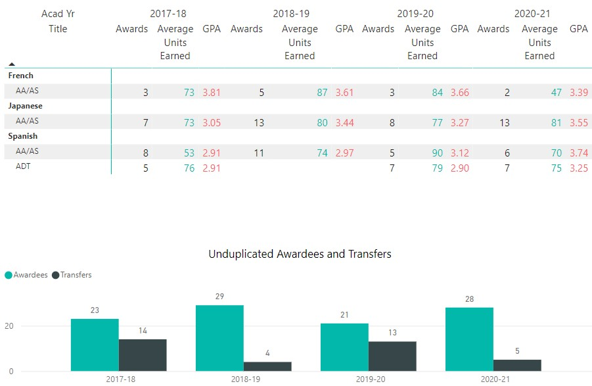

**French AA Program**: 2017-2018 (**3** AAs awarded), 2018-2019 (**5** AAs awarded), 2019-2020 (**3** AAs awarded), 2020-2021 (**2** AAs awarded): (**3 --> 5 --> 3 --> 2**)

**Japanese AA Program**: 2017-2018 (**7** AAs awarded), 2018-2019 (**13** AAs awarded), 2019-2020 (**8** AAs awarded), 2020-2021 (**13** AAs awarded): (**7 --> 13 --> 8 --> 13**)

**Spanish AA Program**: 2017-2018 (**8** AAs awarded), 2018-2019 (**11** AAs awarded), 2019-2020 (**5** AAs awarded), 2020-2021 (**6** AAs awarded): (**8 --> 11 --> 5 --> 6**)

**Spanish ADT Program**: 2017-2018 (**5** ADTs awarded), 2018-2019 (**0** ADTs awarded), 2019-2020 (**7** ADTs awarded), 2020-2021 (**7** ADTs awarded): (**5 --> 0 --> 7 --> 7**)



**Total Degrees awarded by Foreign Languages**: 2017-2018 (**23**), 2018-2019 (**29**), 2019-2020 (**21**), 2020-2021 (**28**): (**23 --> 29 --> 21 --> 28**)

*Identify factors or program modifications that may have had an impact on student achievement and/or degrees:*

Degree completion was overall higher for all foreign language programs before the Covid-19 pandemic hit during the third and fourth years of this Program Review cycle, which is not surprising since transitioning to fully online instruction during this period likely disrupted many educational paths and plans for various reasons. Nevertheless, programs such as the Japanese AA and Spanish ADT remained almost undeterred in degree completion thanks to superior support from faculty members and uninterrupted virtual access to campus programs and resources, such as Counseling, Tutoring, and the Writing Center. In fact, by Spring 2021 the average degree completion for the entire department appears to have recovered to pre-pandemic levels (29 in 2018-2019 versus 28 in 2020-2021). Degree completion will likely increase during the next cycle now that both instructors and students are more comfortable and better trained with hybrid and online instruction, which is likely to stay in high demand going forward.

1. ***Certificate Completion:* Number/percent of students earning a program certificate**

The Foreign Languages department did not offer any certificates prior to this Program Review cycle, only AA degrees (French, Japanese, Spanish) and an AA-T degree (Spanish). As of Fall 2022, the department now offers a Certificate of Accomplishment that can be earned in a “Spanish for Professionals” course.

1. ***Transfer to a four-year institution*: Number/percent of students transferring to a four-year institution**

(see image above for transfer numbers)

**Total Transfers by Foreign Languages majors**: 2017-2018 (**14**), 2018-2019 (**4**), 2019-2020 (**13**), 2020-2021 (**5**): (**14 --> 4 --> 13 --> 5**)

*Identify factors or program modifications that may have had an impact on student transfers:*

Whereas degree completions were at their highest in the 2018-2019 and 2020-2021 academic years, student transfers were in contrast higher during the 2017-2018 and 2019-2020 academic years. Perhaps students were prepared with enough units to transfer before the Covid-19 pandemic hit in Spring 2020 because it did not affect the high transfer rate that semester. Transfers dropped again the following academic year, which could simply be part of a pattern or be a result of low enrollment during the pandemic.

1. ***Scheduling of courses:* Percentage of students enrolled in day/evening courses, on campus/online/hybrid courses**

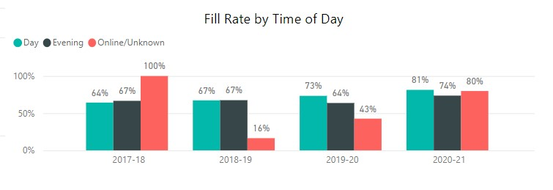

**Fill Rate by Time of Day for Foreign Languages DAY classes**: 2017-2018 (**64%**), 2018-2019 (**67%**), 2019-2020 (**73%**), 2020-2021 (**81%**): (**64% --> 67% --> 73% --> 81%**)

**Fill Rate by Time of Day for Foreign Languages EVENING classes**: 2017-2018 (**67%**), 2018-2019 (**67%**), 2019-2020 (**64%**), 2020-2021 (**74%**): (**67% --> 67% --> 64% --> 74%**)

**Fill Rate by Time of Day for Foreign Languages ONLINE classes**: 2017-2018 (**100%**), 2018-2019 (**16%**), 2019-2020 (**43%**), 2020-2021 (**80%**): (**100% --> 16% --> 43% --> 80%**)

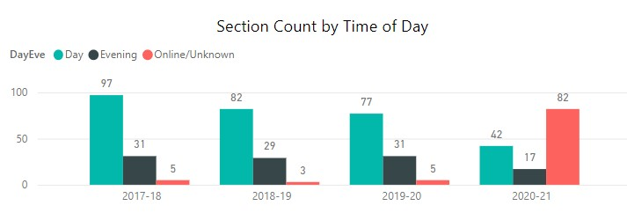

**Section Count by Time of Day for Foreign Languages DAY classes**: 2017-2018 (**97**), 2018-2019 (**82**), 2019-2020 (**77**), 2020-2021 (**42**): (**97 --> 82 --> 77 --> 42**)

**Section Count by Time of Day for Foreign Languages EVENING classes**: 2017-2018 (**31**), 2018-2019 (**29**), 2019-2020 (**31**), 2020-2021 (**17**): (**67 --> 67 --> 64 --> 74**)

**Section Count by Time of Day for Foreign Languages ONLINE classes**: 2017-2018 (**5**), 2018-2019 (**3**), 2019-2020 (**5**), 2020-2021 (**82**): (**5 --> 3 --> 5 --> 82**)

*Are the times and frequencies that courses are scheduled fulfilling the need or demand for courses?*

Fill rates for Day and Evening classes increased over this Program Review cycle, which may be due to higher enrollment in the college and/or our program overall, or due to the lower number of sections offered in both Day and Evening classes, thereby grouping more students together per section offered. Given this data, demand seems to be met here. On the other hand, the number of online sections increased from 5 in 2019-2020 to 82 in 2020-2021 due to the Covid-19 pandemic, and fill rates greatly increased as well (outside of the 100% fill rate in 2017-2018 that was due to online instruction being new to our program and having few sections offered, thereby causing high volatility in fill rates). Judging from these data trends and what the Foreign Languages faculty members personally know from our students, it seems we need to offer more online courses to meet student demand. While it is not the optimal pedagogical learning setting for all students, online sections tend to fill faster than face-to-face sections and asynchronous instruction more easily accommodates a greater number of student schedules and learning paces. All of these factors appear to indicate that increasing the number of online sections benefits our enrollment numbers and student success.

1. ***Fill rate:* Percentage of actual students enrolled in a term in relation to total seats offered**

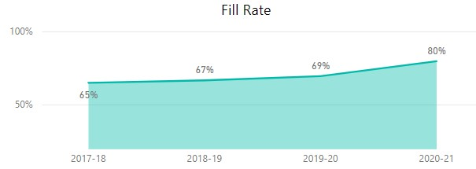

**Total fill rate percentages for Foreign Languages classes**: 2017-2018 (**65%**), 2018-2019 (**67%**), 2019-2020 (**69%**), 2020-2021 (**80%**): (**65% --> 67% --> 69% --> 80%**)

*Identify and address any trends in fill rates:*

As previously mentioned, fill rates for classes in the Foreign Languages department have steadily increased during this Program Review cycle. Given the sharp uptick seen in the 2020-2021 academic year, this was likely bolstered by the transition to fully online instruction during the Covid-19 pandemic. As noted in the previous section, students appear to be very receptive to online instruction, and the lack of specific meeting times for online asynchronous courses is more accommodating to a greater number of student schedules. We should increase our online offerings to attract a larger student body, both nationally and worldwide.

1. ***Grade Distribution:* Percentage of students in a course receiving each of the possible grades that can be awarded**

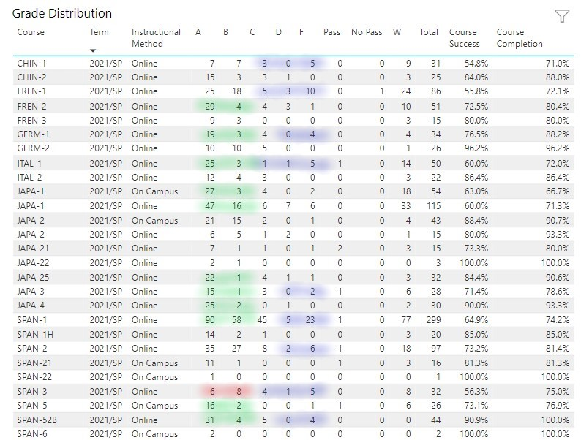

**Grade Distribution for Foreign Languages classes: Spring 2021 (above)**

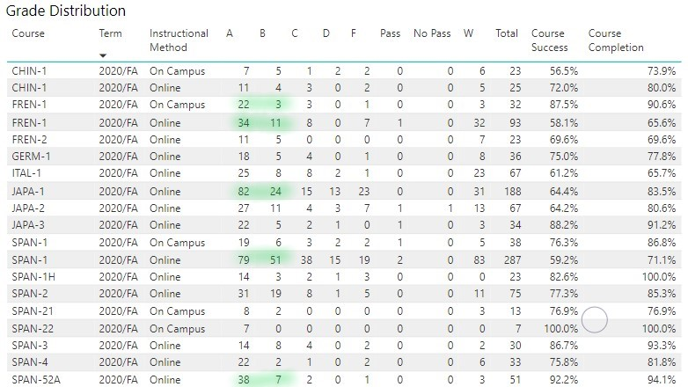

**Grade Distribution for Foreign Languages classes: Fall 2020 (above)**

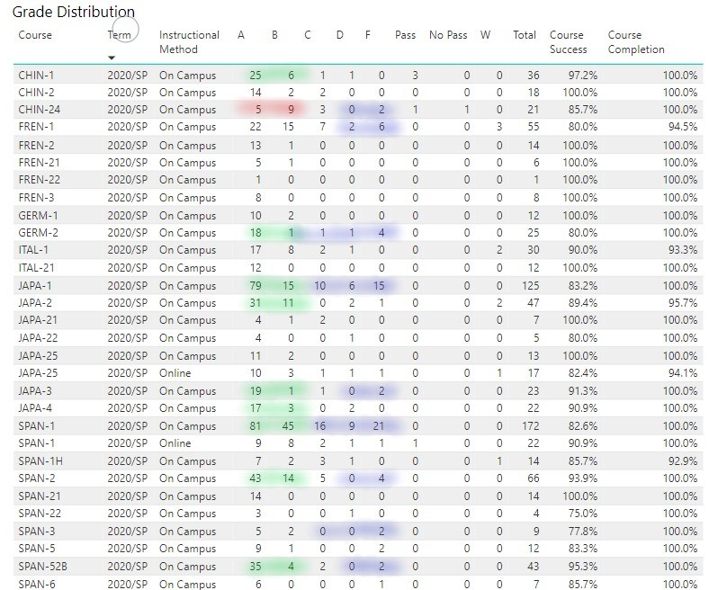

**Grade Distribution for Foreign Languages classes: Spring 2020 (above)**

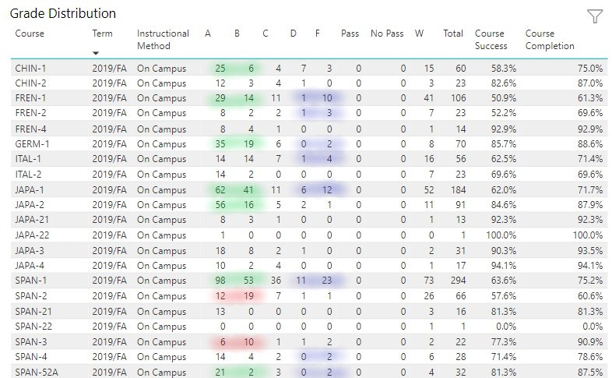

**Grade Distribution for Foreign Languages classes: Fall 2019 (above)**

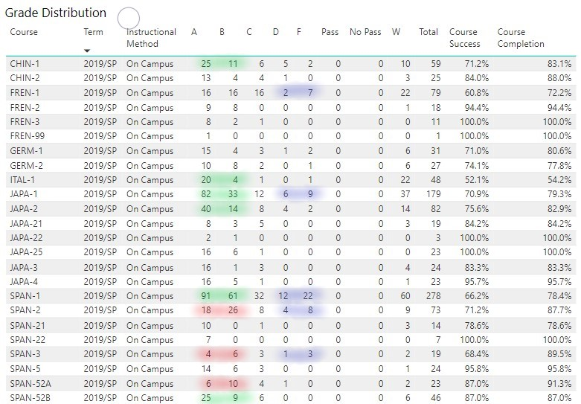

**Grade Distribution for Foreign Languages classes: Spring 2019 (above)**

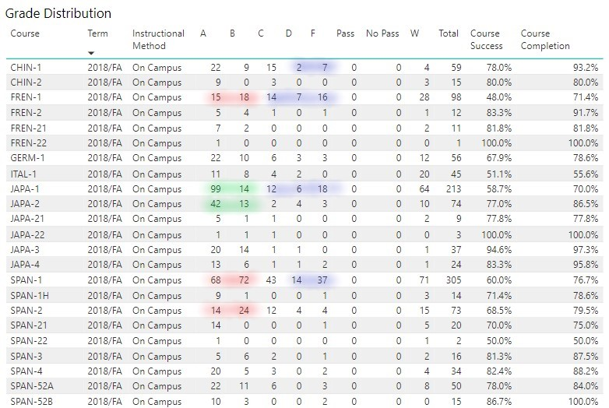

**Grade Distribution for Foreign Languages classes: Fall 2018 (above)**

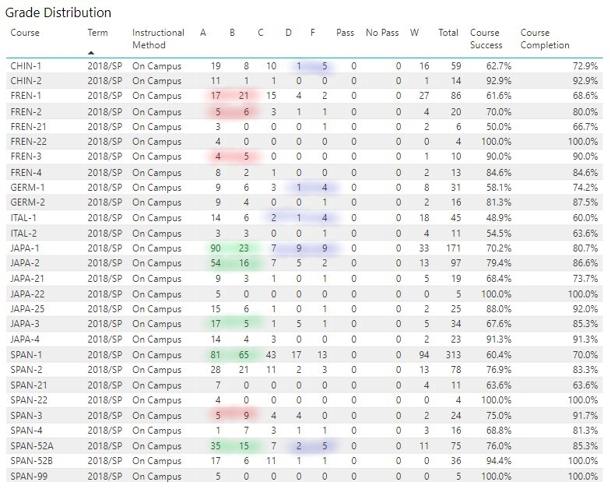

**Grade Distribution for Foreign Languages classes: Spring 2018 (above)**

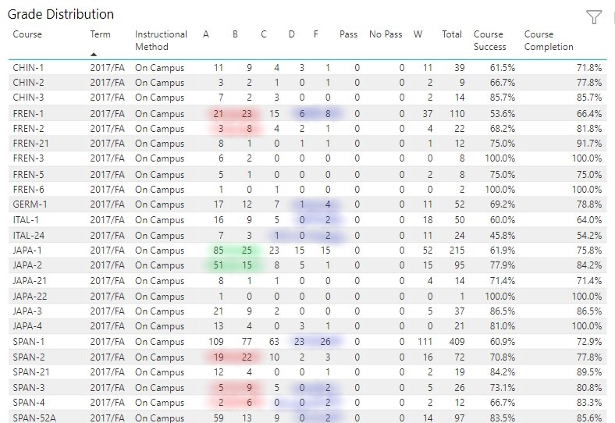

**Grade Distribution for Foreign Languages classes: Fall 2017 (above)**

*Are there any courses that stand out in one way or another in terms of grades?*

In order to help sift through large amounts of data and identify trends in grade distributions across all courses in the Foreign Languages Program, we have highlighted certain anomalies in each of the semester data sets above:

* Red highlights show cases where there were more B grades than A grades in a course
* Green highlights show cases where there were a significantly higher number (i.e. 12 or more) of A grades than B grades in a course
* Blue highlights show cases where there were more F grades than D grades and sometimes C grades.

This system has helped to reveal several important trends:

* With fewer red highlights and more green highlights seen as semesters progressed, it was clear to see that fewer courses were awarding more B grades than A grades, and conversely, more of them awarded a significantly higher number of A grades than B grades. This higher degree of success may be due in part to better access in recent years to trainings for instructors, in particular on equity-based teaching strategies and on more equitable grading practices. All instructors in Foreign Languages also completed certifications in online instruction and have steadily improved their materials in their online sections to make them more accessible and to better suit all types of learners. Students also likely became more comfortable with learning in fully online settings during recent years, and El Camino College increased access to programs for bolstering success, such as First Year Experience, Summer Dual Enrollment Programs, Learning Communities, Tutoring, Supplemental Instruction, Peer Mentoring, and the Writing Center. Lastly, one can see that certain language programs, such as French, experienced a change in faculty that may have led to more equitable grading practices that were more forgiving and thus more likely to increase the number of A grades.
* According to the data, the number of blue highlights was revealed to have stayed more or less the same over this Program Review cycle, meaning that the Foreign Languages department maintained the number of sections awarding more F grades than D and/or C grades. While this does not follow the typical bell curve design for grade distributions, this consistency across semesters and through the Covid-19 pandemic indicates that the increase in online instruction has not negatively affected the number of students receiving non-passing grades. In other words, whereas some instructors may believe that many students cannot succeed at learning a foreign language in a fully online setting, the fail rate appears to have remained the same before online instruction was widely offered in our program. That being said, instructors have noticed certain learning barriers that have emerged during the joint rise of the Covid-19 pandemic and online instruction, including poor time management, poor attendance, poor attention spans (including social media distractions), behavioral issues, a lack of motivation, a lack of consistency in students’ education, and an inadequate access to basic resources, the latter of which greatly hinders their ability to focus on learning.

1. ***Course* Su*ccess:* Percentage of students enrolled at census who complete the course with a grade of A, B, C, or P**

*Discuss success rates and address any performance gaps among different populations of students:*

Success Rates and Completion Rates will be addressed throughout in the sections below, though only when the data for the Foreign Languages Program differed greatly from the Institutional averages, and particularly when the rates were significantly below the Institutional averages in certain instances that point to performance gaps.

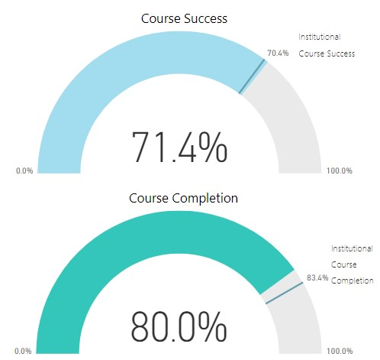

**Course Success percentage for ALL Foreign Languages classes for 2020-2021**: **71.4%** ( > 70.4% = Institutional Course Success)

**Course Completion percentage for ALL Foreign Languages classes for 2020-2021**: **80.0%** ( < 83.4% = Institutional Course Completion)

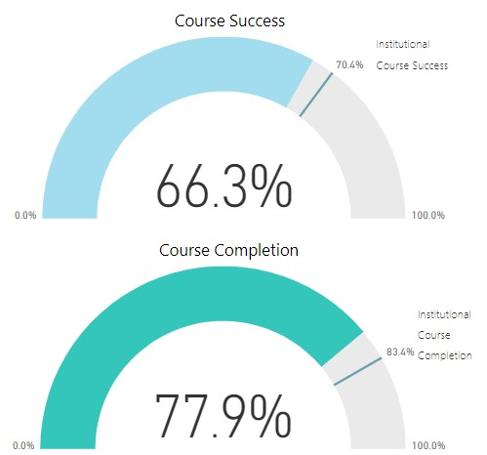

**Course Success percentage for Chinese classes for 2020-2021**: **66.3%** ( < 70.4% = Institutional Course Success)

**Course Completion percentage for Chinese classes for 2020-2021**: **77.9%** ( < 83.4% = Institutional Course Completion)

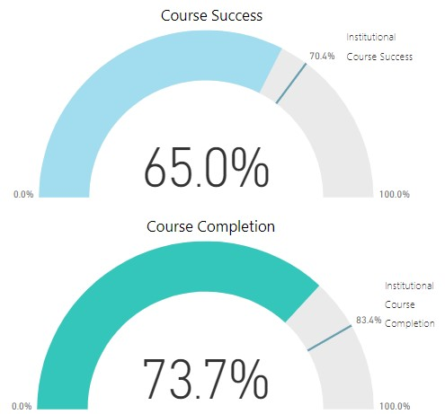

**Course Success percentage for French classes for 2020-2021**: **65.0%** ( < 70.4% = Institutional Course Success)

**Course Completion percentage for French classes for 2020-2021**: **73.7%** ( < 83.4% = Institutional Course Completion)

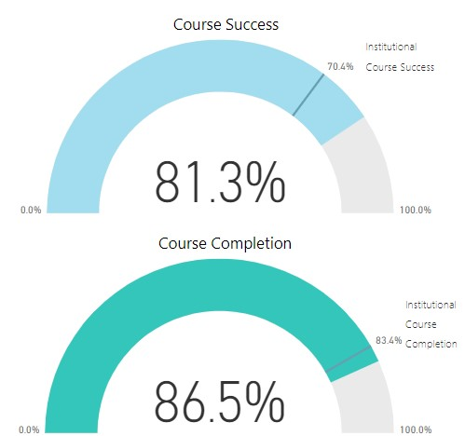

**Course Success percentage for German classes for 2020-2021**: **81.3%** ( > 70.4% = Institutional Course Success)

**Course Completion percentage for German classes for 2020-2021**: **86.5%** ( > 83.4% = Institutional Course Completion)

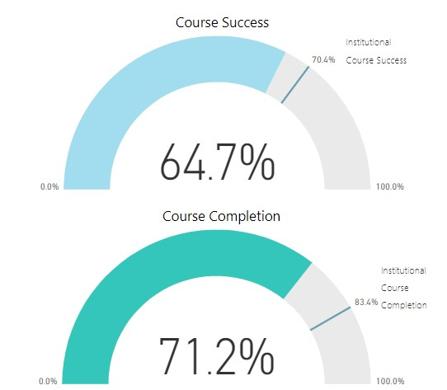

**Course Success percentage for Italian classes for 2020-2021**: **64.7%** ( < 70.4% = Institutional Course Success)

**Course Completion percentage for Italian classes for 2020-2021**: **71.2%** ( < 83.4% = Institutional Course Completion)

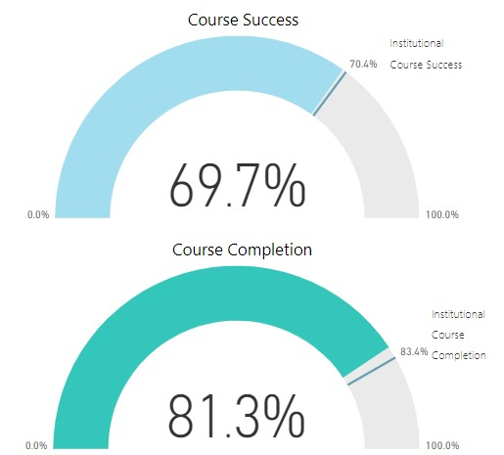

**Course Success percentage for Japanese classes for 2020-2021**: **69.7%** ( < 70.4% = Institutional Course Success)

**Course Completion percentage for Japanese classes for 2020-2021**: **81.3%** ( < 83.4% = Institutional Course Completion)

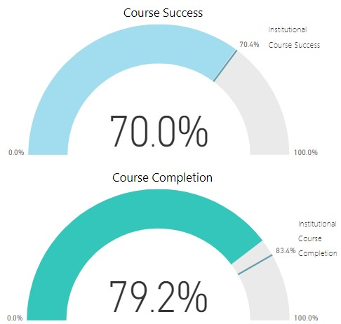

**Course Success percentage for Spanish classes for 2020-2021**: **70.0%** ( < 70.4% = Institutional Course Success)

**Course Completion percentage for Spanish classes for 2020-2021**: **79.2%** ( < 83.4% = Institutional Course Completion)

*Please discuss Success Rates and Completion Rates:*

With the exception of the German program, all foreign language programs fell below the Institutional averages for both Course Success and Course Completion. In fact, it is clear that the high Course Success rate for German (nearly 11% higher than the Institutional average) was the sole factor in bringing our collective program’s Course Success rate above the Institutional average (given that our rates were below in every other language program). While we applaud the efforts of our instructors and students in the German program, we must recognize that this is one of our smallest programs in terms of course offerings, enrollment, and faculty members and thus is not the most accurate representation of the data that reflects the Foreign Languages program’s underperforming.

As for why most of our language programs fell below the Institutional averages, we have compiled a list of possible factors that may have affected foreign language instruction more greatly than other disciplines:

* Language courses are inherently more communicative and thus, for the most part, they have traditionally been offered in face-to-face sections prior to the Covid-19 pandemic. With the sudden move to fully online learning during the pandemic, many students (and instructors) struggled with the paradigm shift and could not cope as easily without having regular contact and communication in a physical classroom. Whereas students of foreign languages usually thrive on interactive experiences in the classroom, in particular those related to hands-on learning of world cultures, they tend to lose motivation and interest in a fully online setting where virtual readings, recordings, and videos are their only touchstones to other speakers and cultures. Without consistent practice and proper motivation, learning a foreign language often seems too daunting and students may drop the class without reaching out for help.
* Unlike most other disciplines in which courses may be divided into discrete units of material, it is standard for foreign language curriculum to continuously build off of previous lessons to create a more comprehensive understanding. This often means that it is more difficult for our students to catch up on the material if they miss a class session or lesson and they may more easily choose to drop the class accordingly due to a sense of feeling lost. Because our discipline is inherently less forgiving to absent students, we as instructors have to make special efforts to reach out to students to make sure they remain on task and understand the ever-growing material before it is too late and they cannot keep up with the work. Perhaps even more can be done on this end to close performance gaps, in particular with the help of other programs such as ECC Connect and the Learning Resource Center.
* Due to the Covid-19 pandemic, an increase in fully online course offerings, and an attempt to increase enrollment, our class schedules became more condensed during the current Program Review cycle, thereby reducing the number of class meetings and condensing them into fewer sessions. Similar to the previous point, this means that when students miss one class session (which may comprise an entire week’s worth of lessons), they miss a greater amount of material than they would if there were three shorter sessions as was standard several years ago. Because it would be difficult to return to the former system now that learning styles and student needs have changed drastically in the post-pandemic era, we need to find better ways to accommodate students under the current circumstances so that they make up the missing time and work and stay on track to succeed.
* When foreign language classes were offered in a fully online asynchronous modality during the Covid-19 pandemic, all instructors held optional Zoom class sessions once or several times per week to help students connect with each other and to better learn the material. However, these optional sessions were always at the discretion of the instructor and thus never posted in the ECC Class Schedule, meaning that students signed up for sections and built their semester schedules without knowing if they could attend the optional Zoom class sessions until the first day of class when they had access to the syllabus. It would be preferred if the online Class Schedule could include such information to better inform students so that they can choose according to their learning preference and availability.
* Online instruction has accommodated a greater number of student schedules and thus increased enrollment in our program yet some students inherently learn better in a face-to-face modality, and in particular because learning a foreign language depends so much on interaction, listening, and pronunciation. We as instructors feel that these types of students suffered during this period of online-only instruction and brought down our Success and Completion rates. For this reason, we want to offer as many face-to-face sections as our budget will allow going forward to appeal to different learning styles across our curriculum. In turn, because this requires an increase in the use of classrooms, we feel this justifies our request for more regular and thorough cleaning and sanitization of the rooms in our building by classified staff.
* The class enrollment cap for beginner-level foreign language classes is 38 students (and 35 for intermediate-level classes) and we as instructors feel that this is much too high in order to promote effective communicative learning. While this cap has been in effect for several years and has not affected the current Program Review cycle especially, it nonetheless felt all the more untenable during the shift to fully online instruction during 2020 and 2021. It is already difficult to get all students to speak and participate in a face-to-face section where there are 38 of them enrolled in one class, and even more so when they are all in a Zoom class session where you cannot even see all the students on one screen. Knowing that The American Council on the Teaching of Foreign Languages (ACTFL) recommends smaller class sizes for student achievement and satisfaction, and that other institutions in the Los Angeles area successfully offer smaller sections (17-25 students), we as a faculty are planning on requesting lower caps in all of our beginner-level foreign language courses during the 2023-2024 academic year in hopes of mediating the below-average Course Success and Completion rates.

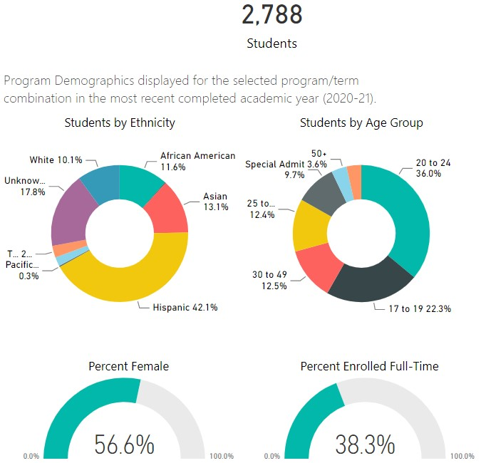

**Program Demographics for Foreign Languages classes: 2020-2021 (2,788 students total)**

[in comparison with the demographics of the entire college, most differences were fairly insignificant except Foreign Languages has 3.9% more Female students and 8.7% fewer students Aged 17 to 19]

Here are possible factors that may account for these differences:

* According to various cultural studies, women traditionally take more foreign language classes than men do
* Foreign language instruction in high schools tends to be more erratic (e.g. incomplete sequence offerings, lack of variety of language offerings) than college-level programs and therefore our local high schools do not feed students as often into our classes as they would in more stable disciplines (e.g. English, math, history), thereby reducing the number of students in the 17-19 group that we enroll.

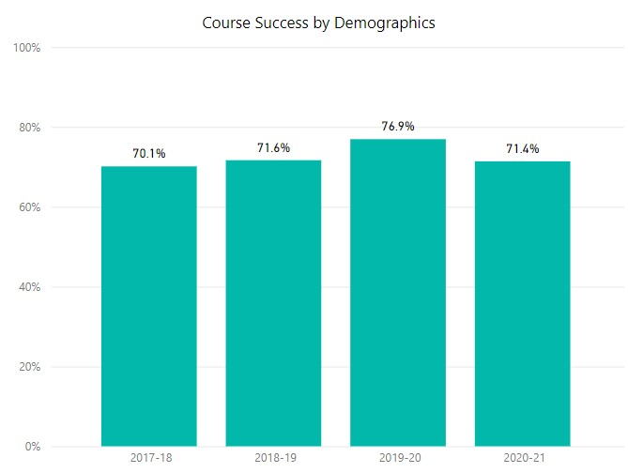

**Course Success for ALL demographics (Gender, Age, Ethnicity) for Foreign Languages:** 2017-2018 (**70.1%**), 2018-2019 (**71.6%**), 2019-2020 (**76.9%**), 2020-2021 (**71.4%**): (**70.1% --> 71.6% --> 76.9% --> 71.4%**)

[in comparison with Course Success of the entire college, differences were insignificant]

**______________________________________________________________________________**

**Gender**

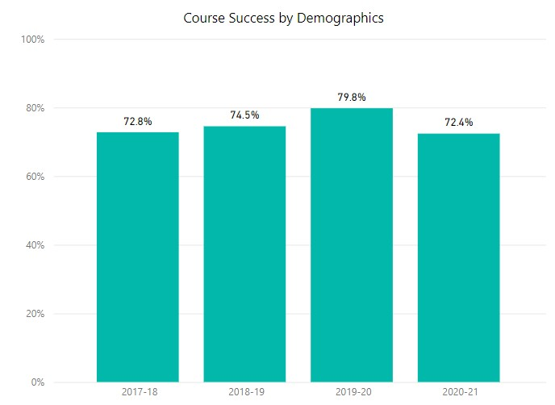

**Course Success for Females for Foreign Languages:** 2017-2018 (**72.8%**), 2018-2019 (**74.5%**), 2019-2020 (**79.8%**), 2020-2021 (**72.4%**): (**72.8% --> 74.5% --> 79.8% --> 72.4%**)

[in comparison with Course Success for Female students of the entire college, Foreign Languages had slightly higher percentages]

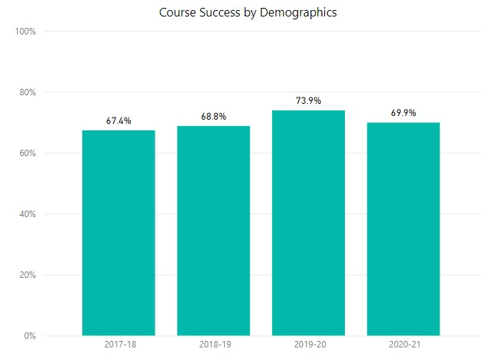

**Course Success for Males for Foreign Languages:** 2017-2018 (**67.4%**), 2018-2019 (**68.8%**), 2019-2020 (**73.9%**), 2020-2021 (**69.9%**): (**67.4% --> 68.8% --> 73.9% --> 69.9%**)

[in comparison with Course Success for Male students of the entire college, Foreign Languages had slightly lower percentages]

To explain the lower rate of Course Success of male students, we as faculty surmised that female students are more motivated to pass and finish foreign language classes because our classes are more often directly related to certain female-dominated occupational goals (e.g. nursing, education, music, art history). As such, female students also continue to take the full sequence of foreign language classes to fulfill their necessary requirements, thereby increasing their rate of success, whereas males may have less strong reasons to succeed and may invest less time in them in order to focus on their major courses. Nevertheless, as is the case for all equity gaps revealed in this Program Review, we will pay more attention to the needs of student groups with lower success rates.

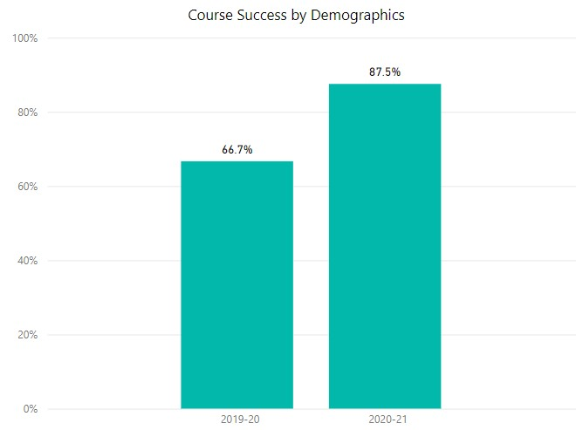

**Course Success for Unknown Gender/Declined to Answer for Foreign Languages:** 2019-2020 (**66.7%**), 2020-2021 (**87.5%**): (**66.7% --> 87.5%**)

[in comparison with Course Success for Unknown Gender/Declined to Answer students of the entire college, Foreign Languages had a significantly lower percentage of success in 2019-2020 (19.3% lower) and a significantly higher percentage in 2020-2021 (7.1% higher). There were no data sets for these parameters for 2017-2018 or 2018-2019 for Foreign Languages.]

To explain the significant growth in the rate of Course Success of Unknown Gender students, we believe as faculty that we have become more aware of such students and that has led to more equity-minded instruction, less stigmatization, and a better understanding of their needs.

___________________________________________________________________________

**Age**

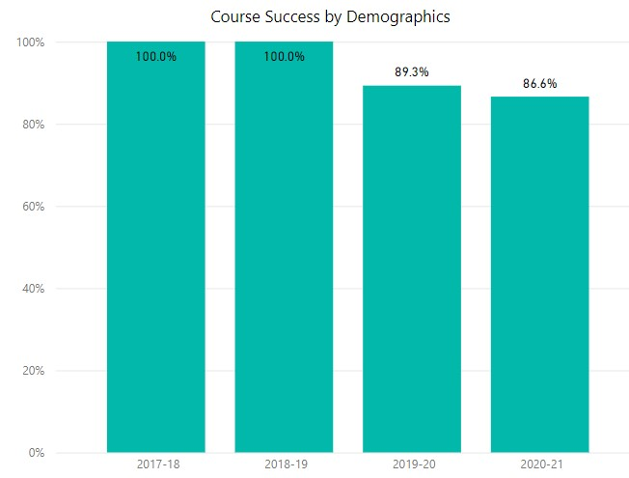

**Course Success for Age 16 and Under for Foreign Languages:** 2017-2018 (**100.0%**), 2018-2019 (**100.0%**), 2019-2020 (**89.3%**), 2020-2021 (**86.6%**): (**100.0% --> 100.0% --> 89.3% --> 86.6%**)

[in comparison with Course Success for Age 16 and Under students of the entire college, Foreign Languages had significantly higher percentages of success in 2017-2018 (16.7% higher), 2018-2019 (7.8% higher), and 2020-2021 (10.0% higher)]

To explain the significantly higher percentages of Course Success for Age 16 and Under students, we think it is clear that the Dual Enrollment program has helped attract strong students to our own programs when local high schools cannot provide the desired foreign language level, or for summer classes when high schools are out of session. In turn, we as instructors have become more experienced with teaching this age group and understanding their specific needs. Furthermore, we use a very controlled entrance system that is personalized and filtered in order to “screen for success” and increase the chances that the student not only manages but thrives in a college-level setting.

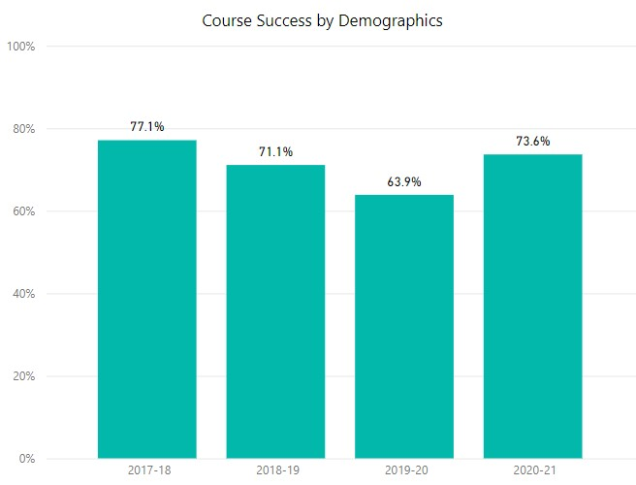

**Course Success for Age 50 and Over for Foreign Languages:** 2017-2018 (**77.1%**), 2018-2019 (**71.1%**), 2019-2020 (**63.9%**), 2020-2021 (**73.6%**): (**77.1% --> 71.1% --> 63.9% --> 73.6%**)

[in comparison with Course Success for Age 50 and Over students of the entire college, Foreign Languages had significantly lower percentages of success in 2018-2019 (6.7% lower), in 2019-2020 (17.3% lower), and 2020-2021 (3.1% lower)]

To explain the lower rate of Course Success of students Age 50 and Over, we surmise that older students were not as well-equipped as younger students to face the shift to fully online instruction during the Covid-19 pandemic, in particular due to the higher demands for technology use. In particular for foreign languages, not only did students need to learn how to navigate our common Learning Management System, Canvas, but also any publisher-based software that is required with some foreign language textbooks. The latter may have discouraged older students with less of a solid grip on new technology due to the numerous activities involving voice recordings and video chats. We also know of several cases in which an older student’s health was directly affected during the pandemic and as a member of a more vulnerable population, he or she needed to drop the class to focus on recovery. Moving forward, we will pay more attention to the needs of students in this demographic.

[all other age groups showed fairly insignificant differences from the total age demographic]

___________________________________________________________________________

**Ethnicity**

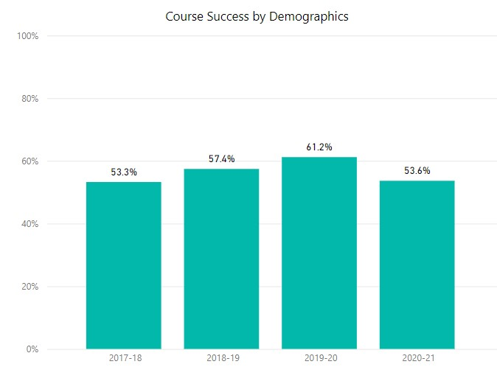

**Course Success for African American for Foreign Languages:** 2017-2018 (**53.3%**), 2018-2019 (**57.4%**), 2019-2020 (**61.2%**), 2020-2021 (**53.6%**): (**53.3% --> 57.4% --> 61.2% --> 53.6%**)

[in comparison with Course Success for African American students of the entire college, Foreign Languages had significantly lower percentages of success in 2017-2018 (7.7% lower), 2018-2019 (5.3% lower), in 2019-2020 (6.7% lower), and 2020-2021 (5.8% lower)]

Here we have encountered a significant equity gap for African American students. As instructors who get to know our students on a more personal level during regular communicative activities, we will have to pay better attention to our students’ educational and cultural backgrounds to better equip us to close equity gaps in which certain students may arrive with less experience and exposure to the material. Moving forward, we will pay more attention to their needs.

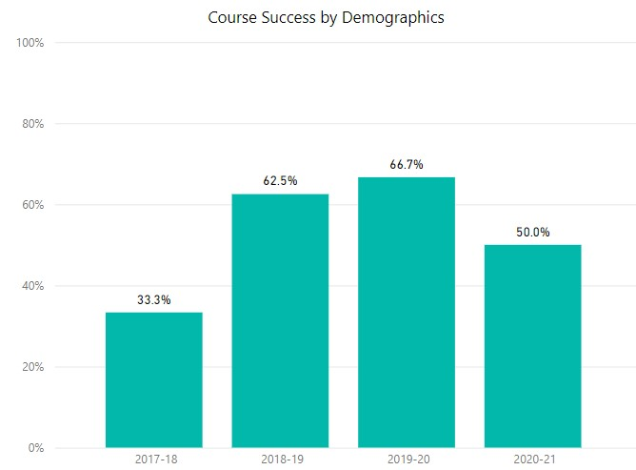

**Course Success for Native American or Alaskan Native for Foreign Languages:** 2017-2018 (**33.3%**), 2018-2019 (**62.5%**), 2019-2020 (**66.7%**), 2020-2021 (**50.0%**): (**33.3% --> 62.5% --> 66.7% --> 50.0%**)

[in comparison with Course Success for Native American or Alaska Native students of the entire college, Foreign Languages had significantly lower percentages of success in 2017-2018 (36.7% lower), 2018-2019 (2.7% lower), in 2019-2020 (2.5% lower), and 2020-2021 (19.1% lower)]

While it is important to note and reflect upon the lower rate of Course Success for Native American or Alaskan Native students, we feel that there is too minimal of data to generalize about the ethnicity’s Success rate as a whole: according to the Program Demographics data, the number of Native American or Alaskan Native students was so small it did not appear in the graph. With only a few students registered, this means that the above results are based on too small of a sample size and could fluctuate greatly depending on the individual students assessed. Nevertheless, we will keep this lower rate in mind when approaching instructional methods for future Native American or Alaskan Native students.

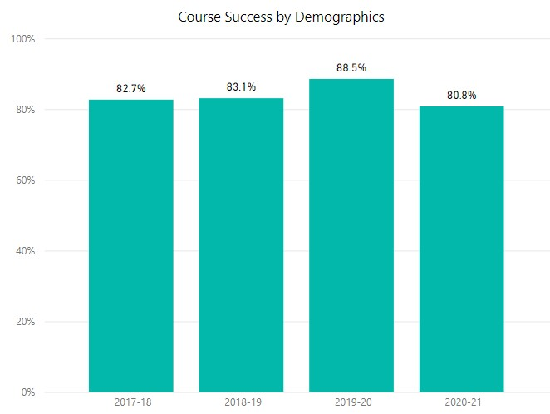

**Course Success for Asian for Foreign Languages:** 2017-2018 (**82.7%**), 2018-2019 (**83.1%**), 2019-2020 (**88.5%**), 2020-2021 (**80.8%**): (**82.7% --> 83.1% --> 88.5% --> 80.8%**)

[in comparison with Course Success for Asian students of the entire college, Foreign Languages had slightly higher percentages]

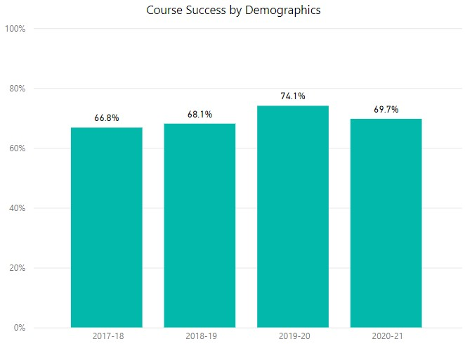

**Course Success for Hispanic for Foreign Languages:** 2017-2018 (**66.8%**), 2018-2019 (**68.1%**), 2019-2020 (**74.1%**), 2020-2021 (**69.7%**): (**66.8% --> 68.1% --> 74.1% --> 69.7%**)

[in comparison with Course Success for Hispanic students of the entire college, Foreign Languages had insignificant differences in percentages]

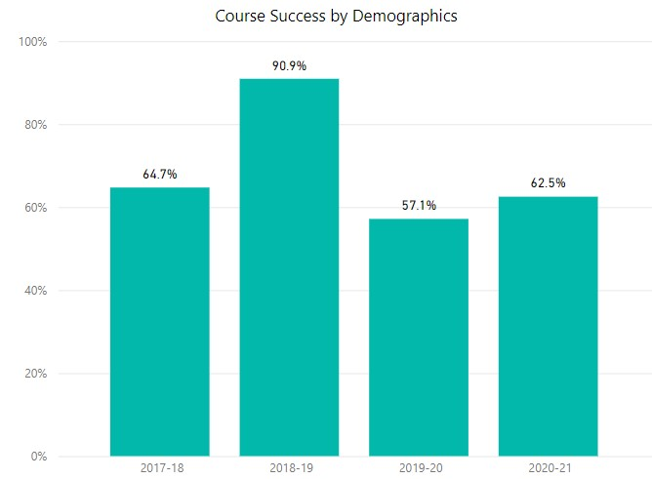

**Course Success for Pacific Islander for Foreign Languages:** 2017-2018 (**64.7%**), 2018-2019 (**90.9%**), 2019-2020 (**57.1%**), 2020-2021 (**62.5%**): (**64.7% --> 90.9% --> 57.1% --> 62.5%**)

[in comparison with Course Success for Pacific Islander students of the entire college, Foreign Languages had significantly different percentages of success in 2017-2018 (4.8% lower), 2018-2019 (23.2% higher), in 2019-2020 (6.9% lower), and 2020-2021 (5.5% lower)]

Again, much like for Native American or Alaskan Native students, we feel that there is too minimal an amount of data to generalize about the Success rate for Pacific Islander students who comprised less than 0.3% of our program’s demographics. As such, the above results are based on too small of a sample size to warrant meaningful analysis but will be of mental note for future students.

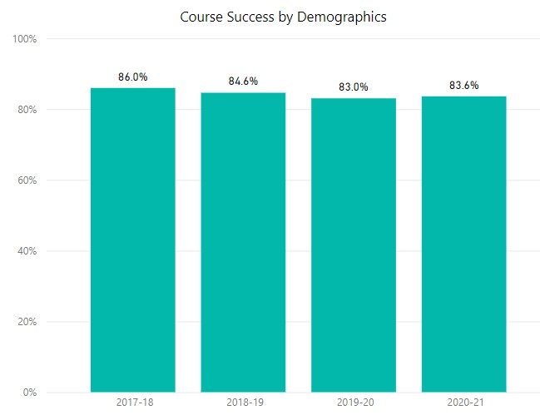

**Course Success for Student Visa for Foreign Languages:** 2017-2018 (**86.0%**), 2018-2019 (**84.6%**), 2019-2020 (**83.0%**), 2020-2021 (**83.6%**): (**86.0% --> 84.6% --> 83.0% --> 83.6%**)

[in comparison with Course Success for Student Visa students of the entire college, Foreign Languages had insignificant differences in percentages]

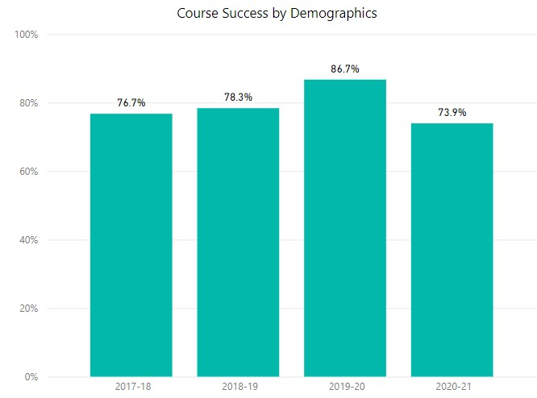

**Course Success for White for Foreign Languages:** 2017-2018 (**76.7%**), 2018-2019 (**78.3%**), 2019-2020 (**86.7%**), 2020-2021 (**73.9%**): (**76.7% --> 78.3% --> 86.7% --> 73.9%**)

[in comparison with Course Success for White students of the entire college, Foreign Languages had significantly different percentages of success in 2017-2018 (4.1% lower), 2018-2019 (3.1% lower), in 2019-2020 (0.9% higher), and 2020-2021 (5.5% lower)]

Again, for future students of any statistically struggling demographic, we will aim to close all equity gaps, including ones such as this in which success fluctuated for White students.

[all other ethnicity groups showed fairly insignificant differences from the total ethnicity demographic]

1. ***Unit Accumulation:* Number of units accumulated by students working towards a program degree/certificate. Discuss whether students who take units beyond the requirements for their educational goals serve educational purposes or not. Focus on general trends, not on particular courses within the program.**



**French AA Average Units Earned**: 2017-2018 (**73** units), 2018-2019 (**87** units), 2019-2020 (**84** units), 2020-2021 (**47** units): (**73 --> 87 --> 84 --> 47**)

**Japanese AA Average Units Earned**: 2017-2018 (**73** units), 2018-2019 (**80** units), 2019-2020 (**77** units), 2020-2021 (**81** units): (**73 --> 80 --> 77 --> 81**)

**Spanish AA Average Units Earned**: 2017-2018 (**53** units), 2018-2019 (**74** units), 2019-2020 (**90** units), 2020-2021 (**70** units): (**53 --> 74 --> 90 --> 70**)

**Spanish ADT Average Units Earned**: 2017-2018 (**76** units), 2018-2019 (**0** units), 2019-2020 (**79** units), 2020-2021 (**75** units): (**76 --> 0 --> 79 --> 75**)

*Discuss whether students who take units beyond the requirement for their educational goals serves an educational purpose or not:*

In our opinion as instructors, anything learned always serves an educational purpose! However, we have seen that when students over-enroll or take unnecessary units, they often do not carefully consider the time commitment, workload, and impact it will have on their schedule, causing them to fail that semester altogether (or at least in part). Furthermore, over-enrolling might have negative effects on several factors of our students’ lives. For one, it might affect the financial aid that they receive, which could be potentially devastating. Secondly, enrolling in too many units might cause undue stress and result in health problems that prevent them from succeeding even longer. Given that taking college classes can already be a stressful and difficult experience for our students, we believe that the priority should be to limit their workloads to manageable amounts so that they reach their educational goals without the added pressure of taking too many units.

1. ***Annual earnings:* Median annual income of alumni who attended the program under review (or the closest related sector)**

N/A

1. ***Living Wage Attainment:* Percent of alumni who attended the program under review (or the closest related sector) and earn living wage**

N/A

**k) *Job in Field of Study: P*ercent of alumni who pursued a career education path with a job related to their field of study.**

N/A

# Curriculum and Outcomes Assessment

1. **Examine the program curriculum using an equity lens by responding to the following questions: To what extent does the curriculum:**

* **Prepare students to actively engage in a diverse society?**

El Camino College is located in the heart of the Los Angeles South Bay and is home to a very diverse community, a community that is 43% Hispanic/Latino, 26% Asian, 21% White, 19% Black/ African American, and 11% two or more races/ethnicities, according to the quick facts presented by the U.S. Census website for 2022.[1] In turn, the Foreign Language Department takes active measures to engage in practices that address the needs of its community. The study of language, language theory, and culture is one of the most effective and direct ways educators and institutions can invite students to engage in a diverse society. The study of any language pushes students to think critically, to intelligently articulate ideas, and to learn how to perceive, understand, and synthesize information from diverse perspectives and experiences. The study of any language helps students better understand their own native language, thereby helping them become better communicators. The study of language, language theory, and culture can also be an effective tool in any liberal arts and humanities education as degrees in any language prepare students to compete in a multilingual and multicultural society and market.

* **Include multicultural content?**

In addition to the use of the target language, a practice that is infused with multicultural content given that vocabulary and cultural-specific ideas are always communicated better in the target language, the faculty in each discipline goes above and beyond to include multicultural content in every unit, module, and lecture. Specifically, the faculty meets regularly (during Faculty Development Day every fall and spring) to ensure that we engage in affirmative action measures that reflect our diverse student body and community. These measures include the following:

1. Selecting textbooks that are inclusive, diverse, and representative of our student body and community. We meet regularly to ensure that we are using textbooks that reflect multicultural and diverse perspectives.
2. Each discipline (Japanese, French, Spanish, Chinese, etc.) shares resources with each other after attending professional conferences or professional development workshops, especially in regards to multicultural content.
3. Our department has regularly scheduled training (during Faculty Development Day every fall and spring) to maximize the use of our textbook resources, to provide consistency across courses, to make decisions as a department.
4. All faculty regularly travel abroad and bring back primary cultural and linguistic resources, which we make available to each other and to our students. Many of these items are easily accessible to everyone in our Foreign Language Lab.

* **Respond to diverse students’ learning needs?**

The faculty in the Foreign Language department engages in a number of initiatives that respond to diverse students’ learning needs as described below:

**1. Ways to promote accessibility to students who have greater financial needs:**

* 1. Book vouchers Program

The French and Spanish Departments secured a donation years ago, one that is housed under the El Camino College Foundation. When students express to us that they don’t have the financial means to purchase our textbooks, we often provide book vouchers to such students. We know that not all of our students have access to financial resources and that one of the pillars of equity is providing the financial means by which our students can access course materials. The funds in this Foundation account were not meant to be a book voucher program. However, the faculty is committed to the learning needs of all students, including those who are financially burdened by book costs. Thus, we provide such services on an informal basis. As mentioned earlier in this Program Review, while each language program has researched the possibility of OER to replace our low- to moderately-priced textbooks, across the board we have found that OER materials for foreign language instruction are vastly inferior to the purchased versions we have meticulously chosen for our classes. Foreign language instruction in particular requires a good deal of quality multimedia (that only comes with purchased software programs) in order to adequately teach our students certain fundamental proficiencies such as speaking skills and listening comprehension.

1. Increased access to The Foreign Language Lab

The Foreign Language Lab is a great resource for students, whether they would like a space for studying their classwork in quiet or for interacting with others studying the same language. It is also useful for those who don’t have access to the Internet or to a computer at home. We make the use of this lab a top priority and have worked closely with our division to expand The Foreign Language Lab hours every semester. When funding has been an issue to expand lab hours, our faculty have held office hours in the Lab so that students can have access to it. In short, we would like the space to evolve from being a simple computer lab to a social learning hub for all students in our program.

**2. Ways to promote greater access of services to students who may struggle reaching out when they need extra help:**

a. Embedded Counseling and Tutoring

Some of our faculty have participated in MyPath equity training, which secures embedded PASS (Peer Assisted Study Sessions) Mentors and MyPath Counselors for their classes (SPAN 1, SPAN 2, SPAN 3, SPAN 4, SPAN 5, SPAN 6, SPAN 52A, SPAN 52B). PASS Mentors are students who have already completed the course and who now sit in class taking notes so that, when students need extra help, students can have a peer tutor them. Our current PASS Mentor is Francisco Ramirez Cisneros. We also have made one of our offices available to counselors (Sabra Sabio, Maribel Hernandez, and Rocio Diaz) so that they can provide drop in hours for counseling. Both of these services (Embedded Counseling and Tutoring) help us respond to the varied and ever-changing needs of our students.

1. Financial aid workshops/ presentations in our classes

It is common for our faculty to include financial aid, EOPS, and other presentations as part of our classes as well as library tours. We do this in order to bring El Camino College’s resources directly to our students as a way to make students feel like they are part of the greater El Camino College community.

* **Encourage instructors and students to investigate their own views, biases and values and discuss multiple perspectives different from their own?**

We teach classes in Chinese, French, German, Italian, Japanese, and Spanish. Because the faculty in our Program is so culturally diverse (our faculty have family roots in the United States, England, Puerto Rico, Peru, Mexico, Spain, Italy, Japan, China, Germany, the American Southwest, etc.), we naturally push our students to approach learning from a multiplicity of views and values as we embrace and celebrate each other’s differences.

Due to the nature of these courses, much of the work that we do in our classes is centered around learning about the socio-historical events that have shaped each of the countries whose languages we teach. Every country that is discussed in relation to our classes, which also includes the United States of America, has been shaped by a multiplicity of perspectives. Topics such as colonialism, independence, revolutions, civil-wars, dictatorships, censorship, civil rights, modernism, etc. take on different meanings, depending on the region or country we are talking about in our class (even within a particular language). As such, our lessons are infused with natural invitations for instructors and students to explore their own views, biases, and values in relation to those of others. In other words, it is a natural occurrence in a language class, particularly in a college or university. We will provide a few examples to illustrate this:

* In the context of Spain and its Civil War, the word “republican” has a very different meaning from what our students understand this word to mean based on their own cultural context.
* The term “national language” takes on a very different meaning in Mexico than in Puerto Rico.
* **Use critical/equity-oriented pedagogy? / Ensure creating an empowering classroom environment?**

To ensure that we create an empowering classroom environment for all of our students, we organize many culture-specific programs, all with equity in mind. As our students see themselves in these programs or as our students see that diversity is celebrated, students feel empowered to embrace their own culture and/or accept others’ culture. For the faculty teaching World Languages, creating equity-oriented pedagogy and empowering our students means having culturally-affirming activities and spaces for our students. Below is a summary of all the activities in which our faculty participate that bring our program closer to equity-oriented pedagogy and student empowerment:

* MICASA (Mexican, Indigenous, Chicano/a/x, Caribbean, Central American, South American Alliance)

Dr. Argelia Andrade and other faculty from other programs recently participated in extensive work aligned with the Affinity Centers on campus. Specifically, a success center for Latino/Hispanic students was secured. Such a center will be a physical space in the new Communications Building that will provide students who are Latino and their allies a place of belonging and organizing.

1. PUENTE

Many of our students in the Spanish for Native/Heritage speakers track are PUENTE students. PUENTE is formally run by counseling and English. However, the faculty in our department often collaborate with counselors Maribel Hernandez and Griselda Torres as well as with professor Shane Ochoa as they lead their family and student events. We attend PUENTE Club meetings and events regularly as well as contribute to their Mentorship Program and Family Events/Programs.

1. *A Celebration of Chicano Culture*

This annual program is an effort headed by Professor Xocoyotzin Herrera from Behavioral and Social Science. Dr. Andrade contributes annually to this program. This year, for example, *A Celebration of Chicano Culture* will be bringing Professor Francisco Balderroma and author Reyna Grande to campus. Students participating in Dr. Argelia Andrade’s Spanish 5/6 class will be using primary historical and literary sources written by Dr. Balderrama and Ms. Grande to put together an art exhibit in our Library’s Lobby. Students from all backgrounds taking Spanish 5/6 this semester will be learning about Mexican-American “Repatriation.”

1. The following is a list of the programs that our faculty have put together for our student body and community.

a. For Hispanic Heritage Month, Dr. Alicia Class organized an event called ‘Music from Puerto Rico’ in the Campus Theatre, Oct. 16 from 2:30-3:30 p.m. Our students attended and different projects and papers were written in relation to this event.

b. Dr. Donna Factor organized the ‘Cuba on the Cusp Symposium’ from October 16-19, 2017. These events included academic lectures from professors, musical and dance performances, and many more culturally-affirming events. Our students also completed class projects and papers during this time.

c. Dr. Ribelles organized an event in 2016 to mark the 80th anniversary of the outbreak of the Spanish Civil War. The program included lectures, film projection, a concert at the Marsee Auditorium, and a photo exhibition at the Library Hall.

* **Use multiple evaluation techniques sensitive to the diverse ways students can demonstrate understanding?**

During Professional Development, after the general meeting and after our Division meeting, the FL faculty always meet to discuss topics such as consistency and general questions related to our teaching, especially now that we have more modalities than before.

 In addition, we use the resources available to us from professional organizations such as ACTFL. The American Council on the Teaching of Foreign Languages (ACTFL) is a professional association and conference that has, since 1967, informs the way more than 13,000 educators and the institutions they serve prepare tomorrow’s professionals. Our faculty are affiliated with this professional association and attend the annual meeting. In our field, the ACTFL Proficiency Guidelines for listening, writing, reading and cross-cultural communication are used consistently across colleges and universities in the nation. We make use of such proficiency guidelines because we believe that the opinion of 13,000 educators who actively engage in professional development and who are still in the classroom is very valuable. Using evaluation techniques that engage listening, writing, reading, and cross-cultural communication ensures that we remain sensitive to the fact that our students benefit from different modalities in order to learn the material. Our SLOs reflect these four evaluation techniques consistently (for all languages and all levels that we teach).

1. **Summarize SLO and PLO assessment results over the past four years for key/gateway courses. Gateway courses are determined by your department & division – contact your Dean. For your gateway courses, present the raw data (number of students who participated in each assessment, number of students who met the standard in each assessment, what success rate for each SLO was for each assessment). This data is in Nuventive. Contact your Division Facilitator and/or Campus SLO Coordinator for assistance.**

Between Fall 2017 and Spring 2021, all gateway courses (i.e. level 1 courses) in Foreign Languages had SLOs that met the standards for success (i.e. at least 70% of students succeeding) except for one outlier marked in red type below.

Below is the raw data (number of students who met the standard/number of students who participated) followed by the percentage of Student Success for each gateway course’s SLOs when they were assessed during this period, from least recent to most recent (going left to right):

CHIN1: SLO #1: (35/39) 90% --> (43/46) 93% --> (16/17) 94.1%

SLO #2: (35/40) 88% --> (42/46) 91% --> (13/16) 81.3%

SLO #3: (33/40) 83% --> (39/46) 85% --> (15/16) 93.8%

FREN1: SLO #1: (57/59) 97% --> (54/58) 93% --> (76/79) 96%

SLO #2: (52/54) 96% --> (82/84) 98%

SLO #3: (53/68) 77% --> (45/58) 78% --> (82/84) 98%

GERM1: SLO #1: (33/40) 82.5% --> (39/42) 93% --> (62/64) 96% --> (25/27) 92.6%

SLO #2: (37/40) 92.5% --> (41/42) 98% --> (63/64) 98% --> (26/27) 96%

SLO #3: (35/40) 87.5% --> (39/42) 93% --> (61/64) 95% --> (25/27) 96%

ITAL1: SLO #1: (22/22) 100% --> (25/25) 100% --> (30/32) 94.1%

SLO #2: (22/22) 100% --> (24/25) 96% --> (30/32) 93.9%

SLO #3: (22/22) 100% --> (24/25) 96% --> (32/32) 100%

JAPA1: SLO #1: (137/144) 95.1% --> (125/132) 95% --> (112/116) 97% --> (113/117) 98.6%

SLO #2: (111/143) 77.6% --> (110/132) 83% --> (84/120) 70% --> (114/126) 90.5%

SLO #3: (85/143) **59.4%** --> (114/132) 86% --> (97/120) 81% --> (114/126) 90.5%

SPAN1: SLO #1: (192/209) 92% --> (133/137) 97% --> (190/201) 94.5%

SLO #2: (203/210) 97% --> (130/138) 94% --> (194/224) 86.6%

SLO #3: (163/208) 78% --> (122/152) 81% --> (156/181) 86.2%

With regard to only the above gateway courses within the Foreign Language program, all five of our PLOs had a 100% Success Rate during the current Program Review period.

1. **Discuss programmatic factors contributing to constant, increasing or decreasing trends in the results for SLO and PLO assessment within the previously examined courses. What do you see that is contributing to increasing, decreasing, or stable success in each SLO analyzed?**

For the majority, each SLO in every course increased its rate of Student Success over the four-year period or maintained a similar rate, with some reaching even a significant 10-30% increase from the beginning to the end. As contributing factors to this overall increase, we see a few changes in our department that may be responsible for this positive growth:

* Instructors have become more aware of equity-based teaching and grading than they were during the beginning semesters of this Program Review period. This is likely due to the college as a whole disseminating information and creating new trainings and programs in order to better advise us and equip us with the tools we need to help our students succeed. Accordingly, the Humanities Division has itself been vocal and encouraging about equity-based methodologies to further immerse us in this more mindful pedagogy.
* The Foreign Languages department has had several changes in faculty since the beginning of the Program Review period that may have affected Success Rates. This includes the retirement and replacement of a full-time French instructor, the retirement and non-replacement of two full-time instructors (one in Chinese, one in Spanish), and the non-rehiring of several part-time faculty members (particularly in Spanish) due to low enrollment.
* Near to the end of this Program Review period, the Covid-19 pandemic ushered in a new age of learning with fully online instruction. While some students struggled to adapt to the new paradigm, others thrived thanks to added flexibility, better accommodations, and a strong connection to digital media and information. That being said, there have also been suspicions of increased cheating and plagiarism on online platforms that have been difficult to control, thereby creating a potential artificial increase in Student Success rates. As instructors continue to learn about more tools and tactics to control these issues, we hope to combat the problem and lay any significant suspicions to rest.

As for the number of students assessed over time, some program totals decreased overall (Chinese, German, and Japanese), some fluctuated but maintained overall (Spanish), and some increased to small degrees (French and Italian). These numbers likely speak to enrollment issues affecting most foreign languages programs, but they may also be affected by differing assessment methods that the Covid-19 pandemic necessitated when students were no longer on campus to be assessed in person. For example, for SLO #1 (i.e. speaking skills) instructors no longer held interviews or conversations in person during the Covid-19 pandemic but rather on Zoom, which comes with its own challenges and impersonal nature. Furthermore, students from more vulnerable populations may have had technical difficulties or personal reasons that prevented them from showing up to their Zoom appointments on time during this unstable period. The same could be said for SLO #2 (i.e. reading comprehension skills) and SLO #3 (i.e. writing skills) as these assessments made the transition to fully online formats that were likely new and unfamiliar to most students and may have presented unforeseen challenges.

As for the maintenance of a high 100% Success rate for all five PLOs in our gateway courses during this Program Review period, we are both enthused and humbled by the great work put forth by all of our colleagues in the department but also by the efforts of our students. It is especially remarkable that Success Rates are at a similar level even during the semesters that were disrupted by the Covid-19 pandemic, which shows that our faculty members have adapted to the challenge successfully. Within the PLO reports, instructors commented that success in these skills correlated strongly with students’ completion of assignments, general preparedness, and motivation to succeed in the course. Additionally, some instructors raised thought-provoking questions, in particular about PLO #2 (Reading Skills). As some instructors saw it, because reading is a passive skill it is “easier” than the more active language skills (such as writing and speaking) and therefore much more likely to have a high rate of success. Nevertheless, the report notes that reading also requires knowledge of grammar, vocabulary, and, depending on the particular text used, varying levels of critical thinking and making inferences, and so it is not all that different in difficulty from the other PLO skills. Regardless, each PLO had the same rate of Success across all language programs and thus they seem to be well-balanced. On that note, perhaps it will be worthwhile to discuss as a faculty or at an administrative level if the rate of Success for PLOs should, in truth, *not* reach a perfect score in all cases, indicating that the current assessments are possibly not challenging enough to truly measure how well students do in each skill. While individualized data supports that many students approach the non-passing threshold at the SLO level, it may be useful and informative to our program to slightly increase the level of difficulty of assessments in the future to better disaggregate the skill levels of our students. In the meantime, however, we should rejoice in the achievements of our students who did, in fact, meet our established goals.

1. **Highlight equity gaps found in SLO and PLO assessment results among different groups of students.**

While we do not currently have access to data that pertains to specific groups of students at the time of this current Program Review cycle, the Foreign Languages program is working on using Canvas Outcomes to collect SLO data and to disaggregate it accordingly. We have experienced a discipline-specific issue with rolling out the usage of Canvas Outcomes in that many Foreign Languages courses rely on publisher-generated content that is located in separate software from Canvas, meaning that instructors must transfer their data from one course management system to another in order to submit results. Thankfully, we have been working closely with leaders of this project in the Assessment of Learning Committee (namely, Professor Kevin Degnan) to find a workaround that would make our publisher software more compatible with Canvas Outcomes. We began using Canvas Outcomes in Spring 2022 for our largest gateway course, Spanish 1, but due to technical issues during this pilot program we were not able to collect any data. We hope to have corrected the issue in Fall 2022 in which French 1 and Spanish 2 participated. We will continue to roll out more courses using Canvas Outcomes over the next few academic years until every Foreign Languages course is using it as a means of providing meaningful disaggregated data that helps us identify equity gaps found in our program’s SLO and PLO assessments results.

# SECTION 3 Program Vision and Future Planning

# Program Vision

1. **Describe the vision of the program for the next four years considering the assessment reported in the previous section, student groups that are underrepresented in the program’s field, and any relevant changes within the program field/industry. A vision statement describes the desired future state of the program.**

The faculty in our program unanimously decided in Fall 2022 to change the name of our program from Foreign Languages to World Languages and Cultures to reflect the intended direction of the Program. This change summarizes what our vision of the program is in the next four years: to promote values of diversity and inclusion, to continuously evaluate our teaching practices and courses to promote equity and access, and to address the needs of our community by designing courses that help students on a transfer track as well as community members wanting to add multilingualism and cultural awareness to their professional toolkit.

In addition to changing our name, we have done the following:

1)     We recently revised our courses to contain more inclusive language and content. We will continue in this direction as we revise and update our curriculum in the next four years.

2)     The study of language can also involve the scientific study of language, called Linguistics. We added this major locally back in 2021 and are currently waiting for CSU and UC articulation in order to offer our major and courses: LING 1A and LING 1B. This will help our students who are interested in the rule-based aspects of languages transfer to colleges and universities that have this major. In addition, this major will provide a hub for students who are studying more than one language so they can declare a major for transfer without having to take more than three semesters of a specific language.

3)     We have developed a [SPAN 10 - Spanish for Professionals](http://catalog.elcamino.edu/preview_course_nopop.php?catoid=7&coid=12420) series to address the growing needs of our community at large. As part of this course series, we offer a Certificate in Spanish for Professionals. This provides degree-seeking and non-degree-seeking students the necessary language skills for designated professional purposes such as business, healthcare, hospitality, and translation, increasing their intercultural competencies to be prepared for success in a global economy. By attaining a specialized certificate that is relevant to a community member’s profession and field, students can make you more marketable and better equipped to work and career.

4)     We will continue offering our Cultural courses such as [JAPA 25 (Cultural Aspects of the Japanese Language)](http://catalog.elcamino.edu/preview_program.php?catoid=7&poid=1514&hl=%22JAPANESE%22&returnto=search) and have decided to reinstate [SPAN 24 (Introduction to Spanish and Latin American Language and Cultures](http://catalog.elcamino.edu/preview_course_nopop.php?catoid=7&coid=11584)) and CHIN 24 (Introduction to Chinese Language and Culture)These courses are taught in English and are available to any student who wants to finish their Language major and/or enhance their multicultural competency.

# Future Planning

**A) Based on the assessment reported in the previous section, develop program goals to be completed during the next four years in relation to:**

* **Adjusting the curriculum for coherence and alignment with students’ workforce needs**
* **Advancing towards a more equitable program to close equity gaps among groups of students**
* **Clarifying students’ paths to completion, further education and employment**
* **Helping students explore options and build foundation skills**
* **Helping students stay on the path**
* **Integrating applied learning experiences**

Developing courses to better fit our students’ professional needs is something that the Foreign Languages faculty has been actively pursuing. We have created the Spanish for Professionals course that is specifically designed to serve students in different fields. For example, one of the recently created courses under Spanish for Professionals is the Medical Terminology class that provides specific language to students interested in the medical field. El Camino College’s nursing program, for example, will directly benefit from this course. Other courses in mind under the Spanish for Professionals title also include Business Terminology. We will continue to design other such courses that align with students’ workforce needs.

Moreover, three of our faculty members have collaborated in the creation of a course in linguistics. This course will greatly enhance our program by offering an important addition to the recommended and/or required courses for our foreign language majors.

One of our program’s greatest assets in closing equity gaps among groups of students is our students themselves. Heritage speakers tend to enroll in many of the languages offered. They might have adequate speaking skills but at times falter in their reading and writing skills. Non-heritage speakers, on the other hand, often lack the speaking capabilities in the target language, yet quickly memorize verb conjugations and the spelling of general vocabulary. Matching these two groups together is what is typically done in our classrooms so that these two groups can benefit from each other’s strong points. This in turn closes equity gaps between them. We will continue to pair students from all cultural and linguistic backgrounds so that they learn from one another and balance their language differences. This has consistently worked. In addition, we will continue to offer tutoring in and outside our language lab in order to provide a more equitable program.

1. **What projects will the program complete to achieve the desired goals? Please specify at least two for each goal.**

We will continue to work on expanding our courses to ensure that our program stays relevant for various educational goals. A recent example is the implementation of our linguistics course and our Spanish course for medical professionals. We are currently collaborating in creating a Spanish course for those majoring in business or already working in the business world. These types of hybrid courses, if you will, not only attract but serve students in particular fields. This, obviously, increases enrollment and benefits our overall program, especially by retaining students who might otherwise search out courses elsewhere to graduate or transfer if certain courses are not available. We hope to continue experimenting with new offerings and modalities to appeal to a broader range of students.

We also wish to provide flexible offerings to maximize the number of students who can take our courses if desired. Our class offerings during the winter and summer sessions have made ECC’s name much more recognizable for university students. Many students from four-year colleges across California, for instance, continue to enroll in our summer French courses, claiming that very few colleges offer French 1 during the summer. We will strive to offer basic language courses during these two important sessions to, again, increase overall enrollment, and to better serve ECC students as well as those from other colleges and universities.

Having a wide range of educational modalities appeals to a more diverse set of student schedules and to different types of learners, and in particular those who may need certain accommodations. While current enrollment trends seem to suggest that students favor fully online asynchronous courses, we as instructors also know that there is still a large subset of students who strongly prefer learning a language in a communicative and interactive face-to-face or hybrid setting. We believe that these latter offerings in turn foster a more cohesive relationship between the students and the campus as a whole, connecting them to more support programs and thus increasing their chances at success.

1. **When the next program review is due, how will the program determine if the goals have been met? Please specify at least one quantitative target or qualitative accomplishment for each goal.**

Our department is looking forward to the fulfillment of our goals in the next four years. Our enthusiasm lies in the fact that our achievements mirror that of our students’. Our quantitative results will be reflected in the increase of our enrollment, the number of AA awards conferred, our fill rates, and if all goes according to plan, the reduction of our class sizes (face-to-face, hybrid, and online) for better instruction and learning. Obviously, the increase in enrollment will hopefully lead to more AA awards. There is nothing more rewarding to us than student success.

As far as our qualitative targets are concerned, our SLO results will continue to illustrate our current or even improved student success in all three skills (speaking, reading, and writing). Most important, our Canvas Outcomes will provide disaggregated data (by ethnicity, age, gender), unavailable to us at present, that will be invaluable for our better understanding of groups that need help and equitable instruction and grading.

# Program Resources

**In the following areas, what are the resources needed by the program to meet the goals for the next four years? Include any recommendations from the previous Program Review that are still active or on hold.**

**List resources in order of priority. Prioritize them within each category and/or develop an overall prioritized list of resources. Explain how these resources contribute to the** [**College’s equity goals**](https://www.elcamino.edu/about/depts/ir/docs/research/outcomes/Local%20Vision%20Goals%20Infographic%202017-18.pdf)**.**

1. **Recommendation:** **Program Growth Self-Study [The Faculty will engage in an informed and meaningful (taking this Program Review into account) discussion of how to secure program growth. This is critical and should be central to all programmatic planning in the next five years.]**

**Notes/Comments:** Program growth requires continuous discussions and analyses: they are central to all critical elements of growth mentioned hereafter. We wish to focus on increasing student success and retention in our classes but in turn this means the college has to improve its methods of drawing students into our programs (see second recommendation below).

1. **Recommendation:** **Marketing Efforts [We need to have an overt marketing campaign to secure program growth. This is critical and should be central to all programmatic planning in the next five years. Community outreach needs to include advertisement materials, an online and social media presence, etc.] --> $10,000/year**

**Notes/Comments:** Recruitment is a vital part of growing our shrinking language programs and thus marketing the value of our department to potential students is highly important for future growth and retention. While faculty members are willing to do their part to promote the program and retain students (see first recommendation above), we are not experts in marketing and therefore need more support from the college to attract students and keep our enrollment numbers up. We would like a more regular and responsive interaction with ECC Marketing & Communications and the Counseling department as well to ensure students are being directed to our program as needed.

1. **Recommendation:** **Partnerships [Partner with the Student Equity Plan (SEP) to create additional support services for our students. Partner with FYE, SER, and PUENTE to collaborate with other learning communities on campus to connect our students to more resources. Create a stronger Honors Transfer Program track for our students.]**

**Notes/Comments:** While some of these programs have changed names (e.g. SEP is now SEA, SER is now MyPath), our students need support and campus resources more than ever in an unstable, post-pandemic economy. Dual Enrollment is a newer program that allows El Camino College to connect with local high school students and to bolster our own course enrollments, and as such, it needs more promotion in the area. Important programs such as these and MyPath help faculty “evaluate how their teaching methods, their views on student learning, their assignment design, and their content delivery may be contributing to equity gaps and impacting degree completion, transfer, and student retention and success.” Lastly, each semester our faculty members nominate successful students to join the HTP but more could be done to ensure students follow through and meet the requirements.

1. **Recommendation:** **Collaboration with Counseling [A better strategy or process for securing Foreign Language majors needs to be made by our department in collaboration with the counseling division.]**

**Notes/Comments:** Since the last Program Review, Counseling has made great strides in being able to connect and help students, including increased access to online appointments, Quick Question chats, and drop-in counseling on the first floor of the Humanities building next to the Foreign Languages department offices. However, this will always be a high-priority need for securing Foreign Language majors. Counseling works closely with all equity-driven programs to help increase transfer rates, increase capacity, and support students of all kinds campus wide. We also learned during the COVID-19 pandemic that some academic counselors were telling students to wait until they transfer to complete their foreign language requirements and this may have hurt our enrollment numbers. We need to establish a stronger, more direct relationship with the Counseling department to ensure that this type of misinformation does not continue or happen again.

1. **Recommendation:** **Student Support [Increase open hours of Foreign Language Lab (at least 2 hours in the evening) daily, Monday through Friday. Our evening students express discontent with our current hours of operation. --> $90,000/year; Hiring one full-time lab coordinator or two on a half-time basis. --> $60,000/year; Hiring of several student lab assistants. -->$10.50/hour at 20 hours/week]**

**Notes/Comments:** The Foreign Languages department continues to hope for funding that will secure a more full-time, functional Foreign Language Lab. The lab exists to support student success in our program specifically and acts as a safe learning space.

1. **Recommendation:** **Spanish 1 and Spanish 52A [Much of the student population is Spanish-speaking. To better serve them, we will offer more SPAN 52A courses than we currently do, replacing a few SPAN 1 courses.]**

**Notes/Comments:** In addition to the continuing challenges the Spanish program faces with regard to difficulty recruiting targeted student groups, the Covid-19 pandemic caused major enrollment issues across all classes in the past couple years. Furthermore, the Spanish program still struggles to find effective placement strategies to properly place students in either SPAN 1 or SPAN 52A. By creating a more effective placement process the Spanish program can better support our students by ensuring they begin in the right classes, and in particular our ever-growing local Latinx communities.

1. **Recommendation:** **Curriculum Improvement [Revise curriculum and major requirements to the majors in French, Chinese, and Japanese in order to make them eligible for TMC AA-T status. Continue to improve course outlines of record to improve our courses and make them better articulate with UC and CSU requirements.]**

**Notes/Comments:** The Foreign Languages department still hopes to make French and Japanese eligible for TMC AA-T status, which mostly got delayed due to enrollment issues caused by the Covid-19 pandemic. Also, the department now offers a new course, SPAN 10 (Spanish for Professionals), and hopes to soon begin offering a Linguistics 1 course to diversify our offerings. This shows how we continue to examine the academic needs of our increasingly diverse student population, which is critical to the achievement of student equity and the fostering of academic excellence.

1. **Recommendation:** **Instructors [Continue to regularly hire part-time faculty that shares our program vision. --> $100,000/year for 5 new hires; Hiring a full-time French instructor. --> $100,000 (salary plus benefits)**

**Notes/Comments:** While a full-time French instructor was hired in 2019, all other hirings have been placed on hold due to difficulties caused by the Covid-19 pandemic. We cannot increase the offerings of our department without more instructors, which in turn prevents us from increasing the number of students in our program and thus the number of degrees awarded, including for disproportionately impacted groups. If the college supports better growth in the program we would like to reopen the possibility of replacing recently retired instructors (e.g. in Chinese and Spanish) and full-time instructors in each of the departments that currently only employ part-time instructors (e.g. Italian and German).

1. **Recommendation:** **Book vouchers [Since 51% of our students need significant financial help to complete their coursework, we would like to secure funds to have a wider book voucher program for financially needy students.] --> $5000/year**

**Notes/Comments:** The Foreign Languages department would like to continue using the book vouchers program to better serve our students, in particular those with the highest financial needs. It is also our preference for the book voucher funds to come from other sources than our language Foundation funds. Additionally, we would like to expand the program to language programs without their own Foundation. It should also be noted that because language instruction requires a good deal of quality multimedia in order to adequately teach our students certain fundamental proficiencies (such as speaking skills and listening comprehension), each program has chosen to forgo the possibility of using OER. Each program has independently researched different OER and found them to be an ineffective solution for replacing our low- to moderately-priced textbooks. Each current textbook has been carefully selected by our instructors in order to offer our students an important balance between quality and value.

1. **Recommendation:** **Classroom Cleanliness [Future budgets set need to include basic classroom cleaning, at least once per month. Currently, faculty currently need to clean their classroom to be habitable. However, this is not a viable long-term solution. Another crewmember can be assigned to our building, given that we are the biggest division on campus.] --> $11,000/year**

**Notes/Comments:** Cleanliness is still a priority in light of Covid-19 and thankfully since the last cycle more cleaning supplies have been offered for instructors to use if needed. Nevertheless, the lack of regular and thorough cleaning of frequently-touched surfaces (e.g. computers, consoles, desks) by classified staff poses a health and safety issue for students and instructors and needs to be addressed.

1. **Recommendation:** **Hardware and Equipment Maintenance [Have a budget in place to maintain and update SMART Classrooms Devices. The 10th anniversary of a lot of technology will be next year. Equipment such as computers, projectors, projector screens and metal hooks for posting need to be replaced.] --> 20 screens, $7,000 ($350/screen); 45 projectors, $36,000 ($800/projector); 45 classrooms hook sets, $2,250 ($50/set)**

**Notes/Comments:** The Humanities building has received some new technology since the last cycle but it will always need to be well-maintained and updated every few years. New computers in the classrooms is the highest priority amongst all the technology listed above. Working clocks on the classroom walls are also desired. Better technology assists instructors with their lessons and provides opportunities to reach different types of learners, which in turn fosters better student success all around.

# [FOREIGN LANGUAGES DOES NOT NEED TO COMPLETE]

# APPENDIX A

# CAREER EDUCATION (CE) SUPPLEMENTAL QUESTIONS

*CE programs must conduct a full program review every 4 years. The comprehensive program review includes responses to the CE supplemental questions below. Every two years (once between full program reviews) these supplemental questions must be answered and submitted to Academic Affairs for posting on the College website.*

***Use labor market data, advisory committee input/feedback, and institutional and program-level data to respond to the following questions:***

**1. How strong is the occupational demand for the program?** In your response, describe any changes in demand over the past 5 years and discuss the occupational outlook for next five (5) years. Provide applicable labor market data (e.g., US Bureau of Labor Statistics, Employment Development Department) that address state and local needs.

**2. How does the program address needs that are not met by similar programs in the region?** In your response, identify any distinctive components of the program (e.g., curriculum, facilities, resources) and/or describe any unique contributions the program or its students/graduates make to the community served.

**3. What are the completion, success, and employment rates for students in the program?** In your response, identify the standards set by the program and discuss any factors that may impact completion, success, and employment rates among students in the program. Describe the status of any action plans for maintaining/improving rates relative to such benchmarks.

**4. List any licensure/certification exam(s) required for entry into the workforce in the field of study and report the most recent pass rate(s) among program graduates.** In your response, identify any applicable performance benchmarks set by regulatory agencies and describe the status of any action plans for maintaining/improving pass rates relative to such benchmarks.

**5. Are the students satisfied with their preparation for employment? Are the employers in the field satisfied with the level of preparation of program graduates?** Use data from student surveys, employer surveys, and other sources of employment feedback to justify your response.

**6. Is the advisory committee satisfied with the level of preparation of program graduates? How has advisory committee input and feedback been used in the past two years to ensure employer needs are met by the program?** Describe the status and impact of any advisory committee recommendations.

California Education Code 78016 requires that the review process for CE programs includes the review and comments of a program’s advisory committee. **Provide the following information:**

a. Advisory committee membership list and credentials.

b. Meeting minutes or other documentation to demonstrate that the CE program review process has met the above Education Code requirement.

1. <https://www.census.gov/quickfacts/fact/table/gardenacitycalifornia/PST045222#PST045222>