**El Camino Community College**

**PROGRAM REVIEW 2022-23**

**Division of Mathematical Sciences**

**Department of Engineering**

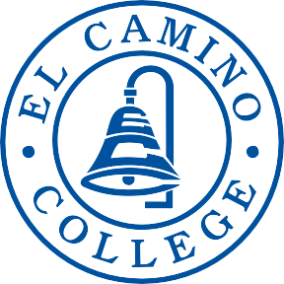

**DEAN:**

Marlow Lemons

**CONTRIBUTOR(S):**

Pavan Nagpal

**TABLE OF CONTENTS**

Contents

SECTION 1 Program Overview 3

SECTION 2 Program Assessment 6

Program Contribution to Student Success and Equity 6

Curriculum and Outcomes Assessment 7

SECTION 3 Program Vision and Future Planning 9

Program Vision 9

Future Planning 10

Program Resources 10

Appendix A Error! Bookmark not defined.

CAREER EDUCATION (CE) SUPPLEMENTAL QUESTIONS 10

# SECTION 1 Program Overview

1. **Provide an abstract of what your program does, who you serve, your previous successes, and where your program is moving in the next four years. Highlight the most interesting, compelling aspects of your program – your recent achievements and needs.**

The mission of the Engineering Program is to educate students to the engineering profession and provide as needed resources to help them transfer to universities as engineering majors. The Engineering Program at El Camino College consists of those courses required for engineering students by many, if not most, of our transfer institutions. These courses include MATH 190, 191, 220 (the calculus sequence), 270, 210, PHYS 1A, 1B, 1C, 1D, CHEM 1A, 1B, CSCI 1, 2, 3, as well as ENGR 1, ENGR 9, ENGR 10, ENGR 11 and ENGR 12. It is, of necessity, a multidisciplinary, comprehensive pre-engineering program.

The Engineering program serves students from local communities surrounding El Camino College, and its demographics cover more than 50% of LatinX students. Many of the program’s engineering student transfer to leading California-based four-year programs including CSU Long Beach, CSU Pomona, UCLA, UC Berkeley, UC Irvine, CSU Los Angeles, and UC San Diego to name a few. Although the students begin as pre-engineering majors at El Camino, many transfer to four-year institutions in mechanical (30%), electrical (23%), aerospace (13%), civil (12%), chemical (9%), and computer engineering (8%), collected from MESA Center data.

The engineering program, since its last program review, has undergone improvements in its curriculum. In the previous four years, the engineering program has increased its course offerings, from two engineering courses (ENGR 1 and ENGR 9) to five courses (ENGR 1 and 9, with ENGR 12 as the lab component of ENGR 11, and Engineering 10). The program consists of one full-time faculty (shared with the Mathematics department) and four active part-time faculty.

In the next four years, the department is planning to introduce more engineering curriculum to offer a comprehensive set of courses that are taken in the first two years of 4-year engineering program. In order to be competitive with local community colleges (SMC and Cerritos), we need to buy equipment to offer laboratory classes. Fortunately, the engineering department has made progress in this endeavor. Recent funds were awarded from Strong Workforce & UCLA grants for the purchase of circuit kits for labs, power supplies, oscilloscopes, function generators, and digital multimeters (DMM). As a result, this has started the engineering program’s expansion to its comprehensive lab equipment and support the growth of the engineering curriculum.

Furthermore, future plans include utilizing Makerspace for projects supplementing our engineering courses as well as increasing the program’s engineering full-time faculty count.

1. **Describe the degrees and/or certificates offered by the program. Consider addressing what makes your program unique to the college and region.**

Currently, the Division of Mathematical Sciences offers a pre-engineering Associate of Science degree. The list of courses taken for this degree depend on the student’s transferring institution. However, all of the course pathways have the following courses in common:

* In mathematics: MATH 190, 191, 220, and 270
* In engineering: ENGR 1, 9
* In physics: PHYS 1A, 1C

The engineering program is unique for two reasons:

* *Connections with Industry*: The engineering program, and its college, is centered in a location surrounding several major engineering companies including Raytheon, Northrup Grumman, Boeing, Aerospace, and SpaceX (to name a few). The engineering program has collaborations with these institutions in which they provide advisement to the department, services and donations to the courses, and internship opportunities to ECC students. For example, engineers from these companies visit the *Introduction to Engineering* classes to speak to students about engineering careers.
* *Diverse pathways to an associate’s degree*: the coursework that students complete towards an associate degree depend on the student’s transferring institution. That way, students are taking courses that are guaranteed to be accepted with the institutions after matriculation.

1. **Explain how the program fulfills the college’s mission. Address the work your program is doing to help the college fulfill its stated mission.**

The pre-engineering associate’s degree program continues to be a popular STEM major at El Camino College and, as such, uniquely supports many facets of El Camino College’s mission statement:

* “comprehensive educational program”: The engineering curriculum requires students to begin with an introductory engineering course. This course gives students the opportunity to learn of various engineering pathways, learn how to get into an engineering pathway (supporting the ECC’s Guided Pathways framework), and trains students on how to succeed in an engineering program and career.
* “services”: The engineering program is advised by an engineering advisory committee. Some of its members contribute to the introductory engineering course as speakers and mentors. El Camino offers services to our students. The Maker Space is a recent addition to the college. It provides a space for engineering students to build and test their ideas. Finally, MESA provides academic support, enrichment opportunities and financial resources to its STEM students.

There are many opportunities for employment after graduation (with a bachelor’s degree). Any college which claims to offer a comprehensive educational program must include preparation for a major in the various fields of engineering. Many of the students who are majoring in engineering are first generation college students and their success will be a positive influence on the lives of their extended family.

1. **Discuss the status of recommendations from your previous program review. In the “Notes/Comments” section, please discuss the known impact of a completed recommendation or the rationale for recommendations that are on active, on hold, and/or abandoned.**

*If more than ten recommendations were presented in the previous program review, expand the enumerated list below as needed.*

1. **Recommendation:** **Reactivate and offer the Electric Circuits course.**

**Status:** Completed

**Notes/Comments:** Instead of reactivating the previous version of the Electrical Circuits course, a new circuits course (ENGR 11) with lab (ENGR 12) has been developed. The course focuses on theory and practice of electrical circuits with the latest technological tools, which makes the former circuits course defunct. Moreover, ENGR 11/12 covers the objectives outlined in its respective CID from the Chancellor’s Office so that it articulates to California CSUs and UCs. This course was introduced by the new faculty hired in 2019 (see item 2). Spring 2023 is the third semester the course is offered. In all three semesters, approximately 36 students successfully enrolled and completed the course. Steps are being taken to help announce the course and improve its enrollment trends.

1. **Recommendation:** Hire an instructor capable of, and interested in, teaching both mathematics and engineering (or computer science and engineering).

**Status:** Completed

**Notes/Comments:** A full-time Engineering instructor, who also teaches Math, was hired in the Fall 2019 semester. Since 2019, the incumbent has achieved tenure. Although this recommendation was completed, it will be reopened due to the increased enrollment and continual growth of the pre-engineering program.

The new faculty member focused on curriculum and professional development, grant acquisition, and outreach. Examples include:

* Researched and bought laboratory equipment for the circuits class by visiting local universities and speaking with various vendors.
* Acquired a UCLA and workforce development grants to fund the needed equipment.
* Obtained curriculum approval for ECC to offer a Dynamics (ENGR 10) course, which is typically taken at four-year colleges in their sophomore year.

While the current faculty is developing new courses, a new faculty will help grow the program by working with students in teaching new courses and doing projects with students in Makerspace. Also, a dedicated full-time faculty can scope local research competitions for students to participate, which, in turn will attract students to the engineering program.

1. **Recommendation:** Modify ENGR 9 (Statics) to increase the number of hours students spend in class, with the aim of improving their problem solving skills.

**Status:** Discontinued

**Notes/Comments:** Increasing the hours lead to increase number of units. The concern is two-fold. First, increasing the number of units would affect its articulation with its CID. Second, the increase would affect the total number of units an pre-engineering student will need to graduate. The problem is this program, along with other majors within the STEM meta major are significant over its 60-unit capacity.

1. **Recommendation:** Offer free tutoring in engineering courses at El Camino using tutoring in the mathematics department as a model, perhaps even offering the tutoring in or through the Math Study Center.

**Status:** In Progress

**Notes/Comments:** As of the Spring 2023 semester, the Math Study Center transitioned to the authority of the Library & Learning Resources division. The Mathematical Sciences division dean and faculty will work with LLR’s dean and assistant director to address the emerging need for engineering tutors. There is a need for at least two engineering advanced tutors capable of tutoring the statics, dynamics, and circuits courses, to name a few.

1. **Recommendation:** Investigate the possibility of obtaining a dedicated space for all STEM majors to study and work together.

**Status:** Completed

**Notes/Comments:** El Camino College has dedicated funds to create a Makerspace for students. Located in the basement floor of the library, students can design and create their ideas.

1. **Recommendation:** Increase the course offerings in the Engineering Department in a consistent and steady way, beginning with Electric Circuits, and making an ordered list of the other courses that we would like to add. As courses are added to the curriculum, their equipment needs (later addressed in the program resources section) must be addressed and the possibility of sharing equipment can be investigated. Specifically, for a well-developed Introduction to Material Science course requires laboratory equipment (as outlined in the Program Resources section), It is worth noting our local competitor colleges (SMC and Cerritos) are not able to attract students to Material science course due to lack of well-developed labs.

**Status:** In Progress.

**Notes/Comments:** In addition to the Circuits course (ENGR 11/12) , Dynamics (ENGR 10) has been approved and is offered on the schedule of classes. Furthermore, the course outline of record for ENGR 15 (Graphics) is in review with the College Curriculum Committee as of the Spring 2023 semester.

1. **Recommendation:** Increase the number of sections of ENGR 1 if the demand increases.

**Status:** In Progress

**Notes/Comments:** Sections for the ENGR 1 course are opened based on enrollment trends, especially following the recent pandemic. Currently, new sections have become available across various teaching modalities including in-person, online, and live online. This allows the college to attract more community college students across the state.

1. **Recommendation:** Increase the enrollment in ENGR 9 through outreach to students who may be interested, but are not planning to enroll.

**Status:** In Progress

**Notes/Comments:** The division office staff communicates sections with low enrollment to the outreach staff to encourage enrollment growth in engineering courses. No marketing plan has been created, to this date, for promoting the ENGR 9 course.

1. **Recommendation:** Work with the Counseling faculty to disseminate information about engineering careers and preparation for transfer.

**Status:** Completed

**Notes/Comments:** Many of the pre-engineering students are affiliated with the MESA Center, which have counselors that are specific to assisting engineering students. This includes advisement of engineering careers and preparation for transfer to leading California universities.

# SECTION 2 Program Assessment

# Program Contribution to Student Success and Equity

**For the program under review, examine the following data for the last four years by:**

* 1. **Disaggregating by race/ethnicity, gender, and age where possible.**
  2. **Discussing internal and external factors contributing to constant, increasing or decreasing trends.**
  3. **Discuss any known barriers to student success in your program.**
  4. **Highlighting equity gaps found among different groups of students.**
  5. **Present and discuss possible action plans about what could be done to address equity and achievement/opportunity gaps.**
* *If the program under review is a Career Education Program, please examine a) through k) from the list below.*
* *If students taking courses from the program under review end with a degree or certificate issued by the program, please examine a) through h) from the list below.*
* *If students taking courses from the program under review do not end with a degree or certificate issued by the program, please examine d) through g) from the list below.*

Figure 1. Race/Ethnicity Trends from the 2018 to 2022 Academic Years

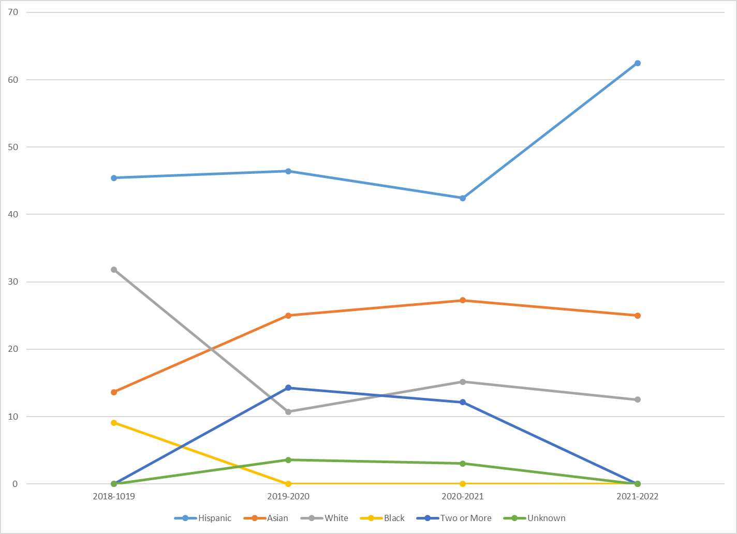

Points to mention:

Overall, there were 134 pre-engineering degrees awards across the 4 academic years; majority of the awardees have been Hispanic students (47.01%) followed by, Asian (24.63%), White (17.16%), students of two or more races (6.72%), and then Black (2.99%). Approximately 70.90% of awardees were male; most of the graduates were less than the age of 35 (98.51%), with the remaining between 35 to 44 years of age. Black engineering students decreased over the four years to rate and non-existent percentages; Asian student population increased; Hispanic population was steady between 2018 and 2020 academic years, then significantly increased.

These statistics appear to be consistent with national engineering statistics reported by Zippia Careers where:

* 3.3% of engineers are Black or African American;
* 86% of engineers are male; and the
* Typical engineer by age is between 26 to 33 years of age (which is when college graduates complete their undergraduate and possible graduate studies).

Table 1: Gender Distribution by Year of Entering Pre-Engineering Students

|  |  |  |  |  |
| --- | --- | --- | --- | --- |
| **Gender** | **Percentage by Year** | | | |
| 2018-2019 | 2019-2020 | 2020-2021 | 2021-2022 |
| Male | 68.18% | 75.00% | 63.64% | 81.25% |
| Female | 31.82% | 25.00% | 36.36% | 18.75% |

Female engineering students were highest in the 2019-2020 and 2020-2021 academic years. Lowest female engineering student enrollment occurred in the 2021-222 academic year. There was more than a 4-to-1 ratio of males to females in the 2021-2022 academic year.

Figure 2. Bar Chart of Age Distribution across Academic Years

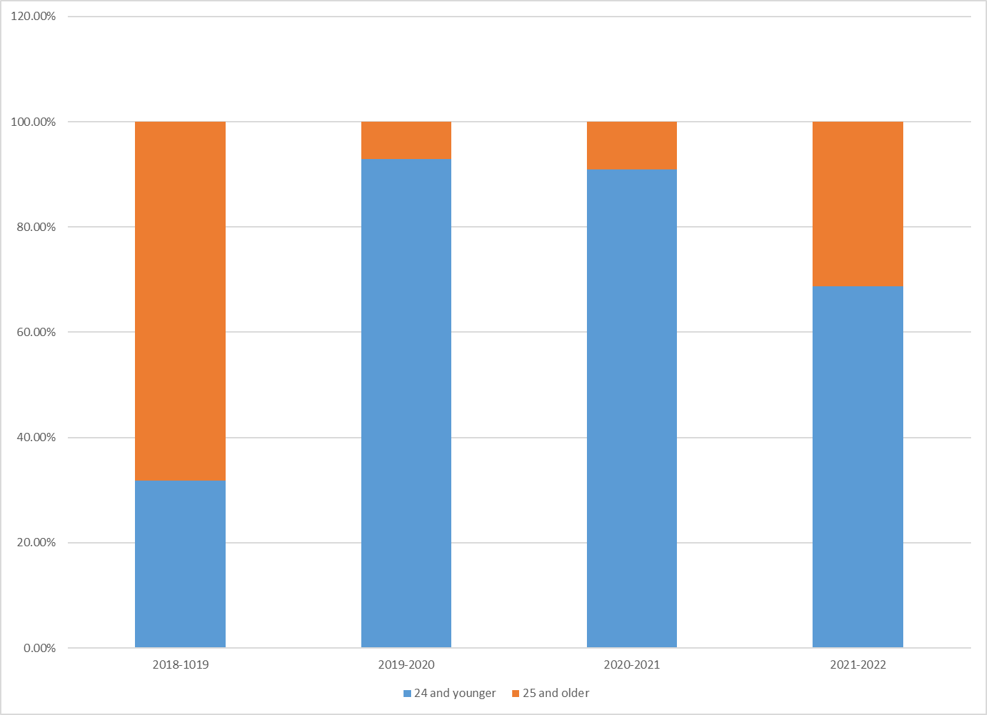

Figure 2 shows the distribution of pre-engineering students by age groups. The 19 and younger age groups has low counts and, thus, was combined with the 20-24 age group. Also, students aged 35 and higher were combined with the 25 to 34 group due to their small population sizes.

Points to mention: there was a significant growth in younger pre-engineering students after the 2018-2019 academic years.

Possible barriers to student success may include a sufficient support group for Black students prior to the 2022-2023 academic year. Fortunately, the newly-developed Black Student Success Center will provide support for this population. Another possible barrier is the lack of tutoring services in engineering courses. This has been due to lack of funding in earlier years and the challenge of finding engineering tutors to produce a sufficient pool of qualified tutors (especially tutors with representation to support Black student success).

1. ***Degree Completion:* Number/percent of students earning a program degree**

Table 2 shows the number of students awarded the pre-engineering degree, the number of students that transferred.

Table 2: Pre-Engineering Award Statistics

|  |  |  |  |  |
| --- | --- | --- | --- | --- |
| **Statistics** | **Academic Years** | | | |
| 2018-19 | 2019-20 | 2020-21 | 2021-22 |
| Number of Engineering Degrees Awarded | 22 | 28 | 33 | 16 |
| Number of Students within Division | 99 | 73 | 97 | 56 |
| Percent of Eng. Students within Division | 22.2% | 38.4% | 34.0% | 28.6% |

Pre-engineering students made up between 22% to 38.4% of all students in the mathematical sciences division who received a degree for transfer. The largest percentages occurred in the 2019-2020 and 2020-2021 academic years. For the 2022-2023 academic year, enrollment appears to be rebounding following the recent pandemic.

1. ***Certificate Completion:* Number/percent of students earning a program certificate**

The engineering program does not offer a certificate of achievement in pre-engineering.

1. ***Transfer to a four-year institution*: Number/percent of students transferring to a four-year institution**

Table 3: University Transfer of Graduates Statistics

|  |  |  |  |  |
| --- | --- | --- | --- | --- |
| **Statistics** | **Academic Years** | | | |
| 2018-19 | 2019-20 | 2020-21 | 2021-22 |
| Number of Transfers | 6 | 25 | 5 | 12 |
| Percent of Eng. Students within Division | 6.1% | 34.2% | 5.2% | 21.4% |

Table 3 shows statistics of how well pre-engineering students transferred to four-year universities from the 2018 to 2021 academic years. Pre-engineering students transferring to four-year institutions were at its highest in the 2019-2020 and 2021-2022 academic years. Graduates transferring to universities was at its lowest in 2018 since the program was developing and slowly growing. The 2020 academic year was during the pandemic, for which the college experienced a significant decrease in enrollment. Fortunately, the trend appears to be turning for the 2022-2023 academic year.

1. ***Scheduling of courses:* Percentage of students enrolled in day/evening courses, on campus/online/hybrid courses, days of the week**

Figure 3: Fill Rates and Section Counts by Modalities and Time of Day

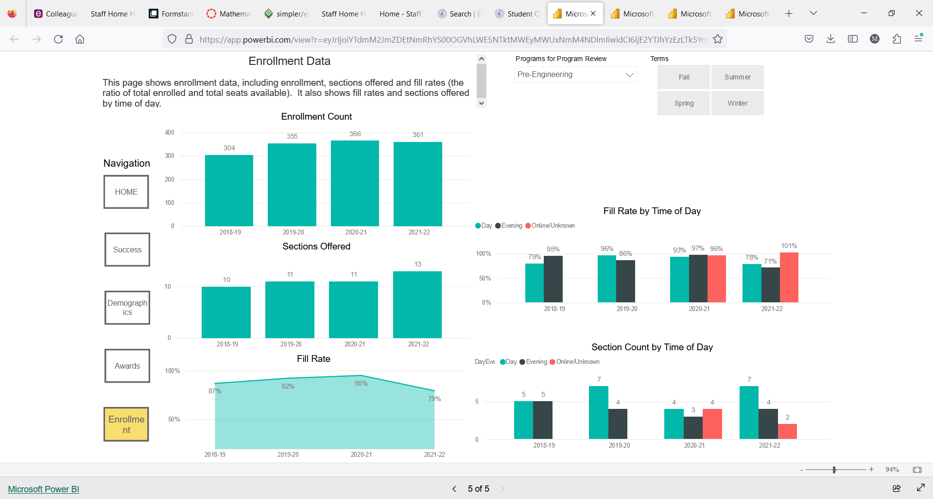

Figure 3 shows two bar graphs analyzing fill rates (Figure 3a) and section counts (Figure 3b) across the last four academic years. Figure 3a shows that fill rates were at least 70% every academic year. Online accessibility of engineering courses began in the 2020-2021 academic years. Figure 3b shows that more engineering sections were offered in the daytime than the evening.

1. ***Fill rate:* Percentage of actual students enrolled in a term in relation to total seats offered**

Figure 4: Overall Fill Rates of Pre-Engineering Courses



Figure 4 shows the overall fill rate of engineering courses from the last four academic years. Fill rates ranged between 79% (in the 2021-2022 academic year) to 96% (in the 2020-2021 academic year).

1. ***Grade Distribution:* Percentage of students in a course receiving each of the possible grades that can be awarded**

Table 4a: Percentage of Students Receiving Respective Grades in ENGR 1

|  |  |  |  |  |
| --- | --- | --- | --- | --- |
| **Grades** | **Academic Years** | | | |
| 2018-2019 | 2019-2020 | 2020-2021 | 2021-2022 |
| A | 34 | 50 | 52 | 41 |
| B | 29 | 17 | 16 | 16 |
| C | 10 | 8 | 7 | 7 |
| D | 2 | 1 | 0 | 0 |
| F | 12 | 13 | 14 | 17 |
| W | 13 | 11 | 10 | 19 |

Table 4b: Percentage of Students Receiving Respective Grades in ENGR 9

|  |  |  |  |  |
| --- | --- | --- | --- | --- |
| **Grades** | **Academic Years** | | | |
| 2018-2019 | 2019-2020 | 2020-2021 | 2021-2022 |
| A | 26 | 52 | 46 | 43 |
| B | 29 | 32 | 29 | 30 |
| C | 20 | 8 | 8 | 22 |
| D | 12 | 0 | 0 | 0 |
| F | 9 | 2 | 3 | 0 |
| W | 5 | 6 | 10 | 4 |

Tables 4a and 4b show the grade distributions of students completing the ENGR 1 and ENGR 9 courses. For both courses, success rates (earning a grade of C or higher) were relatively strong. From 2018 to the conclusion of 2021 academic years, approximately 75% of students successfully completed ENGR 1. The success rate for ENGR 1 in the 2021-2022 academic year was 64%. For ENGR 9, success rates ranged between 75% (in the 2018-2019 academic year) to 95% (in the 2021-2022 academic year). The high success rates can be attributed to small class sizes which allow for more student-to-instructor interaction, as well as project-based and collaboration-based learning teaching models.

1. ***Course* Su*ccess:* Percentage of students enrolled at census who complete the course with a grade of A, B, C, or P**

Table 5a: Course Success by Ethnicity

|  |  |  |  |  |
| --- | --- | --- | --- | --- |
| **Success Rates** | **Academic Years** | | | |
| 2018-2019 | 2019-2020 | 2020-2021 | 2021-2022 |
| Overall Success (%) | 70.7 | 83.8 | 73.5 | 73.6 |
| African American | 52.2 | 76 | 40 | 76.7 |
| Asian | 83.9 | 85.4 | 95.7 | 89.1 |
| Hispanic | 67.7 | 85.5 | 73.5 | 67.9 |
| White | 76.7 | 87.5 | 84.4 | 85 |

There is wide variation in success rates between years, presumably due to effects of online versus in-person classes. African American group had the lowest success rate compared to all other groups for each year according to Table 5a. Low success rates is possibly an artifact of small sample size.

**Success by Age group**

Table 5b: Course Success by Age

|  |  |  |  |  |
| --- | --- | --- | --- | --- |
| **Success Rates** | **Academic Years** | | | |
| 2018-2019 | 2019-2020 | 2020-2021 | 2021-2022 |
| Overall Success (%) | 70.7 | 83.8 | 73.5 | 73.6 |
| 17-19 | 66.7 | 74.2 | 63.2 | 68 |
| 20-24 | 76 | 89.5 | 80.6 | 79.4 |
| 25-29 | 65.1 | 90 | 69.1 | 65.5 |
| Special Admit | 77.8 | 87.1 | 75 | 79.2 |
| 50+ | NA | 0 | 100 | 33.3 |

Highest success rate is for age 20-24 cohort. This group tends to be more motivated and possibly sure of their potential major compared to age 17-19 cohort.

**Success by Gender**

Table 5c: Course Success by Ethnicity

|  |  |  |  |  |
| --- | --- | --- | --- | --- |
| **Success Rates** | **Academic Years** | | | |
| 2018-2019 | 2019-2020 | 2020-2021 | 2021-2022 |
| Overall Success (%) | 70.7 | 83.8 | 73.5 | 73.6 |
| Male | 73.7 | 84.3 | 72.1 | 73.1 |
| Female | 53.3 | 81.8 | 78.3 | 76.2 |

Except for 2018-2019, there was not a wide variation in the success rates between male and female students.

1. ***Unit Accumulation:* Number of units accumulated by students working towards a program degree/certificate. Discuss whether students who take units beyond the requirements for their educational goals serve educational purposes or not. Focus on general trends, not on particular courses within the program.**

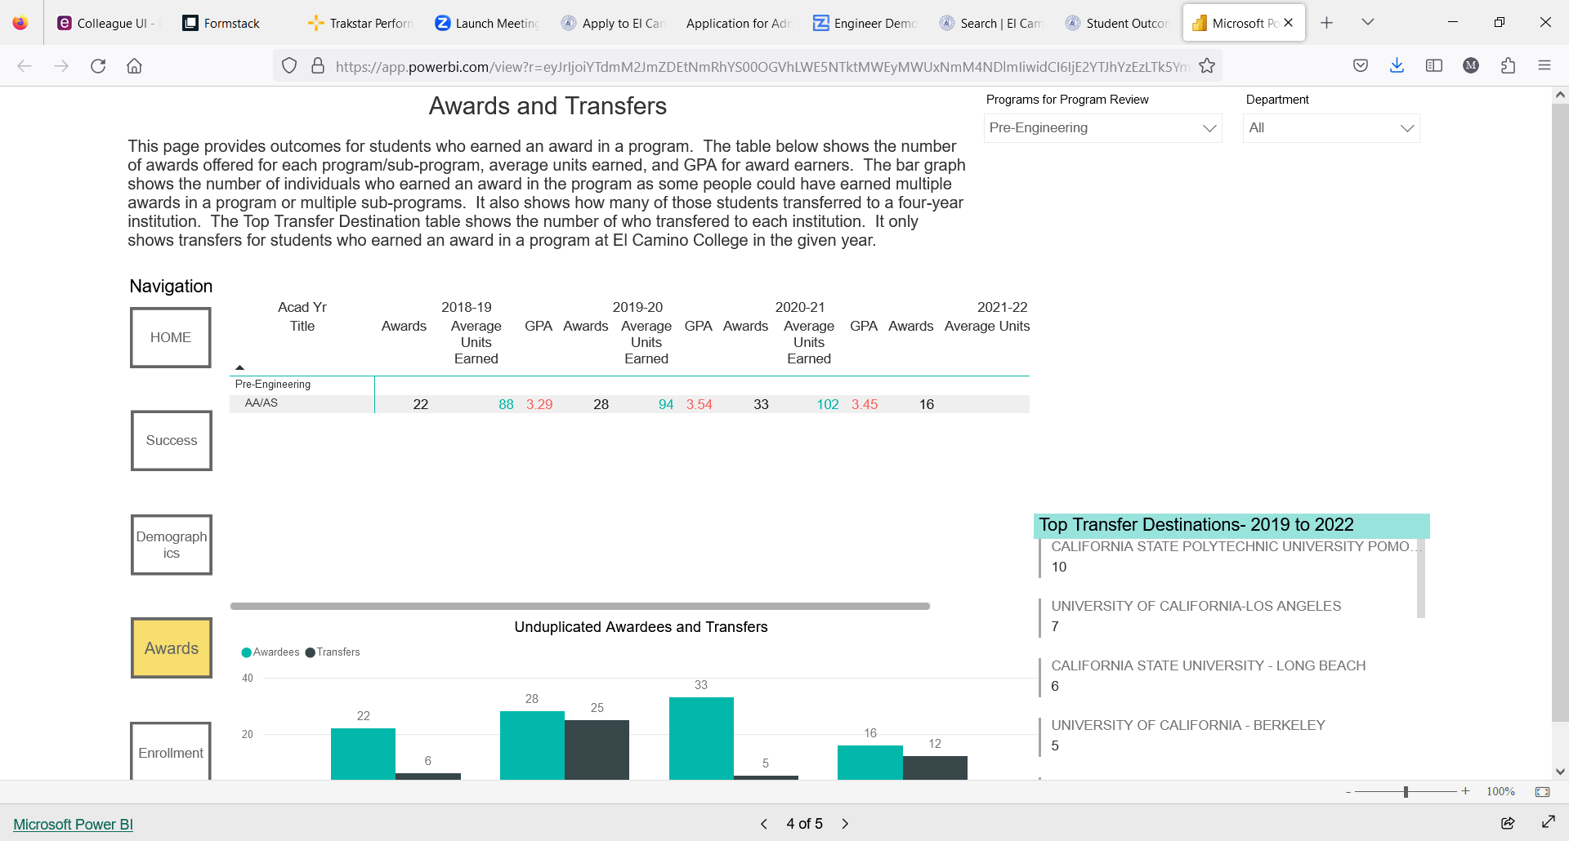

Pre-engineering students from 2018 to 2021 appear to complete an average of at least 88 units before transfer. According to the data, this average increased following the 2018-2019 academic year by 6 units (in 2019-2020) and 14 units (in 2020-2021). It is believed that pre-engineering students are double-majoring in mathematics, or the generic associate of science degree. The reason for mathematics is because both degrees require the same calculus sequence. Pre-engineering students may also be double-majoring in the general associate of science degree since all of the degree requirements for the pre-engineering degree also satisfy the general science associate’s degree.

1. ***Annual earnings:* Median annual income of alumni who attended the program under review (or the closest related sector)**



Median earnings for students attaining an associate’s degree in general engineering ranged between $25,000 and $35,000. The highest peak occurred in the 2014-2015 academic year with approximately $32,500. The trend appears to be relatively constant. This data suggest that the associate’s degree does not significantly give students a comfortable living wage after finishing just a two-year degree. Thus, students are encouraged to pursue even more higher learning.

1. ***Living Wage Attainment:* Percent of alumni who attended the program under review (or the closest related sector) and earn living wage**

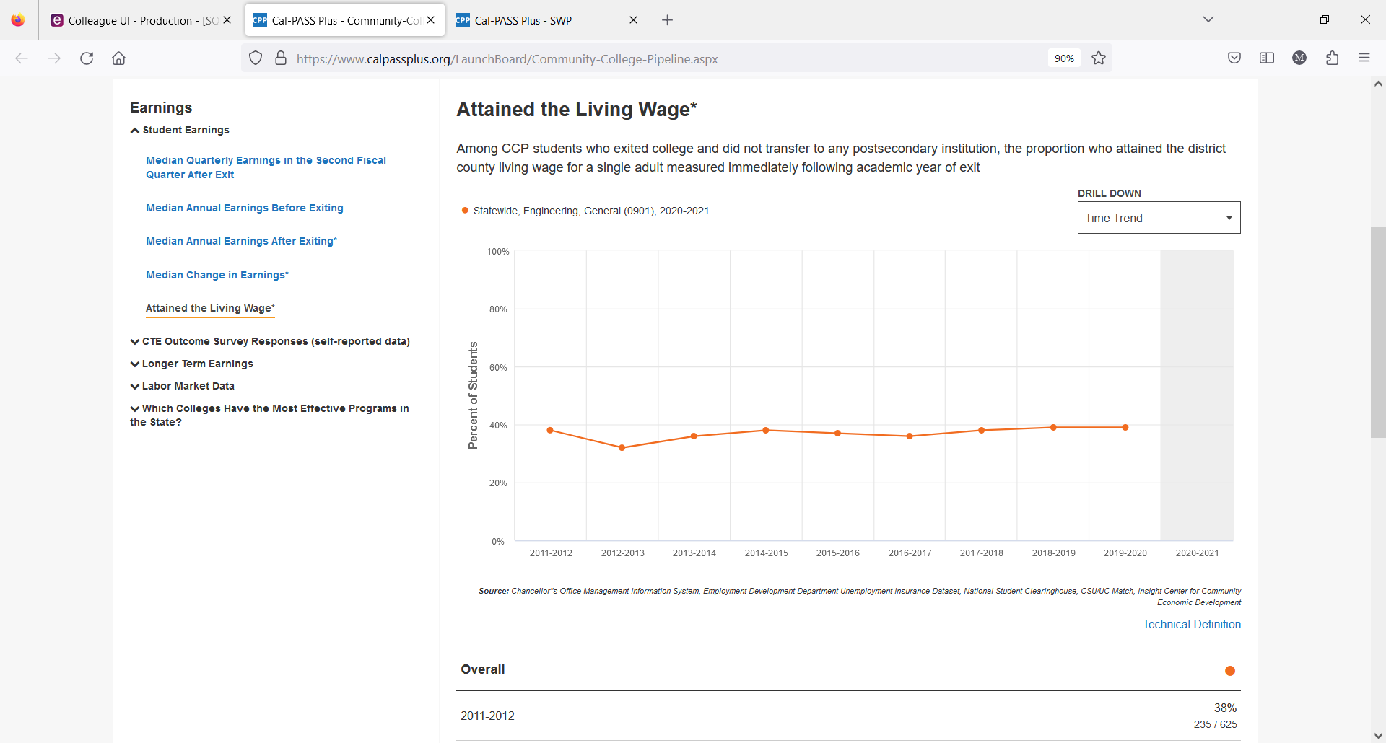

According to the data above, less than 40% of students completing an associate’s degree and not transferring to a baccalaureate program in engineering are about to attain a living wage. This concurs with the data from the previous section.

1. ***Job in Field of Study: P*ercent of alumni who pursued a career education path with a job related to their field of study.**

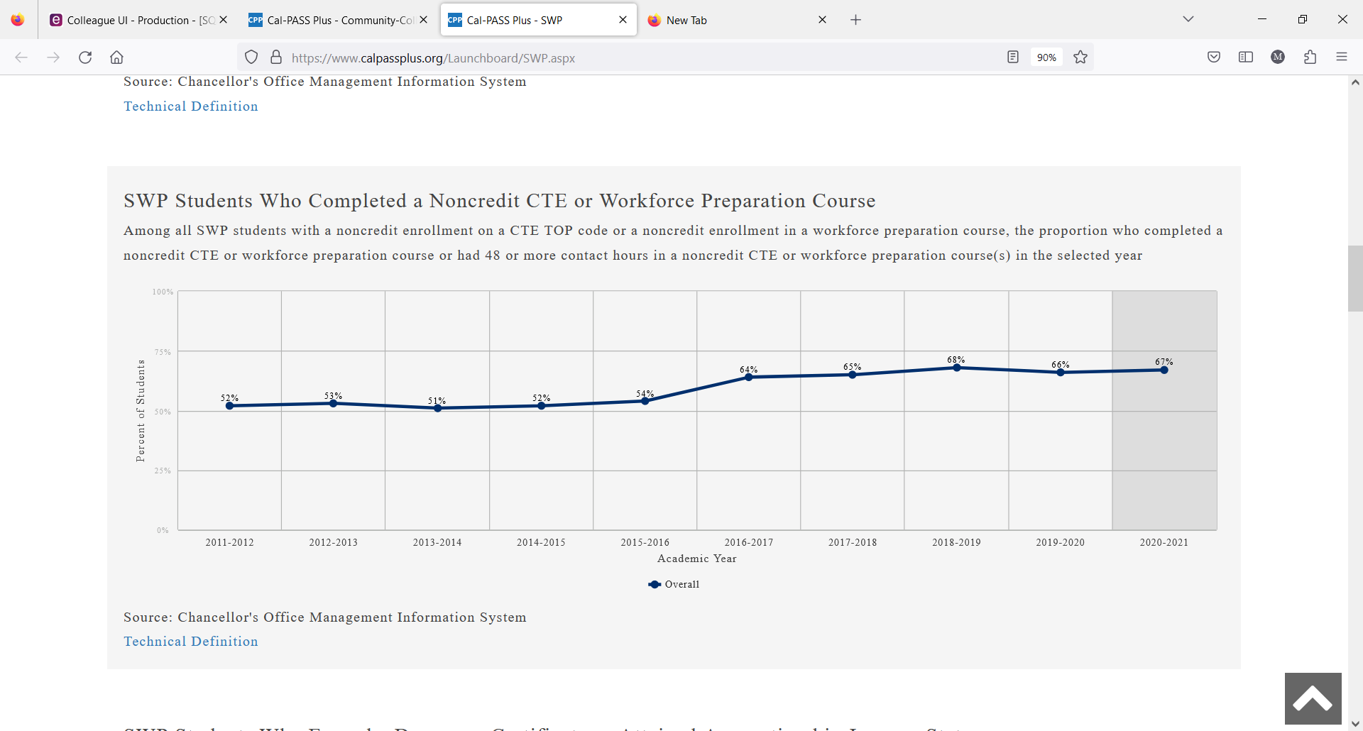

Student completing non-credit CTE or workforce preparation have increased from the 2011/2012 (52%) to the 2020/2021 (67%) academic years. The largest jump occurred after the 2015-2016 academic years where 64% of Strong Workforce Program alumni took advantage of this pathway.

# Curriculum and Outcomes Assessment

1. **Examine the program curriculum using an equity lens by responding to the following questions: To what extent does the curriculum:**

* **Prepare students to actively engage in a diverse society?**

There are several ways students are prepared for a diverse society in the Introduction to Engineering class.

* 1. *Critical Thinking*: Students are taught to think critically about their own cultural biases and assumptions, and to evaluate the validity of stereotypes and generalizations.
  2. *Diversity Lecture*: Students are provided information about different cultures, ethnicities, religions, and other forms of diversity done through classroom discussions, reading assignments, and multimedia resources.
  3. *Promote cultural exchange*: Students are encouraged to interact with people from different backgrounds by studying abroad.
  4. *Safe and inclusive classroom*: Classroom environment is welcoming and respectful of all students, regardless of their background.
* **Include multicultural content?**

Guest speakers from diverse backgrounds speak to the class about their experiences and perspectives. This provides students with valuable insights and help them understand different cultural perspectives. Discussions/assignments are given that explore diverse perspectives and experiences help students learn from each other and develop empathy and understanding. For example, an African American woman, who is also on our Engineering Advisory board, has spoken many times to students in Engr-1 class. Students ask questions about biases she faced during her thirty-five year career and how she addressed and overcame the biases.

* **Respond to diverse students’ learning needs?**

Diverse learning needs are met in various ways:

* Variety of instructional approaches are used to meet the needs of different learners, including visual and auditory learners by using multimedia resources, hands-on activities, and group discussions. Courses such as Engr-1, Engr-9 and Engr-10 do not have a lab component, therefore a well-developed makerspace can provide “visual support” to these theoretical classes that will enhance learning and success.
* Regular feedback is given to students on their progress and provide support and guidance for improvement. Hiring an engineering tutor can be beneficial in helping to improve student success rates.
* Assessment strategies to meet the needs of diverse learners, including those with disabilities or those who are English language learners. This includes providing extra time, and/or modifying tasks.
* Accommodations to support students with disabilities or special needs is provided. Students are typically given double time and other extra resources during exams and quizzes.

**Write about pedagogy.**

* **Encourage instructors and students to investigate their own views, biases and values and discuss multiple perspectives different from their own?**

Instructors can use inclusive language that welcomes and encourages diverse perspectives. Questions such as what are the different ways to explore this topic, or what are the different perspectives? Instructors should self-reflect their own biases, and sharing their assumptions. By doing so, students will feel more comfortable in sharing their biases. Instructors should assign readings and materials that represent diverse perspectives and experiences. This can help students broaden their understanding and challenge their assumptions. Instructors should set ground rules for respectful dialogue and model how to engage in constructive conversations with others who hold different views. For example, in the introduction to engineering a chapter specifically address implicit and explicit biases. Discussion is held in the class for students to explore their biases, and techniques shown to overcome the biases.

* **Use critical/equity-oriented pedagogy?**

Instructors should critically analyze the power dynamics that shape our society, including race, gender, class, and other forms of identity. Encourage students to question their own assumptions and biases and to recognize how their experiences may differ from others. They should help students connect what they are learning in class to real-world issues and problems. Encourage them to think about how they can use their knowledge and skills to create positive change in their communities. They should challenge students to question the status quo and to think critically about the issues and ideas presented in class. Encourage them to develop their own opinions and arguments, and to use evidence to support their claims. Using a variety of texts, materials, and media that represent a range of identities, experiences, and cultures. This can help students see beyond their own perspectives and develop empathy for others. In a discussion of biases, instructor lead a discussion of biases (high or low expectations) that students had faced in their academic careers. Instructor provided examples of biases that he had seen particularly against minorities and females.

* **Ensure creating an empowering classroom environment?**

By recognizing and celebrating student successes, both big and small. Use positive reinforcement to encourage students to continue making progress and taking risks in their learning. Creating a safe and supportive learning environment by addressing any disruptive behavior, providing emotional support for students, and promoting positive relationships among students. Empowering students to take ownership of their learning by providing opportunities for them to lead discussions, present projects, and share their perspectives. This can help students develop their leadership and communication skills.

* **Use multiple evaluation techniques sensitive to the diverse ways students can demonstrate understanding?**

In engineering curriculum, offering group projects and presentation are critical for several reasons:

* 1. Engineers will work with other engineers on projects.
  2. Engineers are prone to presentations to clients in the workforce.
  3. Because team projects are central to an engineer’s career, social skills are needed. This is done through group projects and presentation.

From an assessment and curriculum standpoint, projects and presentations are especially useful for students who may struggle with traditional forms of evaluation, such as written exams. By evaluating their own work and that of their peers, students can gain a deeper understanding of the material and develop important critical thinking and analytical skills. In Intro to Engineering class, students work in groups for the class project and give a presentation to the class at the end of the semester. Also, Engr-12 is hands-on laboratory class in which students help each other.

1. **Summarize SLO and PLO assessment results over the past four years for key/gateway courses. Gateway courses are determined by your department & division – contact your Dean. For your gateway courses, present the raw data (number of students who participated in each assessment, number of students who met the standard in each assessment, what success rate for each SLO was for each assessment). This data is in Nuventive. Contact your Division Facilitator and/or Campus SLO Coordinator for assistance.**

ENGR 1: Intro to Engineering

|  |  |  |
| --- | --- | --- |
| **SLO** | **Semester Assessed** | **Results** |
| SLO-1 | Spring 2022 | Except for 1 student, all students received 2 or more in this SLO.  Almost 90% showed complete understanding.  The reason for the high success is students do a project in which they see the preparation required to get an engineering degree.  Furthermore, many chapters talk about the practice, obligations and ethics in the engineering profession. |
| SLO-2 | Spring 2021 | Students were given this assignment with the following instructions:  Read chapter 3 for cognitive skills and chapters 1, 4 and 5 for academic success strategies. Half the grade was assigned for the cognitive skills, and other half for academic success strategies.   The average score for the cognitive skills was lower than the average score for the academic success strategies. Students provided good strategies to improve academic performance.    No student scored 0 or 1.  Sixteen students out of sixty one students score 2, forty-five students scored 3. |
| SLO-2 | Spring 2019 | Equal weights were given to each part of the question (50% Cognitive Skills, 50% Success).  As expected, almost everyone could provide very good examples of how to implement academic success strategies. This is mainly due to the fact that the whole concept and strategies are tangible and easy to understand.  On the other hand, what differentiates the students in their overall evaluation is their understanding of Bloom’s “Taxonomy of Educational Objectives”: Remembering, Understanding, Applying, Analyzing, Evaluating, Creating. The answers are sometimes very general and do not specifically point to a specific category.  Overall, the outcome of SLO was satisfactory. I believe that the given hint could lead the students into the right direction, so they had a good understanding of what the question is asking for. To improve the results for upcoming semesters, a more comprehensive discussion on Bloom’s “Taxonomy of Educational Objectives could be helpful.  From the 3 sections of Engineering 1 that were assessed, no students (0%) earned either a score of 0 or a score of 1. Scores of 0 or 1 correspond to students not being successful, while scores of 2 or 3 correspond to students being successful at this SLO. Out of a total of 58 students, 30 (52%) earned a score of 2 and 28 (48%) earned a score of 3. Thus, 100% of the students (all 58) scored 2 or 3 and therefore were successful at applying at assessing cognitive skills and applying success strategies related to the study of Engineering |

ENGR 9: Statics

|  |  |  |
| --- | --- | --- |
| **SLO** | **Semester Assessed** | **Results** |
| SLO-1 | Spring 2022 | Only 45% received 2 or more, 4 students left the question blank, and 8 students showed some understanding.**Number of Students who Participated in this Assessment**22  **Number of Students Who Successfully Met the Standard for this Assessment**10  **% of Success for this SLO**45 |
| SLO-2 | Spring 2019 | From the only section of Engineering 9 that was assessed, 2 students (9.5%) earned a score of 0 and 2 other students (9.5%) earned a score of 1. Scores of 0 or 1 correspond to students not being successful, while scores of 2 or 3 correspond to students being successful at this SLO. Out of a total of 21 students, 8 (43%) earned a score of 2 and 9 (43%) earned a score of 3. Thus, 81% of the students (17) scored 2 or 3 and therefore were successful at drawing diagrams and determining distributed forces, shear forces, and moments in beams. However, 4 students (17%) scored a 0 or 1 and were thus unsuccessful at this SLO. |
| SLO-2 | Spring 2021 | Approximately, 26 students took the assessment.  About 60% of the grade was assigned for the shear and moment method/equation, 40% of the grade was for drawing the diagrams, 2 students (8%) scored 1 for some understanding.  Four students score 2, and 20 students scored 3. |

1. **Discuss programmatic factors contributing to constant, increasing or decreasing trends in the results for SLO and PLO assessment within the previously examined courses. What do you see that is contributing to increasing, decreasing, or stable success in each SLO analyzed?**

**For the SLO-1 (for ENGR 1), the trend was improving.** The reason for the high success is students do a project in which they see the preparation required to get an engineering degree.  Furthermore, many chapters talk about the practice, obligations and ethics in the engineering profession.

**For the SLO-2 (for ENGR 1), results were stable.** As for the various intellectual skills mentioned in the cognitive domain, students could not provide very good examples.  Some were able to give extremely good examples of each of the various skills- remembering, understanding, applying…, creating.  However, these skills are mostly attained through experience.  With more examples in the class, students will be able to achieve better outcome for this part. Overall, the result was satisfactory.  A much greater discussion of Bloom’s taxonomy and a homework related to Bloom’s taxonomy will be helpful.

**For the SLO-1 (for ENGR 9), the trend was decreasing.** This was a challenging problem.  The way to improve the performance for this type of problem is the emphasize homework/quizzes with many concepts combined. Although faculty conducting this test did give them 20 minutes to solve the problem, a challenging problem like this requires more time.  An open notes may have helped. In the previous assessment it was part of take-home exam that had unlimited time. The decreasing trend may have been due to less time.

**For the SLO-2 (for ENGR 9),** The results were improved.  It was due to problems that were done in the class worksheet and in the homework.  The method and the diagrams were explained with both calculus and non-calculus methods.  Emphasis was placed on the diagrams during teaching

1. **Highlight equity gaps found in SLO and PLO assessment results among different groups of students.**

Data not available. For the Spring 2023 Engr-1 and 9 will use Canvas outcomes.

# SECTION 3 Program Vision and Future Planning

# Program Vision

1. **Describe the vision of the program for the next four years considering the assessment reported in the previous section, student groups that are underrepresented in the program’s field, and any relevant changes within the program field/industry. A vision statement describes the desired future state of the program.**

El Camino College will be known for the excellence of its engineering program, for both its academics and support services. All of the courses necessary or desirable to be taken prior to transfer will be offered. Information on transfer requirements will be easily available to all students. Free tutoring will be available for all engineering courses. There will be a dedicated space on campus where students in the various STEM fields can meet to work together and assist each other, both academically and personally. (Students often have similar difficulties to overcome, under preparation, difficult work/school/family responsibilities, etc., and can offer others advice and strategies that have worked for them.) Such a facility should have access to computers and printers.

The first of these is perhaps the easiest to achieve and is progressing well. Over time the college will increase its engineering course offerings, concentrating on those courses which will help the most students prepare for transfer to the schools most popular among our students. A reasonable goal might be to add a new course offering every two or three years. Despite the slowdown due to COVID-19 pandemic, the program has offered two new courses, Circuits (with a lab) and Dynamics.

Members of the Counseling faculty possess the information that engineering students need for transfer, but not all of the students avail themselves of this resource. Perhaps the faculties of Counseling and Engineering can work together to help get the information to the students. This would likely result in engineering students taking more engineering courses prior to transfer, thus increasing their likelihood of success. We are not certain of the best way to achieve this goal, but it is something to investigate.

It may be possible to introduce tutoring in engineering to El Camino in a manner similar to the mathematics tutoring offered in the Math Study Center, particularly since the two departments are part of the same division.

A Makerspace has been identified. Equipment for students to do engineering projects is needed, which will require funding.

# 

# Future Planning

**A) Based on the assessment reported in the previous section, develop program goals to be completed during the next four years in relation to:**

* **Adjusting the curriculum for coherence and alignment with students’ workforce needs**

Curriculum: Data analysis (by conducting surveys in classroom and talking to Industry experts), we have identified the gaps between what is being taught in the curriculum and the skills needed in the workforce. Our plan is to introduce Engineering Graphics (ENGR 15), Strength of Materials (ENGR 16) and Introduction to Material Science (ENGR 14/14L) in the next four years. Furthermore, curriculum for the courses will be aligned with workforce needs. For example, with the current national impetus towards in-house semiconductor processing will increase workforce needs. Material Science curriculum will incorporate topics in semiconductor manufacturing.

* **Advancing towards a more equitable program to close equity gaps among groups of students**

In order to close the equity gaps, our main goal is to provide targeted support to students who are most affected by the equity gaps. These students include students who are struggling within their first sequences of calculus or engineering. Targeted support will include additional academic support, counseling, mentorship, and tutoring. Our goal is to hire a dedicated engineering tutor. Furthermore, it is important to evaluate students’ progresses to determine if the interventions are working. Use data to monitor progress and adjust strategies as needed.

* **Clarifying students’ paths to completion, further education and employment**

A dedicated engineering counselor where students can get career guidance and counseling to help them identify their interests, strengths, and goals. This can help them choose a path that aligns with their interests and strengths. Map pathways to completion, further education, and employment for students. Show them the different options available to them, such as vocational training programs, apprenticeships, and college degree programs. Provide information on job opportunities and labor market trends to help students make informed decisions about their future careers. This information can include job projections, salary expectations, and required skills and qualifications.

* **Helping students explore options and build foundation skills**

In order for students to explore options, our goal is to connect students with alumni and industry professionals in their field of interest. This can help them build networks, learn about job opportunities, and gain insights into the industry.

Beginning in the 2023-2024 academic year, we plan to hold an Engineering Day for students. This day will involve participation of engineers from local companies covering several activities, including (but not limited to):

* *Resume workshops*- allowing students to meet with industry professionals to discuss how to professionally market their skills for internships or employment;
* *One-on-One Mentoring*- allowing students to be paired with engineers to discuss how to transition from the book bag to the briefcase;
* *Information Session*- opportunities for students to speak with academicians on what courses are important for success transfer into leading university baccalaureate programs; and
* *Testimonial Session*- allowing students to speak with alumni who have transitioned to the profession
* **Helping students stay on the path**

A dedicated *engineering-based* Makerspace will help students feel connected to their school and peers, which can increase their motivation and sense of belonging. By setting goals students will stay focused on their academic and career aspirations. Celebrate their achievements along the way and encourage them to persist through setbacks. Our goal is to start engineering awards similar to Math awards. A dedicated engineering counselor can offer career counseling and guidance to help students explore their interests and strengths and develop a plan for achieving their career goals. This can help students see the relevance of their coursework and stay motivated.

* **Integrating applied learning experiences**

Lab work in courses (such as Circuits and Material Science) provide students with applied learning experiences. Also, a Makerspace provides opportunities to conduct original research and apply their knowledge to real-world problems. This approach can help students build critical thinking, problem-solving, and research skills. Internships provide students with hands-on experience in their chosen field. They can help students build professional networks, gain practical skills, and explore potential career paths. Many job ads also specify hands-on projects in college as prerequisite for internships.

1. **What projects will the program complete to achieve the desired goals? Please specify at least two for each goal.**
2. Curriculum
   1. Introduce Engineering Graphics, Strength of Materials and Introduction to Material Science.
   2. Buy laboratory equipment for Materials Science Course.
3. Equitable Program
   1. Hire engineering tutor to provide targeted support.
4. Integrating Applied learning experience
   1. Buy equipment for Material Science course
   2. Buy equipment for project in Makerspace.
5. **When the next program review is due, how will the program determine if the goals have been met? Please specify at least one quantitative target or qualitative accomplishment for each goal.**

1. Number of courses developed for the Engineering department.

* Six engineering courses will be completed and offered in the college’s academic catalog by 2026.

2. A well-developed laboratory for Material Science.

* The course will operate with the laboratory in place.

3. By 2026, the MESA Center, Math Study Center will hire tutors specifically capable of tutoring all possible engineering courses.

* The goal is to have at least 2 advanced tutors since maintaining student tutors will be challenging for a two-year program.

4. Increase faculty in the Department of Engineering.

* Apply for engineering faculty via the hiring prioritization process annually; achieve one additional tenure-track engineering full-time faculty member by 2026.

# Program Resources

**In the following areas, what are the resources needed by the program to meet the goals for the next four years? Include any recommendations from the previous Program Review that are still active or on hold.**

**List resources in order of priority. Prioritize them within each category and/or develop an overall prioritized list of resources. Explain how these resources contribute to the** [**College’s equity goals**](https://www.elcamino.edu/about/depts/ir/docs/research/outcomes/Local%20Vision%20Goals%20Infographic%202017-18.pdf)**.**

**a) Staffing**

Given the development of several new courses in the engineering curriculum, the need for faculty will become greater. El Camino College’s faculty hiring prioritization process takes place during the fall semesters of each year. Approvals are determined before the end of that semester, and hiring begins in the spring for new faculty in the subsequent academic year.

Currently, there is only one full-time engineering faculty member in the department along with four dedicated part-time engineering faculty members. Based on scheduling needs as well as need to assist in program review and SLOs, there is a need to recruit 3 additional full-time faculty within the next five years. Starting the 2023-2024 academic year, bids will be placed by Division of Mathematical Sciences to recruit one full-time engineering faculty member per year to achieve this goal. Additional full-time faculty can assist in developing new courses that are not required but also help prepare students for workforce (a course in Digital Design, for example). Furthermore, additional faculty can develop projects for Maker Space which will motivate students to pursue engineering, thereby increasing enrollment in advanced engineering courses such Engr-9, 10, 11 and 12.

**b) Facilities and Equipment**

The ENGR 14/14L, 15, and 16 courses in development require our current state of engineering lab and classroom space (and equipment) to significantly improve. For example, the ENGR 14/14L course requires processing materials (hot and cold rolling) and measuring material properties (hardness, tension, compression, impact, fatigue, creep) using testing techniques. As mentioned earlier, without the equipment, the course cannot be offered or as our competitor colleges have seen that it fails to attracts students.

Below is just a sample of the equipment needed for measuring properties:

* *Hardness Tester*: This equipment is capable of performing both Rockwell and Vickers hardness tests. This particular model has a user-friendly interface, making it easier for students to use, and can perform tests on a wide range of materials, including metals, alloys, ceramics, and composites. Furthermore, this model has a high level of accuracy and repeatability, which are essential requirements for metallurgical testing.
* *Desktop Tensile Machine*: The equipment we are interested in is a [Insert Name and Model Number of the Desktop Tensile Machine], which is a compact and versatile testing system that can perform tensile and compression tests on various materials, including metals, plastics, composites, and textiles. This model has a user-friendly interface, making it easier for students to use, and can be used for testing a wide range of materials, from thin films to bulk materials.
* *Optical Microscope*: This is a research-grade upright microscope with 50x to 2000x magnification range to observe a wide range of materials; LED illumination with adjustable intensity to minimize heat generated by the microscope and provide consistent lighting; objective lenses with a minimum of 10x, 20x, 40x, and 100x magnification for high-quality imaging; a high-resolution digital camera to capture high-quality images and videos.

The table below provides a breakdown of all of the needed equipment, including estimated costs for essential versus optional equipment: Essential equipment is “minimum” equipment required to offer the class.

|  |  |  |
| --- | --- | --- |
| **Items & Purpose** | **Essential or Optional?** | **Cost** |
| *Brass, Steel and Copper Specimens*  Process the material for studying mechanical properties ($12 per strip, 30 strips × 4 semesters). | Essential | $1,440.00 |
| *Hardness Testers*  To test the strength/hardness of the metal before and after heat treatment. | Essential | $10,300 |
| *Furnace*  Heat and treat the metal specimens. | Essential | $4,600.00 |
| *Tensile Machine*  Study the stress strain curvers. | Optional | $60,000.00 |
| *Optical Microscope*  Study Microstructure before and after treatment | Essential | $7,250 |
| *Thermocouples $50 each, 10*  [ ] | Essential | $500 |
|  |  |  |
| **Total of Essential + Optional Supplies $84090**  **Total of Essential Supplies only $24090** |  |  |

**c) Technology/Software**

N/A

**d) Contracts/Services**

N/A

# APPENDIX A

# CAREER EDUCATION (CE) SUPPLEMENTAL QUESTIONS

*CE programs must conduct a full program review every 4 years. The comprehensive program review includes responses to the CE supplemental questions below. Every two years (once between full program reviews) these supplemental questions must be answered and submitted to Academic Affairs for posting on the College website.*

***Use labor market data, advisory committee input/feedback, and institutional and program-level data to respond to the following questions:***

**1. How strong is the occupational demand for the program?** In your response, describe any changes in demand over the past 5 years and discuss the occupational outlook for next five (5) years. Provide applicable labor market data (e.g., US Bureau of Labor Statistics, Employment Development Department) that address state and local needs.

**2. How does the program address needs that are not met by similar programs in the region?** In your response, identify any distinctive components of the program (e.g., curriculum, facilities, and resources) and/or describe any unique contributions the program or its students/graduates make to the community served.

**3. What are the completion, success, and employment rates for students in the program?** In your response, identify the standards set by the program and discuss any factors that may impact completion, success, and employment rates among students in the program. Describe the status of any action plans for maintaining/improving rates relative to such benchmarks.

**4. List any licensure/certification exam(s) required for entry into the workforce in the field of study and report the most recent pass rate(s) among program graduates.** In your response, identify any applicable performance benchmarks set by regulatory agencies and describe the status of any action plans for maintaining/improving pass rates relative to such benchmarks.

**5. Are the students satisfied with their preparation for employment? Are the employers in the field satisfied with the level of preparation of program graduates?** Use data from student surveys, employer surveys, and other sources of employment feedback to justify your response.

**6. Is the advisory committee satisfied with the level of preparation of program graduates? How has advisory committee input and feedback been used in the past two years to ensure employer needs are met by the program?** Describe the status and impact of any advisory committee recommendations.

California Education Code 78016 requires that the review process for CE programs includes the review and comments of a program’s advisory committee. **Provide the following information:**

a. Advisory committee membership list and credentials.

b. Meeting minutes or other documentation to demonstrate that the CE program review process has met the above Education Code requirement.