**El Camino Community College**

**PROGRAM REVIEW 2022-23**

**DIVISION OF MATHEMATICAL SCIENCES**

**DEPARTMENT OF COMPUTER SCIENCE**

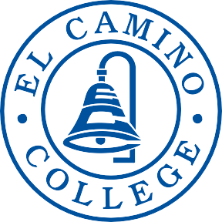

**DEAN:**

Marlow Lemons

**CONTRIBUTOR(S):**

Solomon Russell (chair)

Edwin Ambrosio

Satish Singhal

Rafael Diaz Valdovinos

Victor Matos

**TABLE OF CONTENTS**

**Contents**

SECTION 1 Program Overview 3

SECTION 2 Program Assessment 5

Program Contribution to Student Success and Equity 5

Curriculum and Outcomes Assessment 6

SECTION 3 Program Vision and Future Planning 8

Program Vision 8

Future Planning 8

Program Resources 9

Appendix A 10

CAREER EDUCATION (CE) SUPPLEMENTAL QUESTIONS 10

# SECTION 1 Program Overview

1. **Provide an abstract of what your program does, who you serve, your previous successes, and where your program is moving in the next four years. Highlight the most interesting, compelling aspects of your program – your recent achievements and needs.**

The El Camino Computer Science Department strives to provide students with the best educational opportunities to prepare them for technical careers and enrollment in four-year institutions. Over the past six years, we have created new pathways for students, innovative classes, and collaborations to fulfill our goals. Over the next four years, we plan to expand our offerings into new topics like data science and databases and host conferences for students to learn about computer science.

There are several compelling aspects of our program.

1. Our classes are purposefully structured, with laboratory and lecture time available to students with a professor present. This format allows us to offer rigorous courses with the necessary support for our students to develop.
2. We have the only student-run Association of Computing Machinery (ACM) community college chapter in Los Angeles County. We have made strides in several areas over the last six years.
3. We have expanded our high school dual enrollment.
4. We have focused on streamlining the attaining of four-year degrees by creating the Warrior-Toro program, a computer science pathway collaboration between El Camino and CSU Dominguez Hills.
5. We received two grants from the California Educational Learning Lab to make open educational resources (OER) assessment materials for students.
6. We have established new data science courses, becoming one of the first California community colleges to do so.

These achievements have been made despite having a high adjunct to full-time ratio and limited laboratory space for our classes.

1. **Describe the degrees and/or certificates offered by the program. Consider addressing what makes your program unique to the college and region.**

El Camino College students can earn a computer science certificate of achievement by taking 21 to 22 units of CS courses. The department has been approved to offer a new data science certificate of achievement with CSCI-8: foundations of data science and CSCI-9: The Principles of Data Science as required courses starting Fall 2023. This new certificate establishes El Camino College as a leader in data science programs at the southern California community college level. The department is currently working on creating an associates degree in Data Science in the next two years. The computer science department does not offer a computer science associate's degree since to offer one would require us to change the structure of our courses drastically. The department concludes that doing so would hinder our courses' effectiveness.

1. **Explain how the program fulfills the college’s mission. Address the work your program is doing to help the college fulfill its stated mission.**

*The mission of El Camino College is to make a positive difference in people’s lives by providing a comprehensive educational programs and services that promote student learning and success in collaboration with our diverse communities.*

The computer science program at El Camino College is a comprehensive program that prepares students for matriculation into four-year institutions and gives valuable skills and knowledge that are immediately useful in the workforce. The courses offered by the department spanned what you would see typically in the first two years of a bachelor's degree program and introductory non-major courses that have been prevalent in high school offerings. The department seeks to diversify the major through the Warrior-Toro program, increase student persistence, and reduce overall student time-to-degree. With the proposed new data science certificate, the department is looking to collaborate with other disciplines, including the communications and social sciences departments. In Spring 2023, the department was awarded a grant to offer professional development to non-CS faculty that are interested in adding data science components to their courses. The grant activities, funded by the California Educational Learning Lab, will begin in July 2023 and conclude in June 2026.

1. **Discuss the status of recommendations from your previous program review. In the “Notes/Comments” section, please discuss the known impact of a completed recommendation or the rationale for recommendations that are on active, on hold, and/or abandoned.**

*If more than ten recommendations were presented in the previous program review, expand the enumerated list below as needed.*

1. **Recommendation:** To upgrade the resources in the labs in a 3 year cycle plan.

**Status:** Active

**Notes/Comments:** Laptops were approved for upgrade in MBA 320 in 2022. However, those upgrades are planned to be completed in summer 2023. Two classrooms that computer science used for labs, MBA 120 and 220, were converted to traditional classrooms. As a result, the department has utilized mobile laptops carts for some of our programming laboratories. The department would benefit from having another hardwired lab similar to MBA 113.

1. **Recommendation:** To provide a productive Unix/Linux environment (alternative operating systems) we would need a web hosting site to allow students to have both on and off campus access to their accounts. Our IT department has vetoed allowing students to login to accounts running on campus hosts for security reasons. The cost for such a site would be $10-$15 per month. ($180 per year). For on campus access, replacing equipment costs $2740.

**Status:** Completed

**Notes/Comments:** ITS has installed two virtual UNIX/Linux servers which are currently being used for CSCI 40. This recommendation has been fulfilled.

1. **Recommendation:** To provide budgeting to allow faculty to explore newer technologies (Software and Hardware) in order to catch up with current technology and meet student demand. For courses that allow software development for those newer technologies. An example would be the purchase of iPads, at a cost of $600 to $800 each (total $3,600 to $4,800), for faculty with the intent of being able to fully explore the development of apps for such technology, and finally the ability to offer a course in that software development to our students.

**Status:** On Hold.

**Notes/Comments:** Faculty have yet to identify the technologies that would be required for purchase; instead, we have focused on open-source and free software alternatives.

1. **Recommendation:** To provide budgeting for a Macintosh Lab with 25 computers.

**Status:** On Hold.

**Notes/Comments:** Without the proper facility to host such a lab, this recommendation has not been fulfilled. IT does not possess the expertise to support a Macintosh lab. This is no longer a priority for the department.

1. **Recommendation:** To provide budgeting for faculty training and travel to sites for training on new technologies.

**Status:** Active

**Notes/Comments:** Training and travel to sites was delayed due to the pandemic, but is now picking up again with the resumption of conferences and training on location, in addition to virtually.

1. **Recommendation:** Hiring new full time faculty to meet our needs and potential growth based on section 3 data.

**Status:** Active

**Notes/Comments:** One full-time professor, Victor Matos, was hired in 2018. Two more full-time professors are slated to be hired in 2023. However, one full-time professor, Massoud Ghyam, retired in January 2023.

1. **Recommendation:** Creating new courses to accommodate re-training of displaced workers with required technology to compete in today’s job market.

**Status:** Active

**Notes/Comments:** Four new courses have been created and one reactivated to meet the needs of displaced workers. CSCI 7 (The Beauty of Computer Science Principles) aids in reaching out to students who are prospective computer science majors that are novices and interested in learning more about computer science in its entirety. CSCI 17 (Computer Programming in MATLAB) teaches students basic concepts and applications of MATLAB that are used in industry. CSCI 23 (Advanced Java Programming and the Android Operating System) was reactivated not only to teach advanced concepts in Java, but to incorporate development of applications in the native Android language that are currently relevant. Finally, two new data science courses (CSCI 8 - Foundations of Data Science and CSCI 9 - Practical Data Science) were developed to meet the burgeoning needs of data scientists in the industry. Each course has either UC or CSU transferability, with the exception of CSCI-9.

1. **Recommendation:** Budget for Lab aides in lab classes.

**Status:** On Hold

**Notes/Comments:** Lab aides have been added to lab classes where there are large lectures, especially for CSCI 1, one of our introductory courses in computer science.

1. **Recommendation:** Based on survey results in section 2 there is strong interest in computer science courses in mobile computing, cyber security and cloud computing.

**Status:** Active

**Notes/Comments:** As mentioned above, CSCI 23 was reactivated and modified to add mobile computing, specifically the development of native Android applications. Further courses are being discussed to meet further needs in mobile computing, as well as cybersecurity and cloud computing.

1. **Recommendation:** Establishing relationships with local CSUs for a seamless transfer program and articulating as many of our courses as possible.

**Status:** Completed

**Notes/Comments:** In 2020, the Warrior-Toro Pathway Cohort was developed between El Camino College and Cal State University, Dominguez Hills to provide a seamless transfer of computer science courses from the community college level to the four-year university level with the purpose of allowing students to graduate with their undergraduate degree in computer science in four years, as well as providing internships and a track to employment opportunities after graduation.

# SECTION 2 Program Assessment

# 

# Program Contribution to Student Success and Equity

1. **Degree Completion: Number/percent of students earning a program degree**

Currently, the CS department does not offer an associate degree in CS. However, a college initiative led by CS and MATH faculty is underway to establish a multi-departmental Data Science Associate Degree.

1. **Certificate Completion: Number/percent of students earning a program certificate**

The Computer Science department offers a program leading to a "Computer Science Achievement" certificate. It consists of a core sequence and elective courses totaling 21-22 units. The following is a description of the program.

Mandatory core: Computer Science 1, 2;  
Three electives from: Computer Science 3, 12, 14, 16, 23, 30, 40, Mathematics 210   
 At least 17 units must be taken at El Camino College. The minimum grade for each course is C.

Historical data indicates that only a small number of students choose to complete the certificate program. Therefore, we speculate that most of our students are interested in completing the main core CS courses and then transferring to a four-year university as soon as they are accepted. Figure 1 depicts the number of awardees and the total of each group that expressed an interest in continuing with further university-level education.

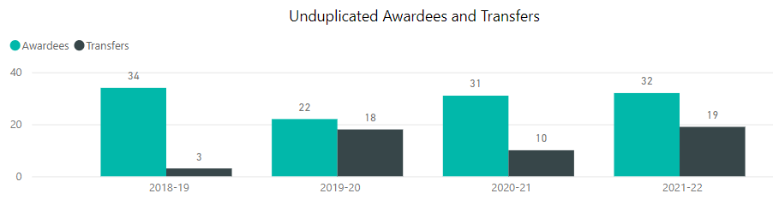

**Figure 1: CS Achievement Certificate Awards and University Transfers**

In the period 2018-2021, the CS1 Fall term enrollment consisted of 228, 278, 286, and 221 students, respectively. If one assumes that the size of an incoming class is defined by those registered in CSCI-1, then the number of awardees is relatively small (about 10%).

**Computer Science Students Educational Goals**

|  |  |  |  |  |  |  |  |  |  |  |
| --- | --- | --- | --- | --- | --- | --- | --- | --- | --- | --- |
|  | **Fall 2018** | | **Fall 2019** | | **Fall 2020** | | **Fall 2021** | | **Fall 2022** | |
|  | # | % | # | % | # | % | # | % | # | % |
| Intend to Transfer | 293 | 62.7 | 305 | 56.6 | 271 | 49.3 | 298 | 60.9 | 341 | 60.9 |
| Degree/Certif. Only | 7 | 1.5 | 10 | 1.9 | 15 | 2.7 | 20 | 4.1 | 16 | 2.9 |
| Retrain/recertif. | 10 | 2.1 | 4 | 0.7 | 6 | 1.1 | 8 | 1.6 | 11 | 2 |
| Basic Skills/GED | 39 | 8.4 | 35 | 6.5 | 39 | 7.1 | 31 | 6.3 | 43 | 7.7 |
| Enrichment | 24 | 5.1 | 39 | 7.2 | 29 | 5.3 | 36 | 7.4 | 37 | 6.6 |
| Undecided | 68 | 14.6 | 85 | 15.8 | 86 | 15.6 | 70 | 14.3 | 96 | 17.1 |
| Unknown | 26 | 5.6 | 61 | 11.3 | 104 | 18.9 | 26 | 5.3 | 16 | 2.9 |
| **Total** | **467** |  | **539** |  | **550** |  | **489** |  | **560** |  |

Table 2: Computer Science Students Educational Goals, fall semesters, 2018-22

Based on Table 2, the vast majority of students consider *transfer readiness* as their primary goal. That would be a reasonable explanation as to why so few decide to complete all the requirements for the CS-Achievements certificate. Perhaps, a survey should be used to begin collecting data on this issue. At least the following two questions should be asked; (1) Why did you choose CS at El Camino College? and (2) Why do you (or you do not) work toward a CS certification?

1. **Success rates (Discuss your program’s rates in light of the college’s success rate standard. Set a standard for your program.)**

Figure 3 illustrates the success rate of all the Computer Science courses combined. The program ranks at 64.2%, and the Institutional mark is 70.4%.

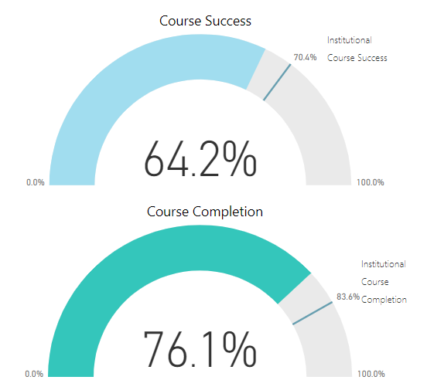

Figure 3. CS Course Success

Although the performance indicator is below the desired target, it should not be considered a failure. According to *Careerlinen* (2022), "even compared to other STEM disciplines, computer science majors seem to struggle the most when it comes to academic course load and maintaining good grades." Simply stated, the discipline is complex. In addition, computing knowledge is in an active state of evolution. Students constantly learn new concepts and theories that build upon one another. Consequently, it can be challenging to keep up with the material.

Figure 4 provides an overview of how the student body of the CS program is distributed. It shows the headcount of each of the thirteen CS courses tallied during the 2018-2021 period.

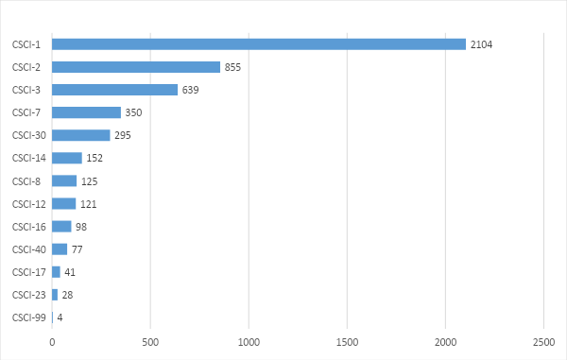

Figure 4. Headcount by Course 2018-2021

Please observe that most of our enrollment occurs around the core courses CSCI-1 and CSCI-2 (both use C++ language). This pair is followed by CSCI-3 where students are exposed to a second computer programming language (Java). CSCI-7 (The Beauty of Computer Science Principles) is a new entry in our curriculum, and Math and CS faculty jointly teach it. Our fourth most populated course CSCI-30 is a review of advanced programming features supported by the C++ language.

Figure 5 shows the success and retention rate of each course in the CS program. Instead of an annual breakdown, we have chosen to cluster all data items collected during the evaluation period. It is our belief that this is a better way of assessing the program's performance without being forced to speculate about the radical changes in instruction methodology employed during the year of the COVID pandemic.

|  |  |  |
| --- | --- | --- |
|  | Course Success | Course Completion |
| CSCI-1 | 57.9% | 73.6% |
| CSCI-2 | 66.7% | 73.9% |
| CSCI-3 | 77.9% | 85.9% |
| CSCI-7 | 87.1% | 89.4% |
| CSCI-8 | 75.5% | 67.2% |
| CSCI-12 | 60.3% | 83.5% |
| CSCI-14 | 57.9% | 75.0% |
| CSCI-16 | 75.5% | 82.7% |
| CSCI-17 | 78.0% | 82.9% |
| CSCI-23 | 85.7% | 85.7% |
| CSCI-30 | 72.9% | 80.0% |
| CSCI-40 | 85.7% | 92.2% |
| CSCI-99 | 100.0% | 100.0% |

Figure 5. 2018-2021 CS Course Success and Completion Rates

The study of the summary data leads to the following observations.

1. CSCI 1 is the course drawing the highest number of students to the CS program. Somestudents enroll in this course as a requirement of the CS major. However, others register for CSCI 1 to enhance their computing skills. Many see coding not as a core in their majors, but rather as an enabling skill that will facilitate further achievements in their fields. Many students attracted to computing are not aware of the rigorous nature of the discipline and lose interest as the coursework intensifies. A correction needs to be made to improve student retention and success in this critical course. Maintaining a small student-faculty ratio is critical for the success of our students. Small sections would offer an opportunity to work one-on-one, help those in need, and identify those who may require a transition to another computing path. We are considering the possibility of performing an early detection in CSCI-1 of students likely to fail. For those at-risk students, we recommend switching to a modified version of CSCI-14, targeted at non-computer science majors. The new version of CSCI-14 has no programming or math requirements and should begin in the third (or fourth) week of the semester.
2. Arguably, the material covered in CSCI-2 is the most challenging in any CS program. Here students are introduced to the design of custom data architectures for advanced programming. If the plan suggested in point 1 is applied, better-prepared students will arrive at CSCI-2 and be in a much better position to succeed. We hope this approach will improve the success rate of CSCI-2.
3. CSCI-3 is our third most populated course (after CSCI-1 and CSCI-2). We are pleased to see better performance indicators.
4. The new courses CSCI-7 (The Beauty of Computer Science Principles) and CSCI-8 (Foundations of Data Science) are part of the proposed Data Science degree program. The results obtained in both are very encouraging. We envision a sizable multi-disciplinary audience for the degree once it is approved.
5. We are concerned about the CSCI-12 and CSCI-14 courses. Both are attractive and practical computing subjects and should produce better results. We will apply an in-depth review of the courses and most likely introduce programmatic changes.
6. CSCI-12 is a complex class that prepares the participants to develop what in the industry is known as a "full-stack" solution to Internet-based applications. That means that students learn how to design a web application's user-side and server-side components. The course teaches various tools and technologies (HTML, CSS, JS, PHP, SQL). Perhaps the material should be spread into two semesters, or we could introduce a simpler framework supporting full-stack development.
7. CSCI-17 (Computer Programming in MATLAB) is a new course. It is open to CS students, but it primarily targets engineering majors. It surpasses the institutional mark of success and sustains a satisfactory retention rate.
8. CSCI-23 is a new course. It uses the Java programming language to create mobile applications running on the Android Operating System. The material introduced in the course provides students a significant competitive advantage with respect to other colleges and universities yet to incorporate this material in their curriculum. The indicators of success and completion are amongst the best in our program.

**Course Completion**

Figure 6 shows the CS program completion rate at 76.1%. This value is below the desired institutional mark of completion set at 83.6%



Figure 6. CS Program Completion Rate 2018-2021

Figure 7 illustrates the individual completion rates of CS courses.

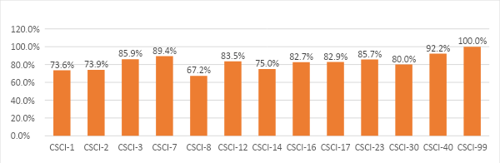

Figure 7. CS Course Completion 2018-1022

Please, observe that only three of our thirteen CS courses stand noticeably below the institutional 83.6% mark. Those are CSCI-1 (73.6%), CSCI-2 (73.9%), and CSCI-8 (67.2%). The case of CSCI-1 and CSCI-2 has been discussed in the previous section. Arguably, they are very challenging courses with rich and complex content, and many students struggle with the material. To address these specific course completion issues, the department has emphasized the importance of our CSCI-7 course to students and counselors. This course is designed to act as a bridge between CS interested students and traditional CS courses; increased enrollment in CSCI-7 should better serve incoming CSCI-1 students.

CSCI-8 is a different case. This is a new entry introduced during the crisis of the COVID pandemic. The course introduces descriptive analytics, where students learn techniques to summarize large datasets so they can answer questions explaining what happened in the observed samples. The recorded success and completion marks received in the two offerings of CSCI-8 are abnormal for the program. We are still determining what happened.

**Success Rates by Gender**

The female population of the CS program stands at 30.9%. Figure 8 and Figure 9 illustrate success/retention rates by gender. Notice that charts reflect the results collected during Fall 2018-2021. The data shows that female CS students are generally more engaged and tend to outperform their male students, sometimes by a significant margin. Female students are also more prone to remain in the program than male students. The only observed exception occurred in the 2020 Fall term, corresponding to the COVID pandemic's highest point.

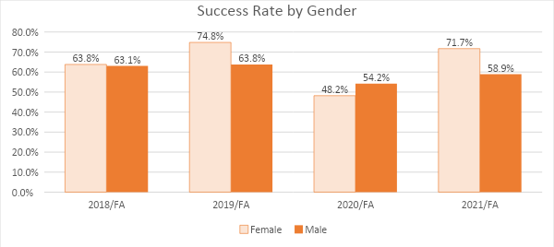

Figure 8. Success Rates by Gender

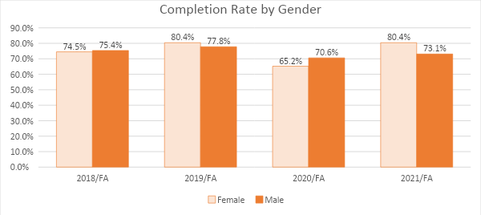

Figure 9. Completion Rate by Gender

For instance, consider the 2021/Fall semester. Female students were more successful than their male peers by almost a 13% margin; in the same period, 7.3% more female students completed their courses.

Our results are consistent with the national trend suggesting that the percentage of female graduates with core STEM degrees is steadily growing. However, according to (STEMWomen 2022), the USA split is just 26%. These numbers show that more work needs to be done to encourage women to study these subjects and transition into the workforce.

**Success Rates by Ethnicity**

Figure 10 shows the CS student body breakdown by Race/Ethnicity. This census data was updated each Fall term during the cycle 2018-2021. Please observe that most of our students are Hispanic, Asian, and White, representing about 75% of our enrollment.

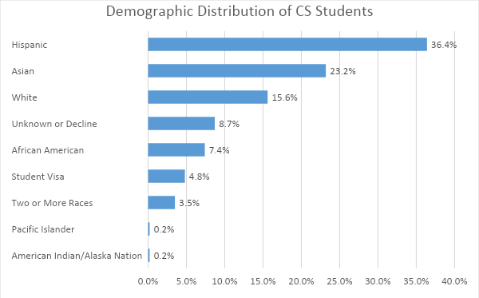

Figure 10. Proportions of the CS Student Population by Race/Ethnicity

Figure 11 depicts the 2018-20221 accumulative success rate of our students by ethnicity. Here, we will discuss groups having more than ten students. The highlighted sectors indicate areas of concern, that is, groups that achieve at a rate near 50% or less. African-Americans and Latinos fall into this category.

|  |  |  |  |
| --- | --- | --- | --- |
| Race/Ethnicity | Enrollment | Success Rate | Completion Rate |
| American Indian | < 10 |  |  |
| Asian | 688 | 70.2% | 79.4% |
| Black or African American | 138 | 50.7% | 69.6% |
| Hawaiian/Pacific Islander | < 10 | 28.6% | 71.4% |
| Latino | 849 | 50.4% | 68.4% |
| Two or More Races | 115 | 70.4% | 78.3% |
| Unknown or Decline | 59 | 64.4% | 84.7% |
| White | 355 | 67.6% | 77.5% |

Figure 11. Success and Retention Rates by Ethnicity – Fall Semesters 2018-2021

These groups' success rates were notably lower than the other two major groups, Asian and White. As a result, the department is committed to addressing this equity issue. Some solutions include promoting a more active engagement with special programs such as MESA, the Tutoring Center, and joining student organizations such as the ACM Student Club. Inside the department, our efforts in running the Warrior-Toro program is to increase retention and success, especially among traditionally underrepresented minorities in STEM.

1. **Completion rates and the Impact of Online Transition due to Covid-19 Pandemic**

This section will use metrics collected for our two leading core courses, CSCI-1 and CSCI-2. The goal is to see with a finer degree of granularity changes in enrollment and whether the COVID pandemic has changed the growing trend of the program. To provide context for this analysis, Figures 11 and 12 depict the Fall term enrollment count for the two selected CS courses.

|  |  |
| --- | --- |
|  |  |
| Figure 12. CSCI-1 Enrollment Fall Terms | Figure 13. CSCI-2 Enrollment Fall Terms |

We observe that CSCI-1 experienced a decline in enrollment during the 2020 and 2021 Fall semesters. This fact is critical as the course is the entry port for fresh students in the program. Interestingly, CSCI-2 remained relatively steady in the same period despite the pandemic.

In Figure 13, we observe that although the retention indicator of CSCI-1 was relatively high, its success rate notably declined during the pandemic to a level of grave concern. In addition, our instructional methodology changed to mostly online delivery during this period. One may speculate that this instructional change negatively impacted students taking a CS course for the first time.

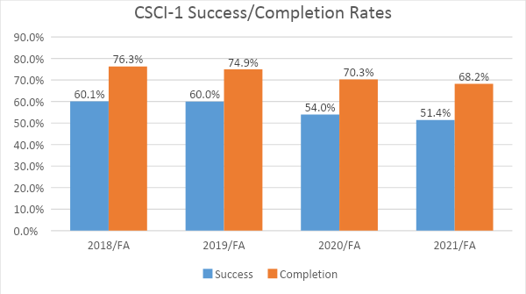

Figure 14. 2018-2021 CSCI-1 Success and Retention Rates

An interesting situation is shown in Figure 15. Here we observe that students taking their second CS course remained more engaged with the class and were more successful than their CSCI-1 classmates. This situation may be explained as a consequence of our students being more mature and having a better understanding of the self-instructing nature of computing.

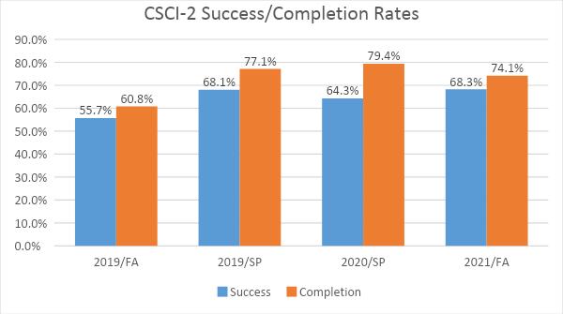

Figure 15. 2018-2021 CSCI-2 Success and Retention Rates

1. **A comparison of success and retention rates in face-to-face classes with distance education classes**.

Figure 16 shows that on-campus learning significantly outperformed the online option.

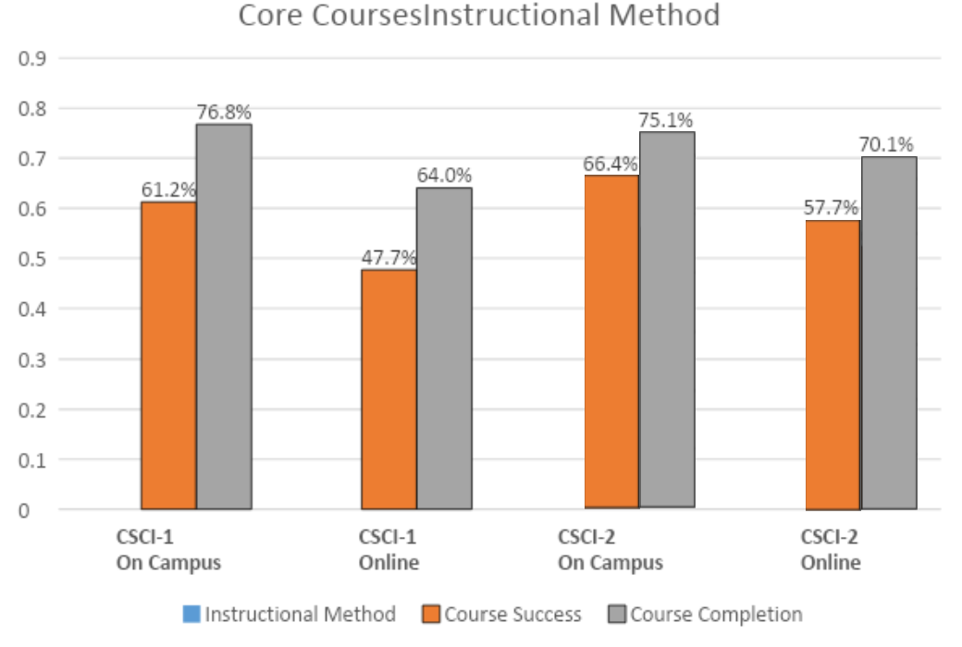

Figure 16. Success/Retention Rates of Course CS courses by Instructional Method

Figure 16 shows that on-campus learning outperformed the equivalent online option significantly. For instance, the online sections of CSCI-1 were 13.5% less successful than the face-to-face sections, and CSCI-2 online was 8.7% below the on-campus courses. Retention rates were also in favor of the on-campus mode. For instance, CSCI-1 online had a 12.8% higher desertion rate than the on-campus courses. However, the decline is smaller for CSCI-2, where on-campus is better than online learning by 5%. These numbers suggest that on-campus instruction is generally better for our student's success. However, some students have expressed their interest in more online courses.

We may raise some topics regarding this subject.

1. The pandemic was extraordinarily stressful and profoundly impacted our community and the rest of the world.
2. We, faculty and students, were not ready for the sudden transition to online-only learning. One must take into account that not all CS courses had a distance education version, not all faculty members were trained for online teaching mode, and most students had never had any previous experience with distance learning.
3. The early online instructional material used during the time of the pandemic could have been of better quality.
4. The online nature of learning opened the door to the vast masses of Internet available material. As an unwanted consequence, severe cases of academic misconduct were observed. Many incidents of cheating and plagiarism were reported alleging the use of unreferenced online material and even the use of paid solutions.
5. We are expecting college-level recommendations on how to better deal with cases of academic integrity violation.

**Analysis of Enrollment and Fill Rate Percentage**

In the last eight years, CS enrollment has been steadily growing. Even during the pandemic, the number of CS students continued to climb. Figure 17 summarizes the 2018-2021 enrollment count. This growth is consistent with the national trend for first-year college students signing up for computer science courses.

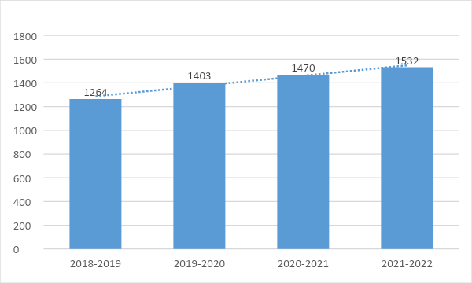

Figure 17. 2018-2021 CS Enrollment Count

We are very optimistic about the program's direction since there is a renewed national interest in Computer Science not seen since the boom days of the year 2000. The program is serving an increasing student base, and we expect this growth to continue in future years.

It is worth noting the observations reported by The National Academies Press (NA, 2017). Those results are relevant to us as we strive to transfer students to those institutions. Here are some of their findings,

* The number of bachelor’s degrees awarded nationally in computer and information science has increased by 74% at not-for-profit institutions since 2009, compared to a 16 percent increase in bachelor’s degrees produced overall. Assuming no artificial limits are imposed, the number of students attaining computer science bachelor’s degrees will likely rise sharply for at least the next several years.
* The increasing demand for computer science courses is not limited to those majoring in the field, the report says; interest in these courses has grown at a similar rate among non-majors, reflecting the increasing importance of computing skills across occupational fields and in daily life. As they make their plans, colleges and universities should be strategic and consider the role of computing across the institution and for the long term.
* Rising enrollments are straining program resources at many institutions, the report says. The most common challenges cited by departments include increased faculty workload; too few faculty, instructors, or teaching assistants; greater need for academic undergraduate advisers and administrative support; and increased need for classroom, lab, and office space.

Figure 18 shows the CS fill rate percentages for the evaluation period. The rate started to decline in 2020. However, these figures are only partially reliable and do not coincide with the statistical model used before (including only students who received grades at the end of the semester). The reason is that during the upset of the Covid-19 pandemic, the school facilitated the transition to online instruction. This transition (which occurred after the census) ultimately led to students being permitted to withdraw without receiving a grade at the beginning of the pandemic (an 'emergency withdrawal').

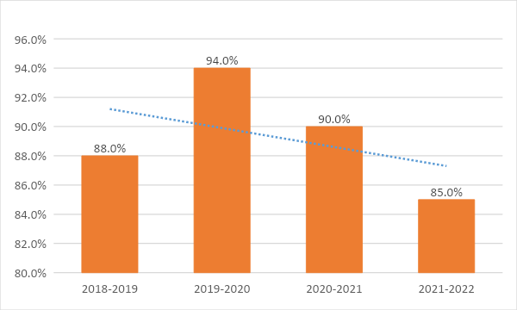

Figure 18. 2018-2021 CS Fill Rates

1. ***Grade Distribution:* Percentage of students in a course receiving each of the possible grades that can be awarded**

Table 19 (below) shows the grade distribution for students enrolled in CS courses for the four academic years of the evaluation period Fall 2018 to Spring 2021. Figure 20 shows the average grade distribution for all CS courses for the current (2018-2021) and previous (2014-2018) assessment cycles.

|  |  |  |  |  |  |  |  |  |  |  |
| --- | --- | --- | --- | --- | --- | --- | --- | --- | --- | --- |
| Course | A | B | C | D | F | Pass | No Pass | W | Total | Success |
| CSCI-1 | 30.9% | 16.3% | 10.7% | 4.2% | 11.4% | 0.0% | 0.1% | 26.4% | 2104 | 57.9% |
| CSCI-2 | 34.0% | 20.1% | 10.2% | 2.3% | 6.5% | 0.5% | 0.2% | 26.1% | 855 | 66.7% |
| CSCI-3 | 47.6% | 24.1% | 6.3% | 3.1% | 4.7% | 0.2% | 0.0% | 14.1% | 639 | 77.9% |
| CSCI-7 | 45.1% | 25.1% | 9.1% | 2.9% | 7.1% | 0.0% | 0.0% | 10.6% | 350 | 87.1% |
| CSCI-8 | 28.8% | 18.4% | 12.0% | 1.6% | 6.4% | 0.0% | 0.0% | 32.8% | 125 | 75.5% |
| CSCI-12 | 38.8% | 14.0% | 7.4% | 6.6% | 16.5% | 0.0% | 0.0% | 16.5% | 121 | 60.3% |
| CSCI-14 | 32.9% | 17.1% | 7.9% | 5.3% | 10.5% | 1.3% | 0.0% | 25.0% | 152 | 57.9% |
| CSCI-16 | 29.6% | 27.6% | 18.4% | 4.1% | 3.1% | 0.0% | 0.0% | 17.3% | 98 | 75.5% |
| CSCI_17 | 73.2% | 4.9% | 0.0% | 0.0% | 4.9% | 0.0% | 0.0% | 17.1% | 41 | 78.0% |
| CSCI-23 | 60.7% | 25.0% | 0.0% | 0.0% | 0.0% | 0.0% | 0.0% | 14.3% | 28 | 85.7% |
| CSCI-30 | 42.4% | 19.3% | 11.2% | 1.7% | 5.1% | 0.3% | 0.0% | 20.0% | 295 | 72.9% |
| CSCI-40 | 53.2% | 16.9% | 15.6% | 2.6% | 3.9% | 0.0% | 0.0% | 7.8% | 77 | 85.7% |
| CSCI-99 | 100.0% | 0.0% | 0.0% | 0.0% | 0.0% | 0.0% | 0.0% | 0.0% | 4 | 100.0% |

Table 19. Letter Grade Distribution of CS Courses during 2018-2021

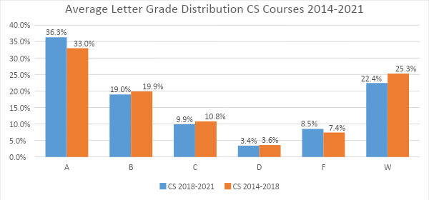

Figure 20. 2018-2021 Average Grade Distribution of CS Courses

Some observations follow.

1. The grade distribution of the two evaluation periods is virtually the same, although the 2014-2018 cycle is slightly better by just a slim margin. This result is surprising, considering the dramatic impact of having to move all our courses to a distance learning mode during the pick of the Covid-19 pandemic.
2. The withdrawal rate of CS courses for 2018-2021 is only 2.9% higher than in the previous evaluation.
3. In general, students' success increases as they complete the core and continue to take more advanced CS courses. For instance, CSCI-3 is usually taken immediately after CSCI-1 (commonly in parallel with CSCI-2); its success rate is 77.9%. With the only exception of CSCI-12 and CSCI-14, all the advanced CS courses exhibit a sensible success ratio stretching between 72.9% to 87.5%.
4. Before the Covid-19 pandemic, CSCI-12 was the only online course offered by the CS department. Its grades have a pronounced bi-modal distribution as they are either very good or very poor. This course has the highest rate of D and F grades in the CS curriculum. Again, the course is listed for review.
5. CSCI-14 has a poor success rate only comparable to that of CSCI-1. We need to investigate how to improve this situation. As indicated earlier, the course is listed for curriculum review.
6. ***Course* Su*ccess:* Percentage of students enrolled at census who complete the course with a grade of A, B, C, or P**

Table 21 summarizes the computer science course success and completion rates for courses from Summer 2018 to Spring 2022.

|  |  |  |  |  |  |  |  |  |  |  |  |  |  |  |  |  |  |  |  |  |  |  |  |  |  |  |  |  |  |  |  |  |  |  |  |  |  |  |  |  |  |  |  |  |  |  |  |  |  |  |  |  |  |  |  |  |  |  |  |  |  |  |  |  |  |  |  |  |  |  |  |  |  |  |  |  |  |  |  |  |  |  |  |  |  |  |  |  |  |  |  |  |  |  |  |  |  |  |  |  |  |  |  |  |  |  |  |  |  |  |  |  |  |  |  |  |  |  |  |  |  |  |  |  |  |  |  |  |  |  |  |  |  |  |  |  |  |  |  |  |  |  |  |  |  |  |  |  |  |  |  |  |  |  |  |  |  |  |  |  |  |  |  |  |  |  |  |  |  |  |  |  |  |  |  |  |  |  |  |  |
| --- | --- | --- | --- | --- | --- | --- | --- | --- | --- | --- | --- | --- | --- | --- | --- | --- | --- | --- | --- | --- | --- | --- | --- | --- | --- | --- | --- | --- | --- | --- | --- | --- | --- | --- | --- | --- | --- | --- | --- | --- | --- | --- | --- | --- | --- | --- | --- | --- | --- | --- | --- | --- | --- | --- | --- | --- | --- | --- | --- | --- | --- | --- | --- | --- | --- | --- | --- | --- | --- | --- | --- | --- | --- | --- | --- | --- | --- | --- | --- | --- | --- | --- | --- | --- | --- | --- | --- | --- | --- | --- | --- | --- | --- | --- | --- | --- | --- | --- | --- | --- | --- | --- | --- | --- | --- | --- | --- | --- | --- | --- | --- | --- | --- | --- | --- | --- | --- | --- | --- | --- | --- | --- | --- | --- | --- | --- | --- | --- | --- | --- | --- | --- | --- | --- | --- | --- | --- | --- | --- | --- | --- | --- | --- | --- | --- | --- | --- | --- | --- | --- | --- | --- | --- | --- | --- | --- | --- | --- | --- | --- | --- | --- | --- | --- | --- | --- | --- | --- | --- | --- | --- | --- | --- | --- | --- | --- | --- | --- | --- | --- |
| Table 21   |  |  |  |  |  |  |  |  |  |  |  |  | | --- | --- | --- | --- | --- | --- | --- | --- | --- | --- | --- | --- | | **Course** | **A** | **B** | **C** | **D** | **F** | **Pass** | **No Pass** | **W** | **Total** | **Course Success** | **Course Completion** | | **CSCI-1** | 650 | 342 | 226 | 89 | 239 | 1 | 2 | 555 | 2104 | 57.94% | 73.62% | | **CSCI-12** | 47 | 17 | 9 | 8 | 20 | 0 | 0 | 20 | 121 | 60.33% | 83.47% | | **CSCI-14** | 50 | 26 | 12 | 8 | 16 | 2 | 0 | 38 | 152 | 59.21% | 75.00% | | **CSCI-16** | 29 | 27 | 18 | 4 | 3 | 0 | 0 | 17 | 98 | 75.51% | 82.65% | | **CSCI-17** | 30 | 2 | 0 | 0 | 2 | 0 | 0 | 7 | 41 | 78.05% | 82.93% | | **CSCI-2** | 291 | 172 | 87 | 20 | 56 | 4 | 2 | 223 | 855 | 64.80% | 73.92% | | **CSCI-23** | 17 | 7 | 0 | 0 | 0 | 0 | 0 | 4 | 28 | 85.71% | 85.71% | | **CSCI-3** | 274 | 144 | 39 | 20 | 26 | 1 | 0 | 82 | 586 | 78.16% | 86.01% | | **CSCI-30** | 125 | 57 | 33 | 5 | 15 | 1 | 0 | 59 | 295 | 73.22% | 80.00% | | **CSCI-40** | 41 | 13 | 12 | 2 | 3 | 0 | 0 | 6 | 77 | 85.71% | 92.21% | | **CSCI-7** | 158 | 88 | 32 | 10 | 25 | 0 | 0 | 37 | 350 | 79.43% | 89.43% | | **CSCI-8** | 36 | 23 | 15 | 2 | 8 | 0 | 0 | 41 | 125 | 59.20% | 67.20% | | **CSCI-99** | 4 | 0 | 0 | 0 | 0 | 0 | 0 | 0 | 4 | 100.00% | 100.00% | | **Total** | 1752 | 918 | 483 | 168 | 413 | 9 | 4 | 1089 | 4836 | 65.38% | 77.48% | |

Our largest course, CSCI-1, is also the course with the lowest course success rates. This is the first course that many computer science interested students enroll in. The departmental standard and target for course success is 70%. As mentioned before, promoting CSCI-7 to students may serve as a way of better preparing students for success in later coursework. The success rates generally increase with the expected progressions of courses. The courses with the highest success rates, excluding CSCI-99 (the independent study course), are CSCI-40 and CSCI-23, each at 85.71%. CSCI-40 has no prerequisite but is often taken by students that have already taken other CS courses. CSCI-23 is an advanced course in Java programming where students have taken a minimum of two CS courses to enroll.

1. ***Unit Accumulation:* Number of units accumulated by students working towards a program degree/certificate. Discuss whether students who take units beyond the requirements for their educational goals serve educational purposes or not. Focus on general trends, not on particular courses within the program.**

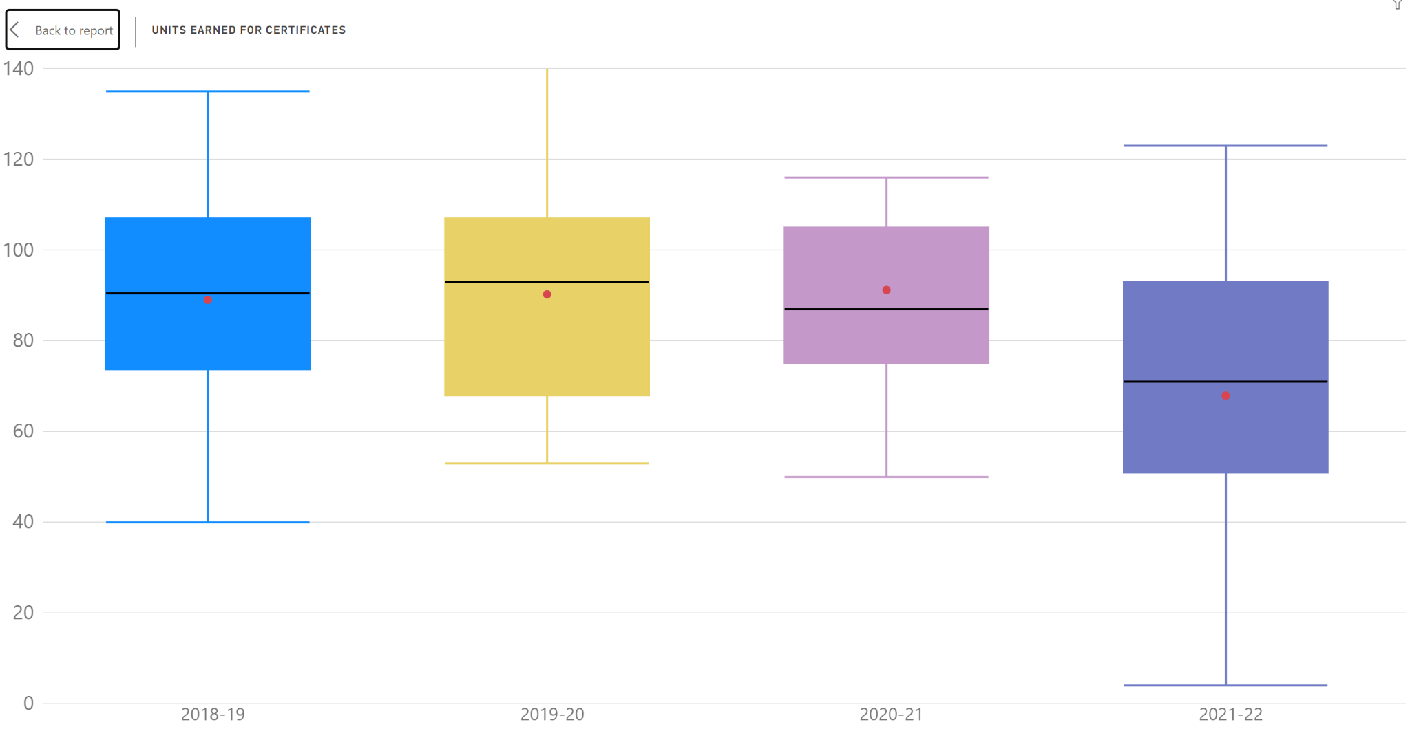

**Figure 22: CS student credit accumulation boxplot**

The data covering the last four years include those semesters during the pandemic (Figure 22). Therefore, the academic year 2021-22 may not give usable insights. In the academic years 2018-2021, the average number of units accumulated yearly is around 90. This is due to the large number of classes required for computer science majors and also because most of our courses are four units due to the additional laboratory requirements.

1. ***Annual earnings:* Median annual income of alumni who attended the program under review (or the closest related sector)**

According to the Chancellor's Community College pipeline dashboard, students at El Camino College who took credit or noncredit CS courses in 2019-20 had a median earning of $25,820. In the 2017-18 data, 37% attained a living wage, and 46% were employed two semesters after exit. Based on this data, the department must continue exploring curricula that meet computing students' changing needs. According to the Los Angeles/Orange County Center of Excellence for Labor Market Research (COE) for the middle-skill computer programming related occupations, typical entry-level hourly wages are in a range between $22.84 and $26.93 ($47,507 to $56,014 annually). For the above middle-skill computer programming occupations, typical entry-level hourly wages are in a range between $40.31 and $49.35 ($83,844 to $102,648 annually). Experienced workers can expect to earn wages between $40.31 and $71.65 ($83,844 to $149,032 annually), which are higher than the self-sufficiency standard.

1. ***Living Wage Attainment:* Percent of alumni who attended the program under review (or the closest related sector) and earn living wage**

At present, the college doesn’t keep track of alumni once they leave the program so we are unable to give exact data. However, according to the the Los Angeles/Orange County Center of Excellence for Labor Market Research (COE) state that the occupations related to computer programming have entry-level wages above the self-sufficiency standard wage for one adult ($18.10 in Los Angeles County).

***k) Job in Field of Study: P*ercent of alumni who pursued a career education path with a job related to their field of study.**

At present, the college doesn’t keep track of alumni once they leave the program so we are unable to give exact data.

# Curriculum and Outcomes Assessment

1. **Examine the program curriculum using an equity lens by responding to the following questions: To what extent does the curriculum:**

* **Prepare students to actively engage in a diverse society?**
* **Include multicultural content?**
* **Respond to diverse students’ learning needs?**
* **Encourage instructors and students to investigate their own views, biases and values and discuss multiple perspectives different from their own?**
* **Use critical/equity-oriented pedagogy?**
* **Ensure creating an empowering classroom environment?**
* **Use multiple evaluation techniques sensitive to the diverse ways students can demonstrate understanding?**

The computer science curriculum responds to the diverse students’ learning needs through the varied use of technology and the different forms of learning, from hands-on development in labs to demonstrations of working examples in lecture. In addition, pair programming where students work together to solve problems, as well as group projects, foster collaboration that encourages students to investigate their own views and discuss multiple perspectives different from their own with respect to problem solving and critical thinking. Multiple evaluation techniques, from examinations to project-based learning to discussion responses provide students with a diverse set of ways to demonstrate understanding of computer science concepts.

1. **Summarize SLO and PLO assessment results over the past four years for key/gateway courses. Gateway courses are determined by your department & division – contact your Dean. For your gateway courses, present the raw data (number of students who participated in each assessment, number of students who met the standard in each assessment, what success rate for each SLO was for each assessment). This data is in Nuventive. Contact your Division Facilitator and/or Campus SLO Coordinator for assistance.**

The program learning outcomes (PLOs) have been met by the department in two of the last four assessments. Specifically, the last two PLO assessments, which have occurred during varying levels of COVID restrictions, have had approximately half of our courses meet the standard.

Listed below are the specific PLOs for the department with a brief summary of the results of all the courses and the gateway courses.

**PLO1**: “Upon completion of their course of study in the Computer Science department, students, when given a specification for a program or program segment, will be able to design, code, compile, test and document a solution.”

PLO 1 was last assessed in the Spring of 2019, and the standard was met. In general, the overall performance of our computer science courses was high. Seven out of the eight classes were assessed met our 70 70 standards (where 70% of the students score greater than 70% on their assessment). The two highest percentages of students showing proficiency are our CSCI 14 and CSCI 3 classes, 100% and 92% respectively. All of our gateway courses met the standard for this PLO.

**PLO2**: “Upon completion of their course of study in the Computer Science Department, students, when given a code segment, will be able to trace the execution and give the output.”

PLO 2 was last assessed in the Spring of 2020, and the standard was met. Overall the performance of our computer science courses was high. Eight out of the nine classes were assessed met our 70 70 standards (where 70% of the students score greater than 70% on their assessment). The three highest percentages of students showing proficiency are our CSCI-14, CSCI-3 and CSCI-16 classes, 100%, 94%, and 94% respectively. All of our gateway courses met the standard for this PLO.

**PLO3**: Upon completion of their course of study in the Computer Science Department, students, when given a code segment with errors, will be able to identify and correct the problems.

PLO 3 was last assessed in the Spring of 2021, and the standard was not met. Overall the performance of our computer science courses was low for this SLO, especially considering past years. Only four out of the nine classes that were assessed met our 70 70 standards (where 70% of the students score greater than 70% on their assessment). The three highest percentages of students showing proficiency are our CSCI 2, CSCI3, CSCI 12, and CSCI 14 classes. Two courses just missed our standard as a department, CSCI-1, and CSCI-16, by 4% and 2%, respectively. Two of our newer courses, CSCI-7 and CSCI-23, had meager passage rates, 50%, and 60%, respectively. Only one of the four gateway courses met the SLO standard for this PLO.

**PLO4**: Upon completion of their course of study in the Computer Science Department, students will be able to explain concepts specific to a particular language.

PLO 4 was last assessed in the Spring of 2022, and the standard was not met. The overall performance on this PLO was low. Of the eight courses assessed for SLO4, only four met the standard. The highest performing class was CS12, a course that was already taught in an online or hybrid format before the pandemic. The two lowest performing Classes were CS14 and CS30, with 59% and 55% of students meeting proficiency levels, respectively. Due to the small number of students in CS14, however, making significant conclusions may not be valid. Two of the four gateway courses met the SLO standard for this PLO.

**Gateway courses**

**CSCI-1**

|  |  |  |  |  |
| --- | --- | --- | --- | --- |
| Reporting Period | % Student Success | College Average | SLO | Standard |
| 2017-18 (Fall 2017) | 57.0% | 76.1% | 4 | Not Met |
| 2018-19 (Fall 2018) | 100.0% | 81.2% | 1 | Met |
| 2019-20 (Fall 2019) | 87.0% | 76.3% | 2 | Met |
| 2020-21 (Fall 2020) | 65.5% | 65.1% | 3 | Not Met |
| 2021-22 (Fall 2021) | 77.4% | 72.5% | 4 | Met |

Table 23: CS1 Student Learning Outcomes, Fall semesters, 2017-2021

There has been a wide variation in Student Success scores in the reporting period in Table 23. For instance, the assessment of slo4 in the fall semesters of 2017 and 2021 shows a 20% gap in Student Success. Upon further inspection, the two assessments were of different difficulty while testing the same outcome. Thus comparing SLO semesters to previous ones is difficult. As a result, the department will consider reusing previous SLO questions to allow for direct comparisons of Student Success changes over time.

**CSCI-2**

|  |  |  |  |  |
| --- | --- | --- | --- | --- |
| Reporting Period | % Student Success | College Average | SLO | Standard |
| 2017-18 (Fall 2017) | 90.0% | 76.1% | 4 | Met |
| 2018-19 (Fall 2018) | 79.5% | 81.2% | 1 | Met |
| 2019-20 (Fall 2019) | 71.4% | 76.3% | 2 | Met |
| 2020-21 (Fall 2020) | 73.0% | 65.1% | 3 | Met |
| 2021-22 (Fall 2021) | 87.0% | 72.5% | 4 | Met |

Table 24:CS2 Student Learning Outcomes, Fall semesters, 2017-2021

The SLO data for CSCI-2 is generally acceptable since it has met the standard set forth by the department for each assessment in the period outlined in Table 24. SLO 2 and 3 are the lowest reported. Those SLOs deal with the tracing of code and identifying errors in code. The department will be mindful of tracking these trends to determine if modification strategies are needed for instruction or assessment.

**CSCI-3**

|  |  |  |  |  |
| --- | --- | --- | --- | --- |
| Reporting Period | % Student Success | College Average | SLO | Standard |
| 2017-18 (Fall 2017) | 80.0% | 76.1% | 4 | Met |
| 2018-19 (Fall 2018) | 92.0% | 81.2% | 1 | Met |
| 2019-20 (Fall 2019) | 94.0% | 76.3% | 2 | Met |
| 2020-21 (Fall 2020) | 75.0% | 65.1% | 3 | Not Met |
| 2021-22 (Fall 2021) | 70.0% | 72.5% | 4 | Not Met |

Table 25: CS3 Student Learning Outcomes, Fall semesters, 2017-2021

CSCI-3 has success scores of over 70% for each semester, see Table 25. However, because of this class's general SLO success, the standard for success was raised to 80%.

**CSCI-30**

|  |  |  |  |  |
| --- | --- | --- | --- | --- |
| Reporting Period | % Student Success | College Average | SLO | Standard |
| 2017-18 (Spring 2018) | 84.0% | 66.9% | 1 | Met |
| 2018-19 (Spring 2019) | 30.5% | 70.3% | 2 | Not Met |
| 2020-21 (Fall 2020) | 23.6% | 65.1% | 3 | Not Met |
| 2021-22 (Fall 2021) | 55.0% | 72.5% | 4 | Not Met |

Table 26: CS1 Student Learning Outcomes, Fall semesters, 2017-2021

There is a steep drop in the student success rates for CCI-30 after 2019; see Table 26. the pandemic and the sudden switch to online courses may have impacted the data covering the fall semesters of 2020 and 2021. Students that were enrolled in online courses may lack the hands-on experience that our classes traditionally offer. These may be a reason why many struggled in CSCI-30. The spring 2019 drop in student success is likely due to the assessment for that semester being a difficult question on an advanced topic.

1. **Discuss programmatic factors contributing to constant, increasing or decreasing trends in the results for SLO and PLO assessment within the previously examined courses. What do you see that is contributing to increasing, decreasing, or stable success in each SLO analyzed?**

Generally, many courses suffered from the online nature that the COVID-19 pandemic had on our courses. Even the courses that met their standards saw decreased proficiency levels of students that scored 70% or better. The pandemic most likely contributed to this widespread impact. These results indicate that we as a department must look at ways of strengthening our online offerings. CSCI-1 SLO success rates have generally been reasonable. The lowest success was in the Fall of 2020, and this decrease was consistent with the college's overall reduction in SLO success rates. The standard for success in CSCI-3, usually 80% passing, is higher than the other computer science courses that follow the 70-70 standard. CSCI-3 has been held to a higher standard due to the past level of student success in the course. The last three CSCI-30 SLO success rates have been considerably lower than the college-wide average and have not met the standard we have set for the class.

1. **Highlight equity gaps found in SLO and PLO assessment results among different groups of students.**

The most noticeable equity gap exists between students with varying levels of programming experience. Our intro courses generally meet the standards we set; however, the CSCI-30 course has seen low levels of success in recent years. Unfortunately, our SLO and PLO assessment data have not been disaggregated by student demographics. The computer science department is transitioning to an SLO process that will allow us to highlight other differences between student groups.

# SECTION 3 Program Vision and Future Planning

# Program Vision

1. **Describe the vision of the program for the next four years considering the assessment reported in the previous section, student groups that are underrepresented in the program’s field, and any relevant changes within the program field/industry. A vision statement describes the desired future state of the program.**

The computer science program at El Camino College seeks to create innovative curriculum and pathways for students to reach their full potential.

# Future Planning

**A) Based on the assessment reported in the previous section, develop program goals to be completed during the next four years in relation to:**

* **Adjusting the curriculum for coherence and alignment with students’ workforce needs**
* **Advancing towards a more equitable program to close equity gaps among groups of students**
* **Clarifying students’ paths to completion, further education and employment**
* **Helping students explore options and build foundation skills**
* **Helping students stay on the path**
* **Integrating applied learning experiences**

Goal 1: Create greater opportunities for non-majors to have meaningful experiences with computing.

Goal 2: Develop a pathway for students to experience the interdisciplinary field of data science.

Goal 3: Aid student understanding of the course sequence that will help them achieve their goals

1. **What projects will the program complete to achieve the desired goals? Please specify at least two for each goal.**

* Goal 1: Create greater opportunities for non-majors to have meaningful experiences with computing.
  1. Advertise our introductory courses to students in other majors.
  2. Coordinate with other departments to incorporate computing in other classes.
* Goal 2: Develop a pathway for students to experience the interdisciplinary field of data science.
  1. Create a data science group or committee at the college
  2. Increase the number of data science courses offered at the school
* Goal 3: Aid student understanding of the course sequence that will help them achieve their goals
  1. Develop suggested course sequence maps for students
  2. Regularly communicate with STEM counselors on course changes and updates.

1. **When the next program review is due, how will the program determine if the goals have been met? Please specify at least one quantitative target or qualitative accomplishment for each goal.**

* Goal 1: Create greater opportunities for non-majors to have meaningful experiences with computing.
  1. Increase by 50% the number of sections of our CSCI-7: The Beauty of Computer Science Principles course.
* Goal 2: Develop a pathway for students to experience the interdisciplinary field of data science.
  1. 10 Students graduate with either a data science certificate or associate’s degree.
* Goal 3: Aid student understanding of the course sequence that will help them achieve their goals
  1. 70% of computer science students have educational plans.

# Program Resources

**In the following areas, what are the resources needed by the program to meet the goals for the next four years? Include any recommendations from the previous Program Review that are still active or on hold.**

**List resources in order of priority. Prioritize them within each category and/or develop an overall prioritized list of resources. Explain how these resources contribute to the** [**College’s equity goals**](https://www.elcamino.edu/about/depts/ir/docs/research/outcomes/Local%20Vision%20Goals%20Infographic%202017-18.pdf)**.**

**a) Staffing**

Additional full-time faculty will be needed to not only meet the current needs of students, but also expansion of the computer science department with the initiation of a data science certificate, as well as increased enrollment on-ground as well as online.

**b) Facilities and Equipment**

There are currently two dedicated laboratories and one portable laboratory for the entire computer science department. These are solely for classroom purposes. In order for computer science students to continue to develop their skills outside of the classroom, a lab with solely Macintosh computers, as well as upgraded equipment in the laboratories, was suggested in the most recent program review. Only one laboratory has been upgraded since the last review. Not only does the technology need to be upgraded, but additional facilities need to be made available for computer science students to develop in a dedicated lab that is not course dependent. An assessment of lab utilization by various programs on campus may highlight lab space that is needed by the computer science department. The results of this assessment might reallocate space to the CS department.

**c) Technology/Software**

In the last program review, updated technology and software was to be explored to further meet the needs of the computer science student population. Partly due to funding difficulties and staffing challenges, there has not been sufficient headway made to meet the needs with respect to technology and software.

**d) Contracts/Services**

Contracts with our publishers such as Pearson and zyBooks need to continue in order for the needs of our computer science student population to be met.

# APPENDIX A

# CAREER EDUCATION (CE) SUPPLEMENTAL QUESTIONS

*CE programs must conduct a full program review every 4 years. The comprehensive program review includes responses to the CE supplemental questions below. Every two years (once between full program reviews) these supplemental questions must be answered and submitted to Academic Affairs for posting on the College website.*

***Use labor market data, advisory committee input/feedback, and institutional and program-level data to respond to the following questions:***

**1. How strong is the occupational demand for the program?** In your response, describe any changes in demand over the past 5 years and discuss the occupational outlook for next five (5) years. Provide applicable labor market data (e.g., US Bureau of Labor Statistics, Employment Development Department) that address state and local needs.

The demand for computer science related jobs continues to be strong. According to the US Bureau of Labor Statistics, “In 2021, there were nearly 10 million workers in STEM occupations and this total is projected to grow by almost 11% by 2031, over two times faster than the total for all occupations.” U.S. News and World Report recently ranked software developer as the #1 best job in 2023.

Figure A1

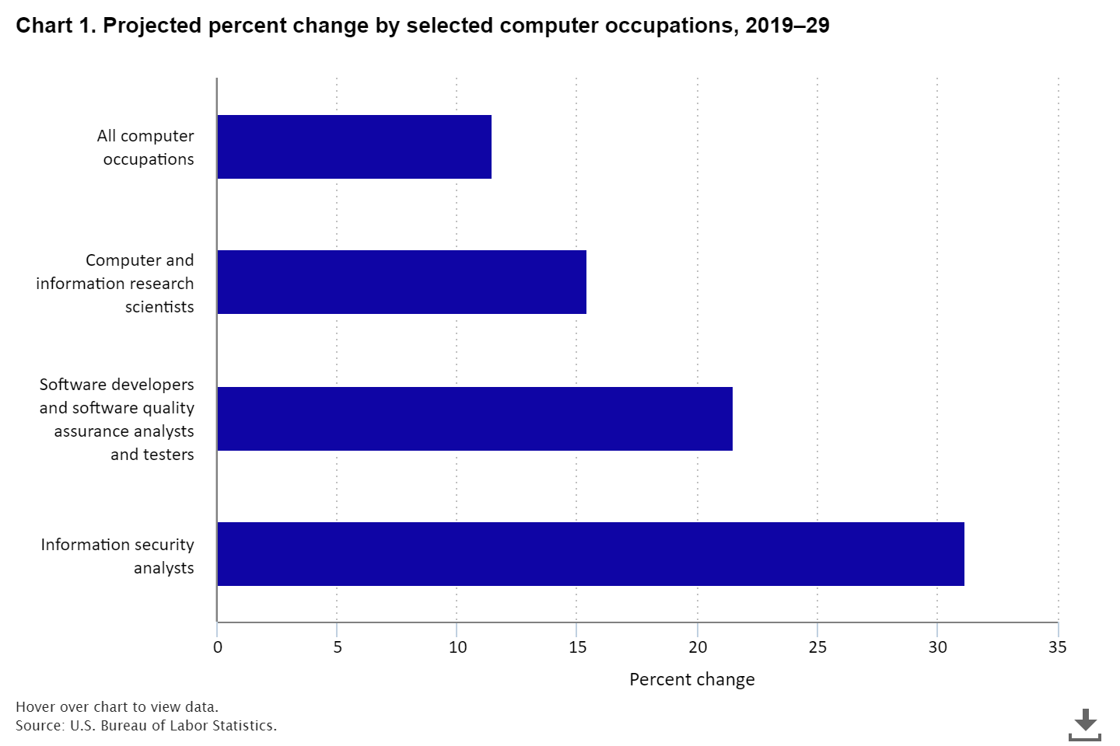

The computer science program is also offering data science courses. According to Glassdoor’s yearly rankings, the job was in the top 3 for the 50 Best Jobs in America from 2016 through 2022, taking the top spot in all but the last two years. According to the US Bureau of Labor Statistics data scientists is projected to grow 36 percent from 2021 to 2031, much faster than the average for all occupations.

Figure A2

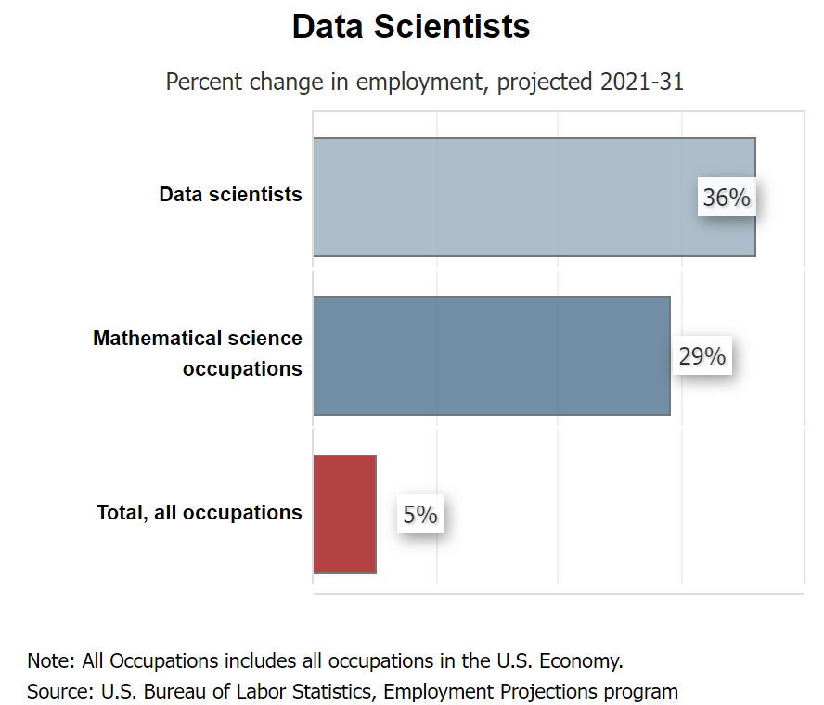

The Los Angeles County Center of Excellence for Labor Market Research (COE) prepared a report to provide Los Angeles/Orange County regional labor market supply and demand data related to eight computing and data occupations. COE found supply gaps in the region for relevant CTE job descriptions noting that “there is projected to be 7,151 jobs available annually in the region due to new job growth and replacements, which is more than the 2,175 awards conferred annually by educational institutions in the region.” They also found that the occupations have entry-level wages above the self-sufficiency standard wage.

**2. How does the program address needs that are not met by similar programs in the region?** In your response, identify any distinctive components of the program (e.g., curriculum, facilities, resources) and/or describe any unique contributions the program or its students/graduates make to the community served.

We offer rigorous courses that prepare our students to be successful in industry and at 4 year institutions. Most other community colleges in Los Angeles County do not provide students with dedicated lab time with their professors. Instead they offer 3-unit programming courses with no lab. Our 4 and 5 unit programming classes, with a lab, makes El Camino College Computer Science Department distinct and much more responsive to student needs. We are also the only community college in Los Angeles County to have an Association of Computing Machinery (ACM) Chapter.

In fall 2019 we welcomed our first Warrior-Toro CS Pathway cohort to the El Camino College Computer Science Department. We are in partnership with CSU Dominguez Hills (CSUDH) that would allow students to receive a Bachelor’s degree in CS within four years. Students in the program would take courses at ECC and CSUDH. They will take most of their classes together, study together, and receive significant additional support including cohort enrichment workshops, professional development, tutoring, priority registration, and guidance to apply for competitive internship experiences. This program is an NSF funded replication of a very successful CS Pathway program that began at CSU Monterey Bay (CSUMB) and Hartnell College. There is no other program like this in Southern California.

El Camino College is leading the way with an innovative data science program.. El Camino College launched its first Data Science offering, *CSCI-8: The Foundations of Data Science,* in the Spring of 2021. It resulted in the most significant increase in enrollment of underrepresented minorities and women that the computer science department has seen to date. A total of five instructors have taught CSCI-8, two full-time and three adjunct faculty. The department recently passed through the curriculum process *CSCI-9: The Principles of Data Science course*. The course will bridge the gap between CSCI 8 and a 4-year institution’s first upper-division data science course. It will deepen students’ understanding of essential data science concepts.

The El Camino College computer science department has been awarded two California Educational Learning lab grant opportunities, the 2020-22 Innovation Grant (IG) and the 2022-24 Scaling Success grant (SSG). As part of the Innovation Grant, ECC, in conjunction with UC Berkeley and CSULB, collaborated on developing open educational resources (OER) using PrairieLearn, a platform for creating randomized questions. This has the potential to bring down costs for students taking courses at El Camino College.

**3. What are the completion, success, and employment rates for students in the program?** In your response, identify the standards set by the program and discuss any factors that may impact completion, success, and employment rates among students in the program. Describe the status of any action plans for maintaining/improving rates relative to such benchmarks.

Over the last four years, from the Fall of 2018 to the Spring of 2022, the CS department has awarded 117 Certificates of Achievement. This helps close the supply gap with certificates in jobs that pay well above the self-sufficiency standard wage. The department has generally adhered to the ambitious 70-70 rule when assessing student learning outcomes. By that standard 70% of students should reach proficiency, 70% or higher.

The following table summarizes the course enrollment for CTE classes in computer science 2015-20.

|  |
| --- |
| Table A1 |

The following chart summarizes the Course Success Trend in the Computer Science program for the Fall semesters 2018-21.

|  |
| --- |
| Figure A3 |

The following chart summarizes the Course Success Trend in the Computer Science program for the Fall semesters 2018-21, broken down by demographics.

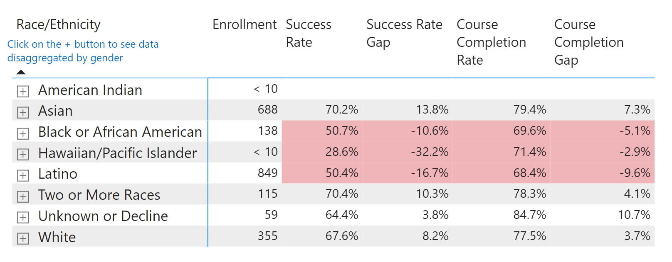

The overall success rate for all our classes from Fall 2018 to Spring 2022 is 65.38%, see Table A2. By looking at the success rates by demographics, certain groups are well below the average success rates, particularly African Americans, Hawaiian/Pacific Islanders, and Latinos, Table A3. To increase our success rates, we plan to offer additional opportunities for students to interact with the materials in the course. We plan to encourage more students to take advantage of the tutoring on campus. We also plan to host events like Computer Science Week and a data science conference to increase student's awareness of the subject and sense of belonging.

**4. List any licensure/certification exam(s) required for entry into the workforce in the field of study and report the most recent pass rate(s) among program graduates.** In your response, identify any applicable performance benchmarks set by regulatory agencies and describe the status of any action plans for maintaining/improving pass rates relative to such benchmarks.

There are no licensure/certification exams required for entry into the workforce for computer science.

**5. Are the students satisfied with their preparation for employment? Are the employers in the field satisfied with the level of preparation of program graduates?** Use data from student surveys, employer surveys, and other sources of employment feedback to justify your response.

At present, the college doesn’t keep track of students once they leave the program and they also don’t track transfers to private colleges or public universities. In addition, most of the students in the computer science program are prepared to transfer to a four year college. The feedback from our advisory board has been largely positive about our programs.

**6. Is the advisory committee satisfied with the level of preparation of program graduates? How has advisory committee input and feedback been used in the past two years to ensure employer needs are met by the program?** Describe the status and impact of any advisory committee recommendations.

California Education Code 78016 requires that the review process for CE programs includes the review and comments of a program’s advisory committee. **Provide the following information:**

a. Advisory committee membership list and credentials.

b. Meeting minutes or other documentation to demonstrate that the CE program review process has met the above Education Code requirement.

*Advisory Board Members*

|  |  |
| --- | --- |
| **Name** | **Position & Company** |
| Leslie Aaronson | Strategic Director for K-12 Initiatives at National Center for Women & Information Technology |
| Dr. Tahir Aziz | Professor, Computer & Office Studies (COS) at Long Beach City College |
| Dr. Mohsen Beheshti | Chair and Professor, California State University, Dominguez Hills |
| David Bohannon | SpaceX |
| Datuki Bonner | Principal Database Technologist at Raytheon Systems |
| Julie Flapan | Executive Director, ACCESS and Director, Computer Science Project at UCLA X |
| Robert Gould | UCLA, Department of Statistics |
| Matt Gray | Vice President of Engineering at Honey |
| Ray Huffaker | Senior Software Engineer at Raytheon Systems |
| Kevin Judge | Senior Staff Engineer at John Deere |
| Winston Kwong | Supervisor of Software Engineering at John Deere ISG-Torrance |
| Dr. Alvaro Monge | Professor, California State University, Long Beach |
| Karlene Nguyen | Technical Director at MobilityWare |
| Thong Nguyen | Project Manager at Internet Brands |
| Kevin O’Connell | South Bay Web App Security Pen-Testers |
| Michael Perry | UC Berkeley MS Former ECC student |
| Brad Rumery | Sampra Energy |
| David Smallberg | Senior Lecturer SOE at UCLA Computer Science Department |
| Dan Stanfill | Software Engineer and Video Gamer at DICE-LA |
| Jon Wada | Engineer at Raytheon |
| Alek Zdziarski | Hulu |

