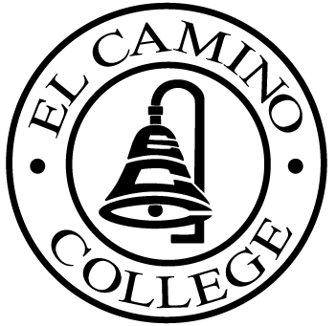

El CAMINO COLLEGE
Office of the Vice President – Administrative Services

Here are the Area Council dates from January to November 2006:

January 24, 2006
February 28, 2006 - Stadium Room
March 28 2006 - Stadium Room
April 25, 2006 - Stadium Room
May 23, 2006 - Stadium Room
June 27, 2006 - Stadium Room
July 25, 2006
August 22, 2006 (begins @ 9:00 a.m.)
September 26, 2006
October 24, 2006
November 28, 2006

** Unless otherwise noted all meetings are held in the Library 202 and begins at 8:30 a.m.

