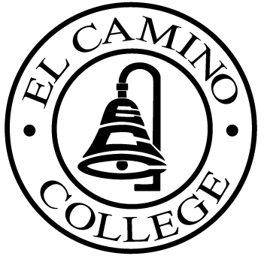

El CAMINO COLLEGE
Office of the Vice President – Administrative Services

Here are the Area Council dates from January to November 2005:

January 25, 2005
February 23, 2005 (Wednesday @ 9 a.m.)
March 22 2005 (begins @ 9 a.m)
April 26, 2005
May 24, 2005
June 28, 2005
July 26, 2005
August 23, 2005
September 27, 2005
October 25, 2005
November 22, 2005 (begins @ 9:00 a.m.)

** Unless otherwise noted all meetings are held in the Stadium Room and begins at 8:30 a.m.

