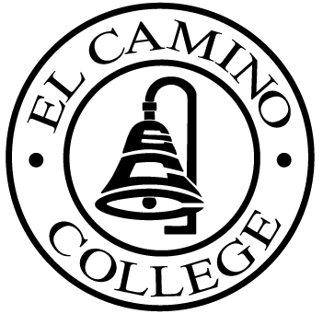

El CAMINO COLLEGE
Office of the Vice President – Administrative Services

Here are the Area Council dates from January to December 2003:

January 28, 2003
February 25, 2003
March 25, 2003
April 22, 2003 (9:00 – 11:00)
May 28, 2003 (Wednesday)
June 24, 2003
July 22, 2003 (9:00 – 11:00)
August 26, 2003
September 23, 2003
October 28, 2003
November 25, 2003

