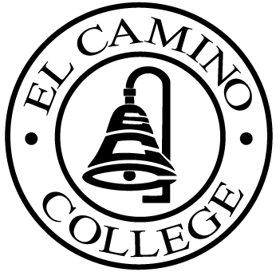

EL CAMINO COLLEGE

Office of the Vice President - Administrative Services

AGENDA
CITIZENS’ BOND OVERSIGHT COMMITTEE
El Camino College Board Room
November 19, 2008
3 p.m.

1. Open Meeting Darlene Love 3:00 p.m.

2. Approval of September 17 Minutes Darlene Love

3. Measure E Agendas Bob Gann
-October 20, 2008
-November 17, 2008

4. Open Discussion All Members

5. Public Comment Public

6. Adjournment Darlene Love 4:00 p.m.

PURPOSE: To inform the public concerning bond revenue expenditures and to actively “review and report” on the expenditure of these funds. (Ed. Code sec. 15278(a)

