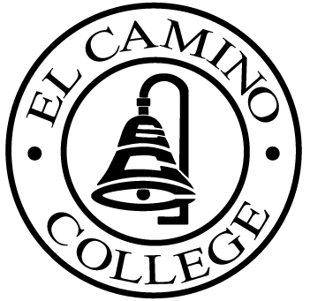

EL CAMINO COLLEGE

Office of the Vice President - Administrative Services

AGENDA
CITIZENS’ BOND OVERSIGHT COMMITTEE
El Camino College
Administration Building – Board Room
November 18, 2015
3:30 p.m.

1. Open Meeting 3:30 .

2. Approval of July 15th minutes

3. Measure “E” agenda Tom Brown
- July 20, 2015
- August 17, 2015
- September 8, 2015
- October 18, 2015

4. Schedule of Future Meetings Chair

5. Open Discussion All Members

6. Public Comment Public

7. Adjournment

PURPOSE: To inform the public concerning bond revenue expenditures and to actively “review and report” on the expenditure of these funds. (Ed. Code sec. 15278(a)

