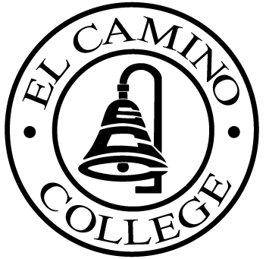

EL CAMINO COLLEGE

Office of the Vice President - Administrative Services

AGENDA
CITIZENS’ BOND OVERSIGHT COMMITTEE
El Camino College Board Room
November 17, 2004
3 p.m.

1. Open Meeting Kurt Weideman 3:00 p.m.

2. Approval of Oct. 13 Minutes Kurt Weideman 3:00 – 3:05 p.m.

3. Measure “E” Agenda Vic Hanson 3:05 – 3:25 p.m.
-November

4. Ad Hoc Committee Report Nina Velasquez 3:25 – 3:50 p.m.

5. Annual Report Mary Ann Keating 3:50 – 4:05 p.m.

6. Open House Kurt Weideman 4:05 – 4:15 p.m.

7. Schedule of Future Meetings Kurt Weideman 4:15 – 4:20 p.m.

8. Open Discussion All Members 4:20 – 4:30 p.m.

9. Public Comment Public 4:30 – 4:40 p.m.

10. Adjournment Kurt Weideman 4:40 p.m.

PURPOSE: To inform the public concerning bond revenue expenditures and to actively “review and report” on the expenditure of these funds. (Ed. Code sec. 15278(a)

