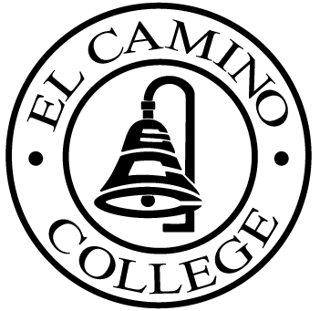

EL CAMINO COLLEGE

Office of the Vice President - Administrative Services

AGENDA
CITIZENS’ BOND OVERSIGHT COMMITTEE
El Camino College Board Room
November 15, 2006
3 p.m.

1. Open Meeting Leandro Carde 3 p.m.

2. Approval of September 27 Minutes Leandro Carde 3 – 3:05 p.m.

3. Annual Report Committee Leandro Carde 3:05 – 3:15 p.m.

4. Measure “E” Agenda Bob Gann 3:15 – 3:30 p.m.
-October 16, 2006

5. Open Discussion All Members 3:30 – 3:45 p.m.

6. Public Comment Public 3:45 – 4:00 p.m.

7. Adjournment Leandro Carde 4:00 p.m.

PURPOSE: To inform the public concerning bond revenue expenditures and to actively “review and report” on the expenditure of these funds. (Ed. Code sec. 15278(a)

