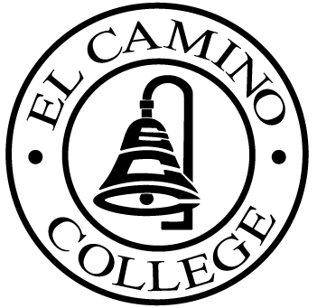

EL CAMINO COLLEGE

Office of the Vice President - Administrative Services

AGENDA
CITIZENS’ BOND OVERSIGHT COMMITTEE
El Camino College Board Room
November 14, 2007
3 p.m.

1. Tour of Central Plant, Learning
Resources Center All 3 p.m.

2. Open Meeting Chris Powell

2. Approval of September 26 Minutes Chris Powell

3. Measure E Agenda Bob Gann
-October 15

4. Facilities Master Plan Update Jeff Marsee

5. Policy on Bond Fund Purchases Jeff Marsee

6. Open Discussion All Members

7. Public Comment Public

8. Adjournment Chris Powell 4 p.m.

PURPOSE: To inform the public concerning bond revenue expenditures and to actively “review and report” on the expenditure of these funds. (Ed. Code sec. 15278(a)

