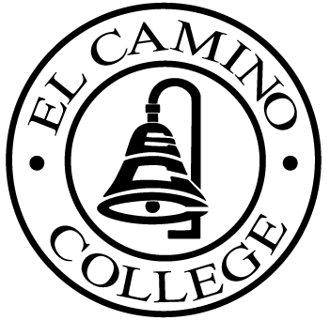

EL CAMINO COLLEGE

Office of the Vice President - Administrative Services

AGENDA
CITIZENS’ BOND OVERSIGHT COMMITTEE
El Camino College Library 202
September 27, 2005
3 p.m.

1. Open Meeting Kurt Weideman 3 p.m.

2. Approval of September 14 Minutes Kurt Weideman 3 p.m.

3. Opening and Review of Audit Bids All 3:05 p.m.

4. Schedule of Future Meetings Kurt Weideman 3:35 p.m.
5. Open Discussion All Members 3:40 p.m.

6. Public Comment Public 3:50 p.m.

7. Adjournment Kurt Weideman 4:00 p.m.

PURPOSE: To inform the public concerning bond revenue expenditures and to actively “review and report” on the expenditure of these funds. (Ed. Code sec. 15278(a)

