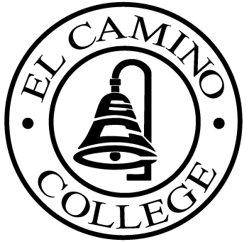

EL CAMINO COLLEGE

Office of the Vice President - Administrative Services

AGENDA
CITIZENS’ BOND OVERSIGHT COMMITTEE
El Camino College Board Room
September 26, 2007
3 p.m.

1. Open Meeting Chris Powell 3:00 p.m.

2. Approval of July 25 Minutes Chris Powell

3. Measure E Agendas
-May 21, 2007
-June 18, 2007
-July 16, 2007
-August 20, 2007
-September 4, 2007

4. Open Discussion All Members

5. Public Comment Public

6. Adjournment Chris Powell 4:00 p.m.

PURPOSE: To inform the public concerning bond revenue expenditures and to actively “review and report” on the expenditure of these funds. (Ed. Code sec. 15278(a)

