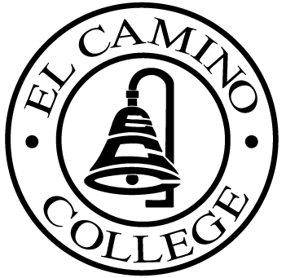

EL CAMINO COLLEGE

Office of the Vice President - Administrative Services

AGENDA
CITIZENS’ BOND OVERSIGHT COMMITTEE
El Camino College
Administration Building – Board Room
September 21, 2011
3:00 p.m.

1. Open Meeting 3:00 .

2. Welcome & Introduction

3. Approval of July 20 Minutes

4. Measure “E” agenda Bob Gann
- July 18, 2011
- August 15, 2011
- September 8, 2011

5. Schedule of Future Meetings Chair

6. Open Discussion All Members

7. Public Comment

8. Adjournment

9. Tour of Social Science Building All Members

PURPOSE: To inform the public concerning bond revenue expenditures and to actively “review and report” on the expenditure of these funds. (Ed. Code sec. 15278(a)

