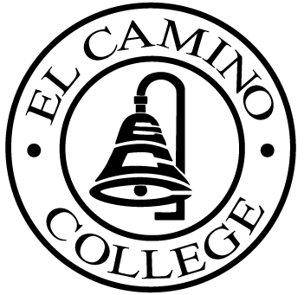
Revised

EL CAMINO COLLEGE

Office of the Vice President - Administrative Services

AGENDA
CITIZENS’ BOND OVERSIGHT COMMITTEE
El Camino College
Administration Building – Board Room
September 19, 2012
3:30 p.m.

1. Open Meeting 3:30 .

2. Introduction of New Members

3. Approval of July 25th Minutes

4. Measure “E” agenda Tom Brown
- August 20, 2012
- September 4, 2012

5. 2012 Measure E Ann Garten

6. Schedule of Future Meetings Chair

7. Open Discussion All Members

8. Public Comment Public

9. Adjournment

PURPOSE: To inform the public concerning bond revenue expenditures and to actively “review and report” on the expenditure of these funds. (Ed. Code sec. 15278(a)

