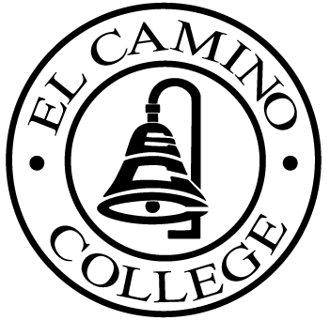

EL CAMINO COLLEGE

Office of the Vice President - Administrative Services

AGENDA
CITIZENS’ BOND OVERSIGHT COMMITTEE
El Camino College Board Room
September 17, 2008
3 p.m.

1. Open Meeting Darlene Love 3 p.m.

2. Approval of Minutes Darlene Love
- May 21
- July 16

3. Measure E Agendas Bob Gann
- July 21
- August 18
- September 2

4. Open Discussion All Members

5. Public Comment Public

6. Adjournment Darlene Love 4 p.m.

PURPOSE: To inform the public concerning bond revenue expenditures and to actively “review and report” on the expenditure of these funds. (Ed. Code sec. 15278(a)

