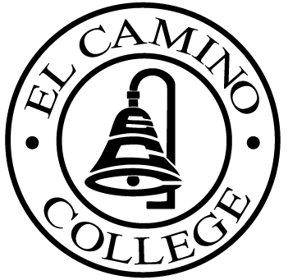

EL CAMINO COLLEGE

Office of the Vice President - Administrative Services

AGENDA
CITIZENS’ BOND OVERSIGHT COMMITTEE
El Camino College Board Room
September 16, 2009
3:30 p.m.

1. Open Meeting 3:30 p.m.

2. Approval of July 15 Minutes

3. Measure E Agendas: Bob Gann
-July 20, 2009
-August 17, 2009
- September 9, 2009

4. Open Discussion All Members

5. Public Comment Public

6. Adjournment 4:30 p.m.

PURPOSE: To inform the public concerning bond revenue expenditures and to actively “review and report” on the expenditure of these funds. (Ed. Code sec. 15278(a)

