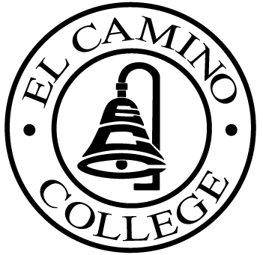

EL CAMINO COLLEGE

Office of the Vice President - Administrative Services

AGENDA
CITIZENS’ BOND OVERSIGHT COMMITTEE
El Camino College Board Room
September 14, 2005
3 p.m.

1. Open Meeting Kurt Weideman 3:00 p.m.

2. Approval of June 1 Minutes Kurt Weideman 3:05 p.m.

3. Thomas M. Fallo 3:05 – 3:15 p.m.

4. Measure “E” Agendas Bob Gann 3:15 p.m.
-June 27, 2005
-July 18, 2005
-August 15, 2005

5. Auditor Selection Nina Velasquez 3:25 p.m. Sub-Committee Report Mark Marion
Pam Fees

6. Annual Report Schedule Nina Velasquez 3:35 p.m.
Kurt Weideman

7. Student Representation Jeff Marsee 3:45 p.m.

8. Schedule of Future Meetings Kurt Weideman 3:55 p.m.

9. Open Discussion All Members 4:00 p.m.

10. Public Comment Public 4:10 p. m.

11. Adjournment Kurt Weideman 4:10 p.m.

PURPOSE: To inform the public concerning bond revenue expenditures and to actively “review and report” on the expenditure of these funds. (Ed. Code sec. 15278(a)

