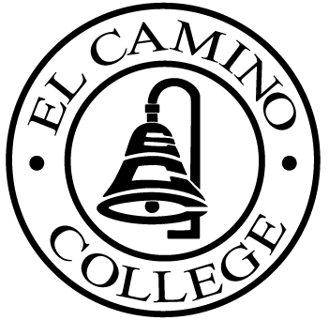

EL CAMINO COLLEGE

Office of the Vice President - Administrative Services

AGENDA
CITIZENS’ BOND OVERSIGHT COMMITTEE
El Camino College
Administration Building – Board Room
August 20, 2014
4:30 p.m.

1. Open Meeting 4:30 .

2. Approval of March 19th minutes

3. Measure “E” agenda Tom Brown
- March 17, 2014
- April 21, 2014
- May19, 2014
- June 16, 2014
- July 21, 2014

4. Schedule of Future Meetings Chair

5. Open Discussion All Members

6. Public Comment Public

7. Adjournment

PURPOSE: To inform the public concerning bond revenue expenditures and to actively “review and report” on the expenditure of these funds. (Ed. Code sec. 15278(a)

