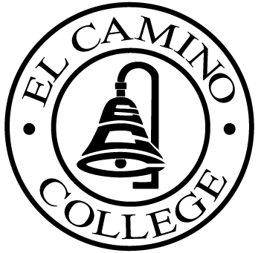

EL CAMINO COLLEGE

Office of the Vice President - Administrative Services

AGENDA
CITIZENS’ BOND OVERSIGHT COMMITTEE
El Camino College
2nd Floor Bookstore Conference Room
July 26, 2017
3:30pm

1. Open Meeting 3:30 .

2. Approval of March 29, 2017 minutes

3. Measure “E” agenda Tom Brown
- March 20, 2017
- April 17, 2017
- May 22, 2017
- June 19, 2017

4. Schedule of Future Meetings Chair
(November meeting scheduled
for November 15 @ 3:30pm)

5. Open Discussion All Members

6. Public Comment Public

7. Adjournment

PURPOSE: To inform the public concerning bond revenue expenditures and to actively “review and report” on the expenditure of these funds. (Ed. Code sec. 15278(a)

