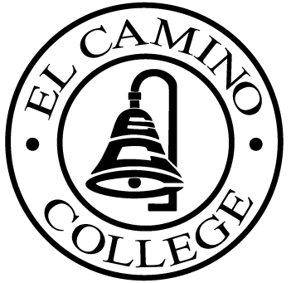

EL CAMINO COLLEGE

Office of the Vice President - Administrative Services

AGENDA
CITIZENS’ BOND OVERSIGHT COMMITTEE
El Camino College Board Room
July 25, 2007
3 p.m.

1. Open Meeting Chris Powell 3 p.m.

2. Approval of May 23 Minutes Chris Powell

3. Measure E Agendas: Bob Gann
- May 21, 2007
- June 18, 2007

4. Open Discussion All Members

5. Public Comment Public

6. Adjournment Chris Powell 4 p.m.

PURPOSE: To inform the public concerning bond revenue expenditures and to actively “review and report” on the expenditure of these funds. (Ed. Code sec. 15278(a)

