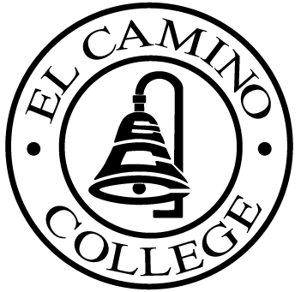

EL CAMINO COLLEGE

Office of the Vice President - Administrative Services

AGENDA
CITIZENS’ BOND OVERSIGHT COMMITTEE
El Camino College
Administration Building – Board Room
July 20, 2016
3:30pm
Meeting Postponed

1. Open Meeting 3:30 .

2. Approval of March 16th minutes

3. Measure “E” agenda Tom Brown
- March 21, 2016
- April 18, 2016
- May 16, 2016
- June 20, 2016

4. Schedule of Future Meetings Chair

5. Open Discussion All Members

6. Public Comment Public

7. Adjournment

PURPOSE: To inform the public concerning bond revenue expenditures and to actively “review and report” on the expenditure of these funds. (Ed. Code sec. 15278(a)

