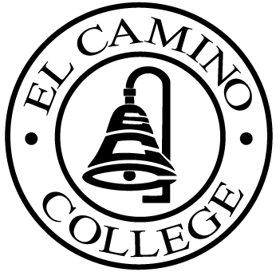

EL CAMINO COLLEGE

Office of the Vice President - Administrative Services

AGENDA
CITIZENS’ BOND OVERSIGHT COMMITTEE
El Camino College Board Room
July 16, 2008
3 p.m.

1. Open Meeting Darlene Love 3 p.m.

2. Campus Tour All

3. Approval of May 21 Minutes Darlene Love

4. Measure E Agendas Bob Gann
- May 19, 2008
-June 16, 2008

5. Open Discussion All Members

6. Public Comment Public

7. Adjournment Darlene Love 4 p.m.

PURPOSE: To inform the public concerning bond revenue expenditures and to actively “review and report” on the expenditure of these funds. (Ed. Code sec. 15278(a)

