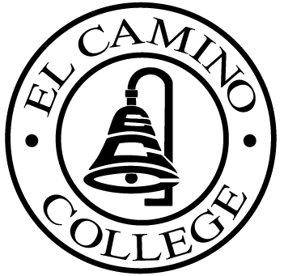

EL CAMINO COLLEGE

Office of the Vice President - Administrative Services

AGENDA
CITIZENS’ BOND OVERSIGHT COMMITTEE
El Camino College Board Room
July 15, 2009
3:30 p.m.

1. Open Meeting 3:30 p.m.

2. Approval of May 20 Minutes

3. Measure E Agendas Bob Gann
-May 18, 2009
-June 15, 2009

4. Open Discussion All Members

5. Public Comment Public

6. Adjournment

PURPOSE: To inform the public concerning bond revenue expenditures and to actively “review and report” on the expenditure of these funds. (Ed. Code sec. 15278(a)

