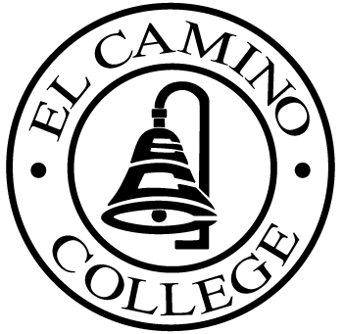

EL CAMINO COLLEGE

Office of the Vice President - Administrative Services

AGENDA
CITIZENS’ BOND OVERSIGHT COMMITTEE
El Camino College Board Room
June 1, 2005
3 p.m.

1. Open Meeting Kurt Weideman 3:00 p.m.

2. Approval of April 6 Minutes Kurt Weideman 3:00 – 3:05 p.m.

3. Measure “E” Agendas ECC Staff 3:05 - 3:30 p.m.
- April 18, 2005
- May 16, 2005

4. Member Replacement Alex Kelley 3:30 – 3:35 p.m.

5. Schedule of Future Meetings Kurt Weideman 3:35 – 3:40 p.m.

6. Open Discussion All Members 3:40 – 3:50 p.m.

7. Public Comment Public 3:50 – 4:00 p.m.

8. Adjournment Kurt Weideman 4:00 p.m.

PURPOSE: To inform the public concerning bond revenue expenditures and to actively “review and report” on the expenditure of these funds. (Ed. Code sec. 15278(a)

