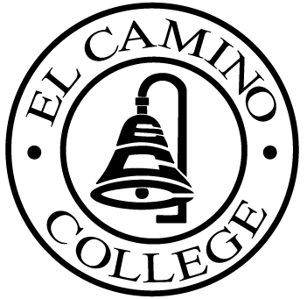

EL CAMINO COLLEGE

Office of the Vice President - Administrative Services

AGENDA
CITIZENS’ BOND OVERSIGHT COMMITTEE
El Camino College Board Room
May 24, 2006
2 p.m. (Tour)
3 p.m. (Meeting)

1. Campus Tour Bob Gann 2 – 3 p.m.

2. Open Meeting Leandro Carde 3 p.m..

3. Approval of April 19 Minutes Leandro Carde 3 – 3:05 p.m.
4. Measure “E” Agendas Bob Gann 3:05 – 3:20 p.m.
-April 17, 2006
-May 15, 2006

5. Calendar Subcommittee Report Ray Roney 3:20 – 3:30 p.m.

6. Audit Leandro Carde 3:30 – 3:40 p.m.

7. Schedule of Future Meetings Leandro Carde 3:40 – 3:45 p.m.

8. Open Discussion All Members 3:45 – 3:55 p.m.

9. Public Comment Public 3:55 – 4:05 p.m.

10. Adjournment Leandro Carde 4:05 p.m.

PURPOSE: To inform the public concerning bond revenue expenditures and to actively “review and report” on the expenditure of these funds. (Ed. Code sec. 15278(a)

