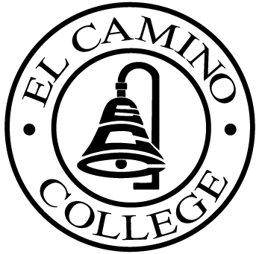

EL CAMINO COLLEGE

Office of the Vice President - Administrative Services

AGENDA
CITIZENS’ BOND OVERSIGHT COMMITTEE
El Camino College
Administration Building – Board Room
May 23, 2012
3:00 p.m.

1. Open Meeting 3:00 .

2. Approval of March 21st Minutes

3. Measure “E” agenda Tom Brown
- March 12, 2012
- April 16, 2012

4. Schedule of Future Meetings Chair

5. Open Discussion All Members

6. Public Comment Public

7. Adjournment

PURPOSE: To inform the public concerning bond revenue expenditures and to actively “review and report” on the expenditure of these funds. (Ed. Code sec. 15278(a)

