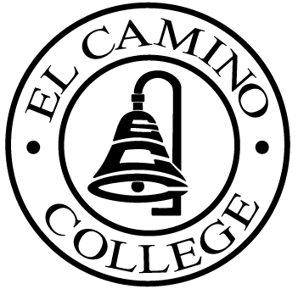

EL CAMINO COLLEGE

Office of the Vice President - Administrative Services

AGENDA
CITIZENS’ BOND OVERSIGHT COMMITTEE
El Camino College Board Room
May 23, 2007
3 p.m.

1. Open Meeting Chris Powell 3 p.m.

2. Approval of March 26 Minutes Chris Powell

3. Measure “E” Agenda Bob Gann
-March 19
-April 16

4. Open Discussion All Members

5. Public Comment Public

6. Adjournment Chris Powell 4 p.m.

PURPOSE: To inform the public concerning bond revenue expenditures and to actively “review and report” on the expenditure of these funds. (Ed. Code sec. 15278(a)

