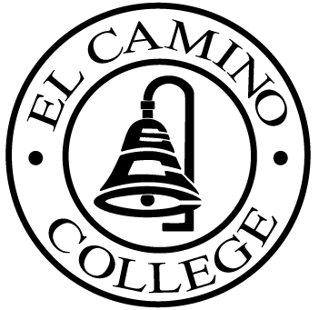

EL CAMINO COLLEGE

Office of the Vice President - Administrative Services

AGENDA
CITIZENS’ BOND OVERSIGHT COMMITTEE
El Camino College Board Room
May 21, 2008
3 p.m.

1. Open Meeting Tom Quintana 3 p.m.

2. Approval of February 28 Minutes Tom Quintana

3. Introduction of New Members Tom Quintana

4. Selection of Chair and Co-Chair All

5. Measure E Agendas Bob Gann
-March 10, 2008
-April 21, 2008

6. Creation of Yearly Meeting All
Calendar

7. Open Discussion All Members

8. Public Comment Public

9. Adjournment Tom Quintana 4 p.m.

PURPOSE: To inform the public concerning bond revenue expenditures and to actively “review and report” on the expenditure of these funds. (Ed. Code sec. 15278(a)

