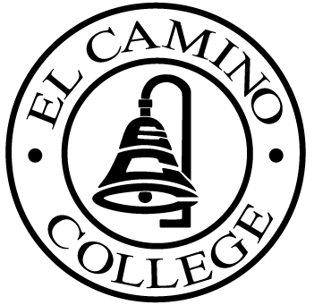

EL CAMINO COLLEGE

Office of the Vice President - Administrative Services

AGENDA
CITIZENS’ BOND OVERSIGHT COMMITTEE
El Camino College Board Room
May 20, 2009
3 p.m.

1. Open Meeting Chair 3 p.m..

2. Approval of March 18 Minutes All

3. Measure E Agenda Bob Gann
-March 16, 2009
-April 20, 2009

4. Committee Membership All

5. Election of Chair and Co-Chair All

6. Meeting Schedule 2009-10 All

7. Open Discussion All Members

8. Public Comment Public

9. Adjournment Chair 4 p.m.

PURPOSE: To inform the public concerning bond revenue expenditures and to actively “review and report” on the expenditure of these funds. (Ed. Code sec. 15278(a)

