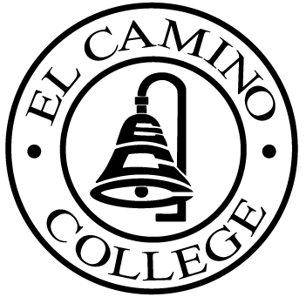

EL CAMINO COLLEGE

Office of the Vice President - Administrative Services

AGENDA
CITIZENS’ BOND OVERSIGHT COMMITTEE
El Camino College Board Room
April 6, 2005
3 p.m.

1. Open Meeting Kurt Weideman 3:00 p.m.

2. Approval of February 15 Minutes Kurt Weideman 3:00 – 3:05 p.m.

3. Measure “E” Agenda Pam Fees/Bob Gann 3:05 – 3:20 p.m.
a. February 22
b. March 21

4. Lessons Learned All Members 3:20 – 3:35 p.m.

5. Selection of the Vice Chair Kurt Weideman 3:35 – 3:45 p.m.

6. Schedule of Future Meetings Kurt Weideman 3:45 – 3:50 p.m.
7. Open Discussion All Members 3:50 – 4:00 p.m.

8. Public Comment Public 4:00 – 4:10 p.m.

9. Adjournment Kurt Weideman 4:10 p.m.

PURPOSE: To inform the public concerning bond revenue expenditures and to actively “review and report” on the expenditure of these funds. (Ed. Code sec. 15278(a)

