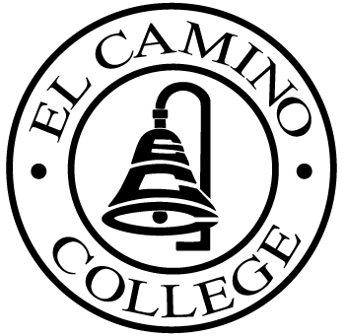

EL CAMINO COLLEGE

Office of the Vice President - Administrative Services

AGENDA
CITIZENS’ BOND OVERSIGHT COMMITTEE
El Camino College
Administration Building – Room 127
April 19, 2006
3 p.m.

1. Open Meeting Nina Velasquez .

2. Approval of March 1 Minutes Members

3. Selection of New Chair Members

4. Orientation Members

5. Measure “E” agenda David Miller
- March 20, 2006

6. Schedule of Future Meetings Chair

7. Open Discussion All Members

8. Public Comment Public

9. Adjournment Chair

10. Tour All

PURPOSE: To inform the public concerning bond revenue expenditures and to actively “review and report” on the expenditure of these funds. (Ed. Code sec. 15278(a)

