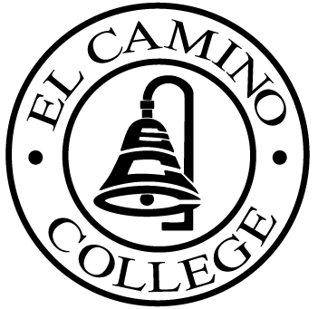

EL CAMINO COLLEGE

Office of the Vice President - Administrative Services

AGENDA
CITIZENS’ BOND OVERSIGHT COMMITTEE
El Camino College
Administration Building – Board Room
March 21, 2012
3:00 p.m.

1. Open Meeting 3:00 .

2. Approval of November 16 Minutes
Approval of January 18 Minutes

3. Measure “E” agenda Tom Brown
- January 17, 2012
- February 21, 2012

4. Bond Audit Auditor

5. Annual Report Review Ann Garten

6. Schedule of Future Meetings Chair

7. Open Discussion All Members

8. Public Comment Public

9. Adjournment

PURPOSE: To inform the public concerning bond revenue expenditures and to actively “review and report” on the expenditure of these funds. (Ed. Code sec. 15278(a)

