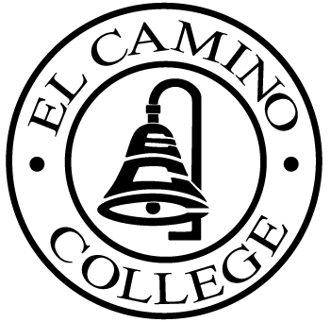

EL CAMINO COLLEGE

Office of the Vice President - Administrative Services

AGENDA
CITIZENS’ BOND OVERSIGHT COMMITTEE
El Camino College
Administration Building – Board Room
March 18, 2015
3:30 p.m.

Meeting Canceled

PURPOSE: To inform the public concerning bond revenue expenditures and to actively “review and report” on the expenditure of these funds. (Ed. Code sec. 15278(a)

