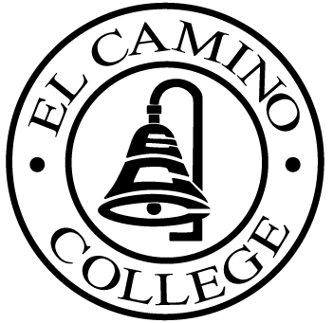

EL CAMINO COLLEGE

Office of the Vice President - Administrative Services

AGENDA
CITIZENS’ BOND OVERSIGHT COMMITTEE
El Camino College Board Room
March 18, 2009
3 p.m.

1. Open Meeting Darlene Love 3 p.m.

2. Approval of January 21 Minutes Darlene Love

3. Bond Audit Renee Graves
(Vicenti, Lloyd, Stutzman LLP)

4. Annual Report (Final Review) Ann Garten

5. Measure E Agendas Bob Gann
-January 20
-February 17

6. Review of Plans for
Math/Business/Allied Health
Building Bruce Hoerning

7. Selection of New Members/ All
Officers

8. Open Discussion All Members

9. Public Comment Public

10. Adjournment 4 p.m.

PURPOSE: To inform the public concerning bond revenue expenditures and to actively “review and report” on the expenditure of these funds. (Ed. Code sec. 15278(a)

