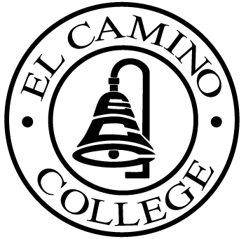

EL CAMINO COLLEGE

Office of the Vice President - Administrative Services

AGENDA
CITIZENS’ BOND OVERSIGHT COMMITTEE
El Camino College
Administration Building – Board Room
March 16, 2016
3:30 3:00p.m.

1. Open Meeting 3:00 .

2. Approval of November 18th minutes

3. Measure “E” agenda Tom Brown
- November 16, 2015
- December 14, 2015
- January 20, 2016
- February 17, 2016

4. Audit VLS

5. Annual Report Review Ann Garten

6 Schedule of Future Meetings Chair

7. Open Discussion All Members

8. Public Comment Public

9. Adjournment

PURPOSE: To inform the public concerning bond revenue expenditures and to actively “review and report” on the expenditure of these funds. (Ed. Code sec. 15278(a)

