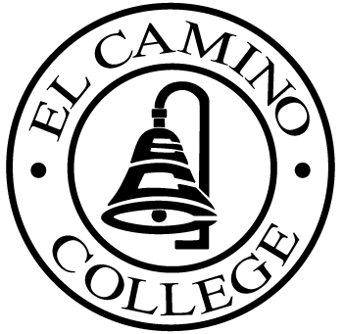

EL CAMINO COLLEGE

Office of the Vice President - Administrative Services

AGENDA
CITIZENS’ BOND OVERSIGHT COMMITTEE
El Camino College
Administration Building – Board Room
March 16, 2011
3:30 p.m.

1. Open Meeting 3:30 .

2. Approval of November 17 Minutes
Approval of January 19 Minutes

3. Measure “E” agenda Bob Gann
- January 18, 2011
- February 22, 2011

4. Annual Report Review /Annual Audit Auditor

5. 2011-13 Appointments Ann Garten

6. Schedule of Future Meetings Chair

7. Open Discussion All Members

8. Public Comment Public

9. Adjournment

PURPOSE: To inform the public concerning bond revenue expenditures and to actively “review and report” on the expenditure of these funds. (Ed. Code sec. 15278(a)

