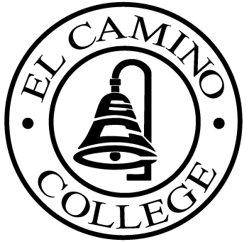

EL CAMINO COLLEGE

Office of the Vice President - Administrative Services

AGENDA
CITIZENS’ BOND OVERSIGHT COMMITTEE
El Camino College
Administration Building - Room 127
March 1, 2006
3 p.m.

1. Open Meeting Kurt Weideman 3 p.m.

2. Approval of January 25 Minutes Kurt Weideman 3:00 – 3:05 p.m.

3. Measure “E” Agenda Bob Gann 3:05 – 3:15 p.m.
-February 21

4. 2004-2005 Annual Report Kurt/All 3:15 – 3:30 p.m.

5. Amendment of By-Laws Kurt Weideman 3:30 – 3:40 p.m.

6. Schedule of Future Meetings Kurt Weideman 3:40 – 3:45 p.m.

8. Open Discussion All Members 3:45 – 3:55 p.m.

9. Public Comment Public 3:55 – 4:00 p.m.

10. Adjournment Kurt Weideman 4:00 p.m.

PURPOSE: To inform the public concerning bond revenue expenditures and to actively “review and report” on the expenditure of these funds. (Ed. Code sec. 15278(a)

