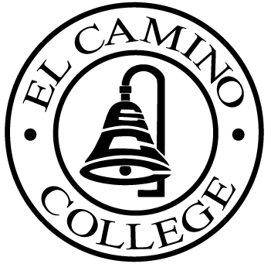

EL CAMINO COLLEGE

Office of the Vice President - Administrative Services

AGENDA
CITIZENS’ BOND OVERSIGHT COMMITTEE
El Camino College Board Room
February 28, 2007
3 p.m.

1. Open Meeting Leandro Carde 3 p.m.

2. Approval of January 24 Minutes Leandro Carde 3:00 – 3:05 p.m.

3. Measure E Agenda Bob Gann 3:05 – 3:15 p.m.
- January 22, 2007

4. Annual Report Chris Powell 3:15 – 3:25 p.m.

5. Committee Membership Ann Garten 3:25 – 3:35 p.m.

6. Open Discussion All Members 3:35 – 3:50 p.m.

7. Public Comment Public 3:50 – 4:00 p.m.

8. Adjournment Leandro Carde 4 p.m.

PURPOSE: To inform the public concerning bond revenue expenditures and to actively “review and report” on the expenditure of these funds. (Ed. Code sec. 15278(a)

