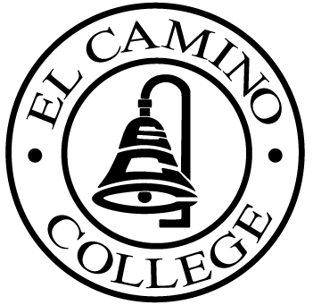

EL CAMINO COLLEGE

Office of the Vice President - Administrative Services

AGENDA
CITIZENS’ BOND OVERSIGHT COMMITTEE
El Camino College Board Room
February 16, 2005
8 a.m.

1. Open Meeting Mary Ann Keating 8:00 a.m.

2. Approval of January 12 Minutes Mary Ann Keating 8:00 – 8:05 a.m.
3. Measure “E” Agenda Vic Hanson 8:05 – 8:15 a.m.
- January, 2005

4. Audit Report Vic Hanson 8:15 – 8:25 a.m.

5. Annual Report Mary Ann Keating 8:25 – 8:35 a.m.

6. Schedule of Future Meetings Mary Ann Keating 8:35 – 8:40 a.m.

7. Open Discussion All Members 8:40 – 8:50 a.m.

9. Public Comment Public 8:50 – 9:00 a.m.

10. Adjournment Mary Ann Keating 9:00 a.m.

PURPOSE: To inform the public concerning bond revenue expenditures and to actively “review and report” on the expenditure of these funds. (Ed. Code sec. 15278(a)

