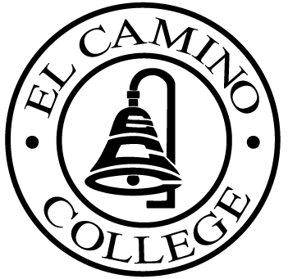

EL CAMINO COLLEGE

Office of the Vice President - Administrative Services

AGENDA
CITIZENS’ BOND OVERSIGHT COMMITTEE
El Camino College - Administration Building Room 127
January 25, 2006
9 a.m.

1. Open Meeting Kurt Weideman 9 a.m.

2. Approval/November 9 Minutes Kurt Weideman 9:00 – 9:05 a.m.

3. Audit Report Kurt Weideman 9:05 – 9:15 a.m.

4. Measure “E” Agendas Bob Gann 9:15 – 9:35 a.m.
-November 21, 2005
-December 19, 2005
-January 23, 2006

5. Schedule of Future Meetings Kurt Weideman 9:35 – 9:40 a.m.

6. Open Discussion All Members 9:40 – 9:50 a.m.

7. Public Comment Public 9:50 – 10:00 a.m.

8. Adjournment Kurt Weideman 10:00 a.m.

PURPOSE: To inform the public concerning bond revenue expenditures and to actively “review and report” on the expenditure of these funds. (Ed. Code sec. 15278(a)

