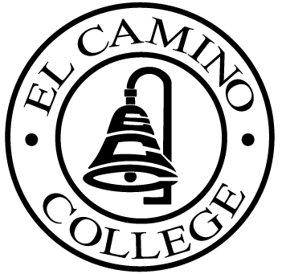

EL CAMINO COLLEGE

Office of the Vice President - Administrative Services

AGENDA
CITIZENS’ BOND OVERSIGHT COMMITTEE
El Camino College
Administration Building – Board Room
January 19, 2011
3:30 p.m.

1. Open Meeting 3:30 .

2. Approval of November 17 Minutes

3. Measure “E” agenda Bob Gann
- November 15 , 2010
- December 13, 2010

4. Schedule of Future Meetings Chair

5. Open Discussion All Members

6. Public Comment Public

7. Adjournment

PURPOSE: To inform the public concerning bond revenue expenditures and to actively “review and report” on the expenditure of these funds. (Ed. Code sec. 15278(a)

