**El Camino College**

STUDENT & COMMUNITY ADVANCEMENT

**Puente Project Program Review**

**Program Review**

Program Review is a tool used by program personnel to critically evaluate the services offered by the program and to recommend necessary improvements that address the needs of the College or the Center and the community.

**Desired Outcomes**

Desired Program Review outcomes include: a thorough evaluation of the program’s effectiveness using quantitative and qualitative data; recommendations for program improvement (or if appropriate program discontinuance); and placement of the recommendations into the program’s annual plan.

**Program Description**

***Assume the reader of the program review does not know about your program***

1. **Describe the program. How does the program link to the College’s mission statement, statement of values, or strategic initiatives?**

The Puente Project Program is an academic and student support services program designed to transfer underrepresented students to the four-year university. The program includes three components: teaching, counseling, and mentoring which work together to prepare students for transfer to four-year colleges and universities. Teaching and counseling emphasizes the Latino experience in the U.S. The program provides students with English instruction as well as academic and career counseling. Students additionally are matched with a professional mentor from the community to gain support. The purpose of this program is to provide a supportive and stimulating environment to help students build confidence in their writing skills and ability to navigate the college system to succeed in higher education.

The mission of the Puente Project is to increase the number of educationally underserved students that will enroll in colleges and universities, earn degrees, and return to the community as leaders and mentors to future generations. Puente is open to all interested students.

Puente students are served by the Puente program for the duration of their time on ECC’s campus from the time they enroll in the program until they graduate and transfer. Roughly 75 students are admitted to the program as Phase I students in fall semester. Those who continue in the spring are considered Phase II students. After students complete the first year in the program, including the required four Puente courses, mentor events, university tours, etc, Puente students are considered Phase III students until they graduate and transfer to a four-year university. Combined with the Phase II and III students, the Puente Program is currently serving 147 students in total. Recruitment is underway for 2018-2019 Phase I students. Puente students’ persistence rate for three consecutive semesters (Phase I to Phase III) is higher than the general population at El Camino College as well as other Latino students at the college.

**Percentage of all El Camino College Students and Puente Students Persisting in First Three Consecutive Terms**

**2009-10 Cohort (Outcomes by 2014-15)\***

100%

80%



90%

72%

73%

76%

67%

72%

*Definition: The percentage of first-time students with a minimum of 6 units earned who attempted any math or English in the first three years and achieved the following measure of progress within six years of entry: 1) Enrolled in the first three consecutive primary semester terms (or four quarter terms) anywhere in the CCC system 2) Earned at least 30 units in the CCC system.

60%

40%

0%

20%

Puente Students

White

Hispanic

All Students at College

Asian

African

American

The Puente Program began as a way to address Latino students’ low academic achievement and dropout rate. Through the research of its founders, three key components were identified as negatively impacting student success. These components were: students not seeking academic counseling, not enrolling in English college-level classes, and not understanding how to navigate the college system. The Puente Project Program was founded in 1981 in Northern California by Felix Galaviz and Patricia McGrath. Puente is the model and predecessor for learning community programs, retention programs, teacher to student models, and national research. An innovative characteristic of the Puente Project is its team approach to aid in student success. A counselor and an English instructor from each community college campus are paired and trained in the Puente way. This training takes place during an intensive seven to ten day workshop at the University of California, Berkeley. Whenever a new team member is introduced to the program, both teammates must attend this training

The Puente Program is the first program at El Camino College to provide a linked learning community of courses and an established academic support program, which was first established in 1985 and has been operating for 32 years, a milestone for both the college and the Puente State Office, which recognizes El Camino College’s Puente Project as a premiere program in the state due to its high retention, transfer rates, and training legacy of its past and current coordinators. Due to the model of the Puente program, other programs were developed at El Camino College through grants such as the First Year Experience in 2000 and the Learning Communities Program in 2002.

The Puente Project is an educational program that adheres to the college’s mission and statement of values by providing a learning environment where students are motivated to learn and to achieve their academic goals of transferring to a four-year institution. Extensive counseling and mentoring services support the College’s mission to offer “quality, comprehensive educational programs and services to ensure the educational success of students from our diverse community.”

The Puente Program at El Camino College is tied into a larger statewide community where at the top is the Puente Statewide Office which is always lobbying at the state capital for the retention and benefits of the Puente Project, and also more than 60 Puente Project programs are in existence at the California community colleges, more than 50 at the high schools and middle schools, and now also nationally with programs at the community colleges in the states of Texas and Washington. The Puente Project Statewide office holds a training for new Puente for English and Counseling faculty during the summer, in early June, and then a follow-up training in the beginning of August before the start of the school year. They also provide all Puente faculty with training twice a year, one in the fall and the second one in the spring semester. In addition, the Puente Statewide Office provides all Puente phase I students with a Transfer Motivational Conference during the fall semester for the students to be encouraged, inspired and motivated to transfer to a four-year university. In addition, they offer Puente phase II and III students with the opportunity to apply and attend a Summer Leadership Institute where Puente students are taught to be exceptional leaders and come back to their college and implement what they have learned during the institute. Recently, the Statewide Office also developed the Puente Writers Symposium where Puente students could attend during the summer and learn how to develop their own writing by being taught through published authors.

Furthermore, the Puente Program is linked to the ECC’s strategic initiatives as follows:

Under Strategic Initiative B.1*: “Implement programs and services as detailed in the Student Success & Support Program Plan (SSSP), focused on pre-enrollment (access in), post-enrollment (access through), and graduation or transfer (access out).”*

The Puente Program conducts several information sessions starting in January to mid-July to recruit students for the program. The student is required to complete an orientation, assessments, and educational planning with a counselor. Students are also required to attend a mandatory program orientation two weeks before the semester begins. Once in the program, the Puente students will acquire the necessary skills in their English courses that will allow them to succeed in their general education and major courses. In addition, Puente students must take Human Development courses where they are taught the transition to college life and career planning. Furthermore, they receive guidance and support from the Puente counselors and English instructors as well as a professional mentor who will motivate and provide them with additional college and prospective career information. Finally, Phase III students continue to have contact with the Puente counselor and instructor who will assist in their transfer process helping them with their educational plan, university applications, assist in formulating their university essays, and writing job and scholarship recommendation letters.

Under Strategic Initiative B.2: *“Implement the plans indicated by the Student Equity Plan (SEP), focused on improving successful outcomes for all students.”*

The Puente Project aims to increase the number of underrepresented students transferring to a four year university by providing a rigorous English instruction and intrusive academic and career counseling. Students are also matched with a professional mentor from the community in order to have a role model that successfully achieved a bachelor’s degree. In addition, Puente students are exposed to four-year universities through a Puente Transfer Motivational Conference sponsored by a UC campus and organized by the Puente Project Statewide Office. As well as attend additional campus tours to different universities. Furthermore, Puente students are introduced and referred to additional support programs and services within the campus and the community so that they can be successful in their academic and career goals.

Under Strategic Initiative C.3: *“Strengthen collaboration among programs across disciplines and College areas.”*

The Puente Program continues to collaborate and strengthen relationships with various instructional faculty and community members through the mentoring component. Furthermore, Puente continues to work closely with the Financial Aid Office and the EOPS to identify students who are eligible for these services. In addition the Puente Program collaborates with the Transfer Center and universities to bring representatives to the Puente class to discuss transfer requirements and procedures. It also works closely with the Honors Transfer Program and MESA to identify and prepare students to meet requirements for the HTP program and MESA services. These are a few examples of the collaboration among programs across disciplines and College areas but to see a more extensive list, please see the answer to question 4.

1. **Describe the student population served by the program using data. Please note the source of the data. If necessary, please contact the Office of Institutional Research & Planning to obtain data.**

The Puente Program serves approximately 200 students a year from three different phases: Phase I and Phase II students are in their first and second semester taking the required Puente classes, and Phase III are students who have completed the one year required Puente courses and are on their second to fourth year taking courses to either transfer to a four-year university or to graduate with an associate degree from El Camino College.

*Data provided by the El Camino College’s Institutional Research 2018*

|  |  |  |  |  |  |
| --- | --- | --- | --- | --- | --- |
| **Participant Demographic Data** | | | | | |
| **Puente** | | | | | |
| **Fall** |  |  |  |  |  |
|  | | **Fall 2014** | **Fall 2015** | **Fall 2016** | **Fall 2017** |
| **Term Enrollment** | | 78 | 118 | 133 | 147 |
|  |  |  |  |  |  |
| **Gender** | Female | 50.0% | 53.4% | 57.1% | 55.1% |
| Male | 50.0% | 46.6% | 42.9% | 44.9% |
|  |  |  |  |  |  |
| **Ethnicity** | African-American | 1.3% | 1.7% | 1.5% | 0.7% |
| Amer. Ind. or Alask. Native | 0.0% | 0.0% | 0.0% | 0.0% |
| Asian | 0.0% | 1.7% | 0.8% | 0.7% |
| Latino | 98.7% | 96.6% | 97.7% | 98.6% |
| Pacific Islander | 0.0% | 0.0% | 0.0% | 0.0% |
| White | 0.0% | 0.0% | 0.0% | 0.0% |
| Two or More | 0.0% | 0.0% | 0.0% | 0.0% |
| Unknown or Decline | 0.0% | 0.0% | 0.0% | 0.0% |
|  |  |  |  |  |  |
| **Age Group** | Under 18 | 0.0% | 2.5% | 4.5% | 2.7% |
| 18 to 24 | 91.0% | 83.1% | 87.2% | 89.1% |
| 25 to 29 | 5.1% | 11.0% | 6.0% | 6.8% |
| 30 to 39 | 3.8% | 3.4% | 2.3% | 0.7% |
| 40 to 49 | 0.0% | 0.0% | 0.0% | 0.7% |
| 50+ | 0.0% | 0.0% | 0.0% | 0.0% |
|  |  |  |  |  |  |
| **Day/Eve Student** | Daytime | 93.6% | 94.9% | 94.7% | 95.2% |
| Evening | 5.1% | 4.2% | 3.0% | 4.8% |
| Unknown | 1.3% | 0.8% | 2.3% | 0.0% |
|  |  |  |  |  |  |
| **Class Load (in Units taken)** | <6 | 10.3% | 13.6% | 6.0% | 6.8% |
| 6-8.5 | 16.7% | 15.3% | 18.0% | 8.2% |
| 9-11.5 | 28.2% | 28.8% | 16.5% | 12.9% |
| 12+ | 44.9% | 42.4% | 59.4% | 72.1% |
| Not enrolled or N/A | 0.0% | 0.0% | 0.0% | 0.0% |

|  |  |  |  |  |  |
| --- | --- | --- | --- | --- | --- |
| **Participant Demographic Data** | | | | | |
| **Puente** | | | | | |
| **Spring** |  |  |  |  |  |
|  | | **Spring 2014** | **Spring 2015** | **Spring 2016** | **Spring 2017** |
| **Term Enrollment** | | 91 | 91 | 103 | 110 |
|  |  |  |  |  |  |
| **Gender** | Female | 51.6% | 53.8% | 54.4% | 58.2% |
| Male | 48.4% | 46.2% | 45.6% | 41.8% |
|  |  |  |  |  |  |
| **Ethnicity** | African-American | 1.1% | 1.1% | 1.0% | 0.9% |
| Amer. Ind. or Alask. Native | 0.0% | 0.0% | 0.0% | 0.0% |
| Asian | 0.0% | 0.0% | 1.9% | 0.9% |
| Latino | 98.9% | 98.9% | 97.1% | 98.2% |
| Pacific Islander | 0.0% | 0.0% | 0.0% | 0.0% |
| White | 0.0% | 0.0% | 0.0% | 0.0% |
| Two or More | 0.0% | 0.0% | 0.0% | 0.0% |
| Unknown or Decline | 0.0% | 0.0% | 0.0% | 0.0% |
|  |  |  |  |  |  |
| **Age Group** | Under 18 | 0.0% | 0.0% | 0.0% | 0.0% |
| 18 to 24 | 92.3% | 91.2% | 86.4% | 90.0% |
| 25 to 29 | 6.6% | 4.4% | 10.7% | 8.2% |
| 30 to 39 | 1.1% | 4.4% | 2.9% | 1.8% |
| 40 to 49 | 0.0% | 0.0% | 0.0% | 0.0% |
| 50+ | 0.0% | 0.0% | 0.0% | 0.0% |
|  |  |  |  |  |  |
| **Day/Eve Student** | Daytime | 92.3% | 91.2% | 95.1% | 95.5% |
| Evening | 6.6% | 6.6% | 3.9% | 4.5% |
| Unknown | 1.1% | 2.2% | 1.0% | 0.0% |
|  |  |  |  |  |  |
| **Class Load (in Units taken)** | <6 | 13.2% | 17.6% | 13.6% | 8.2% |
| 6-8.5 | 17.6% | 12.1% | 21.4% | 10.0% |
| 9-11.5 | 27.5% | 17.6% | 14.6% | 20.0% |
| 12+ | 41.8% | 52.7% | 49.5% | 60.9% |
| Not enrolled or N/A | 0.0% | 0.0% | 1.0% | 0.9% |

*Data below is provided by the Puente Project Statewide office, titled “El Camino College, Puente Student Outcomes,” 2017*

**El Camino College- Puente Students' First Generation* Status (2015-16)**

First Generation

Non-First Generation

Unknown-Missing

0%

100%

20%

60%

80%

40%

64%

18%

18%

*First Generation is defined as a student whose parents have less than a four year college degree.

1. **Describe how interaction with the program helps students succeed or meet their educational goals.**

In the 32 years that the Puente Project Program has been in existence at El Camino College, the Puente students are being taught how to be successful in college through the English and Human Development courses (a learning community), attending the mentor/transfer activities, university and museum tours, and being encouraged to participate in student organizations and the statewide office activities and opportunities.

The Puente Program focuses on three aspects for student success: counseling, English instruction, and mentoring.

**Counseling Component:**

The Puente Project provides dedicated, personalized counseling to Phrase I, II, and III students for the duration of their time on ECC’s campus. The counselors teach Personal Development courses, such as the Human Development 101, Orientation to College and Education al Planning, and Human Development 105, Career & Life Planning. Through these venues, students receive a variety of information regarding the process of how to navigate the college/university system and the career environment. The counselors introduce various support services and programs to Puente students by coordinating informative panels and bringing to class guest speakers from campus programs and university representatives. In addition, the counselor assists each student to develop a six-semester Educational Plan and to explore universities and careers. Finally, the counselors also guide Phase III students (approximately 175 continuing students on top of the 75 new students). These students are no longer in the active cohort but continue taking classes to meet graduation and/or transfer requirements but still meet with the counselors to ensure that they are on the right academic path, clarify university and/or career questions and/or concerns, and for academic and/or personal counseling and guidance to complete. These students are on their second or third year and ready to transfer to a four-year university or to graduate with an Associate degree from El Camino College.

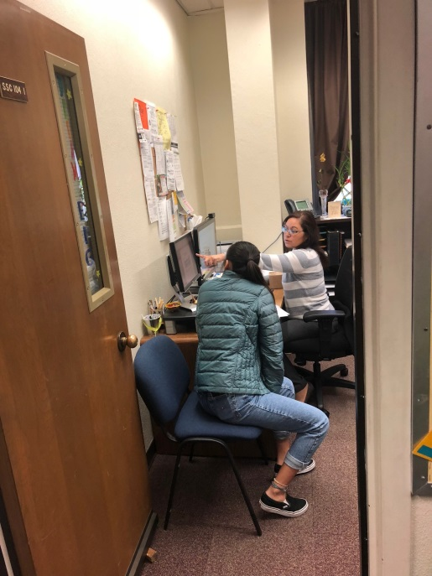 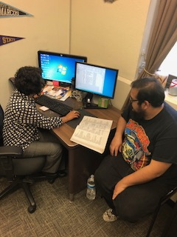

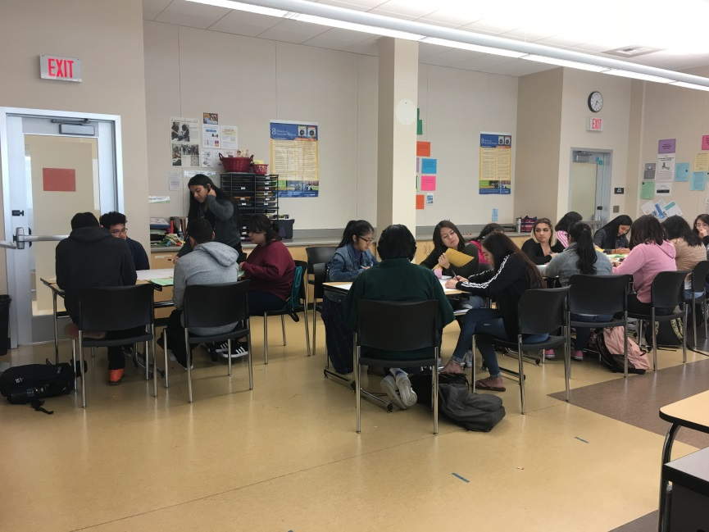

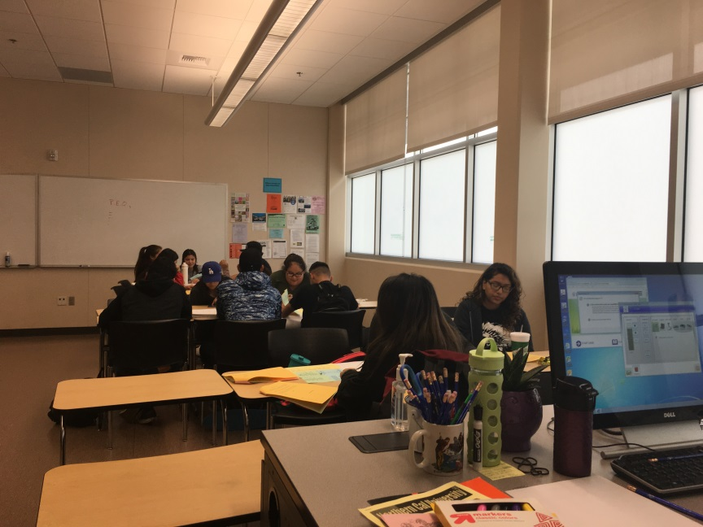

Counseling includes:

The Puente Counselor/Co-coordinator’s functions include but are not limited to the following:

* Recruiting potential Puente students.
* Organizing and planning orientations, events, and campus or museum tours for Puente students.
* Teaching Human Development 101 and 105 courses.
* Assisting Phase I to III students in examining, planning, and setting his/her personal, academic, and/or career goals.
* Developing six semester plans for each student.
* Assisting Phase III students with transfer applications.
* Meeting with university and academic personnel to facilitate transfer process for both Phase I to Phase III students.
* Providing Phase I to Phase III students’ academic, career, transfer and personal counseling.
* Attending Puente Counselor’s Training Conference each fall and spring semester run by the Puente Project Statewide Office.
* Preparing letters of recommendation for students applying to universities, scholarships, and jobs.
* Monitoring and maintaining Phase III Puente students’ academic progress through ongoing counseling appointments.

**English Instruction Component:**

The program provides the active cohort (Phase I and II students) with rigorous, culturally relevant English instruction that prepares them as readers, writers, and critical thinkers to transfer to and succeed at a four-year institution. English instructors are trained in Puente pedagogical practices like formulating *familias* (families) in the classroom and *Conocimiento* (students getting to learn about themselves and other Puente students) through poems, literature, and activities practiced in the classroom to promote a supportive academic environment. Furthermore, to help students understand college-level writing and reading and how to navigate composition in higher education, English instructors are trained through the Puente Summer Institute and yearly ongoing pedagogical summits on how to institute best practices such as acceleration, active learning, cultural responsive teaching, restorative justice, and collaborative, cooperate learning. As a result, Puente students are significantly more likely than their non-Puente peers to successfully transfer to highly esteemed four year universities.

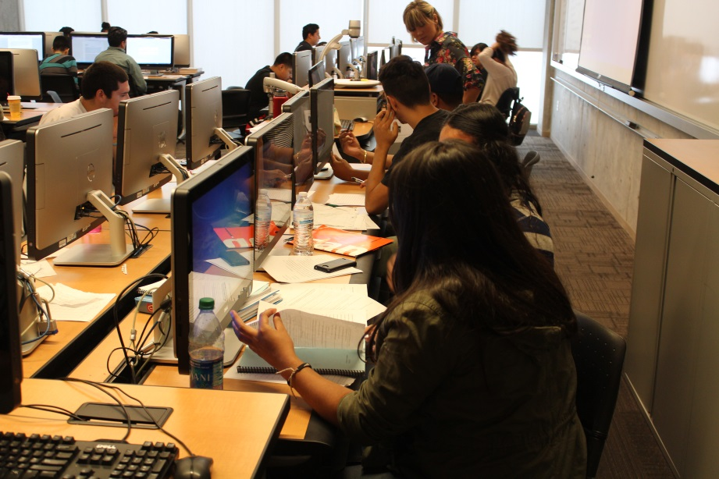

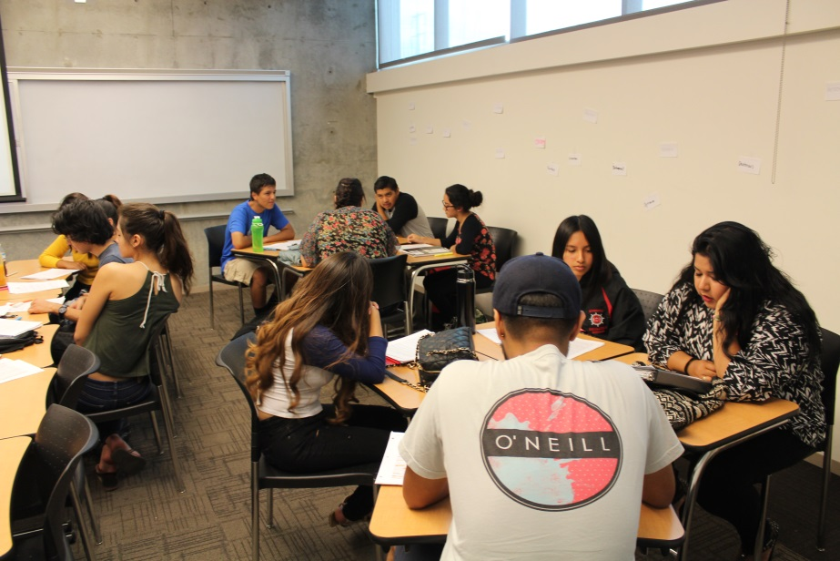

English Writing Instruction includes:

The Puente English Instructor/Co-coordinator’s functions include but are not limited to the following:

* Integrating Latino literature/themes in Phase I and other multicultural literature/themes in Phase II in the English curriculum.
* Teaching writing and critical thinking skills.
* Developing writing assignments where students integrate mentors and their communities as a resource for writing.
* Creating a supportive English writing environment.
* Acting as an academic resource to Phase III students through office hours to review college writing assignments.
* Assisting Phase III students in their college and scholarship personal statement process.
* Planning, developing, and designing the Puente Newsletter for each semester.

**Mentoring Component:**

Since a high percentage of the students are first generation college students, the Puente program includes mentors for students to have a positive, successful adult role model; help to navigate college; guide in setting and achieving goals; and taught how to develop a supportive network. Mentors are individuals who have completed a bachelor’s degree and are recruited from the on- and off-campus community to meet individually with a Puente student to provide him/her with academic, personal, and career guidance. The new mentors must complete a training session on mentoring and the characteristics and needs of the Puente student. Students in the active cohort (Phase I students) are provided with a mentor. Recent research from the National Center for Educational Statistics communicate how three-fourths of Hispanic young people (compared to about one-third of white students) attend schools where most of their classmates qualify as low income; these statistics help explain spreading economic isolation on a statewide level. Socioeconomic factors contribute to many Hispanic students feeling marooned in schools where financial struggle is the rule and economic stability—and all the social and educational advantages linked to it—is very much the exception. Our mentors step in and stop the cycle through exposure and experience. At events we organize, they share personal, academic, and career experiences, providing support to Puente students, their families, the college, and the community. Notably, many of these mentors are our own returning alumni, eager to give back to the program that fed them. Students are also asked to write a reflective paper using quotes from the meetings with their mentor. The commitment of the mentor is for one academic year, to meet the mentee (student) for up to 20 hours for the year through attending Puente events and scheduling additional meetings to discuss educational and career goals.

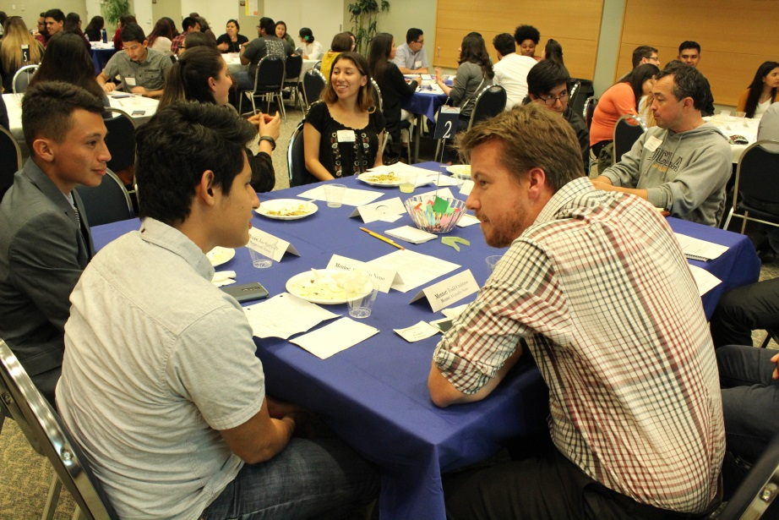

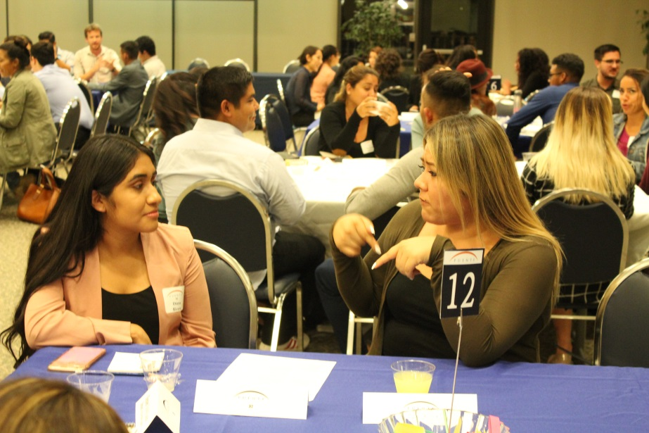

Mentoring includes:

* Sharing personal, academic and career experiences with student.
* Providing academic/social network for students.
* Mentoring assists student with class paper(s).
* Providing academic and career support to students.
* Providing a window into real-life work environments.
* Participating in academic/cultural activities.

In addition, Puente Program students are highly encouraged to be involved on- and off-campus activities. The students in the Puente Program are involved in the Puente Club as well as other student organizations on-campus. Puente students are also encouraged to join the Associated Student Organization as well as Interclub Council so that their voices as students could be heard on the campus and also be a part of the larger campus community. Puente students also have the opportunity to participate in the Puente Statewide Office events such as the Summer Leadership Institute and the Summer Writing Symposium. Puente students from across the state and now nationwide have to apply to these opportunity trainings over the summer where students are trained as leaders or writers depending on the program that they apply to for the summer.

1. **How does the program interact with other on-campus programs or with off-campus entities?**

The Puente Project collaborates closely with all the programs and services as well as with all campus divisions:

**Assessment Center**— Puente obtains lists of potential Puente eligible students through the English placement test.

**Admissions Office**— Puente works with Admissions students encounter glitches with their registration as well as their residency.

**EOPS/Financial Aid**—Puente makes sure the eligible Puente students complete the process to obtain the benefits of these services.

**MESA and KEAS**— Many Puente students are also part of these programs so we work in collaboration with them to ensure the students’ success in their math and science courses.

**First Year Experience**— Puente co-sponsored counseling round tables for the AB540 students and share with each other students’ best practices for success.

**Project Success**—Puente and Project Success collaborated with the Transfer Center, to offer a transfer event to inform their students about the various universities transfer opportunities throughout the country. The event contained representatives from UC/CSU/Private/HBCU campuses and was designed to serve the unique needs of underrepresented students.

**Career Center**— the Puente program collaborates with the Career Center to provide career resources for Puente students to assist them in their career research.

**All campus divisions especially Counseling, Humanities, and Behavioral & Social Sciences**— these departments provide the faculty who are the co-coordinators and instructors for the courses required for the Puente Project.

**Outreach & School Relations**—assists Puente with its recruitment efforts reaching out to high schools and also inviting the program to present at their coordinated presentations.

**The Student Development Office**—provides guidance and support to The Puente Club. Our students have also been heavily involved with the Dialogue series put on by the Student Development Office, helping our campus grow more culturally competent by bravely sharing their experiences and insight on a public forum.

**Four-year Universities**— collaboration with the University of California (UC), California State University (CSU), and private universities in preparing students for transfer to these university systems. Furthermore, the program works closely with the Puente State Office in UC Berkeley, because they provide on-going training and financial support for the mentoring activities. Our students also attend an annual motivation conference at UC San Diego where they hear Latino speakers, tour the campus, meet reps from each of the UC campuses, and attend workshops on topics ranging from “Masculinity and Culture,” “Planning for Graduate School Today” and “Creative Writing” to “Indigenous Practices and Future Doctors.”  We also send two students to a two week long leadership conference each summer hosted by UC Riverside where the students are invited to dorm while they cultivate leadership skills. Last year, in concordance with the UC Riverside Puente Leadership Conference, we also sent two students to a 5 day intensive writing camp where they were able to workshop poetry, fiction, and memoir pieces with award winning author, Alex Espinoza.

**Local Community**—In addition, the Puente Project works in partnership with the local community to recruit professional mentors for the program. Finally, the program reaches out to local business for fundraising and donations to support the program events.

1. **List notable achievements that have occurred since the last Program Review.**

Fall 2014 the Puente Program was in hiatus due to no counselor assignment but students were recruited and enrolled in the assigned Puente sections (English A and Human Development 8 {now 101}). The Puente English section was still being taught by the assigned full-time English Puente instructor. The Human Development courses where being taught by the Human Development department instructors. In Spring 2015, a full-time counseling faculty was re-assigned to work with the Puente Project program, thereby resurrecting the program to active status.

After eleven years of the Puente Program at El Camino College having different temporary full-time or adjunct counseling faculty, which hurt the program’s effectiveness, in the Fall of 2015 a full-time tenure track, 50% Puente and 50% General Counselor was hired which would strengthen the Puente Project program, especially since there was going to be an additional cohort to the program. Since the Puente Program did not have a full-time, tenure track counselor, the adjunct counselor could only work 20 hours a week and because the model requires counselor to conduct the counseling, teaching of the Human Development class, attend the English Puente class, coordinate events, and co-coordinate the mentor component of the program, the program and the Phase III students were affected. There was not accessibility for appointments to ensure that their educational plan was up to date so that they could transfer in a timely matter. Furthermore, because of the time limitations, the Puente adjunct counselor did not have enough time to coordinate activities for Phase III students who are preparing to transfer. When students are ready to transfer, the process is a critical time for counselors to assist these students. These activities consist of: working on university applications, writing personal statements, making sure all classes will be completed. Complete the TAG application, writing letters of recommendation, calculating GPA, completing the Financial Aid application, conducting follow-up contact with universities, applying for graduation, informing and demonstrating to student how to request other college or College Board transcripts, etc.

A second cohort was created in Fall 2016-Spring 2017 academic year for the Puente Project to serve more underrepresented students based on these needs funding was provided by Student Equity. By adding a second cohort of Phase I students in Fall 2016, the Puente Program is able to serve additional students each year above the 130 continuing students of the program and increase the visibility and impact of the program at El Camino College.

Due to the additional cohort demands, the program needed additional clerical support as well as other program needs; a Clerical Assistant was hired through Student Equity funds.

In Fall 2016, due to the growth of the program, a need for additional counseling support was observed; for this reason, two adjunct counselors were requested to serve the counseling needs of all the Puente students and also assist with recruiting new Puente students for the following academic year.

Furthermore, in the Spring of 2017, the program successfully graduated and transferred 30 Puente students to UC and CSU surpassing previous numbers of students transferring to four-year universities. This was the largest number of Puente students who transferred to four-year universities in one academic year.

In Spring 2017, Erica Brenes, Puente English Teacher, was honored by EOPS with the Instructor Appreciation Award for the year, recognizing the impact our program has on equal opportunity.

In addition, one of our Puente students was involved in the Associated Student Organization (student government on campus) as the Puente Club representative and assisted in developing the campus food pantry.

In the Spring of 2018, the Puente Program and Project Success collaborated with the Transfer Center, to offer a transfer event to inform the students in the programs about the various universities and transfer opportunities throughout the country. The event contained representatives from UC/CSU/Private/Historically Black Colleges & Universities (HBCU) campuses and was designed to serve the unique needs of underrepresented students.

Furthermore the program has always maintained numerous mentors for the program which provides a one-to-one ratio of personalized mentoring. With the growth of our program, we were able to recruit additional mentors to still provide this one-to-one ratio. Due to recruitment efforts and word of mouth referrals, the interest in Puente mentoring has increased and we now have mentors on a waiting list for the next academic year.

1. **What prior Program Review recommendations were not implemented, if any, and why? What was the impact on the program and the students?**

* Having a large space similar to EOPS (such as a Multi-Cultural Center) to accommodate students from the Puente and Project Success programs. The Puente Project and Project Success programs’ 30+ years of success at ECC stem from our ability to build communities and personal relationships with our students by interacting with the program’s counselors, staff and other peers which is precisely why we need a space designated as a Cultural Academic Center known by students as the "Village.” The “Village” will serve as a study space for students and a place for students to feel welcomed, appreciated and is seen as being a part of El Camino College’s campus. To be effective, it also needs to house offices for the programs’ counselors and a space for students support services such as tutoring, computer access, printers, and Wi-Fi for personal lab tops for students to be able to do homework and become successful in college. This space enables students who struggle to complete homework at home to do so in a safe, empowering environment that contributes to their ultimate success. Encouraging, even requiring studying on campus works well with our students because it models, practices and affirms sustained and effective study habits for our students. Such a center also has the capacity to facilitate even more opportunities for students/counselor/faculty face-to-face interaction, so that students who historically feel underrepresented and underserved can seek assistance and find answers. The Village is an expression of and celebration of our students’ voices and model for how students can approach their homework. We imagine a center where students freely ask academic related questions, learn from peers, and share college success strategies. Although our two programs have separate missions, our students share many important qualities and would grow exponentially by sharing a space. Seeing that almost all of our students are first generation college students, their shared academic learning environment will directly contribute to student persistence, a sense of belonging, and in turn, student retention through offering exposure, support, familia (family), and a chance to exchange academic tips and resources. As a result, this space is critical because it falls in line with our two programs' shared focus which is helping our students’ succeed at El Camino College and ultimately transfer to a four-year university.

In Fall 2014 through Spring 2016, the Puente program counselor’s office was not located in the area known as the “Village.” At this point students from the Puente Program did not have a space to study or build a relationship with the counselor, staff, and peers that the students did not seem to connect with each other or the program and did not seek out the resources that the program offers or come to meet with the counselor. It is almost as they felt disconnected from the program and their peers which is against the mission of the Puente Project for the students to build a support community, a familia (family), in college.

* Need at least four fully functional computers with internet access and one printer for student use in the Multi-Cultural Center. Purchase five tables or desks for the computers and printer

Students not having access to computers and internet in our “Village,” makes it difficult for students, who are already low-income and do not have access at home to these luxuries, to do their homework in the academic environment already provided to them such as the “Village.” Computer labs are full of other students that it makes it difficult for our students to compete with the general population when we could offer these services to them in the “Village” and assist them in being successful and completing their academic goal at El Camino College.

* Develop an emergency textbook fund

**Program Environment**

***Information in this section should help build a case for additional resources for the program***

1. **Describe the program environment. Where is the program located? Does the program have adequate resources to provide the required programs and services to staff and students? If not, why?**

Currently the Puente program is housed in the Student Services Center inside the Counseling Center in the West wing, this area is known to the students as the “Village.” Where students feel they come and congregate to do homework and build their support community by building relationships with other students, counselors, and staff. This area is also shared with Project Success and Athletics. Each of the full-time Puente counselors has an office in this area along with Project Success, Athletics, and general counselors. The Puente Program counselors share their office with a clerical assistant and student workers. For this reason, the two offices have two computers. However, during the registration and university application periods, this poses a challenge because additional computers are needed in order to assist students with registration and university applications. In addition, the “Village” area is not large enough to hold students from multiple programs at the same time who are seeking tutoring assistance and a place to lounge while they wait for their next class. In the “Village” area Puente hosts English tutoring and Project Success hosts Math tutoring. Each of the programs encourages its students to stop by for the tutoring; however, students often mention that there isn’t enough room to sit for the tutoring, because there are other students already there doing homework. So they end-up leaving and do not return for the tutoring. In the Fall 2017 semester a total of 73 Puente students (Phase I and III), which does not include the tally of the students in the Project Success Program, utilized the “Village.”

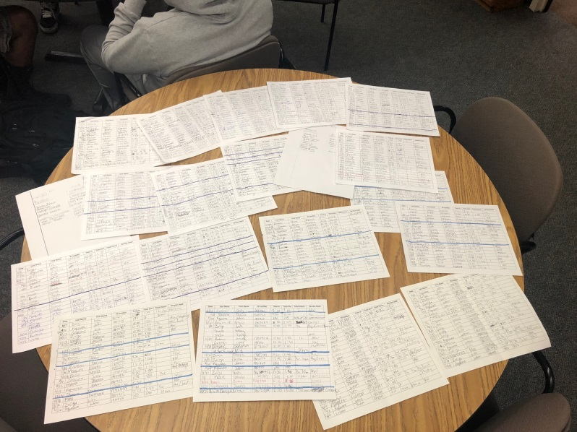

To the right are all the sign-in sheets for the Puente Program students that utilize the “Village” for study time.

Not all students can utilize the “Village” at one time because it is not a big enough space. Finally, the Wi-Fi connection is very poor in the Village area, it does not allow for adequate connection to the internet. Often times, students resort to the Library or go home instead of staying in this area. As a result, students do not build strong relationships with the other cohorts of Puente students, or with students from other programs.

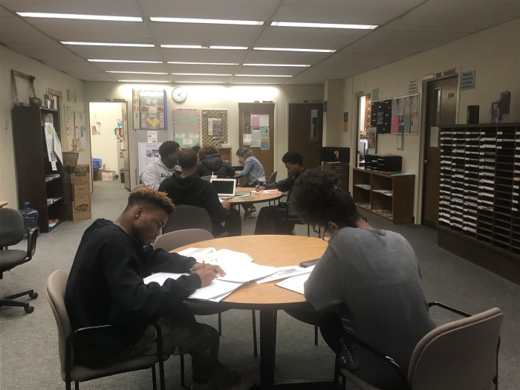

Additional needs of the Puente Program are to have a permanent staff person to serve as a clerical assistant (TNC position) and a program Advisor to assist in the planning and coordination of the Puente events. In order for the program to function properly, we need to have consistency with the TNC staffing. There are a lot of office functions that are critical and must be performed constantly for the program to continue running smoothly. Some of these tasks include placing requisitions for food requests four times a year. There is the process of ordering buses for University tours for students, booking classrooms and other facilities to conduct orientations and workshops throughout the year among other office procedures. In addition a Services Advisor is needed so that this person can assist students in the area of registration and programing for classes as well as in conduction workshops and assisting orientations and recruitment of Puente Students. The need for someone in this capacity is stronger as the program grows from one semester to the next.

1. **Describe the number and type of personnel assigned to the program. Please include a current organizational chart.**

* One - 100% Full-time Puente Counselor
* One - 50% Puente and 50% General Counselor
* Two - 25% release time for two Puente English instructors for two cohorts
* One - 50% Clerical Assistant to provide Puente’s clerical support.
* Three - Work-study students

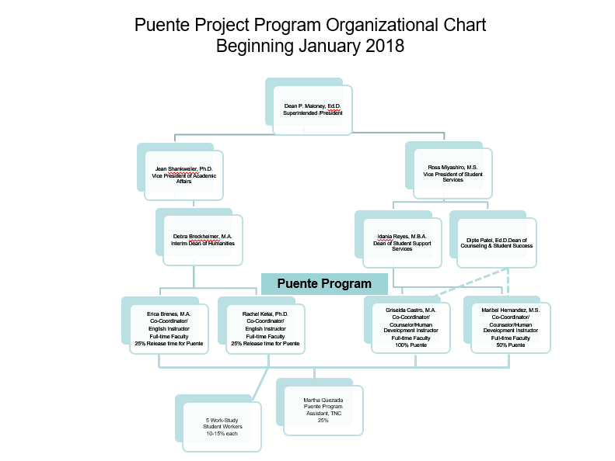

1. **Describe facilities needs for the next four years.**
2. Need a large space similar to EOP&S to accommodate students from the Project Program and Puente Program’s Phases I, II and III to hold study and tutoring sessions with white boards all over the room and at least five computers with desks and chairs, one large printer for students, and furniture to study. The “Village” will serve as a study space for students and a place for students to feel welcomed, appreciated and is seen as being a part of El Camino College’s campus. To be effective, it also needs to house offices for the programs’ counselors and a space for students support services such as tutoring, computer access, printers, and Wi-Fi for personal lab tops for students to be able to do homework and become successful in college. This space enables students who struggle to complete homework at home to do so in a safe, empowering environment that contributes to their ultimate success. Encouraging, even requiring studying on campus works well with our students because it models, practices and affirms sustained and effective study habits for our students. Such a center also has the capacity to facilitate even more opportunities for students/counselor/faculty face-to-face interaction, so that students who historically feel underrepresented and underserved can seek assistance and find answers. The “Village” is an expression of and celebration of our students’ voices and model for how students can approach their homework. We imagine a center where students freely ask academic related questions, learn from peers, and share college success strategies. Although our two programs have separate missions, our students share many important qualities and would grow exponentially by sharing a space. Seeing that almost all of our students are first generation college students, their shared academic learning environment will directly contribute to student persistence, a sense of belonging, and in turn, student retention through offering exposure, support, familia (family), and a chance to exchange academic tips and resources. As a result, this space is critical because it falls in line with our two programs' shared focus which is helping our students’ succeed at El Camino College and ultimately transfer to a four-year university.

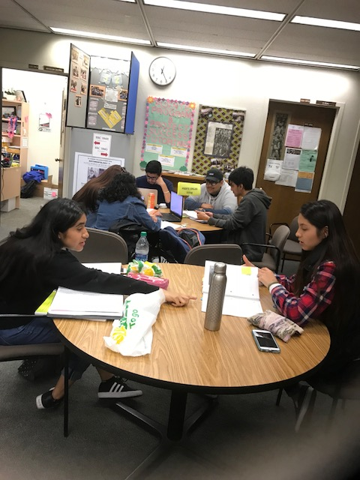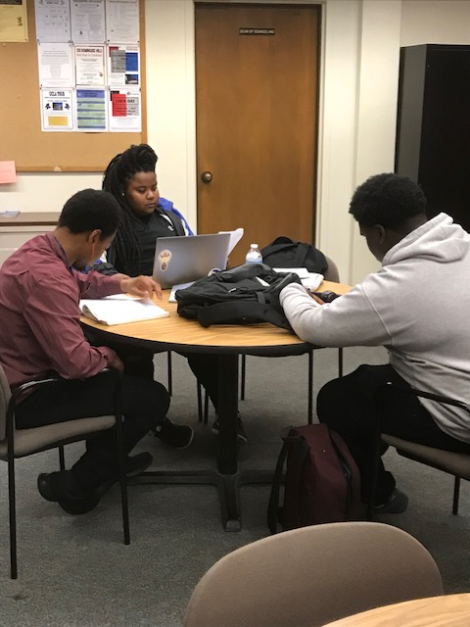

1. In order to grow the program, we would need an additional office space to hire a Puente Program Advisor to assist with coordination of events and activities of the program. Furthermore, we would need an additional office space to place the program’s adjunct counseling faculty and for the program’s English faculty to hold office hours in the cultural/academic center that houses the Puente Program.
2. Student workers to assist Puente staff with various event tasks and duties
3. Need a Clerical Assistant to provide assistance with the various clerical tasks incurred by the program
4. Space needed for peer mentor program to hold information sessions and workshops for recruitment, orientation and tutoring.
5. Space needed to house the Puente counselors and English professors. As well as a third Puente team, so that the inactive team can work with Phase III students and to update any web information about the Puente Project.
6. **Describe the equipment (including technology) needs for the next four years.**
7. Need adequate Wi-Fi connection so students can have access when they are in the Village area
8. Need at least five fully functional computers with internet access for student use for homework, complete orientation, and register for classes as well as to fill-out transfer applications.
9. Need one large printer for students
10. **Describe the specific hours of operation of the program. Do the scheduled hours of operation meet the needs of staff and students?**

Currently the Puente Project hours are Mondays through Wednesdays from 9:00 am till 5:00p.m. Thursdays are from 9:00 am until 7:00 p.m. Currently these hours have improved on meeting the needs of students and staff because the office has a clerical assistant as well as three adjunct counselors who provide a total of 15 hours per week. While the full-time counselors are teaching or away in meetings, or visiting the English classroom, and attending Puente/Transfer training and conferences the adjunct counselors cover the office hours. The clerical assistant is only available 50% and she is also doing recruitment visits at off campus sites; hence, the adjunct faculty is not able to cover all the vacant Puente hours.

1. **Describe the external factors that directly affect the program. Take into consideration federal and state laws, changing demographics, and the characteristics of the students served by the program. How does the program address the external factors?**

Currently the external factor that will affect the program is the bill AB 705, which states that students should complete college transferable English within one year of entering the college. Since one of the components of the Puente Project is English instruction, the recruitment and the English classes will have to be modified in order to comply with the regulations of the bill. One of the ways that the program is addressing this new regulation is by piloting in the 2018-2019 academic year, the English 1As course which is the college level English with a support class. The Puente English faculty will be teaching both the English class and the support English class in order to prepare the students to complete college transferable English in the first semester of college and in the second semester of the program, students will take and complete English 1C, Critical Thinking and Composition. By completing the Puente Project, students will have completed all of the required English courses in order to transfer to a four-year university.

**Service Area Outcomes (SAOs)**

1. ***List the program’s SAOs.***

The Puente Program administered a pre- and post-test to measure the SAO. The pre- and post-test was handed to the Puente students before and after the Motivational Conference.

1. ***How were the SAOs developed? Who was engaged in the creation of the SAOs?***

Due to the Puente Program providing a variety of activities, co-coordinators, Griselda Castro and Maribel Hernandez, decided to create a pre-test and post-test for one of the activities. The Puente Transfer Motivational Conference was chosen as the activity to assess by measuring the transfer process knowledge obtained by the Puente students after attending the conference.

1. ***How often are the SAOs assessed and who is engaged in the discussion?***

The Puente Program was under the Counseling Division during the past Program Review cycles until this Spring 2018 cycle. This is the first time the Puente Program is engaged in developing its own Service Area Outcome.

1. ***What has been done if the SAO assessment results were not as anticipated?***

N/A

1. ***Where the SAOs assessment results shared with staff, students, and the public?***

In the past, the SAO where not done but we plan to share our current results with staff, students, and the public.

1. ***Have the SAO assessment results indicated the need to change or modify components of the program? If so, were the changes implemented?***

In the past there were no SAOs developed so we cannot address this question at this point.

**Program Improvement**

***Information should help determine where program resources should be dedicated***

1. **What activities has the program engaged in to improve services to students?**

The program provides a number of information sessions throughout the Spring and Summer terms to inform perspective students of the program. Puente staff also participates in various events during the semester in order to recruit students. Once in the program, the students engage in a variety of activities that are designed to help them increase their academic attainment. These activities are the following:

Informational Sessions – The Puente Project program has developed and planned a series of Informational sessions throughout the spring semester to inform the high school seniors and continuing ECC college students about the program requirements and to make it accessible to as many students as possible who are interested in being part of a learning community program.

University and cultural tours – As part of the Puente goals and objectives, Puente students must be exposed to universities and to various cultural tours. Students will visit two Southern California Universities (UC Santa Barbara and another UC campus for their Puente Motivational Conference.) Plus, the Puente students are encouraged to apply for a spot in the Northern California tour during spring break, where students visit UC Merced, UC Davis, UC Berkeley, and UC Santa Cruz. In addition, the Puente Program emphasizes cultural diversity, tolerance and knowledge of student’s ancestors in the United States; for this purpose, students are given tours and are offered the opportunities to visit the Museum of Tolerance, the Los Angeles Great Wall, the Los Angeles Contemporary Museum of Art (LACMA) or the Museum of Latin American Art (MOLAA). The Puente counselors and English instructors coordinate these activities and/or inform students of such activities so they will attend these functions and later use this information for a written assignment.

Student/Mentor Mixer, Noche de Familia (Family Night) and End of Year Awards Ceremony – These are three social evening events which students are required to attend. In the first event, mentors are given an orientation and are introduced to their mentee. The second event includes mentors, parents as well as students. In addition, parents are given a brief overview of what the Puente Project is and how they can support their son/daughter in their college journey. During this event parents are seated with their student and the student’s mentor. In the last event, students are awarded certificates for having completed the Puente Phase I and II and will be entering Phase III the following fall semester. In addition, Puente graduating and transferring students are also recognized at this event for having met the requirements of either the Associate Degree or/and transfer requirements. At this event, parents are also invited so they become aware of their students’ potential in higher education. These events will serve approximately 250 people which consist of ECC’s administrators, faculty, staff, and Board of Trustees, Puente students including family members, and Puente mentors.

1. **How have program personnel used metrics to improve program services? Provide metrics from the last four years.**

Seeing the success of the Puente Project Program at El Camino College compared to the general population, the program was supported to grow with a second cohort to replicate the services to an additional group of students.

*Data provided by the El Camino College’s Institutional Research 2018*

|  |  |  |  |  |
| --- | --- | --- | --- | --- |
| **Puente Metrics** | | | | |
| **Fall Terms** |  |  |  |  |
|  |  |  |  |  |
| **Success and Retention** |  |  |  |  |
|  | **Fall 2014** | **Fall 2015** | **Fall 2016** | **Fall 2017** |
| Program Success | 72.3% | 70.1% | 82.8% | 77.1% |
| ECC Success | 67.6% | 68.0% | 68.8% | 69.3% |
|  |  |  |  |  |
| Program Retention | 81.5% | 85.7% | 93.2% | 87.7% |
| ECC Retention | 82.2% | 82.8% | 83.1% | 83.2% |
| |  | | --- | |  | |  |  |  |  |
|  |  |  |  |  |
|  |  |  |  |  |
|  |  |  |  |  |
|  |  |  |  |  |
|  |  |  |  |  |
|  | Fall 2014 | Fall 2015 | Fall 2016 | Fall 2017 |
| Program Success | 0.723076923 | 0.700520833 | 0.828389831 | 0.771062271 |
| ECC Success | 0.675992629 | 0.680018157 | 0.687607466 | 0.692913509 |
| Program Retention | 0.815384615 | 0.856770833 | 0.93220339 | 0.877289377 |
| ECC Retention | 0.822278743 | 0.827980215 | 0.831384625 | 0.831788017 |
|  |  |  |  |  |
|  |  |  |  |  |
| **Persistence** | | | | |
|  | **Fall 2014** | **Fall 2015** | **Fall 2016** | **Fall 2017** |
| Enrollment | 78 | 118 | 133 | 147 |
| 1 Term Persistence | 81% | 91% | 85% |  |
| 2 term Persistence | 68% | 67% | 65% |  |
| **Awards and Transfers** | | | | |
|  | **2013-2014** | **2014-2015** | **2015-2016** | **2016-2017** |
| AA or AS | 16 | 20 | 29 | 39 |
| Certificates | 1 | 1 | 1 | - |
| Transfers | 8 | 10 | 7 | 15 |
|  |  |  |  |  |
| ECC AA or AS | 1,983 | 1,977 | 2,463 | 2,783 |
| ECC Certificates | 459 | 410 | 474 | 558 |
| ECC Transfers | 1,500 | 1,478 | 1,500 | 1,576 |

*Data provided by the El Camino College’s Institutional Research 2018*

|  |  |  |  |  |
| --- | --- | --- | --- | --- |
| **Puente Metrics** | | | | |
| **Spring Terms** |  |  |  |  |
|  |  |  |  |  |
| **Success and Retention** |  |  |  |  |
|  | **Spring 2014** | **Spring 2015** | **Spring 2016** | **Spring 2017** |
| Program Success | 73.4% | 73.2% | 70.7% | 79.9% |
| ECC Success | 67.9% | 68.0% | 69.5% | 69.3% |
|  |  |  |  |  |
| Program Retention | 81.6% | 84.3% | 85.4% | 88.9% |
| ECC Retention | 83.0% | 81.3% | 82.6% | 82.5% |
| |  | | --- | |  | |  |  |  |  |
|  |  |  |  |  |
|  |  |  |  |  |
|  |  |  |  |  |
|  |  |  |  |  |
|  |  |  |  |  |
|  | Spring 2014 | Spring 2015 | Spring 2016 | Spring 2017 |
| Program Success | 0.733552632 | 0.731707317 | 0.707006369 | 0.798525799 |
| ECC Success | 0.679210454 | 0.680185116 | 0.695019661 | 0.693023573 |
| Program Retention | 0.815789474 | 0.843205575 | 0.853503185 | 0.889434889 |
| ECC Retention | 0.82954159 | 0.812791287 | 0.825544698 | 0.825410353 |
|  |  |  |  |  |
|  |  |  |  |  |
| **Persistence** | | | | |
|  | **Spring 2014** | **Spring 2015** | **Spring 2016** | **Spring 2017** |
| Enrollment | 91 | 91 | 103 | 110 |
| 1 Term Persistence | 78% | 81% | 69% | 75% |
| 2 term Persistence | 68% | 74% | 53% |  |
| **Awards and Transfers** | | | | |
|  | **2013-2014** | **2014-2015** | **2015-2016** | **2016-2017** |
| AA or AS | 16 | 20 | 29 | 39 |
| Certificates | 1 | 1 | 1 | - |
| Transfers | 8 | 10 | 7 | 15 |
|  |  |  |  |  |
| ECC AA or AS | 1,983 | 1,977 | 2,463 | 2,783 |
| ECC Certificates | 459 | 410 | 474 | 558 |
| ECC Transfers | 1,500 | 1,478 | 1,500 | 1,576 |

1. **If applicable, explain any patterns in student success, retention, persistence, graduation, and transfer in terms of student characteristics and program objectives and discuss planned responses or changes.**

As noted in the above metrics, the patterns of student success, retention, persistence, graduation, and transfer rates are due to the rigorous training and academic expectations of the students in the Puente Project Program. The faculty is trained by the Puente Project State office every academic semester on teaching pedagogy and counseling techniques to address the needs of the community college student and how to create a supportive environment for that student to be successful, persist, and achieve his/her academic goals, (i.e., certificate, associates, and/or transfer to a four-year university). In addition, the program’s model of building a familia (family) as a part of the program allows the students to create a sense of unity and trust among their peers, faculty, and staff in order to create a supportive network to continue in higher education since more than 50% of the Puente students are first generation college students.

**Customer Service**

***Administer a customer service survey to students or colleagues, if applicable. Please administer the survey the semester prior to submitting your program review.***

1. How was the survey conducted? Please include a copy of the survey to the appendix.

N/A

1. What were the major findings of the customer service survey?

N/A

1. Describe exemplary services that should be expanded or shared with other programs.

N/A

1. What aspect of the program’s service needs improvement? Explain how the program will address service improvements.

N/A

**Conclusions and Recommendations**  
***Only include information previously referenced in the program review***

1. **Summarize the program’s strengths.**

A major strength of the program is that it has been in existence at El Camino College for over 32 years offering to students: learning communities (English and Human Development courses), mentoring, academic and career counseling, math/English tutoring and a supportive networking community at the college level and the state level (summer institutes) to succeed in their higher educational goal. Puente students are being taught how to be successful in college through the English and Human Development courses, attending the Transfer Motivational Conference, the mentor/transfer activities, university and museum tours, being encouraged to participate in student organizations, and also encouraged to participate in the Puente Statewide Office events such as the Summer Leadership Institute and the Summer Writing Symposium. In the 32 years, many Puente students have graduated and transferred to four-year universities and of these students many have returned to become mentors to the Puente’s Phase I students. Hence, the Puente Program has a strong mentor network which currently consists of 68 mentors which is a 1 to 1 ratio of mentor to student (mentee).

1. **Summarize the program’s areas that need improvement.**

The area where the program needs improvement is in the area of gathering data as well as in the area of tracking students because the current data system does not effectively collect the data of all the Puente Project students at El Camino College.

The Puente program also needs assistance in identifying a location for students to congregate, hold their tutoring sessions and be able to do homework, and interact and build relationships with other students, staff, and faculty, a location which is currently known by students as the “Village.”

1. **List the program’s recommendations in a prioritized manner to help better understand their importance to the program.**
   * + 1. The Project Success and Puente Project Program “Village” area
       2. Hire a full-time Puente Program Classified Advisor
       3. Hire an adjunct counselor to work with the Puente phase III students
2. **Please indicate whether the program should continue or be discontinued.**

_X__ Continue Program

___ Discontinue Program. Explain how the program’s services could be handled by another on-campus entity if the program has been declining or is no longer fully utilized.

**Student & Community Advancement Program Review Committee**

***Ratings***

* **Excellent**

The program review was extremely well written. Concise and grammatically correct with few to no spelling errors. A model program review that is ready to be posted online for a public audience.

* **Meets Expectations**

The program review was adequately written. Lengthy or vague at times or included some grammatical and spelling errors. Corrections should be made prior to posting online for a public audience.

* **Needs Improvement**

The program review was poorly written or incomplete. Too lengthy or vague or too many grammatical and spelling errors throughout the document. The program review needs to be rewritten and resubmitted to the Student & Community Advancement Program Review Committee by an established deadline.

**Revised**

5/5/2010; 3/13/2013; 3/31/2014; 4/15/2014; 6/1/2015; 8/20/2016