EL CAMINO COLLEGE AND
EL CAMINO COLLEGE COMPTON CENTER
STUDENT & COMMUNITY ADVANCEMENT
PROGRAM REVIEW TEMPLATE

Program Review
Program Review is a tool used by program personnel to critically evaluate the services offered by the program and to recommend necessary improvements that address the needs of the College or the Center and the community.

Desired Outcomes
Desired Program Review outcomes include: a thorough evaluation of the program’s effectiveness using quantitative and qualitative data; recommendations for program improvement (or if appropriate program discontinuance); and placement of the recommendations into the program’s annual plan.

Program Description
Assume the reader of the program review does not know about your program

- Describe the program. How does the program link to the College’s mission statement, statement of values, or strategic initiatives?

The Extended Opportunity Programs & Services (EOPS) program is a state funded program aimed at serving students of educationally and socio-economically disadvantaged backgrounds. The EOPS program was initiated as a result of the Civil Rights Movement of the 1960s and was signed into state law in 1969 through California Senate Bill 164, (SB 164, Alquist, Chapter 1579, Statutes of 1969). The program was created to enable students affected by language, social, and economic hardships to achieve their educational objective and goals including, but not limited to, obtaining job skills, occupational certificates, associate degrees, and transfer preparedness to four-year colleges and universities. The EOPS program at El Camino College provides academic counseling, direct aid in the form of book vouchers and grants, supplemental tutoring and peer advising, academic progress monitoring, transportation assistance, school supplies, transition services to four-year colleges and universities, student success workshops, and other support services. The mission and charge of the EOPS program is outlined in California Education Code, Sections 69640 through 69656, and California Code of Regulations, Title 5, Sections 56200 through 56292.

The Cooperative Agencies Resources for Education (CARE) program is a state funded program aimed at serving students who are welfare-dependent single heads of household in receipt of Temporary Assistance for Needy Families (TANF), who are eligible for the EOPS program, are at least 18 years of age, and who have at least one child under the age of 14 years at the time of admittance into the program. The CARE program was signed into state law in 1982 through California Assembly Bill 3103 (AB 3103, Hughes, Chapter 1029, Statutes of 1982). The program was created to provide students with job-relevant education to break the welfare dependency cycle and assist them to employment with the eventual goal of self-sufficiency. The CARE program at El Camino College provides academic counseling, assistance with child care, direct aid in the form of book vouchers and grants, school supplies, transportation assistance, supplemental tutoring and peer advising, meal vouchers, student success workshops, vocational board examination and certification fees, and referrals to on-campus resources and off-campus community-based services and public agencies. The CARE program is the first state-funded and only statewide program of its kind in the nation according to the California Community Colleges Chancellor’s Office.

The EOPS and CARE programs support the Mission Statement of El Camino College by truly “making a positive difference in people’s lives.” Both programs are charged with providing “over, above, and in addition to” programs and services in comparison with other on-campus entities in an effort to provide outreach services to the underserved, underprepared, and underrepresented students within our service area, assist students with their transition to higher education, and provide support services that enable students to overcome significant academic, financial, and personal challenges and obstacles to attain a vocational certificate, associate degree, and/or transfer preparedness to four-year colleges and universities. Both programs also support the College’s effort to provide “excellent comprehensive educational programs and services that promote student learning and success in collaboration with our diverse communities” by assisting students with the completion of orientation, assessment testing, education plans, and other steps that are critical for students to succeed in college.

The EOPS and CARE programs support the Statement of Values of El Camino College by responding proactively to the educationally needs of students, employees, and the community; working respectfully with colleagues cooperatively and in cooperation to provide meaningful programs and services to help ensure student success; working with integrity to adhere to federal, state, and local regulations to serve in the best interest of our students, colleagues, and the community; committed to working with a diverse workforce, community, and student population regardless of background for the betterment of all served by the programs; and aspiring to quality and excellence in all that is provided in terms of programs and services by EOPS and CARE personnel.

The EOPS and CARE programs support the Strategic Initiatives of El Camino College with specific emphasis on Strategic Initiative B – Student Success & Support by promoting and empowering student learning, success, and self-advocacy. The EOPS and CARE programs play a vital role in assisting students complete the core services of orientation, assessment testing, education plans, and academic follow-up as outlined in the Student Success Act of 2012 (California Senate Bill 1456) also known as Student Success & Support Program (SSSP). The EOPS and CARE programs as part of their charge focus on pre-enrollment (access in), post-enrollment (access through), and graduation and transfer (access out) as outlined in the Strategic Initiative. The EOPS and CARE programs have also collaborated with the Student Equity Plan (SEP) to help address the disproportionate impact on students as it relates to access, course completion, basic skills completion (including English as a Second Language), degrees, certificates, and transfer given that the student population served by the program mirrors the targeted student population of the Student Equity Program.

- Describe the student population served by the program using data. Please note the source of the data. If necessary, please contact the Office of Institutional Research & Planning to obtain data.

The Office of Institutional Research & Planning provided data for EOPS students since all CARE students must first be EOPS students. Student data for the past four academic years were provided and statistical information was broken down by term enrollment, gender, ethnicity, age group, day/evening student, and class load. It is important to note that the student enrollment during the 2011-2012 and 2012-2013 academic years are lower due to the EOPS program receiving less financial resources from the state during the Great Recession. However, beginning during the 2013-2014 academic year, the EOPS program began to receive additional financial assistance from the state and has now been restored to 2008-2009 academic year levels with regards to funding prior to the start of the Great Recession.

The data obtained reveals that the vast majority of the students served by the EOPS program are females – approximately 65%. This trend somewhat mirrors student enrollment trends in higher education as it relates to gender disparities where enrollment of female students is greater than male students. However it is important to note that the EOPS program does not specifically recruit female students and gender is not taken into consideration during the program eligibility determination process.

The data also reveals that the vast majority of the students come from historically disadvantaged ethnic and racial backgrounds with approximately 80% of students served being of African-American and Latino descent. Although state law prohibits the EOPS program from taking into consideration ethnic and racial background into consideration during the program eligibility determination process, the EOPS program was designed to help first-generation college students and those from socioeconomically disadvantaged backgrounds which oftentimes include a high number or percentage of historically underrepresented groups.

The data reveals that the vast amount of EOPS students served is under the age of 30 accounting for almost 80% of students. The EOPS program does not specifically recruit students by age or take age into account during the program eligibility determination process. However, it is important to note that the vast majority of the outreach efforts undertaken by the EOPS program take place at high schools within our service area. Additional outreach efforts have been initiated to serve students at adult schools and other educational venues within our college district’s service area. Outreach efforts are coordinated with the El Camino College Office of Outreach & School Relations.

The data reveals that the vast amount of EOPS students take classes at El Camino College during the daytime which means that students take classes from as early as 6:00 a.m. through 4:00 p.m. Most EOPS students need to work in order to supplement their income in addition to financial aid and thus are more likely to enroll in daytime classes in order to work in the evenings. It is also important to note that the college in general offers courses during the daytime which also limits enrollment in the evenings.

And the data reveals that approximately half of EOPS students enroll in 12 or more units during each semester. Initial EOPS program eligibility requirements call for students to enroll in at least 12 units their first semester in the program but there is no state law that requires students to remain enrolled in 12 units once they have been admitted into the program. EOPS students oftentimes enroll in 12 or more units in order to complete their educational goals in a timely fashion but also to maximize their financial aid awards per term. EOPS students work with their academic counselors to develop education plans that meet their individual needs and they are advised to follow their plans as closely possible.

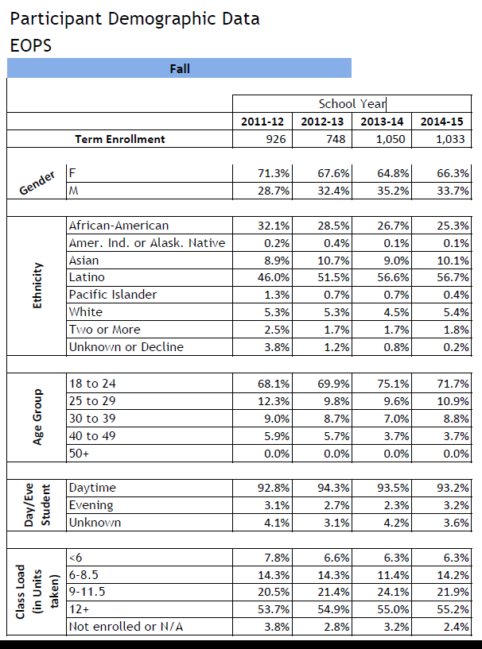

- Describe how interaction with the program helps students succeed or meet their educational goals.

In accordance with Title 5, the EOPS program is charged with serving students of educationally and socioeconomically disadvantaged backgrounds and assisting them with meeting their educational goals of attaining a certificate, associate degree, and/or transfer to a four-year college or university. The EOPS program has hired certificated and classified personnel, who are responsible for conducting orientations to assist with the transition to college, who are responsible for drafting abbreviated and comprehensive educational plans, and who are responsible for following up with students who are struggling academically. Per Title 5, all EOPS students are required to sign an EOPS Mutual Responsibility Contract that stipulates that they must been with EOPS program personnel at least three times per semester, submit academic progress reports, apply for financial aid, and maintain satisfactory academic progress with regards to grade point average and pace of unit completion. EOPS students who do not comply with the EOPS Mutual Responsibility Contract are removed from participating at the end of the semester in which compliance was not met or when the student has exhausted their eligibility for the program in accordance with state law. EOPS students receive grants, book vouchers, and other direct aid to assist them in meeting their unmet financial need to attend college.

In accordance with state law, the CARE program is charged with serving EOPS students who are classified as single head of household, have at least one child under the age of 14, and who is receiving Temporary Assistance for Needy Families (TANF), and who are at least 18 years of age, with attaining a certificate, associate degree, and/or transfer to a four-year college or university. Since all CARE students must first be EOPS students they are eligible for all support services and have access to all EOPS personnel as referenced above. In addition, CARE students receive additional support services such as grants, book vouchers, meal vouchers, transportation assistance, and other direct aid to assist them in meeting their unmet financial need to attend college. CARE students also receive support with ensuring compliance with the welfare-to-work requirements established by the County of Los Angeles, Department of Public Social Services (DPSS) so that they may continue to attend college and receive additional support services.

- How does the program interact with other on-campus programs or with off-campus entities?

Both the EOPS and CARE programs work closely with other on-campus entities including, but not limited to, the Admissions & Records Office, Financial Aid Office, General Counseling, and Outreach & School Relations. The EOPS and CARE programs cannot and do not operate in a silo and require the assistance and support of other on-campus entities to help meet the requirements established by state law in the recruitment, retention, graduation, and transfer of students. The Office of Outreach & School Relations helps the EOPS and CARE programs identify prospective students and establish working relationships with high schools and other secondary institutions of learning. The Admissions & Records Office helps with classifying students as being California residents or meeting the requirements of Assembly Bill 540 (AB 540) for those students who are undocumented. The Financial Aid Office helps with classifying students as Board of Governors Fee Waiver (BOGFW) eligible, awarding EOPS and CARE grants, and for establishing an unmet financial need. And General Counseling helps with providing adjunct counselors in order to have sufficient counseling support for all EOPS and CARE students and for helping train counselors on the latest information pertaining to graduation and transfer requirements.

The CARE program works primarily with the County of Los Angeles, Department of Public Social Services (DPSS) to ensure that students meet their welfare-to-work requirements so that they may continue to be eligible to attend college and receive additional support services.

Both the EOPS and CARE programs refer students to community-based and non-profit organizations to refer students who are having challenges with housing, childcare, food, domestic violence, legal advice, and much more.

And both the EOPS and CARE program has an advisory committee made up of on and off-campus partners that provide assistance, referrals, and guidance to improve outreach, retention, graduation, and transfer of student participants. The advisory committee meets twice per academic year and its membership is approved by the college president. In accordance with Title 5 EOPS Implementing Guidelines, the EOPS and CARE advisory committee membership include representatives from K-12 school districts, four-year colleges and universities, private industry, community-based organizations, current college students, and on-campus personnel.

- List notable achievements that have occurred since the last Program Review.

Since the last Program Review, the EOPS program has hired a full-time EOPS Program Coordinator to replace the vacancy left by David Brown who was hired as the new Assistant Director of EOPS, CARE, and CalWORKs.

The EOPS and CARE programs hired a third full-time Counselor to help come into full compliance with Title 5 EOPS Implementing Guidelines which requires EOPS students to meet with a Counselor at least twice per semester.

The EOPS and CARE programs hired a full-time Director to replace the vacancy left by Dawn Reid who resigned from her position in August 2015 after having served the programs for over twenty years.

Additional EOPS and CARE personnel (temporary non-classified and student employees) were hired to assist with on and off-campus outreach efforts, to provide peer advising, and tutoring.

The EOPS and CARE programs have also worked closely with other Student Services entities for the implementation of the Student Success Act of 2012 (California Senate Bill 1456) to provide and record student support services including orientations, educational plans, and follow-up to students on academic probation (less than 2.0 grade point average) or progress probation (50% or less pace of unit completion). Another important related component that the EOPS and CARE programs have been working on is informing current and prospective students of the new academic criterion for the Board of Governors Fee Waiver (BOGFW) that is due to begin in fall 2016. The receipt of BOGFW is a requirement for eligibility into the EOPS program.

- What prior Program Review recommendations were not implemented, if any, and why? What was the impact on the program and the students?

The EOPS program has been unsuccessful in attaining additional computer stations for EOPS student usage within the office. Information Technology Services (ITS) is unable to provide the additional support for additional computers at this time and the pending move to the new Student Services Building has also impeded on this request. EOPS students must share the limited computers or must be referred to other computer labs within the Student Services Center or elsewhere on-campus. The EOPS program has submitted requests through the Student Equity Program and the Student Success & Support Program to ask for additional funding to purchase needed computers and install the networking needed to support them.

The CARE program has yet to hire a full-time Student Services Advisor to help with the administration of the program. CARE program responsibilities are fulfilled in part by the EOPS Program Coordinator and by temporary non-classified employees who work closely with the California Work Opportunity and Responsibility to Kids (CalWORKs) program at El Camino College. The request to hire a full-time Student Services Advisor remains a priority for the CARE program and continues to be included in the CARE Program Plan. The CARE students are served to be the best of our ability but the desire to do more CARE specific programming and services lags due to a lack of permanent and full-time CARE program personnel. The proposal to hire a Student Services Advisor has been brought forth through the prioritization process for Fiscal Year 2016-2017 and program personnel are hopeful that the position will be approved.

The EOPS and CARE programs continue to struggle as it relates to developing an online presence including the creation of an inquiry card and online program application. The EOPS and CARE programs would like to go paperless in some of its transactions with prospective students but limitations exist at El Camino College due to technology restrictions or existing marketing guidelines. This means that program brochures, inquiry or interest cards, applications, etc. are all paper-based which means more funds required for printing resulting in more waste. The EOPS and CARE programs will continue to work with Information Technology Services (ITS) and the Office of Public Relations & Marketing it its efforts to go paperless in the coming years.

The EOPS and CARE programs continue to work with the Office of Institutional Research & Planning to improve the tracking of transfer students. The information available is limited to success, retention, and the attainment of a certificate or associate degree per semester or academic year. This has made it difficult to report this information to the California Community Colleges Chancellor’s Office on an annual basis. The EOPS and CARE programs have in the past utilized the National Student Clearinghouse but this requires an annual subscription which must be paid with program funds and searching this particular database requires the manual search of individual students by Social Security number which not only takes a substantial amount of time but also limits the collection of such data when students do not provide their Social Security number either by choice or because they do not possess one.

The collection of metrics for EOPS and CARE students who have been served by the general college’s Tutorial Center versus the EOPS Tutorial Center ceased to be collected because there are more programs and venues on-campus providing this service (e.g., Mathematical Engineering Science Achievement - MESA Center, Reading Success Center, Writing Center, etc.) and we could no longer validate past claims that EOPS and CARE students who had utilized the EOPS Tutorial Center were performing better academically as a result of their utilization of the service. However, Title 5 EOPS Implementing Guidelines require the program to offer tutorial services to student participants.

The collection of metrics for EOPS and CARE students who received a book voucher from one or both programs also ceased to be collected because simply receiving a book voucher did not have a direct correlation with academic performance because there are many more various to consider (e.g., counseling, advising, priority registration, tutoring, etc.). To simply state that book voucher recipients do better academically than those who do not receive a book voucher is a very broad statement and very difficult to quantify. However, the EOPS and CARE programs are required to support students with the acquisition of their required textbooks and are able to supplement financial aid awards with program grants to help them meet their unmet financial need to attend college.

Program Environment
Information in this section should help build a case for additional resources for the program

- Describe the program environment. Where is the program located? Does the program have adequate resources to provide the required programs and services to staff and students? If not, why?

The offices of EOPS and CARE programs are located on the second floor of the Student Services Center (SSVC) and operate out of rooms 201, 202, 203, 205A, and 205B. The EOPS and CARE programs are located adjacent to the First Year Experience (FYE) program and the Student Support Services Division Office. The EOPS and CARE programs have sufficient space within the Student Services Center but being separated into five distinct offices makes it difficult to staff appropriately and to make referrals efficiently. However, the EOPS and CARE program administrators are grateful for the physical space assigned to the programs since most colleges assign extremely limited office space, assign offices in less desirable or convenient locations on-campus, or separate the programs into distinct offices altogether making it difficult to serve students efficiently and effectively. The space that was once reserved as a staff lounge now serves as the EOPS Tutorial Center and with the expansion of the program has come additional square footage which is very much appreciated program personnel and students alike.

It is anticipated that the new Student Services Building that is currently under construction and due to be completed in summer 2018 will be able to meet the needs of the EOPS and CARE programs. The EOPS and CARE programs are slated to be assigned to the second floor of the new building adjacent to the Financial Aid Office and General Counseling including the Transfer Center and Career Center. The EOPS and CARE programs will also have access to shared meeting rooms and computer labs on the first and second floors of the new building. EOPS and CARE program administrators have participated in the new building planning process from the start and continue to do so.

- Describe the number and type of personnel assigned to the program. Please include a current organizational chart.

The EOPS and CARE programs are under the area of Student & Community Advancement and are assigned to the Student Support Services Division as a result of an administrative reorganization took place in July 2015. The EOPS and CARE programs employ two administrators, three full-time counselors, eight adjunct counselors, seven full-time classified employees, and various temporary non-classified and student employees. See organizational chart below.
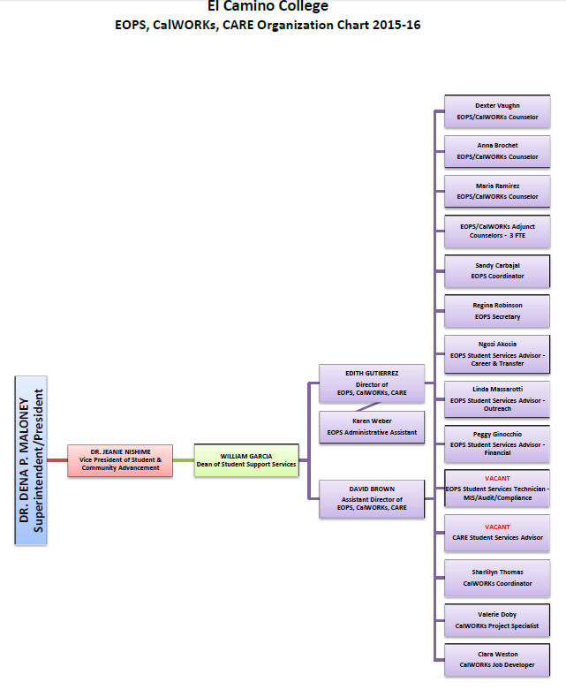

- Describe the personnel needs for the next four years.

The EOPS and CARE programs hired its third full-time Counselor during spring 2016. This hiring represents a replacement of a lost position from spring 2013 due to a retirement. The EOPS and CARE programs once had four full-time Counselors. Depending on the state allocation for the programs and the demand by students, the hiring of a fourth full-time Counselor may considered in future years. The hiring of a fourth full-time Counselor was noted in past EOPS and CARE Program Review.

The EOPS and CARE programs just hired a new full-time Director of EOPS, CARE, and CalWORKs to replace the Director who resigned in August 2015. It is anticipated that the new Director will begin in April 2016.

The CARE program hopes to hire a full-time CARE Student Services Advisor in late spring 2016 to help with CARE related programming and services. Currently, the CARE program does not have any permanent and full-time personnel; all personnel are shared with EOPS and/or with the California Work Opportunity and Responsibility to Kids (CalWORKs) program; and outreach and recruitment efforts have suffered especially as the economy improves leaving less students eligible for Temporary Assistance for Needy Families (TANF). It is anticipated that with the approval of the college’s Cabinet, the CARE program will be able to move forward with hiring a Student Services Advisor for Fiscal Year 2016-2017.

Aside from the positions noted above, there are no current plans to increase the administrative, academic, or classified personnel assigned to the EOPS and CARE programs. The EOPS and CARE programs hope to retain the positions it currently has assigned. And if and when there are retirements and resignations, the programs will work with the Human Resources Office to hire replacements.

- Describe facilities needs for the next four years.

The EOPS and CARE programs have two front counters, various private offices assigned to the administrative and academic personnel, various workstations for classified and temporary non-classified personnel, a small computer lab, and two large open spaces reserved for peer advising and tutoring. The EOPS and CARE programs have sufficient office space but the physical separation of the individual rooms or offices noted above make it inefficient for program personnel who have to transverse the various offices to meet students in the lobby, retrieve student file records and office supplies, or meet with colleagues. The EOPS and CARE program administrators have not submitted requests for consideration by the Facilities Department for office reconfiguration because the response has been that the new Student Services Building will be completed soon and the college cannot continue to invest funds in a building that will be torn down completely.

The EOPS and CARE programs look forward to the completion of the new Student Services Building in summer 2018. The new building will have sufficient private offices, workstations, a computer lab, and sufficient space for peer advising and tutorial services.

- Describe the equipment (including technology) needs for the next four years.

The EOPS and CARE programs would like to increase the number of computers available for students to use within the program offices. There are currently not enough computers for all EOPS and CARE students who wish to utilize them. There is a lack of space for additional computers and not enough electrical and network outlets within the assigned offices. EOPS and CARE students need access to computers with fast and reliable Internet connections and free printing in order to complete online processes on MyECC (student online portal) and complete applications including financial aid, scholarships, and four-year college and university admission applications. The EOPS and CARE program have submitted requests through the Student Equity Program and the Student Success & Support Program to purchase additional technology equipment and to pay for the electrical and network outlets needed to support the new technology.

The new Student Services Building has been designed to have two large computers labs to be shared by the multiple entities to be assigned in the new building. All other equipment including technology has been updated or may be purchased utilizing EOPS and CARE program funds with permission from the California Community Colleges Chancellor’s Office.

The EOPS and CARE programs would like to replace its hard copy student filing system with an online electronic student filing system. Currently, the EOPS and CARE programs make hard copy file folders for each student participant and utilize the file folders as a mechanism to keep all program related documentation on behalf of students (e.g., program application, EOPS Mutual Responsibility Contract, educational plan, program eligibility documentation, etc.) and to keep case management notes by program personnel including those made by academic counselors. The conversion requires significant investment (both human and fiscal resources) by Information Technology Services (ITS) personnel and program personnel.

In the meantime, the EOPS and CARE programs will convert their hard copy student filing system to a more updated one which will allow for the more efficient and confidential storage and maintenance of student files. This conversion is scheduled to begin in summer 2016.

- Describe the specific hours of operation of the program. Do the scheduled hours of operation meet the needs of staff and students?

The EOPS and CARE programs open to the public in accordance the following schedule during the fall and spring semesters. The hours of operation change during the week of Thanksgiving, Winter Recess, Spring Break, and during the summer per the direction of the Vice President of Student & Community Advancement and in adherence to the applicable bargaining unit agreements. The Vice President of Student & Community Advancement reviews the hours of operation for all student services entities at El Camino College and consults with all applicable managers and supervisors to ensure that their entities have sufficient personnel to provide services to students during business hours. During the Great Recession and as a result of the significant cuts to program budgets office hours were decreased but now that the budget has been restored office hours have been increased to help meet the demand and needs of students. The hours of operation noted below serve as a guide for the 2015-2016 Academic Year that must be adhered to by all entities as noted. There may be exceptions due to unexpected personnel vacancies, office retreats or staff meetings, conferences, trainings, or similar circumstances. The EOPS and CARE programs fall under the category of “Other Offices” or “All Offices” on the chart included below which is created by the Office of the Vice President of Student & Community Advancement.

According to the results of the student survey that was administered during spring 2016, approximately 90% of students respondents (out of 101 student surveys submitted) stated that they were satisfied with the hours of operation of the EOPS and CARE programs.

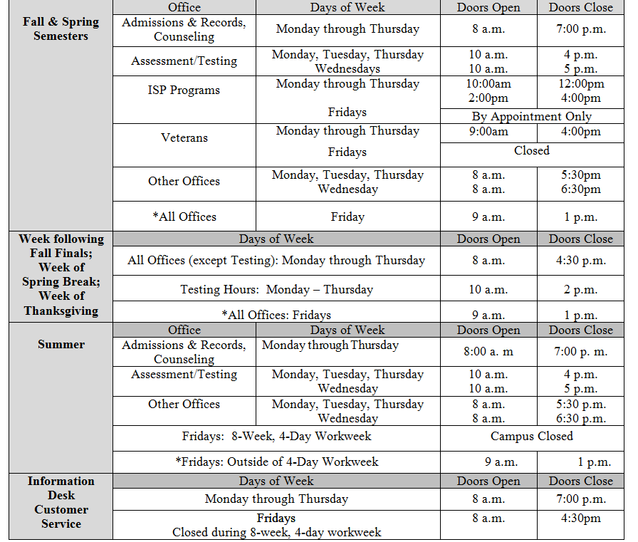

- Describe the external factors that directly affect the program. Take into consideration federal and state laws, changing demographics, and the characteristics of the students served by the program. How does the program address the external factors?

Since the last EOPS and CARE Program Review, the programs have had to adapt to the new California Assembly Bill 131 (AB 131) which allows for undocumented students who are classified as California Assembly Bill 540 (AB 540) to be eligible to apply for state-based financial assistance and resources which includes the EOPS and CARE programs as of January 2013. This means that both the EOPS and CARE programs have been able to serve AB 540 students for the past three years.

The Student Success Act of 2012 (California Senate Bill 1456) includes many legislative changes which will direct affect how the EOPS and CARE programs operate. The first change involves the new academic criterion to determine Board of Governors Fee Waiver (BOGFW) eligibility beginning in fall 2016. Since its inception in 1985, the BOGFW program only required students to meet an income criterion established by the California Community Colleges Board of Governors. Now students will need to meet academic standards (2.0 grade point average) and progress standards (more than 50% pace of unit completion) in order to be eligible for the BOGFW. BOGFW eligibility is required in order for new students to be admitted into the EOPS program. Fortunately, students who lose their BOGFW eligibility once they are in the EOPS program may continue to be served by the program.

The Student Success Act of 2012 also requires all students who have completed three semesters or more than 15 units of college units must have a declared educational goal and must complete a comprehensive educational plan. Thankfully, the EOPS and CARE programs already require the completion or update of an educational plan each semester for each student participant with a declared educational goal.

As part of the Student Success Act of 2012, the EOPS and CARE programs have volunteered to serve as experimental programs to begin utilizing the online Early Alert system being initiated by the Counseling & Student Success Division in coordination with Information Technology Services (ITS) and the California Community Colleges Chancellor’s Office. It is anticipated that the online Early Alert system will enable the programs to move away from utilizing hard copy progress reports which students are required to submit each semester. It is anticipated that the Early Alert system will begin in summer 2016.

The EOPS and CARE programs have sought the opportunity to disburse program based grants via Higher One, the third party vendor that assists the Financial Aid Office disburse federal student aid, but this has proven to be more problematic that originally thought because of changes to federal regulations that go into effect on July 1, 2016. The new federal regulations calls for more transparency of the College’s relationship with Higher One, changing the order or sequence of disbursement options available to students, and removing the automatic carding of students with Higher One Debit Cards which will increase the time in which students may receive their financial aid. The EOPS and CARE programs will continue to work with the Financial Aid Office to determine if the program based grants may be disbursed via Higher One during the 2016-2017 Award Year.

The improving economy is certainly good news and with this comes more employment opportunities for our students. This means that students are less likely to enroll in college, are taking fewer units, or are no longer eligible for welfare assistance including Temporary Assistance for Needy Families (TANF). The implications for the EOPS and CARE programs are that it is becoming more difficult to recruit new students and to retain the students who find employment. It is the hope of program personnel that students are actually finding jobs that lead to careers and not dead end jobs with low wages which are subject to the economic trends of the regional, state, and national economies.

Service Area Outcomes (SAOs)
Please attach SAO assessment results as an appendix to the program review

- List the program’s SAOs.

The EOPS and CARE programs have three Service Area Outcomes (SAOs) per the directive of the Vice President of Student & Community Advancement. The creation, assessment, and discussion relating to SAOs have been long overdue in the EOPS and CARE programs. This was noted on the past Program Review as an area needing attention and improvement. The momentum on this initiative was temporarily ceased with the significant change in program administration including the resignations of the Dean of Counseling; the Director of EOPS, CARE, and CalWORKs; and Assistant Director of EOPS, CARE, and CalWORKs. Not to mention the reorganization within Student Services and the new mandate that was made by Vice President of Student & Community Advancement at the beginning of the 2015-2016 Academic Year.

Service Area Outcome (SAO) #1 -

The EOPS program has as its first SAO to improve the number of students who adhere to the EOPS Mutual Responsibility Contract (MRC) each semester. The MRC which is signed by all EOPS students upon admission into the program requires students to meet with EOPS personnel at least three times per semester, to submit hard copy progress reports each semester, and maintain satisfactory academic progress. This relates directly to the CARE program because students need to be an EOPS student in order to be a CARE student participant. The passage of the Student Success & Support Program supports the notion that students who complete core services of orientation, assessment testing, and education plans and have a declared educational goal are more likely to graduate or transfer versus those students who do not. During the Fall Semester 2015, approximately 65% of EOPS students met the conditions set forth on the MRC. However, the EOPS program has yet to have a full academic year to review the results of this new SAO. It is anticipated that approximately 70% of all EOPS students will meet the conditions set forth on the MRC each semester. This number takes into account students who choose not to participate in the program, students who graduate or transfer, and students who exhaust their eligibility to participate in the EOPS program due to state law. EOPS program personnel will conduct an end of term review of all current student files once the spring semester has concluded in order to determine how many students met the conditions on the MRC.

Service Area Outcome (SAO) #2 -

The EOPS and CARE programs have as its second SAO to measure the attainment of knowledge of student success strategies especially for those students who are on academic probation (less than a 2.0 grade point average) and/or progress probation (50% or less pace of unit completion) by participating in a student success workshop hosted by program counselors. Pre and post surveys will be administered during each workshop to gauge receptiveness, appropriateness of materials presented, and delivery of workshop content by the presenters. During the fall 2015, EOPS and CARE program personnel began to identify students who were considered to be on “Pre-Probation” meaning that they had had a grade point average between 2.0 and 2.4 and/or had a pace of unit completion between 50% and 66% which is under the 67% threshold required by the Financial Aid Office. Workshops were offered during the fall 2015 and continue to be provided during the spring 2016. EOPS and CARE program personnel will assess the pre and post survey results during the summer 2016 and will make modifications to the delivery and content of the materials presented during the workshops as warranted. The Financial Aid Office has a similar SAO which means that the EOPS and CARE team will collaborate on SAO assessment, will review results together, and strategize how to improve for the 2016-2017 Academic Year.

Service Area Outcome (SAO) #3 -

The EOPS and CARE program have as its third SAO to measure the financial aid and financial literacy knowledge of student participants following their attendance at a financial aid workshop. The workshops are hosted in coordination with the Financial Aid Office and are hosted throughout each semester. Workshops are not required but are highly recommended to student participants. Students are given pre and post surveys during the workshops to determine their attainment of information or lack thereof. The workshops began to be hosted in fall 2015 and will continue to be offered in spring 2016. The results of the pre and post surveys will be assessed by program personnel in summer 2016 so that modifications (if warranted) may be made to the hard copy materials distributed, the PowerPoint presentation, and the amount of information shared with students.

- How were the SAOs developed? Who was engaged in the creation of the SAOs?

The SAOs were developed in collaboration with the administrative, academic, and classified personnel of the EOPS and CARE programs during staff meetings that take place twice a month and staff advances (office retreats) that take place once per semester. The Director and Assistant Director of the programs ultimately made the decision of which SAOs to include and assess for the academic year. The Director and Assistant Director of the programs will work closely with the Office of Institutional Research & Planning in the collection of applicable metrics and the assessment of the SAO results. And in the case of the third SAO will work closely with the Financial Aid Office for assessment and future planning purposes.

- How often are the SAOs assessed and who is engaged in the discussion?

The SAOs will be assessed each semester by EOPS and CARE program personnel. The assessment results will be discussed at staff meetings and staff advances with administrative, academic, and classified personnel. Modifications to programs and services will be made as a result of the assessment results as early as the 2016-2017 Academic Year.

- What has been done if the SAO assessment results were not as anticipated?

The three SAOs for the EOPS and CARE programs were introduced during the 2015-2016 Academic Year therefore the programs lack a full year of assessment data. It is anticipated that assessment results will be positive but will also leave room for improvement. If assessment results do not meet anticipated goals, program personnel are committed to making changes which may even include modifying the actual SAOs to ensure they are measurable and actually meaningful for program personnel and student participants.

- Where are the SAOs assessment results shared with staff, students, and the public?

The three SAOs will be shared with EOPS and CARE program personnel during staff meetings and staff advances each semester. The SAOs and their assessment results will be recorded and shared with the public online via the webpage of the Vice President of Student & Community Advancement.

- Have the SAO assessment results indicated the need to change or modify components of the program? If so, were the changes implemented?

Due to the fact that the three SAOs were only introduced during the 2015-2016 Academic Year, the EOPS and CARE programs lack a full year of SAO assessment results and therefore no changes have been made thus far. However, EOPS and CARE program personnel are committed to making changes if the assessment results do not come back as anticipated.

Program Improvement
Information should help determine where program resources should be dedicated

- What activities has the program engaged in to improve services to students?

The EOPS and CARE programs are committed to continuous improvement of services to student participants. The EOPS and CARE programs have awarded program based grants or book vouchers to help new and continuing students meet their unmet financial need to attend college; the EOPS and CARE programs have employed full-time and adjunct counselors in order to help with creating or updating educational plans; and the EOPS and CARE programs have offered additional student support services including four-year university admission application fee waivers, tutoring, peer advising, computer lab with free printing, and much more. The EOPS and CARE programs are thankful to have been restored with regards to their financial allocations from the California Community Colleges Chancellor’s Office during the 2015-2016 Academic Year which has allowed the programs to increase student enrollment while not sacrificing services.

The EOPS program updated the Mutual Responsibility Contract (MRC) during the fall 2015 in order to come into full compliance with Title 5 EOPS Implementing Guidelines. The previous MRC was outdated and did not conform to ever-changing state law. All new and continuing EOPS students had to sign a new MRC during fall 2015 in order to receive support services from the program.

The EOPS and CARE programs have hired a third full-time Counselor to help meet the academic needs of student participants and ensure compliance with Title 5 EOPS Implementing Guidelines. All EOPS students are required to meet at least twice per semester with an EOPS Counselor per the EOPS Mutual Responsibility Contract. The EOPS program has been able to get by with employing part-time Counselors with the support of the Counseling & Student Success Division but this is problematic at times given their availability and other counseling needs campus-wide.

The CARE program hopes to hire a CARE Student Services Advisor to help with CARE program related programming and services in late spring 2016. The CARE program does not have a full-time employee assigned and has had to rely on part-time academic and part-time classified employees to provide CARE program outreach, recruitment, and support services.

- How have program personnel used metrics to improve program services? Provide metrics from the last four years.

The EOPS and CARE programs have worked closely with the Office of Institutional Research & Planning to collect and analyze metrics to improve program services to student participants. Please note that all EOPS metrics include CARE metrics because all CARE students must be EOPS eligible in order to participate in the program. The metrics from the last four years are as follows:

2011-2012 Academic Year
EOPS Program Success 68.9%
EOPS Program Retention 84.2%
Associate Degree Conferred 203
Certificates Conferred 67

2012-2013 Academic Year
EOPS Program Success 69.8%
EOPS Program Retention 84.5%
Associate Degree Conferred 212
Certificates Conferred 61

2013-2014 Academic Year
EOPS Program Success 68.1%
EOPS Program Retention 83.6%
Associate Degree Conferred 186
Certificates Conferred 52

2014-2015 Academic Year
EOPS Program Success 69.9%
EOPS Program Retention 84.0%
Associate Degree Conferred 196
Certificates Conferred 41

While the percentage of EOPS program success and EOPS program retention have remained stable during the four year period in review, the number of students who have had associate degrees and certificates have dropped. As a result, the EOPS program has reassigned the responsibilities of the two full-time Student Services Advisors as of September 2015 in order to better identify proactively who may be eligible for graduation and assist them with the completion of the intent to graduate form required by the Admissions & Records Office. The EOPS program has also significantly revised the EOPS Mutual Responsibility Contract (MRC) for students to better understand and come into full compliance with the Title 5 EOPS Implementing Guidelines. This change should help students better understand the commitment they are making to the program which is aimed at retaining them in college through completion of their educational goal.

The EOPS and CARE programs are hopeful that the metrics will improve significantly in future academic years. The EOPS and CARE programs have had their budgets restored by the California Community Colleges Chancellor’s Office, program administrators have changed the duties and responsibilities for the Student Services Advisors, the programs are taking a closer examination of how direct aid is awarded and issued, and additional program personnel are being hired to provide more personalized services to student participants.

- If applicable, explain any patterns in student success, retention, persistence, graduation, and transfer in terms of student characteristics and program objectives and discuss planned responses or changes.

The EOPS and CARE programs have worked closely with the Office of Institutional Research & Planning to collect and analyze metrics to improve program services to student participants. Metrics collected include retention, persistence, graduation, and transfer rates. The EOPS and CARE programs have consistently been able to maintain their levels of student retention, persistence, graduation, and transfer, in comparison with non-student participants. EOPS and CARE program personnel consider this a great feat because the programs actively and intentionally recruit students of educationally and socioeconomically disadvantaged backgrounds who often test at the basic skills or remedial levels in English and mathematics and have to work hard to progress through the curriculum in order to graduate and transfer. However, the most recent metrics have demonstrated that more needs to be done by the EOPS and CARE programs to assist with retention, persistence, and graduation with an associate degree or certificate. EOPS and CARE program personnel have and will continue to address this challenge at staff meetings and staff advances.

Customer Service
Administer a customer service survey to students or colleagues, if applicable. Please administer the survey the semester prior to submitting your program review.

- How was the survey conducted? Please include a copy of the survey to the appendix.

The EOPS and CARE programs conducted the survey in coordination with the Office of Institutional Research & Planning during the Spring Semester 2016. The surveys were administered to current EOPS and CARE student participants when they visited the office for counseling or paraprofessional appointments or when they were issued support services. The surveys were then collected and the results were tabulated by the Office of Institutional Research & Planning. A total of 101 surveys were collected.

- What were the major findings of the customer service survey?

The major findings of the customer service surveys were that the EOPS and CARE programs are providing exemplary services to student participants. Over 90% of the students that submitted customer service surveys indicated that they are empowered by program personnel, that program personnel support the achievement of their academic goals, that program personnel take their needs into consideration, and that program personnel are aware of campus resources.

- Describe exemplary services that should be expanded or shared with other programs.

The exemplary services that were noted on the survey results that should be expanded or shared with other programs include the commitment and passion had by program personnel to serve students, the program personnel knowledge of on and off-campus resources, and that program personnel have a genuine interest in serving students.

EOPS and CARE program personnel believe that the following are exemplary services that should be expanded or shared with other programs:

- The requirement that all students sign a Mutual Responsibility Contract (MRC) of some sort and are held accountable each term.
- Students must submit progress reports each term in order to gain a better understanding of the academic standing prior to the course withdrawal deadline or end of the term.
- Students on “pre-probation” should be identified early and have proactive and meaningful interventions by counselors and appropriate support staff.
- Case management should be adopted by all student support services entities.
- Student support services entities should strive to work with on and off-campus entities to help students purchased their required textbooks.

- What aspect of the program’s service needs improvement? Explain how the program will address service improvements.

Based on the survey results, the EOPS and CARE programs will be considering improvement in the following areas: (1) referrals to the programs by other on-campus entities; and (2) ensure that program personnel are trained in other areas of campus to help giving students contradictory information. The latter response may have been a result of the confusing wording of the prompt. The EOPS and CARE program administrators will work with the Office of Institutional Research & Planning to ensure that future versions of the customer service surveys are clear and that the information being asked is actually useful for program improvement.

Conclusions and Recommendations
Only include information previously referenced in the program review

- Summarize the program’s strengths.

The EOPS and CARE programs have strengths that have been documented by means of customer service survey results and metrics collected by program personnel in coordination with the Office of Institutional Research & Planning. The EOPS and CARE programs continue to excel at maintaining comparable retention, persistence, graduation, and transfer rates compared with non-student participants; continue to provide over and above student support services including program grants and book vouchers; and employ dedicated administrative, academic, and classified who provide exemplary service to student participants.

The EOPS and CARE programs are in full compliance with Title 5 EOPS Implementing Guidelines and work closely with other campus entities to ensure compliance with College policies and procedures and ever-changing federal and state laws and regulations. The EOPS program has been able to recruit new students to return to pre-recession levels and is making strides to continue to improve the retention and persistence of student participants.

The EOPS and CARE programs have agreed to serve as a pilot for the new online Early Alert system which is being spearheaded by the Counseling & Student Success Division.

The CARE program has an excellent working relationship with the County of Los Angeles, Department of Public Social Services (DPSS) to ensure that students who are in receipt of Temporary Assistance for Needy Families (TANF) meet their welfare-to-work requirements so that they may continue to be eligible to attend college and receive additional support services.

EOPS and CARE program personnel are familiar with and have great working relationships with community-based and non-profit organizations to refer students who are having challenges including, but not limited to, housing, childcare, food, domestic violence, legal advice, and much more.

The EOPS and CARE programs have established a strong and vibrant advisory committee in accordance with the Title 5 EOPS Implementing Guidelines made up of on and off-campus partners that provide assistance, referrals, and guidance to improve outreach, retention, graduation, and transfer of student participants.

EOPS and CARE programs have been approved to replace the full-time Director, hire a third full-time Counselor, and hope to be given the approval to hire a new full-time CARE Student Services Advisor.

- Summarize the program’s areas that need improvement.

The EOPS and CARE programs will hire a full-time Director to provide the administrative leadership and support needed by program personnel. The new Director is scheduled to begin their employment with the College in April 2016. The EOPS and CARE programs have been led by an Interim Director for the past seven months which has made it challenging to plan for future years.

The CARE program personnel will continue to work to increase student outreach and recruitment efforts on and off-campus to meet established enrollment goals with part-time employees and student employees. The CARE program hopes to hire a full-time CARE Student Services Advisor during summer 2016 to help with programming and services aimed at CARE student participants.

The EOPS and CARE programs will continue to work on improving the overall program success and program retention rates since the four year study revealed that the numbers have been decreasing. Program personnel will also work proactively to identify student participants who have met or who are close to meet the requirements to graduate with an associate degree or certificate.

The EOPS and CARE programs will continue to work closely with the Office of Institutional Research & Planning to monitor the Service Area Outcomes (SAOs) established for the programs especially since the 2015-2016 Academic Year was the first year of implementation for the three SAOs.

The EOPS and CARE programs will continue to work with Information Technology Services (ITS) and the Office of Public Relations & Marketing to develop an online presence including the creation of an electronic inquiry card and online program application.

The EOPS and CARE programs will continue to work with the Office of Institutional Research & Planning to improve the tracking of transfer students. This information is important to help monitor our success or lack thereof and for inclusion to end of the year narrative and statistical reports required by the California Community Colleges Chancellor’s Office.

The EOPS and CARE programs will continue to work with Information Technology Services (ITS) to increase the number of computers available for students to use within the program offices. There are currently not enough computers for all EOPS and CARE students who wish to utilize them. There is a lack of space for additional computers and not enough electrical and network outlets within the assigned offices.

The EOPS and CARE programs will continue to work with the various on-campus entities to fulfill the scope of the Student Success & Support Program (SSSP) which includes outreach, orientation, assessment testing, education planning (abbreviated and comprehensive), and student follow-up as it relates to academic and progress probation. While the EOPS and CARE programs believe they serve as a good example for other student support services as it relates to the delivery of the above services, EOPS and CARE program personnel would like to improve and strength existing relationships for the benefit of all prospective and current students.

The EOPS and CARE programs will continue to work with Information Technology Services (ITS) to adopt an online electronic student filing system to replace the current hard copy student filing system.

- List the program’s recommendations in a prioritized manner to help better understand their importance to the program.

- Hire a full-time Director of EOPS, CARE, and CalWORKs.
- Hire a full-time CARE Student Services Advisor.
- Increase student outreach and recruitment efforts to meet enrollment goals.
- Support Student Success Act of 2012 implementation efforts campus-wide.
- Assess new Service Area Outcomes (SAOs) for program improvement.
- Obtain additional statistical program information from external assistance.
- Pilot the new online Early Alert system.
- Convert to a new student filing system.
- Disburse EOPS and CARE grants via Higher One.
- Develop an online inquiry card and online program application.

- Please indicate whether the program should continue or be discontinued.

X Continue Program

___ Discontinue Program. Explain how the program’s services could be handled by another on-campus entity if the program has been declining or is no longer fully utilized.

Student & Community Advancement Program Review Committee
Ratings

- Excellent
The program review was extremely well written. Concise and grammatically correct with few to no spelling errors. A model program review that is ready to be posted online for a public audience.

- Meets Expectations
The program review was adequately written. Lengthy or vague at times or included some grammatical and spelling errors. Corrections should be made prior to posting online for a public audience.

- Needs Improvement
The program review was poorly written or incomplete. Too lengthy or vague or too many grammatical and spelling errors throughout the document. The program review needs to be rewritten and resubmitted to the Student & Community Advancement Program Review Committee by an established deadline.

Revised: 5/5/2010, 3/13/2013, 3/31/2014, 4/15/2014, 6/1/2015
APPENDIX #1

El Camino College
EOPS and CARE Programs
Customer Service Survey Instrument
In an effort to provide effective services for students, we ask you to complete the following survey. We will use your feedback in our ongoing efforts to improve our services to students. The survey is anonymous and voluntary.

Which program are you currently in? (Circle all applicable programs)

- EOPS
- CARE

Please indicate the extent to which you agree with these statements about the program. Please fill in the bubbles completely using a pencil or blue/black ballpoint pen. Response options include: Strongly Agree, Agree, Neither Agree or Disagree, Disagree, or Strongly Disagree.
1. I was referred to this program for assistance by another program on-campus.

2. This program has empowered me to meet my educational goals.

3. I understand my responsibilities to this program.

4. Staff members in this program are helping me achieve my academic goals.

5. This program provides resources through a variety of methods.

6. I feel this program considers the needs of the students.

7. Facilities in this program meet my needs.

8. Staff in this program are aware of other campus resources that can help me meet my goals.

9. The hours of operation for this program meet my needs.

10. I have received information from staff in this program that contradict information I received
from another program.

11. Staff members are courteous towards students.

12. Staff members are knowledgeable about El Camino policies and procedures.
APPENDIX #2

EOPS and CARE Programs
Customer Service Survey Results
Spring Semester 2016

EOPS and CARE Student Survey

N= 101 Spring 2016

1. I was referred to this program for assistance by another program on campus.
2. This program has empowered me to meet my educational goals.

Response Frequency Percent Response Frequency Percent

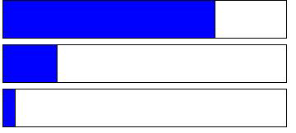

Strongly Agree 44 43.56 Strongly Agree 76 75.25
Agree 14 13.86 Agree 20 19.80

Neither Agree or Disagree
14 13.86 Neither Agree or Disagree
5 4.95



Disagree 18 17.82 Disagree 0 0.00

Strongly
Disagree
11 10.89 Strongly
Disagree
0 0.00

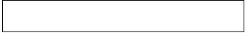
Missing 0 0.00 Missing 0 0.00

3. I understand my responsibilities to this program
4. Staff members in this program are helping me achieve my academic goals.

Response Frequency Percent Response Frequency Percent

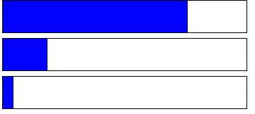

Strongly Agree 74 73.27 Strongly Agree 77 76.24
Agree 20 19.80 Agree 19 18.81

Neither Agree or Disagree
7 6.93 Neither Agree or Disagree
5 4.95

Disagree 0 0.00 Disagree 0 0.00

Strongly
Disagree
0 0.00 Strongly
Disagree
0 0.00

Missing 0 0.00 Missing 0 0.00

5. This program provides resources through a variety of methods.
6. I feel this program considers the needs of the students.

Response Frequency Percent Response Frequency Percent


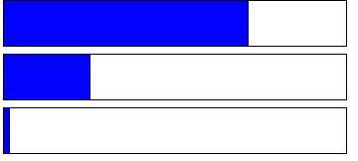
Strongly Agree 72 71.29 Strongly Agree 71 70.30
Agree 26 25.74 Agree 27 26.73

Neither Agree or Disagree
3 2.97 Neither Agree or Disagree
3 2.97

Disagree 0 0.00 Disagree 0 0.00

Strongly
Disagree
0 0.00 Strongly
Disagree
0 0.00

Missing 0 0.00 Missing 0 0.00

7. Facilities in this program meet my needs.
8. Staff members in this program are aware of other campus resources that can help me meet my goals.

Response Frequency Percent Response Frequency Percent

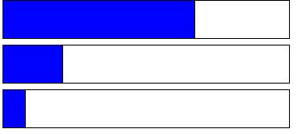
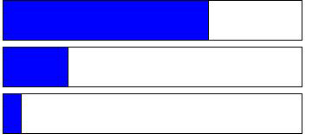
Strongly Agree 70 69.31 Strongly Agree 68 67.33
Agree 23 22.77 Agree 22 21.78

Neither Agree or Disagree
7 6.93 Neither Agree or Disagree
9 8.91


Disagree 1 0.99 Disagree 2 1.98

Strongly
Disagree
0 0.00 Strongly
Disagree
0 0.00

Missing 0 0.00 Missing 0 0.00

9. The hours of operation for this program meet my needs.
10. I have received information from staff in this program that contradicts information I received from another program.

Response Frequency Percent Response Frequency Percent

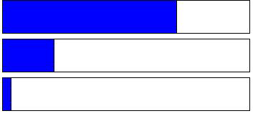

Strongly Agree 71 70.30 Strongly Agree 45 44.55
Agree 22 21.78 Agree 16 15.84

Neither Agree or Disagree
4 3.96 Neither Agree or Disagree
16 15.84



Disagree 4 3.96 Disagree 9 8.91

Strongly
Disagree
0 0.00 Strongly
Disagree
15 14.85

Missing 0 0.00 Missing 0 0.00

11. Staff members are courteous towards students.
12. Staff members are knowledgeable about El Camino policies and procedures.

Response Frequency Percent Response Frequency Percent

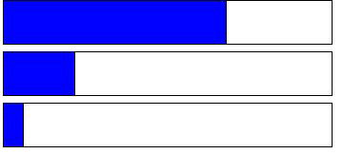

Strongly Agree 70 69.31 Strongly Agree 69 68.32
Agree 25 24.75 Agree 23 22.77

Neither Agree or Disagree
3 2.97 Neither Agree or Disagree
7 6.93

Disagree 2 1.98 Disagree 1 0.99

Strongly
Disagree
0 0.00 Strongly
Disagree
0 0.00

Missing 1 0.99 Missing 1 0.99


Which program are you currently in? Response Frequency Percent
EOPS 74 73.27
CARE 15 14.85

