EL CAMINO COLLEGE AND
EL CAMINO COLLEGE COMPTON CENTER
STUDENT & COMMUNITY ADVANCEMENT
Admissions and Records Department
International Student Program and El Camino Language Academy

Program Review
Program Review is a tool used by program personnel to critically evaluate the services offered by the program and to recommend necessary improvements that address the needs of the College or the Center and the community.

Desired Outcomes
Desired Program Review outcomes include: a thorough evaluation of the program’s effectiveness using quantitative and qualitative data; recommendations for program improvement (or if appropriate program discontinuance); and placement of the recommendations into the program’s annual plan.

Program Description

- Describe the program. How does the program link to the College’s mission statement, statement of values, or strategic initiatives?

Program Description
The International Student Program (ISP) and El Camino’s Language Academy (ECLA) make up the two active international programs on El Camino College’s campus that serves F-1 visa students. Combined, these two programs provide a wide range of services to over 700 international students annually studying at either the academic program (ISP) or the non-credit intensive English language program (ECLA).

Both programs are responsible for their own individual student recruitment, admissions, intake, orientations, activities, transfers as well as assisting students to maintain their F-1 non-immigrant status while complying with United States Citizen and Immigration Services (USCIS) regulations. An F-1 visa is a non-immigrant student visa that allows an individual to pursue education in the United States. The USCIS requires campuses to comply with an abundance of regulations in order to host F-1 visa students on campuses. Certain staff have been designated and trained under USCIS law to be Designated School Officials (DSO) where they are obligated to help maintain a student’s status as an F-1 visa holder. If a student does not maintain their regulations, DSO’s are obligated to terminate a student’s F-1 visa status at the school that they are studying.

Although the ISP and ECLA programs function similarly in their individual processes, they exist as two separate programs, each with their own immigration and academic regulations. The ECLA program offers non-credit courses and operates outside of the academic enrollment procedures. The ISP program, on the other hand, is within the academic for-credit college. This distinction (non-credit vs. academic for-credit) carries certain restrictions and consequences for each program. Academic programs, such as ISP, require additional federally mandated oversight for each student (which absorbs an incredible amount of staff time), while non-credit programs, the ECLA, do not fall under the benefits of FTES status. Examples of FTES benefits include; dedicated classroom space, health center and student service benefits, as well as involvement in student centered activities (sports, clubs, etc.). As a result, the two programs operate separate of one another, each with their own dedicated staff to manage the unique challenges of their individual student population. Below, find the two programs in detail with an explanation of program processes for each area.

El Camino Language Academy (ECLA)
Created in 1998, El Camino Language Academy is an on-campus intensive English language program created for international students who do not meet the minimum English proficiency requirements of El Camino College. The ECLA program operates as a non-credit, non-degree bearing program. El Camino College (as well as other academic programs throughout California) requires its F-1 visa students to provide a minimum English proficiency to be admitted – this policy helps international students succeed in their academic careers, as well as integrate into campus and American life. If an F-1 student does not meet this requirement, they may enroll in the intensive English language program, ECLA. At the end of their successful program, ECLA students take and pass an English proficiency exam and transfer to El Camino College.

The ECLA program offers 20 hours a week of language lessons. USCIS law requires F-1 visa students, to be enrolled in a minimum of 18 hours per week. Each class includes: Reading, Grammar, Writing, Conversation and TOEFL (Test of English as a Foreign Language) Preparation and American Culture. Intensive English, by definition, means that the instruction and curriculum is specifically designed for a student’s level of competency (i.e., reading, grammar, speaking/listening, writing and grammar).

If a student is successfully granted an F-1 visa, they will begin making travel arrangements to the United States. Once those students arrive on El Camino College’s campus, they will then participate in a comprehensive orientation, which includes presentations, placement testing and skills assessment. A student’s English placement level is determined through ECC’s Assessment and Testing Center and English exams. During the orientation, each student is also required to take a written and oral assessment administered by ECLA instructors.

Currently, ECLA has three levels of English:
Level 1 - Beginner
Level 2 - Intermediate
Level 3 - Advanced

Each level has five classes taught per week that equal 20 hours of instruction. The instructors on campus are highly valued, each possessing a Masters degree in a field related to English as a Second Language, as well as other teaching credentials. Please see appendix for the current schedule of classes.

Students work through individual levels and, at the end of each semester, are given the TOEFL exam (Test of English as a Foreign Language). This is an internationally recognized test for international students. The scores are used as a part of the application process for universities across the United States. If a student passes with the appropriate TOEFL score, they are guided through the transfer process to El Camino College’s International Student Program. Currently, ECLA is the largest feeder of international students into El Camino College. Below, find the transfer rate from ECLA into ECC academic classes. The most recent data for the 2015-2016 is an estimate based on the number of advanced level students wishing to transfer in the spring 2016 semester.

ECLA Transfers to El Camino College
Academic Year | ECLA Transfers to ECC
2015-2016* | 67*
2014-2015 | 68
2013-2014 | 54
2012-2013 | 65
*2015-2016 semester still in process

The ECLA program is entirely self-sustaining based on student tuition and application fees. The tuition provides students 20 hours a week of instruction, health insurance, cultural programming throughout the semester, orientation, TOEFL exam and end of the year celebration. In addition, the tuition pays for the five instructor wages, one Temporary Non-Classified Clerical Assistant and one SSP International Student Program Manager’s salaries as well as all operating costs of the program.

International Student Program (ISP)
The International Student Program has been a part of El Camino College and the El Camino Village community since 1993. ISP services the F-1 visa student population who study at El Camino College. The ISP houses all programmatic functions from recruitment to admissions to assisting students to achieve their academic goals. The program enhances student success by offering a comprehensive three-day orientation, academic counseling and personal student assistance. Assistance may include resolving any number of issues related to immigration, medical, housing, personal and academic. The program offers each student the necessary tools to monitor their class schedule, academic transcripts and registration for classes.

Although this is by no means a comprehensive list, below is a short summary of responsibilities that fall within the ISP office:
- Recruitment & marketing of international students
- All communication with students, agents, colleagues, and campus partners
- Processing and tracking of paper based applications in accordance with USCIS, ECC and California Community College regulations
- Issuance of immigration Form I-20 and acceptance packets
- Orientation and onboarding of new students – including: testing, registering and coordinating counseling appointments
- Maintenance of student status, tracking and monitoring student progress and processing ongoing student documentation
- Assistance with student needs – academic, financial, employment, immigration, as well as personal concerns
- Point of contact for emergency situations
- Agent contracts, invoicing and payment processing
- Facilitation of workshops and special programming
- Collaboration with on-campus partners to process petitions, tuition payments, refunds, work authorization, student discipline, agent payments, health insurance data, etc.
- Completion of student record – whether it be transfer, completion or termination

The ISP office has maintained a general goal of providing the best quality service to the students it serves. An additional goal has been referred to in previous Program Reviews (2006/2007) that the program would have a goal to grow to 1,000 F-1 visa students. This is an ambitious increase in size and, with an increase of support staff, would be achievable. However, since that time, nearly 10 years ago, a substantial amount of document processing and student oversight has been added to international offices throughout the U.S., as well internally on the ECC campus.

In reviewing these two goals, it is noted the general document processing that occurs within the ISP office. Although the ISP office is a student centered support space – a large bulk of the office time is spent processing documentation. Thousands of documents are processed each semester by the ISP staff. Each document requiring a tedious amount of dedicated time to research and make a decision to approve, deny or process. Although this is not the entirety of all processes managed in the ISP office, the top three categories of documents processed are provided below to give a snapshot of semester workloads.

Chart A
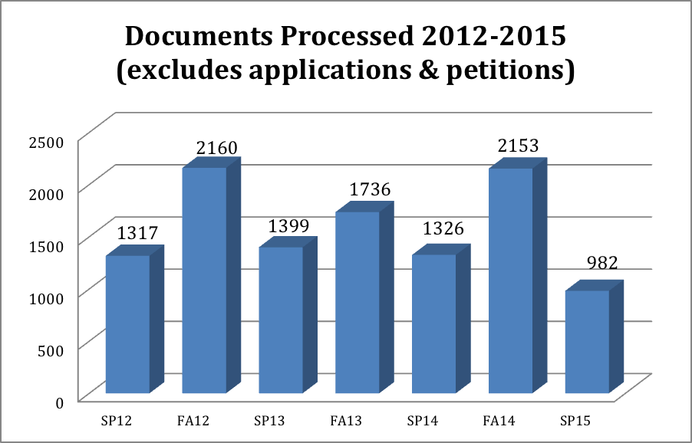

Chart A includes all documents processed – with the exception of the petitions and applications. A sample of documents processed includes, but is not limited to; immigration requests (travel endorsements, work authorizations, reduced course loads, reinstatements, transfers, etc.), personal information updates (change of address, contact information, or financial documentation), processing new student applications, Datatel processing, counseling notations, and student petitions (grade change requests, refund requests, change in schedules, etc.). These documents must often be both approved through the ECC channels as well as through USCIS. The extensive documentation needed to support each case must also be noted. Due to a decrease in staff due to extenuating circumstances, document-processing times have been delayed the past two semesters – which is reflective on the spring 2015 (SP15) data column.

Chart B
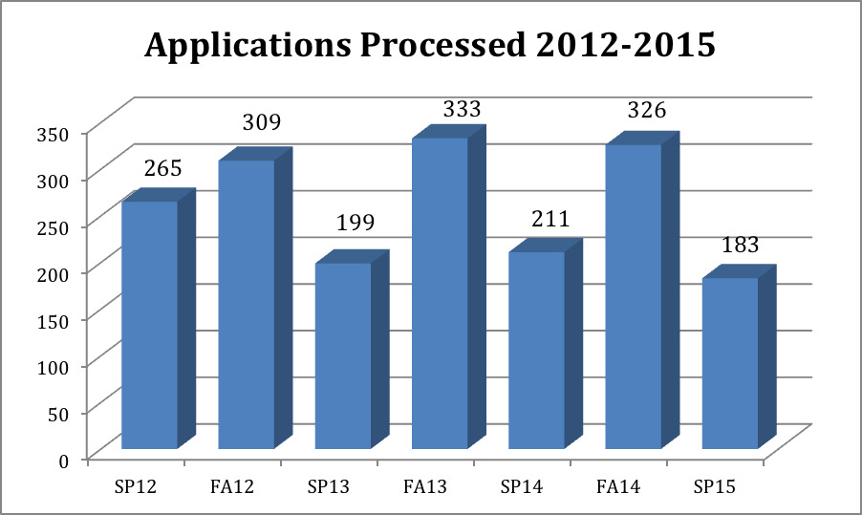

Chart B outlines the number of applications processed. Applications must be manually processed due to supporting documentation needed to complete requirements by USCIS. Once the additional supporting evidence is approved, each student application is manually inputted into the Datatel system. In the 2016-2017, an online application via CCCApply will be launched to help streamline this application process. However, at this time, the application does not include uploading of documents or application fee processing. This will initially delay any application status for potential students, until a comprehensive solution to uploading documents to the application is created. The CCCApply Committee expects a solution to this issue to be proposed in 2017-2018.

According to the applications processed, there is a steady (yet someone decline in the past two semesters) of applicants. The outside variables of a student attending El Camino College include; visa approval and arrival on campus. Some students (a small number), although provided with an F-1 visa to study at ECC, will transfer immediately to another college.

Applications received are processed quickly and efficiently. In a survey to overseas agents who receive the acceptance packets of students, 91% of agents responded that the response time was ‘Excellent’ to receive those documents.

Chart C
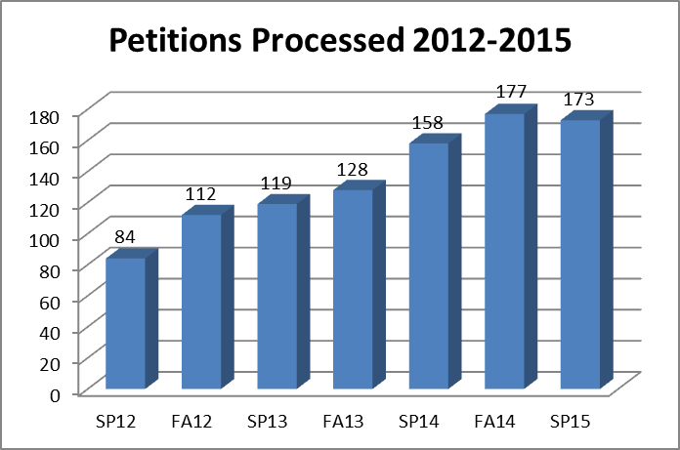

The final chart shows a general category of petitions processed. Petition processing has steadily increased over the past several semesters. Petitions may include fee waivers, reduced course load permission, tuition refunds, payment plan petition as well as other extenuating circumstance that would affect finances or status related issues. These petitions are often cumbersome and difficult to resolve. They must be presented to staff outside the ISP office for conclusions (the Admissions and Records staff, Fiscal Services, or Deans).

Please find a summary of the overall data collected for in-office documents processed and prepared in the ISP office. This data is kept in-house and is archived after every semester. The data reflects some of the major activity that occurs in the ISP office.

Summary of ISP Document Processing Data
Program Function | Spring 2013 | Fall 2013 | Spring 2014 | Fall 2014 | Spring 2015
Applications and Files  Prepared and Processed | 199 | 333 | 211 | 326 | 183
Other Documents  Prepared and Processed | 1399 | 1736 | 1326 | 2153 | 982
Files Pulled and Processed for Counseling Appointments | 685 | 576 | 542 | 919 | 614
Students (Current, New & Prospective) or Visitors Assisted | 3122 | 3676 | 3395 | 4236 | 3204
Transfers to Other University/Colleges | 40 | 131 | 31 | 158 | 31

Links to Mission Statement
According to its mission statement, “El Camino College is committed to making a positive difference in people’s lives. We [El Camino College] provide excellent comprehensive educational programs and services that promote student learning and success in collaboration with our diverse communities.”

The presence of El Camino College’s two international student programs enriches the classroom environment and campus community by adding diversity and promoting cross-cultural understanding. This directly relates to helping “promote student learning and success in collaboration with our diverse communities.” For the graduating students to succeed, they will need to communicate with an ever-changing global face. The presence of international students enhances domestic students’ perceptions and understanding of a world society, serves as a human resource for both conversations in class, as well as student activities, and becomes the foundation for friendships that filter into future social, political and economic partnerships.

The ISP and ECLA programs are directly connected to the mission of El Camino College by providing excellent services to help students learn and succeed while studying in the United States. The staff consistently “provide(s) excellent comprehensive educational programs and services that promote student learning and success.” From the point of acceptance to the end of the students’ educational goals, the staff is in constant communication to help students navigate through their experience as an international student at El Camino College.

Some examples of these types of student-centered support include:
- Mandatory orientation reviewing academic expectations and student code of conduct
- Curriculum and education planning through a dedicated International Student Counselor for F-1 visa students
- Communication regarding upcoming academic workshops and assistance on campus
- Transfer assistance to complete educational goals
- Support for all concerns related to student life (including cultural and academic) throughout time at El Camino College

Link to Strategic Initiatives
The ISP and ECLA programs both create strong links to El Camino College’s strategic initiatives. Strategic initiatives that apply to both the ECLA and ISP programs include: Strategic Initiative A, B, and E, while Strategic Initiative F applies to only the ISP. See below for a detailed explanation.

- Student Learning: Support student learning using a variety of effective instructional methods, educational technologies, and college resources.
- ECLA
Students who enter the ECLA program have little or no English skills and do not meet the minimum English qualifications to enter into El Camino College’s academic program. By “using a variety of instructional methods,” the faculty is able to provide the tools for ECLA students to improve their English language skills and transfer into the academic for-credit classes. Evidence of effective methodology is shown in the improvement of TOEFL scores when students successfully move to each ascending level.
- ISP
The ISP staff has developed an effective and thorough orientation to navigate students through the challenging, and often confusing, first stages of college to support students’ future academics.

- Student Success & Support: Strengthen quality educational and support services to promote and empower student learning, success and self-advocacy.
- ECLA
ECLA continues to “strengthen quality educational and support services” through the wide range of student centered support including; personal admissions assistance, one-one-one student transfer and registration, purchasing of health insurance, hosting social and cultural events, resolving immigration issues and general support and assistance for students new to the country. Through a series of in-class workshops, centered on supporting the needs of students throughout the semester, the ECLA staff is able to “empower student learning, success and self-advocacy.” Some workshops include: tackling culture shock, campus safety, healthy study habits and immigration reminders.
- ISP
The ISP staff works with individual students on a personal level through all stages of their student record – from admissions and visa processing, to counseling advisement, registration and educational planning, transfer assistance and all things in between. They continue to strive to strengthen “support services” by streamlining processes and provide quality assistance.

E. Institutional Effectiveness: Strengthen processes, programs, and services through the
effective and efficient use of assessment, program review, planning, and resource allocation.
- ECLA
The ECLA actively employs annual budget planning and financial projections from previous budgets to ensure program sustainability in salaries and resource allocation. By administering end of the semester surveys to each student, accurate assessment of student learning outcomes are discussed and evaluated among instructors and staff. ECLA also participates in program review annually. These assessment practices help “strengthen processes, programs and services” of the ECLA program.
- ISP
The ISP currently engages in program review with a thorough assessment of both students, El Camino College faculty, as well as referring agents who help recruit students. These assessments help drive change in the office to support students to succeed in their academics and promote the College abroad. Through constant data assessment, annual tracking of seasonal traffic help determine work flow and scheduling. These techniques help to “strengthen processes, programs and services.”

F. Modernization: Modernize infrastructure and technological resources to facilitate a
positive learning and working environment.
- ISP
The ISP program has created a student-centered space by incorporating three student workstations with computers and internet access. Students are able to utilize these workstations to resolve any issues they may be experiencing in class, registration or immigration. Having access to this technology helps “facilitate a positive learning and working environment” for both students and staff.

- Describe the student population served by the program using data. Please note the source of the data. If necessary, please contact the Office of Institutional Research & Planning to obtain data.

El Camino Language Academy
The source of the following data has been collected in-office at ECLA. This data is not available through institutional research and is, instead, kept in-house. All applications and student files are archived for 6 years to maintain the integrity of data. Below, find the data for the fall 2015 semester. Data for the spring 2016 semester is still being updated with late arrivals and terminations.

As you can see described below, the majority of students from Asia populated the fall 2015 student population. The average age of ECLA students was 23 and nearly half were divided evenly between males and females. The majority of the ECLA student body enters into classes with basic to intermediate English skills, as evident by the smaller class size of our lowest Level 1 (beginner) attendance and the increasing size of classes as the language ability grows.
Student Age 2015
Average | 23
18-25 | 77%
25< | 23%
ECLA Fall Semester Demographics 2015
Gender | Student # | Percentage
Male | 36 | 51%
Female | 35 | 49%
Country of Origin | Student #
Vietnam | 20
Japan | 16
China | 13
Korea | 10
Morocco | 3
India | 3
Mexico | 2
Mongolia | 1
Taiwan | 1
Ecuador | 1
Iran | 1
Total | 71

Language Level | Student #
Level 3 | 28
Level 2 | 29
Level 1 | 14

ECLA fluctuates in student demographic every semester, although the primary countries of origin are from the Asiatic region. The number of students has stayed relatively steady in the past two years with an increase in efforts to diversify regions. This current spring 2016 semester, although still in progress, is primarily dominated by Asian countries of origin, however also includes students from the Czech Republic, Ukraine, Venezuela, Mexico and Columbia. This is a result of a concentrated effort to recruit a more diverse student base from South America and Eastern Europe. See table below for ongoing data.

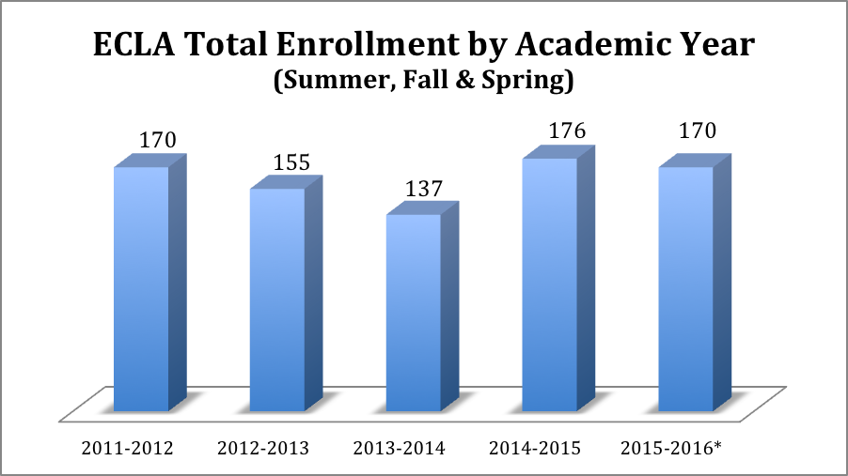
*2015-2016 academic year still in progress – spring 2016 enrollment based on mid-semester total
ECLA Student Countries of Origin*

Country of Origin | Spring 2016* | Fall 2015
Japan | 12 | 16
Vietnam | 12 | 20
China | 11 | 13
Korea | 6 | 10
Colombia | 2 | 0
Mexico | 2 | 2
Mongolia | 2 | 1
Czech Republic | 1 | 0
Morocco | 1 | 3
Ukraine | 1 | 0
Venezuela | 1 | 0
India | 0 | 3
Taiwan | 0 | 1
Iran | 1 | 1
Ecuador | 0 | 1
*2015-2016 academic year still in progress – spring 2016 enrollment based on mid-semester total

It is noteworthy to mention that the ECLA program differs from the academic program through the approvals of F-1 visas by applicants. Below a graph shows the total applications received compared to the applicants that were successfully granted F-1 visas.

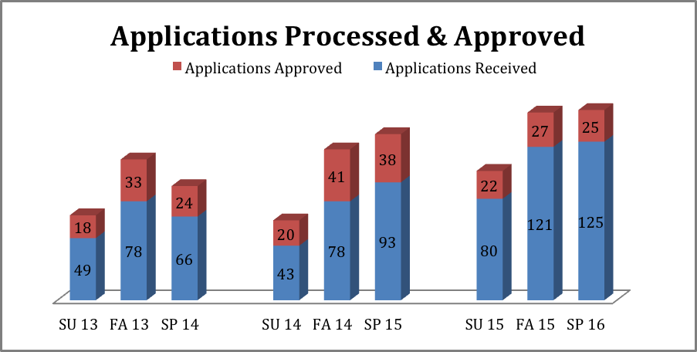

Over the past three years, it has become increasingly more difficult for students studying in non-credit intensive English language programs to successfully obtain an F-1 visa. The application processing still absorbs a large amount of work, just as with the ISP office procedure, however, the outcome is much different in terms of student numbers. The ECLA program is working to better prepare its applicants for the visa process and provide additional information to increase odds of approval.
International Student Program

The ISP has provided services to an average of 690 students annually over the past four years. All of the described data has been provided by Institutional Research and Planning as well as in-house data collected from applications and counseling appointments. Recently, there has been an active focus on promoting diversity among international demographics and recruiting from a wider net of countries. In the past year, recruitment efforts have increased in Eastern Europe, Central America and South America. Although Asian students still dominate the majority of El Camino College’s international population at 84%, the data below shows an increase in students representing other regions.

As competition from other community colleges increase and global concerns arise, it is essential to recruit from a diverse base of international students so that the population is not dependent upon solely one region generation.

The program has witnessed geographic shifting over the past few years due to various economic and political events worldwide. For example, the decrease in the value of the Japanese Yen has affected the Japanese population attending El Camino College. Economic and political difficulties have also decreased populations, in a broad scale, from other countries such as Venezuela and Brazil. Trends like this are anticipated to continue and shift El Camino College’s population. In addition, competition from regional community colleges to internationalize campuses will also influence the face of international students studying at El Camino College. Continuous efforts to draw students will be an important piece of future demographics.

In fall 2014, male students made up 52% of the population while females fell at 48% of the total 690 international populations at El Camino College. As stated above, the majority of students originated from Asiatic region – with a breakdown of the top 15 countries listed below (Japan, South Korea, China and Vietnam making up the top four countries). Students are primarily concentrated in business as they declare a major and fall between the ages of 18-24 years. This is consistent with nation-wide data trends that show a primary concentration of students originating from Asian countries and studying in business related fields.

See charts below for detailed data of international students studying at El Camino College.

 |  | Term
 |  | Fall 2011 |  | Fall 2012 |  | Fall 2013 |  | Fall 2014
Term Enrollment |  | 721 |  | 690 |  | 660 |  | 690
Characteristic |  | n | # | n | # | n | # | n | #
Gender | Female | 320 | 44% | 333 | 48% | 308 | 47% | 332 | 48%
Gender | Male | 401 | 56% | 357 | 52% | 352 | 53% | 358 | 52%
Ethnicity | African-American | 13 | 2% | 21 | 3% | 20 | 3% | 17 | 2%
Ethnicity | Asian | 634 | 88% | 601 | 87% | 569 | 86% | 583 | 84%
Ethnicity | Latino | 16 | 2% | 17 | 2% | 16 | 2% | 21 | 3%
Ethnicity | Pacific Islander | 1 | 0% | 5 | 1% | 3 | 0% | 4 | 1%
Ethnicity | White | 43 | 6% | 36 | 5% | 48 | 7% | 57 | 8%
Ethnicity | Two or More | 0 | 0% | 0 | 0% | 2 | 0% | 2 | 0%
Ethnicity | Unknown or Decline | 14 | 2% | 10 | 1% | 2 | 0% | 6 | 1%
Age Group | 17 and younger | 16 | 2% | 20 | 3% | 10 | 2% | 9 | 1%
Age Group | 18 to 24 | 514 | 71% | 503 | 73% | 469 | 71% | 526 | 76%
Age Group | 25 to 29 | 113 | 16% | 115 | 17% | 121 | 18% | 89 | 13%
Age Group | 30 to 39 | 60 | 8% | 42 | 6% | 46 | 7% | 51 | 7%
Age Group | 40 to 49 | 18 | 2% | 8 | 1% | 12 | 2% | 13 | 2%
Age Group | 50+ | 0 | 0% | 2 | 0% | 2 | 0% | 2 | 0%

Top 15 Majors Fall 2015
Major | Number of Students
Business | 164
General Studies | 35
Pre-Nursing | 31
Pre-Engineering | 29
Economics | 28
Computer Science | 26
Fashion | 24
Accounting | 23
Psychology | 18
Communication Studies | 14
Film/Cinema Studies | 13
Art | 12
Biology | 12
Architecture | 9
Child Development | 9

Top 15 Countries of Origin Fall 2015
Country | Number of Students
Japan | 166
South Korea | 104
China | 80
Vietnam | 54
Hong Kong | 34
Brazil | 14
Russia | 14
Taiwan | 11
Philippines | 9
Venezuela | 7
Indonesia | 6
Spain | 6
Macau | 5
Morocco | 5
Thailand | 5

Value of ISP Program
The ISP Program brings a diversity value, as well as a monetary value to El Camino College and the surrounding community and economy.

According to the 2015-2016 Final Budget (see appendix for data), Non-Resident Tuition from Foreign Students brought in 8.6% of the local revenue generated from the 2013-2014 actual revenue – this amounts to $3,514,497.00 of the $40,828,687.00. When looking at the total revenue from all funding sources, this is a little over 3% of the total revenue from all funding sources 2013-2014. See chart below.

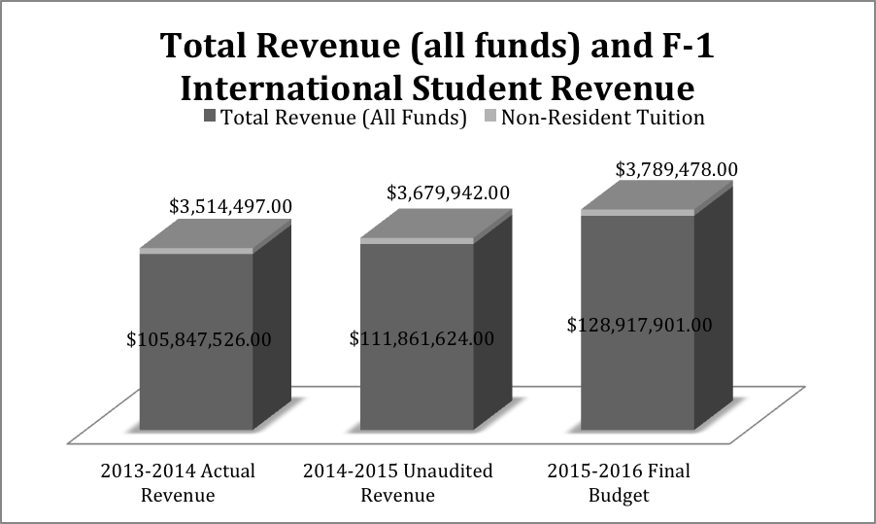
*Source: 2015-2016 Final Budget, p 4

This has been a consistent amount brought in over the past three fiscal years. Please note that these numbers do not include the F-1 visa student enrollment or capital outlay fees. These cannot be accurately determined from the budget data provided, so have been omitted. However, F-1 visa students do pay both capital outlay, as well as enrollment fees as a part of their tuition.

In addition to the value at El Camino College, international students bring economic value to the local community. According to NAFSA (National Association of Foreign Students Abroad)’s Economic Value Tool, El Camino College’s presence of International Students provides $21.2 million and supports 135 jobs in our Congressional District 43 for the 2014-2015 academic year. See below for data.

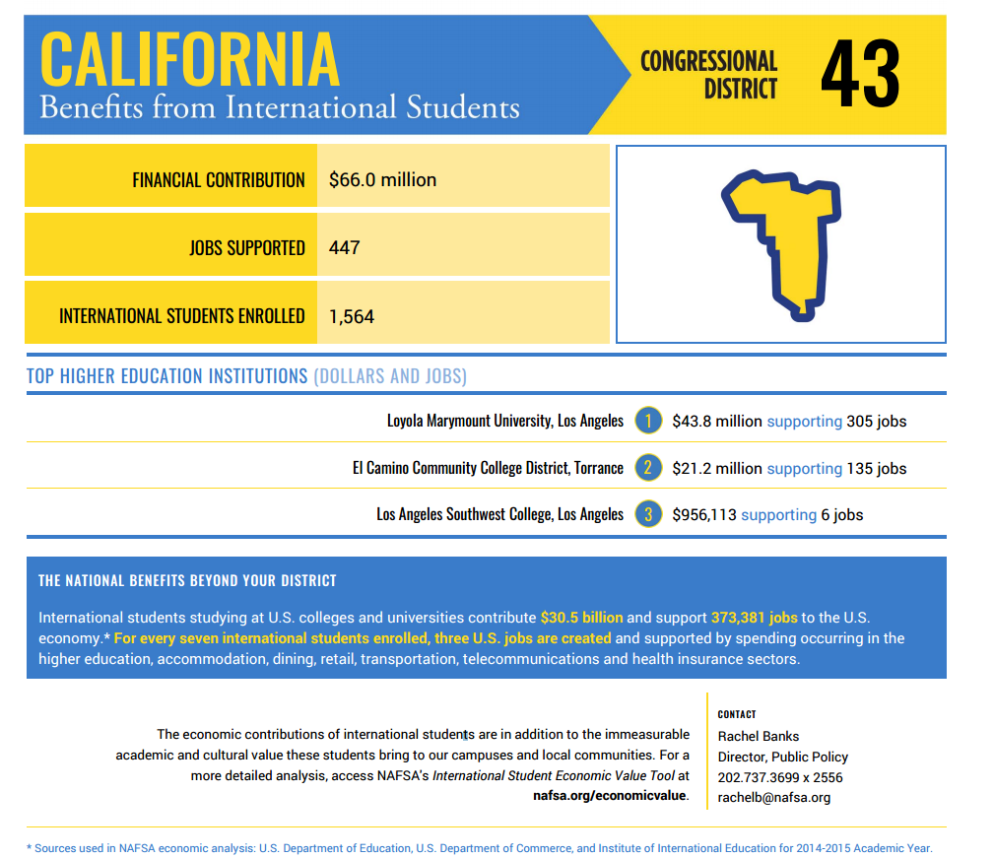

- Describe how interaction with the program helps students succeed or meet their educational goals.

El Camino Language Academy
Language Academy Students have a strong connection with the ECLA instructors and staff from their first day at El Camino. Orientation helps students prepare for the cultural, educational and immigration adjustments that will take place during their educational journey. Assuring that students understand the regulatory practices is vital to their future success. The language program takes place five days a week for four hours each day – helping to provide a consistent, immersive language program that supports the student as a whole. American culture class and regular cross-cultural workshops help students acclimate into American life and education systems. Throughout the program, cultural events and off-site learning is presented regularly to students in the form of transfer workshops, field trips to local museums, luncheons, celebrations, immigration updates, as well as guest speakers.

In addition to supporting the student while attending the ECLA, the staff also walks students through the lengthy transfer process, helping ensure successful transitions into the academic program at ECC. Although this may seem straightforward to domestic students, orientation to a new college is quite unnerving. Having a support network to answer questions and guide new students helps prepare students to gain footing at the college from their first day.

International Student Program
The ISP staff operates a student support center that carries international students through every phase of their academic life. From the first day of orientation, students are guided through immigration regulations, El Camino College policies, testing and assessment, academic counseling with a dedicated international counselor and campus tours. The orientation helps students prepare themselves for the challenges of a new education system and cultural adjustment.

Students are monitored throughout their educational career at El Camino College due a series of checks and balances to ensure students are maintaining their visa status, as well as their academic integrity. Students meet with their international counselor once a semester, attend workshops periodically and are updated regularly through email messaging. Transfer assistance and post-graduation immigration to continue their course of study or vocational work is offered through the Center.

In addition, students often will approach the ISP staff with personal, emotional and/or financial issues. Through developed resources and on-campus partnerships, students are referred to the proper channels. This helps students continue on their academic pathways without distribution through supportive on-campus networks.

- How does the program interact with other on-campus programs or with off-campus entities?

El Camino Language Academy and International Student Program
Cashier & Fiscal Services
The cashiers are a vital component in processing the International Student Program payments, resolving payment issues, and processing refunds. When reviewing student wire transfers and payments, ISP and ECLA works closely with Fiscal Services to determine payments and student holds released. The ISP and ECLA programs also work closely to issue agent requisitions and payments for student referrals. Currently, agents are given student commission for referring students to El Camino College programs. All agent contracts, payments and processing is done in conjunction with Fiscal Services, Purchasing, Admissions and Records and the ISP/ECLA programs.

Purchasing
ISP, ECLA, Admissions and Records and Purchasing work closely when reviewing any contracts for agents, health insurance and oversea travel. In addition, ECLA works closely with purchasing regarding any cultural events that require reservations and reimbursements for programming.

Health Insurance Providers
Both ISP and ECLA work closely with their own insurance providers to ensure that international students receive proper health insurance while studying in their program. Both programs work closely with their providers to issue refunds, waivers, claims and overall coverage.

Counseling
The International Program has its own dedicated international student counselor who is well versed in immigration regulations, as well as general information regarding El Camino College curriculum. During the counseling sessions, counselors must clearly explain why general education courses exist, the purpose and goals of these courses, and which general education plan the student will have to follow to complete their individual education goal.

Assessment and Testing Center
The ISP and ECLA program both administer placement tests through the Assessment and Testing Center. During orientation, staff will administer placement testing for all incoming international students. In addition, the Center proctors the three TOEFL exams that take place annually at the ECLA program. All testing is coordinated with the staff with thorough follow up.

Information Technology Services
When working with data, Datatel or other information related to the F-1 visa cohort, Information Technology Services (ITS) is the primary contact for both ISP and ECLA. The ISP staff anticipate working more closely with ITS in the coming year as the international application is launched online through a CCCApply platform. This will be a large project anticipated for a summer/fall launch.

Campus Police
The ISP and ECLA program have a solid working relationship with Campus Police. The ISP program will use police support to resolve difficult situations involving international students. The ECLA program utilizes the cadets daily to open classrooms on campus.

Overseas Agencies
Both the ISP and the ECLA program utilize overseas agents to recruit students. All partnerships between agencies and El Camino College are issued contracts that are approved through the Board of Trustees every five years. Agents are issued commission fees, which are paid through accounts payable, under most circumstances as wire transfers. The ISP and ECLA programs have strong relationships with overseas agents.

Student Development Office
The ISP program works closely with the Student Development Office (SDO) on cases involving student discipline and dishonesty. The ECLA program works closely with the SDO when issuing student ID cards. Since ECLA students are not enrolled in classes, the ECLA staff must accompany a student to obtain ECC photo ID’s.

Academic Divisions
The ISP program works alongside Academic Divisions to resolve academic, behavior, or miscellaneous issues related to international students. The ECLA program works closely with different Academic Divisions to reserve classrooms and establish a partnership to introduce new international students on campus. The International Student Program Manager has made efforts to attend meetings with Deans to answer questions and resolve issues related to international students.

El Camino Language Academy
Instructors
The instructors and staff have been excellent resources in providing course curriculum, textbooks, classroom materials and classroom activities.

International Student Program
Local Language Schools/High Schools
The ISP continues to maintain and expand relations with local English language schools. The ISP coordinator meets with various language schools to promote transfers to El Camino College. In addition, the ISP coordinator reaches out to local high schools to increase the amount of international students studying at the high school level to transfer to El Camino College.

Community
The ISP staff is in contact with local community members associated with student housing and cultural activities located off-campus. The presence of international students in a community brings economic value in the form of housing, shopping and promotion of tourism. As stated above in the value of international students on campus, El Camino is reported by NAFSA (Association of International Educators) to bring in $21.2 million for the Congressional District it resides.

- List notable achievements that have occurred since the last Program Review.

El Camino Language Academy & International Student Program Integration
The two programs have been actively working together to provide a cohesive, integrated international student centered program that both includes the ECLA students, as well as the ISP student population. Since the ECLA program is the largest feeder of international students into the academic program, it is beneficial for students to feel a part of the ECC community from the beginning of their studies – whether that is in a non-credit or a credited program. A new International Program Manager position was created in 2014 that oversees both the ISP and ECLA program. This position helps to merge the two programs and provide a unified umbrella to house both programs. The programs have integrated well together and continue to develop new ways to collaborate and improve student success and team building. Some activities include; collaborative workshops with both ECLA and ISP populations, staff development and regular staff meetings including both programs and team building such as birthday celebrations and events.

Staff Development
Staff development has been slow due to resources and availability of workshops in close proximity; however, since it’s recommendation in the 2011 Program Review, efforts have been made to include ISP and ECLA staff in increased staff development. The ISP Manager currently serves as the Southern California NAFSA Region Community College Representative and helped organize a regional conference for the international educator stakeholders. Three members of the ISP office were given the opportunity to attend the 1 day conference and brought back knowledge to the office to share. In addition, the entire ISP and ECLA staff will participate in the CCCApply workshop highlighting the upcoming online international application. Staff are encouraged take part in campus professional development to improve skills related to Word, Excel, email communications and website updates.

SEVIS Recertification
In 2014/2015, both the ISP and ECLA programs went through the Department of Homeland Security and SEVIS recertification process to update and adjudicate their permissions to host F-1 visa students at El Camino College. This is an extremely tedious and thorough procedure where all areas of El Camino College and the Language Academy are examined. Often, recertification will remain pending for years, El Camino College international staff were able to recertify quickly and without issue. Both programs were successfully recertified for another 10 years.

International Student Recruitment Plan
The recommendation from the past Program Review highlighted several objectives with a Marketing and Recruitment Plan. Although not all objectives were met, a number of recommendations to create a more cohesive marking structure including both the ISP and ECLA programs were achieved.

Recruitment efforts at El Camino College have been successfully seeing returns in student applications at both the ISP and the ECLA program. Recruitment of international students is necessary to develop personal connections to stake holders abroad. International students have fast become a vital part of U.S. colleges and universities due to the cultural and financial benefits. In addition to providing global experiences for domestic students in classrooms and on campuses, international students pay out of state tuition at public schools that brings in a considerable economic value. As a result, schools have utilized competitive recruitment tools to attract students. The increased competition among schools has facilitated the need for campuses to use multiple recruitment platforms to attract students.

El Camino College has responded to this competition by recruiting across a broad network of countries – all efforts are not dependent upon a single foreign countries’ economic stability or level of interest. Recruitment regions include Eastern Europe and Latin America, in addition to the traditional Asian markets. Since starting an active recruitment campaign in Russia and South America, numbers are beginning to climb in the academic program and applications have increased with the ECLA program.

The current recruitment budget allows for 3-4 recruitment trips per year, as well as the use of overseas agents as on-the-ground recruiters for El Camino College. This, in addition to a stronger online presence, and translations of the website into multiple languages, allows for an increased multi-faceted recruitment strategy.

Recently, the ISP program provided a survey to its overseas agents where agents responded with an overwhelming amount of positive feedback related to response rate, friendliness and quality of staff service The majority of constructive comments made within the survey include updated marketing materials. See the survey portion of the Program Review for additional information.

El Camino Language Academy
Student service continues to thrive at the ECLA program. From initial application to transferring services, the ECLA program offers exceptional personal attention to each student. This has helped retain and attract students throughout the semesters.

Medical insurance has recently become mandatory for all ECLA students. This helps ensure that students are physically well during their time at El Camino. The medical insurance is bundled into the tuition and purchased in partnership with an insurance provider at a bulk discount. Workshops are given throughout the semester to highlight medical updates and concerns.

The ECLA website has been streamlined to include necessary application information, immigration references and campus resources. The website is undergoing a new look that will include staff pictures and biographies to introduce instructors to students prior to arrival. In addition, multiple links are offered to translate the webpage into the top languages served at El Camino College.

Transfer assistance continues to be a strength for the ECLA program which transfers 95% of its transferable students (students who meet the minimum English proficiency) to El Camino College.

Workshops have been developed throughout the semester to guide students through both cultural and academic adjustments. These have been created on a semester cycle that delivers up-to-date information regarding; immigration policies, El Camino College procedures, campus safety, medical insurance and cultural programing.

International Student Program
Student service continues to be an accomplishment for the ISP office. For the past several years, the office has been short staffed and has maintained it level of personal attention to each student.

In a customer survey conducted to assess international student opinion, international students were asked about their experience with the international student program. When asked the overall quality of service of the ISP office, 67% of students responded positively, while 20% said that service was ‘fair’ and only 7% responded ‘poor’ (4% were left missing). In addition, 79% of international students responded favorably that the wait time was short to speak with a staff member at the ISP office – 9% responded ‘fair’ and another 9% responded ‘poor.’ The ISP office has been short staffed the past two years due to staff medical issues. To maintain this high quality of service is exceptional.

Compliance with SEVIS has been long been a strength of the program – this continues to operate with minimal issues which have been easily and quickly resolved. This is evident by the successful recertification of the program through USCIS.

Campus Safety has been an increasing concern for students due to campus incidents throughout the country. To help advocate campus safety, Police Chief Trevis personally reviews the importance of awareness and proactive safety techniques on campus at new student orientations. The staff of ISP has attended active shooter workshops at El Camino College and has devised an emergency plan for different scenarios. Although we cannot change crime rates in our area, we are able to educate students on campus about proper safety and security techniques.

In a customer survey conducted to assess international student opinion, international students were asked about their feelings of campus safety. Of the responses, 67% of international students responded that campus safety felt into either the ‘good’ (49%), or the ‘excellent’ (18%) category. Of the remaining students, 25% responded that campus safety was ‘fair’ and 4% responded ‘poor’ – 4% did not respond.

The ISP Website continues to be updated and used as an additional resource for international students. Documents are in the process of being converted to fillable forms and will be uploaded online. In addition, a staff page with pictures is being created to allow for a more personable program introduction for students. Questions that students may ask in-person is being posted to decrease the number of in-office visits.
The International Student Orientation has been a successful tool to introduce and educate students on campus. With an ever-changing F- visa population, the ISP continues to improve its orientation by addressing issues such as security, academic dishonesty and health insurance/awareness. These orientations include a large number of topics including; immigration, academics, personal safety, student conduct, health issues, medical insurance coverage, banking and finance and personal issues. Guest speakers are invited to review specific topics. The International Student Counselor organizes a presentation to review academic issues and multiple teaching techniques are integrated.

Workshops have been added each semester to help students adjust to life in the United States and El Camino College. In the past academic year, workshops have been coordinated to inform students on post-graduation work opportunities, immigration regulations, transferring options, end of the semester celebrations, as well as the initial orientation to campus. Sustainable programming is being added to the academic year through templates and an events calendar for international students.

- What prior Program Review recommendations were not implemented, if any, and why? What was the impact on the program and the students?

International Student Program
- Marketing and Recruitment Plan
“Develop a comprehensive plan to improve marketing, advertising and recruitment to attract more international students.”
This recommendation contained a number of specific objectives which, although some have been successfully met, some have not been achieved. Some examples of the comprehensive recommendation that were not met are;
- Creation of an international student packet and PowerPoint presentation to assist international students with the application process
- Virtual fair recruitment
- International student newsletter

The reasons that these recommendations were not met are due to staff time and resources. The ISP staff has been suffering a loss of a staff member that has created a large gap in additional services provided. The ISP and ECLA offices will continue to recommend a comprehensive marketing plan that encompasses both programs, as well as those unmet recommendations.

- Technology
“Work with ITS and other constituencies to address and improve hardware and software in ISP and ECLA.”
All of the recommendations within the Technology heading have not been met due to the lack of technology on campus that is compatible with the program needs. The Admission and Records Director and the ISP manager have requested joint meetings to take place in the coming semester with ITS to discuss resolving some of the technology issues. These proposals will continue to be recommended.

- Staffing and Staff Development
“Review the staffing requirements of ISP and ECLA. With an increase in personnel, we can increase staff availability to our students.”
Due to the lack of funding, the additional staffing position has not been added to the ISP program. An additional position has been proposed to increase the amount of full-time classified personnel in the ISP program to three. This position will continue to be advocated for in the coming year.

- ECLA Classroom Reservations
“If possible, reserve 3 classrooms for ECLA and ECLA can modernize the classrooms.”
The ELCA program is dependent upon revenue from its student tuition to operate. The increased projects being built on campus has severely limited the amount of classroom space available. This creates an unstable program that is constantly searching for appropriate space. This topic is being discussed with various Deans and the Admissions and Records on a regular basis. Unfortunately, the ECLA program is not the only program being displaced and several other non-credit programs are in need of classrooms with limited options.

Program Environment
Information in this section should help build a case for additional resources for the program

- Describe the program environment. Where is the program located? Does the program have adequate resources to provide the required programs and services to staff and students? If not, why?
Currently, the ISP and ECLA program share the same lobby space for international students in the International Student Center. This has been a recent transition into one combined international student space. However, the ECLA students may still individually access the ECLA staff at any point throughout the day through a separate door that leads directly to ECLA. When the new Student Services Building is constructed in 2017-2018, the ISP and ECLA programs will share one entrance. Having a gradual process of shared space has been successful and productive the past 6 months.

El Camino Language Academy
Lacks Classroom Space
There is currently very limited space available on campus for ECLA classroom use. The program classes are often assigned last minute in low-tech rooms and are frequently moved throughout campus throughout the semester. With the decrease in campus space due to construction, this will continue to be an increased problem to maintain the program on campus. In a recent survey given to overseas agents, several agents commented that they wished to see the ECLA program grow. The current constraints on space hinder this growth.

If there is no space to house the program, this will directly affect the ISP program numbers with reduced student transfers. If the program were to lease space off-campus, there would need to be a responsive increase in ECLA student fees, which may decrease the attendance. Having the ECLA students study on El Camino Campus is seen as desirable to both students and stakeholders, as well as promotes an academic rigorous environment in learning. To take the classes off-campus would have an unknown impact on the program. Keeping the classes on-campus risks losing space and decreasing classes offered.

Software Grading Program
Classes at the ECLA program are currently not connected to online grade books, roster or attendance resources. The lack of a central system for students and instructors to access is problematic for processing times and archiving. Because the program is non-credit, it cannot access El Camino College’s web based platform for faculty. Alternatives have been researched and recommended at affordable costs.

International Student Program
Staffing Concerns
The decreased staff due to personnel health issues has put a large stress on the current office. However, even when the ISP office was fully staffed, the increased documentation mandated by USCIS, as well as the additional responsibilities added to support and track student success, the full staff felt the stress of their overburdened workload. It is recommended that an additional staff be added to the ISP program to help sustain the student population and maintain regulatory practices.

- Describe the number and type of personnel assigned to the program. Please include a current organizational chart.
The International Student Manager oversees both the El Camino Language Academy and the International Student Program. This position is classified as a Special Services Professional and reports directly to the Director of Admissions and Records. Under each program exists a staff of full time classified employees, temporary non-classified employees, instructors and student workers.

An F-1 visa officer who serves as the coordinator of the program supervises the ISP program. This position is a full time classified and supervises the temporary non classified and the student workers. The ISP office has been extremely short-staffed the past two years due to an employee health issue, as well as the increase in responsibilities from USCIS and regulatory practices. In addition, the F-1Visa Officer/Coordinator is often out of the office on multi-week recruitment trips to maintain and increase student enrollment. This creates another void in the office.

The ECLA office is directly managed by the International Student Program Manager who divides time between the ISP office, ECLA functions and administrative tasks. One temporary classified staff helps aid the program 3 days a week. Five instructors teach the curriculum.

In addition, one International Student Counselor serves all 650+ international students every semester to advise academic plans. This position is directly managed by the Dean of Counseling and indirectly by the Director of Admissions and Records. This position is paid from the International Student Program budget.

Please see the organization chart below.
International Student Program and El Camino Language Academy Organizational Chart March 2016

Admissions and Records Director
Dean of Counseling

International Programs Manager
International Student Counselor

Temporary Non Classified
Clerical Assistant (x1)
Instructors (x5)
International Student Program Staff
El Camino Language Academy Staff
F-1 Visa Officer
Student Services Specialist
(vacant)
Clerical Assistant
Temporary Non Classified Office Aids (x3)

Student Workers (x2)

- Describe the personnel needs for the next four years.
The ISP program has suffered a drastic and sad loss in personnel this past year. The office has been functioning with only two full-time staff to manage all admission, onboarding and immigration related issues (which is time sensitive and critical to a student success), with the assistance of the temporary non-classified employees. Once the one vacant ISP position is filled, it is recommended that the ISP and ECLA programs be provided with additional full-time staffing.

In recent years, due to heightened security and global concerns, the Department of Homeland Security has dramatically increased the monitoring and reporting of F-1 visa students. Documentation and oversight of each individual student is necessary in order to maintain proper credentials with USCIS. This creates a large increase in document processing and student oversight. In addition, a new online application system is being launched in 2015-2016 to process international students through the CCCApply online system. In order for the program to simply maintain the number of current international students, as well as an successfully launch new projects, two new staff is being requested within the office processing:
- Student Services Technician
- ECLA Senior Clerical Assistant

Another position of Outreach Coordinator is also recommended to join the ISP/ECLA staff. Currently, the F-1 Visa Officer coordinates the office management, as well as all international outreach and recruitment. To maintain the current numbers and provide growth in the F-1 visa population, the outreach and recruitment should be made separate from the coordinator role. In this way, all agent communication, local and international recruitment as well as marketing can be focused by one position over the two programs. The F-1 Visa Officer position would continue to specialize in immigration and student services with minimal to no travel.

It is recommended that the program grow by these three additional full time staff to accommodate for the following anticipated changes:
- Online application processing and monitoring
- Increased USCIS regulatory policies and documentation
- Anticipated increase in student population
- Outreach and communication planning an recruitment efforts

In addition, if the ECLA program is considering any type of growth, this program will need to replace the one temporary classified employee with a full-time employee to assist in classroom scheduling and day-to-day tasks. Currently, the ISP manager and the one part-time employee run all aspects of the language academy. For the program to grow, additional assistance will be necessary.

It is also recommended that the current Program Manager hired as an SSP be made into a permanent managerial position. If this role is expected to continue within the International Programs and oversee both departments, the position should become a permanent manager position. The current structure of the SSP position gives the perception of a temporary leader that may not continue from one year to the next. The current position is paid from the ECLA budget and would continue to be drawn from that account.

Please see the adapted proposed organizational chart for details.
Proposed International Student Program and El Camino Language Academy Organizational Chart

Admissions and Records Director

Dean of Counseling

International Programs Manager

International Student Counselor

International Student Program Staff
El Camino Language Academy Staff
Senior Clerical Assistant
Instructors (5-8)
F-1 Visa Officer
Student Services Specialist
(vacant)
Student Services Technician
Senior Clerical Assistant

Outreach Coordinator

- Describe facilities needs for the next four years.
Both the ECLA and ISP program have been working towards creating a cohesive international student lobby to host both programs’ international students. This space is a welcoming environment to students to ask questions, research necessary information on the computers or schedule various advising and counseling appointments. With the construction of a new Student Services Building, the programs will be housed under one lobby roof. It will be essential to make this space inviting to those international students attending both the ECLA and ECC courses. It is difficult to assess the needs of a new space that has yet to be built, however, dedicated and private space for students to discuss sensitive issues is a priority. It is the hope of the ISP and ECLA staff that the new building will be both functional and welcoming to the growing population it serves.

Once a new center is established in the new building, the following should be incorporated into the center:
- Computer terminals for student use (registration/research) with internet access
- Work station for students completing forms
- Wall mounted information display to provide forms to students
- Seating lounge
- Wall mounted television
- Wall art and plants

- Describe the equipment (including technology) needs for the next four years.
Both the ISP and ECLA program would benefit with an online payment system to process student tuition and application fees from overseas. Several area community colleges (Fullerton College, Orange Coast College and Goldenwest College) have all piloted a free third party online payment structure called ‘PeerTransfer.’ This is an entirely free system for both students and colleges, that allows for overseas transactions with low exchange rates. Currently, to pay application fees, students must mail cash or checks to El Camino College. In addition, online tuition payments are limited to the MyECC accounts where parents may not have access. This type of payment structure will be essential for creating a student-friendly processing. It would also streamline wire transfers and reduce the payment timing for tuition transactions.

Once the new building is completed, it would be helpful to include a wall mounted television set to display notices and updates for students waiting to talk to staff. A wall outlet and necessary wiring will need to be created for this to be installed. Both programs would utilize the television.

El Camino Language Academy
The office space and equipment currently in the ECLA location meets its current needs.
However, software to allow for a program-wide roster, grading and attendance tracking is necessary. Currently, all rosters for grading and attendance are done manually, which is exceptionally time consuming. Current programs exist to help manage these types of classroom activity and would be highly valued.

International Student Program
The ISP office will be relocated in early 2018 once the new Student Services Building is completed. Currently, the ISP lobby offers a generous space for students to meet, wait to speak with staff and utilize one of the three available computer kiosks. At this time, because the office will be relocating within the next two years, the current space is adequate for the ISP needs.

In regards to technology, an additional software purchase would streamline the online immigration system by ‘talking’ to the Datatel system. Many colleges utilize a user-friendly system called “FSA Atlas” that is compatible with Datatel and SEVIS. Updates and comments can be made on this additional system and allow for multiple stakeholders
(Counselors and ISP staff) to view student files in lieu of a physical student file. This would drastically cut time where files are being pulled and transported to the counseling division. A central note taking system would also streamline communication between staff and counselors. This expense is often split between divisions in other institutions.

- Describe the specific hours of operation of the program. Do the scheduled hours of operation meet the needs of staff and students?

The ISP program operates Monday –Friday 7:45 am - 4:30 pm. However, the hours that the office is open to the public are limited to Monday – Thursday 10:00 am -12:00 pm and 2:00 pm - 4:00 pm. Friday (as well as at any time during the week) is by appointment only.

The ECLA program is making strides to utilize the ISP lobby during the ISP hours of operation; however, ECLA students and visitors often arrive during any time throughout the day from 10:00 am to 5:00 pm accessing an alternative entrance.

According to the survey administered to F-1 visa students, 46% of students responded that the hours of operation was either ‘Excellent’ or ‘Good.’ The other 25% believe the hours to be ‘Fair,’ and the remaining 25% believe the hours to be ‘Poor.’ In addition, several students indicated in the additional comments that the hours need to be expanded. Once the ISP office is fully staffed, expanding hours would be feasible. However, under the current staffing structure, if the hours were extended, it would be detrimental to documentation and immigration adherence. It is proposed that once additional staffing is hired, the hours be altered to 9 am-12 pm and 1-4 pm.

- Describe the external factors that directly affect the program. Take into consideration federal and state laws, changing demographics, and the characteristics of the students served by the program. How does the program address the external factors?

The International Student Program and the El Camino Language Academy share similar external influences that influence the programs. Some of these factors may include:
- Increased federal regulations mandated by Department of Homeland Security, Department of Labor, USCIS and El Camino College. These increased regulations require additional workload and processing times for the ISP and ECLA offices.
- Political consequences of visa restrictions and tightening border security – the recent terror attacks have restricted visa approvals in countries in North Africa and Middle East.
- Global natural disasters that impact overseas markets and countries – the tsunami in Japan in 2011 impacted the country’s student population.
- Global economic downturns – for example, the reduced oil prices per barrel have affected Middle Eastern and oil rich countries such as Venezuela and Nigeria. This is created economic instability to pay overseas tuition.
- Increased competition from other colleges and language programs.

Although some of these issues are out of the control of El Camino staff, a push to diversify students from around the globe minimize the risk of any one incident detrimentally impacting the programs fate.

El Camino College Fill Rate
The high fill rate on ECC campus makes it difficult for international students to acquire the needed classes to fulfill their transfer plans, as well as the federally required minimum 12 units per semester. International students are allowed entry to the U.S. no earlier than 3 weeks before the semester start. Therefore, by the time international students arrive on campus, registering for the mandatory 12 units is extremely challenging. This is an issue on most campuses. Some campuses, such as Orange Coast College, East Los Angeles and Santa Monica College, have taken steps to resolve this problem by offering shadow seats to international students. A small amount (5) spots are held from registration until international students arrive on campus. These spots are opened to international students, then to the wider community (or the waitlist) if they are not filled. The shadow seats ensure that classes are not cancelled and F-1 visa students fulfill their immigration requirements with necessary classes.

Service Area Outcomes (SAOs)
Please attach SAO assessment results as an appendix to the program review

- List the program’s SAOs.

El Camino Language Academy
Student Learning Outcome - SLO
“Students will successfully achieve a higher level of English skills than when entering ECLA.”

Service Area Outcome - SAO
“To provide a quality, comprehensive educational program and service to those international students who do not have a TOEFL score.”

International Student Program
Service Area Outcome - SAO
“Students will be able to successfully matriculate while attending El Camino College by attending the international student program orientation.”

- How were the SAOs developed? Who was engaged in the creation of the SAOs?
El Camino Language Academy
The ECLA Student Learning Outcome (SLO) was developed by the previous Program Manager and instructors at the ECLA program. It is a strong SAO and SLO and is currently used to assess students entering and successfully exiting the program.

International Student Program
The SAO was created before the arrival of the International Student Program manager in 2014. According to previous Program Review information, the ISP classified staff created the SAO. Discussion and review of the SAO has occurred, however, the analysis and assessment has focused on issues that have risen during the ensuring terms. The issue of ‘successful matriculate’ has never been addressed.

It is advised that the ISP staff will redevelop a new SAO that best fits the needs of the program and student body. The current SAO cannot be accurately measure because of the term ‘matriculate’ and how F-1 visa students on campus define their personal matriculation. One student may only wish to achieve a certificate, while another would like to transfer and continue to achieve their 4-year degree. The matriculation of each student is not accurately evaluated.

When redeveloping the new SAO, the international student counselor, ISP staff, manager and Admissions & Records Director will be involved. This will help to develop a holistic service area outcome that is both achievable, as well as measurable.

- How often are the SAOs assessed and who is engaged in the discussion?
El Camino Language Academy
Students are given a placement test with El Camino College’s Testing and Assessment Center at the beginning of their studies at the ECLA program. Once a student successfully transfers to El Camino College, they are given the same assessment test. The results are compared to when the student entered into the ECLA program and provided to the student for their information.

Students, on average, will gain an increase in one level for each 1.5 semesters studied at ECLA. For example, a student staying 3 semesters at ECLA who tested into the lowest ESL course at El Camino College upon entering ECLA- ESL Level 53A, will successfully achieve an ESL Level 53C level advancement. This is an increase of two classes. In addition, the students enter into ECC are more prepared both academically and emotionally than if they were to directly enter from their host country due to cultural acclimation.

International Student Program
The SAO is evaluated after every orientation through a post-orientation survey. However, the data is not relevant to the continued studies of each student. The survey helps to shape the orientation provided to students at the beginning of their studies, but does not update student success or program service throughout a student’s academic career. Upon creation of new SAO’s, a survey will be instituted to students annually in conjunction with Institutional Research.

- What has been done if the SAO assessment results were not as anticipated?
El Camino Language Academy
The student’s files and history would be examined, as well as course content for curriculum. Offer studying advice to student entering ECC academic program if there is continued difficulty at the colligate level.

International Student Program
The ISP program, after evaluating the surveys from orientation, would adapt the next semester’s material and presentations according to customer/student response.

- Where are the SAOs assessment results shared with staff, students, and the public?
The El Camino Language Academy and the International Student Program can do a better job at sharing the SAO and SLO’s with the public. The ECLA program does not post the SAO or the SLO anywhere on their website, office, marketing materials or application. The ISP office, however, does post the SAO in the international office where students and staff can read the description.

The ECLA program will work to better provide assessment results in the future and make the data available.

- Have the SAO assessment results indicated the need to change or modify components of the program? If so, were the changes implemented?

El Camino Language Academy
The ECLA program has an excellent performance rate with the pre and post assessment testing. However, the instructors are constantly evolving the program material to provide updated learning techniques for English as a Second Language learners.

International Student Program
Upon completing the Program Review, it has become evident that the SAO of ISP will need to be edited to find a more achievable student service outcome. This will be an objective for the following year to create a Service Area Outcome that both meets the needs of the students, is measurable by data and can be realistically achieved by staff.

Program Improvement
Information should help determine where program resources should be dedicated

- What activities has the program engaged in to improve services to students?

El Camino Language Academy
ECLA ensures that students participate in campus activities as well as off-campus events. Students are active on-campus, attend workshops, learning labs and participate in ECLA sponsored activities (semester field trips, lunch parties, orientations and graduation parties). All of these activities help students gain confidence in managing new cultural, linguistic and educational experiences in the United States. ECLA provides transferring students with assistance in applications, placement testing, class registration and counseling appointments.

International Student Program
Due to the constant changes to USCIS and SEVIS policy, the ISP office must keep in direct contact with the students to announce any important updates to rules and policies. The ISP has continued to increase its level of communication via email, phone and in-person to contact students regarding general information or specific concerns. In addition, the ISP office issued by the Student Development Office, Accounts Payable and the Health Center to contact students regarding any issues that may arise within those areas. Such issues may include: violation of Student Code of Conduct, unpaid tuition and fees and health emergencies. Emails, phone calls and in-person requests are made directly to the student.

In addition to providing up to date information to students regarding immigration or campus concerns, the ISP office has been developing workshops to help F-1 visa students succeed in their academic and cultural adjustments. These workshops include:
- Transfer information for F-1 visa students
- Occupational Practical Training (OPT) workshops
- Regulation refresher and updates
- Mid-semester breaks with ISP (snacks or food offered in office while students ask questions informally)

Another service that the ISP office has been implementing is providing fillable forms and applications online. This will allow students to download the forms, complete at home and submit in the office. This should provide an efficient streamline system to decrease in-office visits.

The ISP staff is constantly improving its orientation for newly arrived students and will continue to develop new methods to education and orientate. Newly developed additions to the orientation include: campus tour, refreshments and a learning game to reinforce information provided. The last Program Review created new presentations from Campus Police and the Health Insurance Provider that continue to be implemented.

- How have program personnel used metrics to improve program services? Provide metrics from the last four years.

International Student Program
As standard workflow through the office, document processing is a large piece of the office function. Refer to the ISP program description in pages 4-7 of this Program Review. In addition to these documents, ISP services a large number of in-office visitors annually requiring individual attention, either for specific documentation, academic assistance or immigration help. The goal is to decrease the number of visitors needing to come to the office by streamlining systems online and effectively problem solving issues from the first visit.
The charts below describe both the amount of in-office visits annually, as well as per month during one academic year.

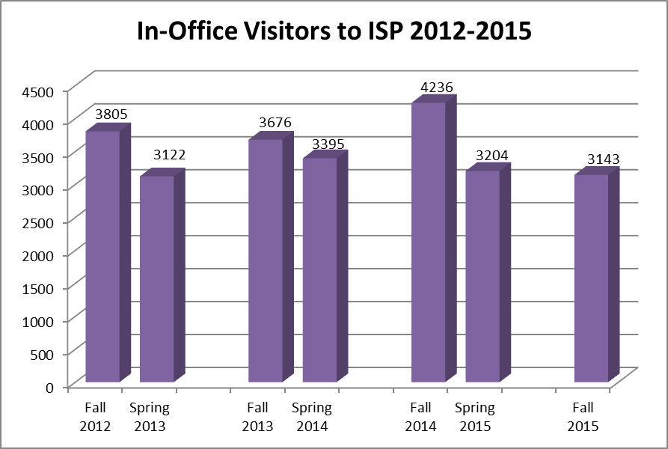

The chart above describes the annual in-office visits. Again, the goal will be to track the visitor rates and adapt new systems in order to streamline visits.

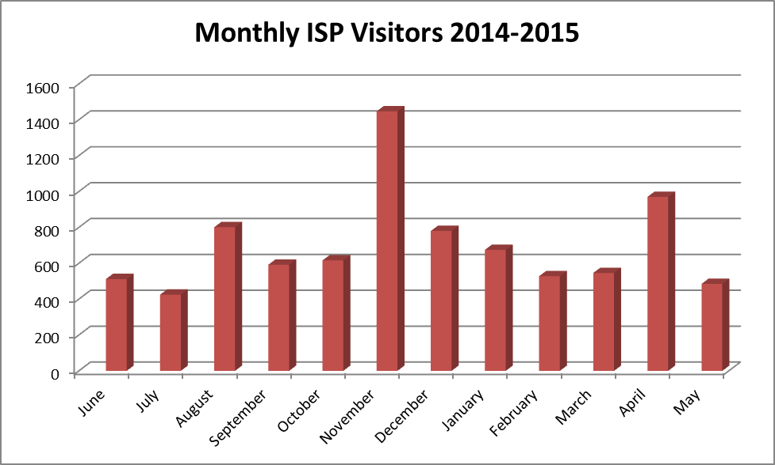

Through tracking the number of monthly visitors, the ISP office can anticipate it’s seasonal hieghts and lulls. This helps to determine workshops and communication scheduleing, as well as staff vacations and workflow.
The overall objective is to help provide the best possible student service in an efficient and effective manner. While increasing staff would be one solution, the ISP office also needs to incorporate other methods to decrease in-office visits. Some ideas may include:
- Adapting forms to be accessed online
- Submitting basic requests through a drop box, off hours
- Scheduling counseling appointments over the phone
- Resolving issues upon initial visits

- If applicable, explain any patterns in student success, retention, persistence, graduation, and transfer in terms of student characteristics and program objectives and discuss planned responses or changes.

F-1 International students have consistently seen higher program and retention success than the overall student population at El Camino College – the average increase at 12% more than overall success rates over the past four years and an average of 10% more for retention over the past four years. However, there seems to be a decreasing trend in the F-1 visa population’s program success rate, as well as the retention rate. The cause of this decrease is unknown and further investigation with the international students will be conducted.
 | Fall 2011 | Fall 2012 | Fall 2013 | Fall 2014
ISP Success | 81.9% | 81.2% | 80.2% | 77.7%
ECC Success | 67.4% | 69.7% | 67.5% | 67.4%
ISP Retention | 94.1% | 93.3% | 93.1% | 90.9%
ECC Retention | 81.7% | 84.3% | 83.0% | 82.1%

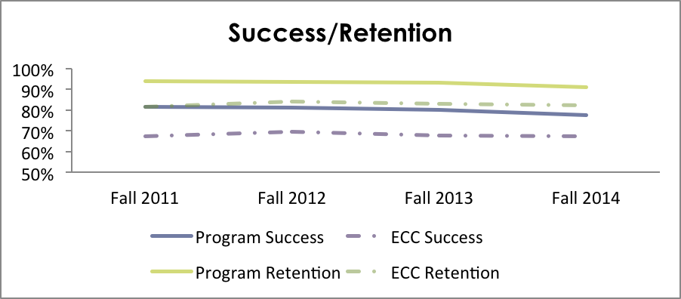
Typically, F-1 visa students are on a streamlined path towards achieving their degree, certificate or transfer goal. F-1 visa students pay a considerable amount more tuition than a person studying with in-state tuition and is mandated to take, at least, 12 units per semester (with exceptions). This high cost of tuition and guaranteed full course load of study help F-1 visa students stay on the path to achieve their academic goals. Over the past three years, there has been a decrease in students earning an AA or AS degree, as well as a certificate degree. One rationale is for the increase in students transferring directly to a four year University or College.

Type of Degree Earned by Year
 | Award Year
Degree Type | 2011-12 | 2012-13 | 2013-14 | 2014-15
ISP AA or AS | 121 | 142 | 125 | 95
ECC AA or AS | 1,659 | 2,012 | 1,998 | 1,977
ISP Certificate | 15 | 32 | 19 | 17
ECC Certificate | 516 | 592 | 478 | 410

Looking at the table “Type of Degree Earned by Year” (above) shows students being awarded a degree or certificate has steadily declined over the past 5 years with the steepest decline in 2014-2015.

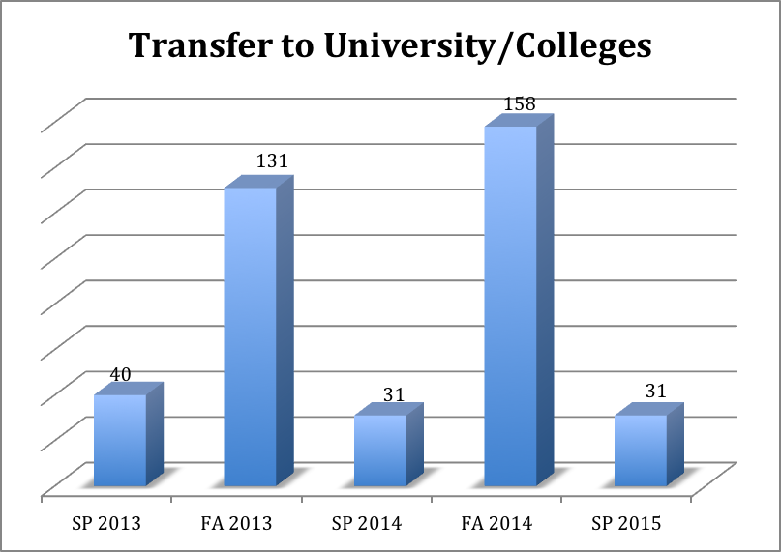

However, when reviewing actual transfer rates of students going on to 4-year universities, the data for student transfers increase. Looking at the chart above “Transfer to University/Colleges,” the year that the fewest degree and certificates were awarded, 2014-2015, was the year with an increase in transfer rates. This may be one explanation to accommodate for the decrease in awards earned.

Customer Service
Administer a customer service survey to students or colleagues, if applicable. Please administer the survey the semester prior to submitting your program review.

- How was the survey conducted? Please include a copy of the survey to the appendix.
Three surveys (attached to appendix) were developed jointly with Institutional Research to evaluate the following stakeholders and outcomes:
- F-1 visa student satisfaction
- ECC faculty regarding F-1 visa holders
- Overseas agent satisfaction

- What were the major findings of the customer service survey?

International Student Program Survey
The survey focused on four main areas: counseling, registration and overall student satisfaction. The survey was sent to all students in the international program via email communication. All results were anonymous.

The survey produced a response from 97 students. Of those 97 responses, 57% were female and 40% were male. The majority of responses, 39% of students surveyed had been studying at El Camino College for 1-2 years and 27% of respondent studied over 2 years.

Counseling
The majority of responses from the international students polled in the survey responded positively towards the international student counselor.

The majority of students, 90%, understand how to make an appointment with the international student counselor, while only 7% responded that they did not know the procedure. The remaining 3% did not answer. Although this is a large percentage of knowledge, additional information can be more widely advertised about the counselor appointment process in the ISP office.

When asked if the international counselor could answer the majority of questions posed during their sessions, 71% responded ‘yes,’ and 26% said ‘no.’ The remaining 3% did not answer. Although a majority are feeling satisfied with counselor response, ISP and the international student counselor need to work on reaching the 1 out of 4 students who do not feel that they are receiving all of the answers to their questions. This may also be due to language barriers or misunderstandings.

Of applicants polled, 65% of international students said that they meet with the international student counselor at least once per semester and 29% two or more times per semester while only 1% said that they have never seen the counselor. This is a positive response that the over 94% of students are speaking with their appropriate counselor, at least, once a semester.

Students responded positively that they were able to receive the appointment time they desired with the counselor – 86% responding that the time was convenient and 11% noting that the time the were scheduled to see the counselor was not convenient. In a follow up question about best time to schedule the appointment with the counselor, 52% of students preferred a 9 am -12 pm meeting and 32% preferred a 1 pm -3 pm meeting. The minority of students, only 12%, responded that they would like to schedule a time after 3 pm and into the evening. Many international students do not enroll in evening classes due to lack of transportation and scheduling conflicts, so evening hours for the counselor are not as convenient at morning and early afternoon scheduling.

Registration
International students must be enrolled in, at a minimum, 12 units to be considered ‘in status’ with immigration and not at risk for termination. Therefore, it is essential that international students have a smooth registration process and find classes. The majority of students were either ‘satisfied’ 48% or ‘very satisfied’ 37% with the registration process. When registering for classes, 87% of students were able to register for the class that they preferred, while 11% were not able to register for their desired classes. Registration for classes and finding available courses is usually not an issue for continuing students, however, for new incoming international students; this is a very difficult task. International students are allowed to enter the country only 30 days prior to the program start and are only registered for classes two weeks prior to semester start. This eliminates desirable classes for incoming international students since continuing students will have filled those classes. These comments were noted on the additional feedback section of the survey.

Overall Program Satisfaction
Overall, international students responded positively towards the international student program and its quality of service.

The area that has been highlighted by either the comments or survey sections includes expanding the hours of operation of the office.

The hours of operation for the ISP office can be improved with additional staff to operate the office. Only 10% of students responded that the hours of operation were ‘Excellent,’ and 36% responding that the hours were ‘Good.’ This left a remaining 52% of students responding that the hours were either ‘Fair’ or ‘Poor.’ This was also a repeat comment when students were asked to expand upon how to improve the program. As noted previously, a large portion of staff time is devoted to document processing, allowing the office to be closed at certain times throughout the day allow staff to concentrate on regulatory processing. During the open hours, the ISP staff is devoted to student support and problem resolution.

Faculty Survey
A survey was administered to various faculties that represent the English as a Second Language and Mathematics Department. The survey asked faculty various questions regarding F-1 visa international students on El Camino Campus. The largest theme that is present among the answers is that the faculty does not know the distinction between F-1 visa students and other international students studying at El Camino College. This is an important distinction in terms of class registration, unit requirements and immigration policies. Please see Appendix for full survey results.

When asked if faculty know the distinction between F-1 visa students and other international students, 75% responded that they did not know the difference while 25% responded that they did know the distinction. For the remainder of the questions asked, these were specific to F-1 visa students and the faculty chose to not respond to the questions – meaning that they left the answer blank. This would account for the 75% of faculty not being able to answer specific questions geared towards F-1 visa students.

The comments regarding overall experience with F-1 visa students provide a deeper insight. The majority of the comments describe every student as being different from the next – there is not one overall arching theme to whether students arrive at El Camino College more or less prepared than other students. Language and culture barriers are highlighted, as well as international student lack of participation in class discussions.

Agent Survey
A survey was administered to overseas agent who partner with El Camino College. There was a response of 22 agencies representing over 14 different countries worldwide. The response was overwhelming positive for the staff of the ISP and ECLA programs, as well as for El Camino College facilities.

For respondents, the majority of agents have long-term relationships with El Camino College, 59% of agents have been with ECC for over 5 years, while 27% have had a relationship for 3-5 years and the remaining 14% for 1-2 years. This shows strong connections to the college and staff.

The majority of overseas agents responded that the quality of materials was either ‘Excellent’ (36%) or ‘Good’ (50%). Only 4% (1 agency) responded that the materials were ‘Poor’ and 9% said that they were ‘Fair.’

When asked about the response time for receiving acceptance packets, 91% of agencies responded that ‘Excellent’ with 4% responding ‘Good’ and another 5% responding ‘Fair.’ This is an overwhelmingly positive response and supported by additional comments regarding promptness of response.

The response to the friendliness of staff was also positive with 82% responding ‘Excellent’ and 14% saying ‘Good.’ Only 5% responded ‘Fair’ to this question. Additional comments highlight the friendliness of staff at El Camino College.

When asking about commission fees, 64% of agents responded that El Camino College is comparable to other schools in terms of commission fees and 37% that ECC is not. In the comment section, several agents noted that if El Camino College offered higher commission fees, they would refer more students.

Agents also responded positively for being paid commission fees in a timely manner – 45% of agents replied that the payment response time was ‘Excellent’ and 41% responded that it was ‘Good.’ Only 14% responded ‘Fair’ that El Camino College pays in a timely manner. Issuing payments to agents requires additional follow up, contract renewal, invoicing and payment instructions. The programs do an excellent job keeping track of agent payments and contract renewals.

The one area that can be improved is in regards to the websites. Although agents replied with a 72% favorable response (36% ‘Excellent’ and 36% ‘Good’), additional comments highlighted that El Camino can improve its website (and marketing) for students. In addition to these comments, 23% of agents responded that the website was ‘Fair’ and 5% responded ‘Poor.’ These were the most negative responses on the survey.

Other comments highlighting the strengths of El Camino College include;
- “Urban Location”
- “Provide English course for international students. Various programs. Reasonable tuition. Reputation, good student support services. Location.”
- “Transfer rate, and time it takes to transfer, and ECC’s small population of international students.”

Comments that outlined the weaknesses at El Camino College primarily include housing topics and the knowledge of the school overseas.

- Describe exemplary services that should be expanded or shared with other programs.
According to the recently administered Student Survey, students have responded strongly that the ISP office works hard to solve problems associated with the immigration and campus related problems. The personal one-to-one care that the ISP staff shows students is a student-centered approach to holistically supporting students. Evidence of this support is provided in both the quantitative data, as well as the qualitative comments provided in the survey.
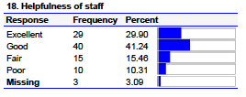
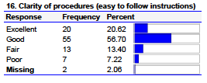
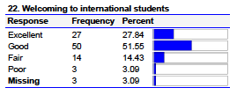

Survey Question: What does the ISP do well?
“With the staff that are willing to help an are nice enough to be nice and kind.”
“Very helpful and will attend to our request or need as soon as possible.”
“In every case, they try to help as much as they can.”
“The International Student program makes sure that your documents are in order and if they are not, they will do anything they can to help you with.”

In addition to the staff trying to help resolve issues surrounding international student problems, another highlight of the program that should be shared is the positive partner relationships ISP/ECLA shares with overseas agents. The overwhelming positive remarks are a result of prompt email and phone responses. The communication between colleagues, community and students is excellent and could be replicated in other areas.
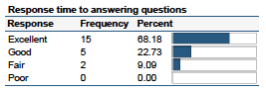
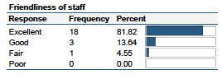
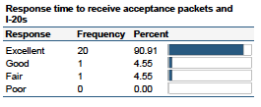

4. What aspect of the program’s service needs improvement? Explain how the program will address service improvements.

Recommendations from Student Survey
Students have outlined that areas for improvement can be made with the hours of operation, updated technology and customer service. These topics have been addressed in the ISP office and a number of ways to improve have been implemented or suggested in the past semester. See below for specific improvements.

Hours of Operation: Students have expressed a need to have the ISP office available during other times of the day. This has been suggested and, under the current staffing, is not manageable to expand at this time. However, once the ISP office receives additional staffing support, this issue will be resolved.

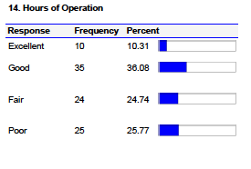
Customer Service: Although students shared that they were satisfied with the quality of problem solving and issue resolution in the ISP office, there were mixed commentary regarding the customer service of the office. Of students surveyed, 68% were satisfied with the overall quality of service. Additionally, there were several comments made towards the friendliness of staff. This issue has been addressed and methods to provide a friendlier environment have been implemented. Staff now wear name badges so that students can identify with a personal member of the team, candy is being left at the sign in desk so that the office invites students into the space, and staff have been made aware of how their actions are perceived. An issue with being short-staffed and over-stressed has been reviewed, which may result in a less friendly environment. However, even with a 32% fair or poor rating regarding quality of service, students still express positive notes in regards to the helpfulness and genuine care of staff.
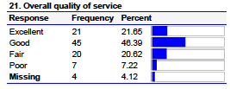

Updated Technology: Students responded in the written comments that the technology piece of the ISP and ECC campus, in general, is lacking. This is an issue that cannot be readily resolved due to software capabilities with the current systems and internet access. However, some updates may be feasible – such as converting forms to fillable PDF’s and allowing access online. This is a project being researched and piloted in the ISP office currently.

Some student voices from the survey results include:
“It is annoying to go all the time to the officer when we should be able to do everything online.”
“The school system is very old and outdated. Often result in a very slow procedure. Tech support is non existent. Some student have trouble with getting into myecc page when their computer or browser is incompatible.”

Recommendations from Agent Surveys
The overall feedback from the overseas agents was very positive. However, some of the agents responded through comments that they would like to see the website updated more often with advanced marketing materials and expand the ECLA program.
This feedback can be seen throughout the sections, “How can El Camino improve?” “What would it take for El Camino College to recruit more students from your agency?” and, “What would you like to see on the El Camino College website?” Overwhelming responses included a general theme of: “more information, nicer photos, more marketing materials.” Please refer to pages 2-4 of the “International Student Program Agent Survey” in the appendix.

Recommendations from Faculty Surveys
The faculty survey revealed that 3 of 4 faculty members are not aware that there is a distinction between an F-1 visa student and an international student. This distinction is extremely important for unit requirements, class placements and background information regarding policy and procedures. It would be helpful to provide a staff development session at the next staff flex day to promote diversity understanding among the different international populations studying at El Camino College.

Of the additional comments faculty supplied, one comment regarding the ISP manager attending ESL meetings has been followed up on. Currently, the International Program Manager is attending all ESL faculty meetings and will identify other faculty areas that may be helpful to participate.

Conclusions and Recommendations
Only include information previously referenced in the program review

- Summarize the program’s strengths.

El Camino Language Academy and International Student Program

One Stop Philosophy: Both programs have an advantage over many other students. Their admissions, registration, visa status, health insurance, tuition payment status, preparation and transfer can all be accessed and resolved in one house. This is an extremely helpful tool to identify needs and resolve issues efficiently.

Counseling is at the core of all academic information and advisement provided to F-1 students. Upon arrival at El Camino College, F-1 visa students are required to meet with their international counselor to organize their education plan for their course of study. Each semester, the ISP office will coordinate appointments for students to visit the international student counselor. Academic counselors help to maximize student potential to graduate from El Camino College or transfer to a 4-year college. Counselors also help ECLA students transfer to the academic program.

Dedicated Staff: The staff and faculty of the ISP and ECLA both go above and beyond the call to student service. They often arrive early, stay late and resolve issues in all times between. They provide personal one-to-one service to each student who arrives on campus and in the office. They are trained to be experts in their fields and serve on committees to provide additional immigration advice to colleagues and support staff.

- Summarize the program’s areas that need improvement.

El Camino Language Academy and International Student Program

Marketing & Communication
The two programs are currently marketing and advertising together, however, it is disjointed and has inconsistent marketing materials. This is highlighted by the overseas agent survey and comments.

International Student Program
Software Support/Technology
As described by both students and overseas agents, the technology piece is lacking for both the ISP and ECLA programs. Internally, the systems are antiquated and do not provide the support needed to oversee federal regulations.

Limited Staff Resources for Growth
The limited number of full-time staff is a continued issue. USCIS policies and procedures regarding visa maintenance continue to unfold. There is a demand to increase the F-1 visa student population on El Camino’s campus. With the current staffing, it is difficult to abide by regulations and even maintain the current student population. New projects and procedures demand more full-time staffing to help students succeed responsibly.

Availability of Classes
F-1 visa students have a difficult time obtaining the necessary classes to fulfill their immigration regulations. Due to the high tuition that each student pays ($288 per unit in 2015/2016), students try not to waste their units on classes that do not directly relate to their degree requirements. However, these classes are often the ones that fill first, leaving F-1 students to take recreational classes at a high cost that will not contribute towards their degree. This is a universal problem among F-1 visa students studying in the United States.

ECLA Classroom Space Availability
The classrooms have been a consistent problem when reserving for the semester. If the program is going to continue or grow, a solution for space must be resolved. If the space is not available, the classes are at risk to being cancelled or relocating.

- List the program’s recommendations in a prioritized manner to help better understand their importance to the program.
- Limited Staff Resources for Growth
Recommendation: Review the staffing requirements of ISP and ECLA. With an increase in personnel, there can be an increase in student to staff contact and more efficient services offered to support students. See the proposed chart on page 31.

- ECLA Classroom Space Availability
Recommendation: Work with area deans and vice-presidents to allow for three reserved classrooms for ECLA throughout the academic year.

- Availability of Classes
Recommendation: Many campuses have successfully implemented shadow seats for F-1 visa students. This would require the support of faculty, deans and the vice presidents on campus.

- Marketing and Communication
Recommendation: A comprehensive marketing plan that involves both programs needs to be developed where up to date and modern materials are developed. A wider encompassing communication to students should be developed through use of newsletters and brochures. This can be used to highlight programs and educate students.

- Software Support/Technology
Recommendation: Implement the following to allow for better technology, in partnership with IT:
- ECLA does not have online classroom support to help create rosters, attendance or classroom management.
- SEVIS integration and software compatibility with Datatel.
- Datatel does not allow an automatic alert system to notify staff of when students drop below 12 units or enter probation throughout the semester. This requires a manual processing to abide by USCIS policies.
- Data tracking is done manually in-house which creates a large workload to collect and analyze semester metrics.

4. Please indicate whether the program should continue or be discontinued.

X Continue Program

___ Discontinue Program. Explain how the program’s services could be handled by another on-campus entity if the program has been declining or is no longer fully utilized.

Student & Community Advancement Program Review Committee
Ratings

- Excellent
The program review was extremely well written. Concise and grammatically correct with few to no spelling errors. A model program review that is ready to be posted online for a public audience.

- Meets Expectations
The program review was adequately written. Lengthy or vague at times or included some grammatical and spelling errors. Corrections should be made prior to posting online for a public audience.

- Needs Improvement
The program review was poorly written or incomplete. Too lengthy or vague or too many grammatical and spelling errors throughout the document. The program review needs to be rewritten and resubmitted to the Student & Community Advancement Program Review Committee by an established deadline.

Revised: 5/5/2010, 3/13/2013, 3/31/2014, 4/15/2014, 6/1/2015

F-1 student enrollment data collected from ISP/ECLA program statistics and institutional research
Refer to El Camino Student Catalog 2015-2016, page 11
ECCD Final Budget 2015-2016, page 4
http://www.wsj.com/articles/international-students-stream-into-u-s-colleges-1427248801
https://www.insidehighered.com/news/2013/04/18/concerns-about-international-student-safety-come-fore

