**EL CAMINO COLLEGE**

**STUDENT SERVICES**

**ADMISSIONS, RECORDS, REGISTRATION & EVALUATIONS**

**PROGRAM REVIEW 2015**

**Program Description**

1. *Describe the program emphasizing the program’s objectives and how the program supports the college’s mission and vision statements, strategic initiatives, and core competencies.*

The program under review here comprises the functions contained in Admissions, Records, Registration, and Evaluations. The functions within the Admissions unit are the on-line application for admissions (CCCApply), K-12 Concurrent Enrollment processing, verification, special programs (Fire Technology, Terminal Island Prison classes), Grade Submission Assistance, Online Active Enrollment (Census) and No-Show Report assistance, Subpoenas, overriding problem prerequisites, MIS error checking, Residency Determination and Appeals, AB540 processing, name changes, address corrections, SSN corrections, change of major, online and in-house transcript processing, document scanning, credit-by-exam, academic renewal, grade change petitions and processing, cross-enrollment, reinstatements, online registration, registration help line, registration problems and issues, section-level transfers, repeat clearance, and probation level II clearance. The Evaluations Program serves the interests of all students who are applying for an Associate of Arts degree, Associate of Science degree, Certificates, CSU (California State University) General Education Breadth Requirement, IGETC (Intersegmental General Education Transfer Curriculum), certification, probations and dismissals.

The scope and wide ranging impact of Admissions, Records, Registration, and Evaluations on students is significant. Students have

**Mission Statement**

El Camino College makes a positive difference in people’s lives. We provide excellent comprehensive educational programs and services that promote student learning and success in collaboration with our diverse communities.

All four areas: admissions, registration, records, and evaluations make every effort to create a positive difference. Supporting a diverse campus community through in person or electronic means the personnel performing these functions commit themselves to service that can lead to success.

**Vision Statement**

El Camino College will be the college of choice for successful student learning that transforms lives, strengthens community, and inspires individuals to excel.

Successful student learning can be hindered by poor or obstructionist student service. These four vital functions must, in an atmosphere of heavy federal and state regulations, advance student service and avoid hindrance of student learning.

Application for Admissions

Applications for admissions to El Camino College are processed online. El Camino College was a pilot college for the state online application for the admissions project sponsored by the California Community College Chancellor’s Office. Development of the application began in summer 2000 and was completed in spring 2001. El Camino College has been a member of the Steering Committee of CCCApply since its inception. The current El Camino College Director of Admissions served as its Chairman for six out of eight years and now serves as the Past Chairman. In 2013 a new cloud based application was developed for CCCApply. The new and improved Open CCCApply was implemented by El Camino College in June 2014 just prior to the opening of applications for Spring 2015. The cost of the application is now born by the California Community College Chancellor’s Office.

Since the inception of the CCCApply application the college and the community college system as a whole has incorporated both state and federal requirements. For example, the race and ethnicity question was reformatted to meet the requirements of the United States Department of Education, the gender question was restructured to meet AB 620 of the California State Legislature, and questions related to athletic interest were added to meet one of the prongs of Title IX of the federal government. The use of the statewide application sponsored by the Chancellor’s Office ensures that the application remains up to date technologically and in compliance with relevant federal and state laws and regulations.

Supporting Admissions Functions

Among some of the supporting functions are online add assistance (see Add Process), online drops, reinstatements, section level transfers, pre-requisite clearance problems, auditing classes, and issues related to special programs such as Fire Technology and Cosmetology.

Roster Processing

Roster processing involves the processing of “No Show" reports, “Active Enrollment” reports, “Grade” reports, and all supporting grade documents including attendance rosters. These particular rosters are now fully online. However, attendance rosters and supporting grade rosters (showing tests, quizzes, homework, etc.) continue to be paper driven. A Student Services Specialist is assigned by Admissions & Records to assist faculty with issues, problems, or questions regarding their class rosters.

Verifications

Students request verifications for a variety of reasons: health insurance, car insurance, employer tuition reimbursement, job and other college applicant requirements, and scholarships. Loan deferment verifications are done through the National Student Clearing House. However, many students continue to request verifications in person.

Concurrent Enrollment

This area encompasses the enrollment of all students wishing to enroll at El Camino College who are also enrolled in a secondary or primary school. Personnel dealing with concurrent enrollment must ensure that all students in this category applying for admission to El Camino meet all requirements. This includes filing a completed application and a completed concurrent enrollment form and, if circumstances require, other supporting documentation. Personnel in this area must also ensure that concurrently enrolled students are granted permission to enroll in approved courses and receive an appropriate registration appointment. Concurrent enrollment derives authorization from the California Education Code, Section 76001 and the El Camino College Administrative Procedure 5011.

Residency

Students who are classified as a non-resident during the application of admissions process have a right to petition that status. There is a defined process as outlined in Title 5 and the district’s procedure. Pursuant to law, there is also an appeal process.

Petitions

General student petitions (not related to grades, grievances, or the like) are accepted in Admissions. Most students file these petitions because they are debating a fee or a "W." A Petitions Committee is assembled several times through the year. The committee is chaired by the Director of Admissions & Records or, in his absence, the Assistant Director of Admissions & Records. It is comprised of teaching faculty, counseling faculty, academic and student service deans and directors, evaluators, and representatives from Fiscal Services. Since the district contracted with COTOP (Chancellor's Office Tax Offset Program), the committee has witnessed an increase in petitions. Before the committee can render a decision, significant research must be conducted on every petition. This is done by an employee within Admissions. The decision of the committee is final. However, a student can re-petition if the student can present new documentation or evidence to support the petition.

RECORDS

The functions within the Records unit are transcript processing, academic renewal, maintenance of student records, and maintenance of class rosters, certification/IGETC, and course repetition, credit by exam, incomplete grade processing, military service credit, academic renewal, grade changes, and record imaging.

Transcripts

Tens of thousands of El Camino College transcripts are prepared every year for mailing to other colleges, scholarship organizations, employers of students, and to the students themselves. Approximately two-thirds are processed for mail-out with the remaining third processed for next day pick-up. El Camino College contracts with Credentials Inc. to process official transcripts. Students order transcripts online. Credentials will validate and process the requests, collect the fees, and send the batch to the Records Office where the transcripts are printed, enveloped, and mailed. Since 2013 the Records Office now uses security transcript paper to guarantee the integrity of the college’s official academic transcripts. Future plans include shifting the mail out process to Credentials. This will speed up delivery time to students and further enhance the security of the official academic transcripts.

El Camino College is also one of the founding members of eTranscriptCA for California. eTranscript California is a statewide electronic transcript exchange to support the needs of all four segments of California’s postsecondary environment: the California Community Colleges, the University of California, the California State University, and private Colleges in California.

Academic Renewal

Approximately 500 petitions for academic renewal are processed each year. The academic renewal process follows Title 5 and the El Camino College policy and procedure.

Credit by Exam

Approximately 500 requests for Credit-by-Exam are processed annually. The vast majority of these requests are for foreign languages: Spanish, Japanese.

Imaging

All incoming transcripts (those received from other colleges), attendance records, education plans, residency petitions, old paper applications for admission, and denied grade changes are scheduled for imaging. The volume is significant and the division will be exploring the use of vendors to scan most of these historical documents.

Record Maintenance

The vault of the Records Office contains the academic records of all students since the college opened in 1947. The older records are stored in bound volumes and micro film. On an almost daily basis the Records Office receives requests for transcripts from the 1960s and 1970s. This requires time consuming research to pull the old records. In addition, the Student Services Specialist in the Records Office assists the Admissions Unit in the processing of subpoenas for old documents which may include academic transcripts, rosters, and other support documentation.

REGISTRATION

The functions within the Registration unit include online registration, the registration help line, and the online add process.

Online Registration

Online registration is conducted through the El Camino College Portal. Over the years it has migrated from the Web Advisor product of Datatel to the present customized Portal. With the infusion of new screens, a “shopping cart” and a streamlined flow through the on-line registration process, all students now use web registration.

Registration Help Line

When students encounter problems in registering online, they contact the Registration Help Line. This service is offered only during registration cycles and is staffed by one or two part-time employees. This service is offered for students at the El Camino College campus and the Compton Center.

Add Process

In Fall 2009 both El Camino College and the Compton Center migrated fully to an online add process. This process is conducted in the first two weeks of each semester and during the first week of each summer session. Support personnel are provided at both ECC and CEC to assist students who have questions regarding the online add process. Certain factors prevent some students from adding online: the student may need a pre-requisite clearance, there are excessive repeats, or the course has a co-requisite.

EVALUATIONS

Evaluator’s evaluate all student records, El Camino transcripts and those of other colleges to determine a student’s eligibility for any of the above named degrees certificates and/or certifications. They also review course repetitions that use course work from other institutions. Evaluate all Academic Renewal Petitions which require course work from other institutions.

1. *Describe the student population served by the program using available data.*

All students wishing to enroll in a credit course or audit must submit an online application for admissions and then register for the courses they wish to pursue. Therefore, the population served by these two key Admissions and Registration functions, mirror the population of the college. In Fall 2013 the student data was as follows for gender and ethnicity: There were a total of 23,993 students enrolled in that semester.

|  |  |  |
| --- | --- | --- |
| Gender | | |
| Female | 12,321 | 51.4% |
| Male | 11,670 | 48.6% |

|  |  |  |  |
| --- | --- | --- | --- |
| Ethnicity | | | |
|  | 2010-12 | 2011-12 | 2012-13 |
| Latino | 38.1% | 40.1% | 43.8% |
| White | 17.8% | 16.7% | 15.6% |
| African-American | 18.5% | 19.0% | 18.4% |
| Asian | 16.8% | 16.6% | 15.7% |
| Unknown | 5.0% | 3.2% | 1.8% |
| Two or More Races | 2.9% | 3.4% | 3.9% |
| Pacific Islander | 0.7% | 0.6% | 0.6% |
| American Indian | 0.3% | 0.3% | 0.2% |

In Fall 2013 a total of 16,802 of the enrolled students were considered “traditional” age students (under 25). There were 7,191 students who were “non-traditional.”

Of the 23,993 students who enrolled, 15,116 (63.0%) were continuing students from the prior term (spring 2013). There were 6,085 (25.4%) first-time students to El Camino College and 2,555 (10.6%) returning students. There were also 237 K-12 Concurrently Enrolled students. These first-time, returning, and K-12 students were required to apply for admissions first and then register for their courses.

The major function in the Records Office is the production and issuance of unofficial and official transcripts. There is no demographic data on the students who request transcripts. Students, former and current, will request transcripts to be sent to other colleges or universities, to employers, to themselves, and to other third parties.

Applications for degrees and/or certificates are open to all students. However, the awarding of degrees and certificates are subject to students meeting the criteria as set forth by the California State Legislature, the Board of Governors of the California Community College System, the Board of Trustees, the Curriculum Committee, and the Academic Senate of the El Camino Community College District.

1. *What happens after students participate in the program’s activities? If applicable, address whether students are successful in meeting their educational goals.*

Application for Admissions

Students apply online to El Camino College. Applicants can either be a concurrently enrolled, new, or a returning student. Concurrently enrolled students (K-12 students) must apply every term until the student graduates high school. New students are students who have never been enrolled at El Camino College or had been previously a K-12 student. Returning students are those students who had been enrolled in a previous term (other than K-12), and have been separated from El Camino College for at least one primary term. It is expected that students will understand the online application and complete it accurately and in a timely manner.

Supporting Admissions Functions

There is a myriad of supporting functions in admissions: faculty online forecasting, final grade, no-show and census report, and drop assistance; subpoena processing, special program operations (fire tech, honors transfer program,

Verifications

Students request verification of enrollment for a variety of reasons. Most current students request verification for insurance or scholarship purposes. Some need verification because they receive employer reimbursement for their education. Both current and former students ask for verification of enrollment or degree/certificate received when applying for a job. Most of these requests now transact through the National Student Clearing House. However, we continue to receive in-person requests

Concurrent Enrollment

Students who participate in this function of the program are expected to complete all aspects of the concurrent enrollment admissions and registration process in a timely manner and in accord with the provisions of the California Education Code and the policy and procedure of El Camino College. K-12 students who successfully complete the process are permitted to enroll in the pre-approved courses and are subsequently treated as a college student with all rights, privileges, and responsibilities.

Petitions

There are four primary types of petitions in this program; grade change, residency, late add, and general petitions. There are also some minor petitions – those with lower usage: credit by exam, academic renewal.

RECORDS

The functions within the Records unit are outgoing transcript processing, in-coming transcript request processing, academic renewal, maintenance of student records, maintenance of class rosters, certification/IGETC, course repetition, credit by exam, incomplete processing, military service credit, academic renewal, grade changes, and record imaging.

Transcripts

Both incoming and outgoing transcripts are under the jurisdiction of the records office. Incoming transcripts are opened and scanned for future use by counselors and evaluators. Outgoing transcripts are processed in accordance with the requests of the student: next day pick up or mail or standard mail (10 business days). Transcript requests may be made in person, through the mail, or through the online 24/7 transcript request process. El Camino College uses credentials Inc. for this service. The records office staff must still print, fold, and mail the online transcript requests.

Academic Renewal

If a student meets the district’s requirements on academic renewal, then the student can realize an improvement in the grade point average on the academic transcript. Thus, a student may then qualify for a degree or certificate. In addition, many four year colleges recognize and honor academic renewal and a student’s goal to transfer can be fulfilled.

Credit by Exam

Students who meet the college’s requirements for credit by exam will file the petition with the records office. It is the records office that is responsible for verifying the student has met the criteria for credit by exam as set forth by board policy and procedure. It is also the records office that collects all relevant fees for the exam, posts the outcome on the student’s transcript, and maintains the records of the credit by exam petition and subsequent outcome.

Imaging

The timely and correct imaging of student records is a great service to students directly and indirectly. Students, counselors, and other academic professionals with a need to know can extract this information and use it for Education Plans, degree audits, or other tools that can lead to student success.

Record Maintenance

Record maintenance is essential. It is not only legally required, but it allows for students and counselors to refer back to previous documents. This facilitates academic counseling and student decision making.

REGISTRATION

The functions within the Registration unit include online registration, the registration help line, and the online add process.

Online Registration

Online registration, although losing the personal touch that in-person registration once had, provides students with opportunities to register 24/7 from their home, the college or across the country, after a student’s registration appointment time. It is a cost effective tool for the district and a service of convenience for the students.

Registration Help Line

The registration help line lives up to its name. It provides student service to students who are experiencing difficulty in accessing or maneuvering through the online registration system. It is also there to answer some fundamental registration questions regarding prerequisites or overloads. The help line will refer students to counseling, the academic division offices, fiscal services, or financial aid when appropriate. It is this help line that assists both el Camino and Compton students.

Add Process

It is anticipated that students will be able to add courses online with the use of AddCode stickers. The Admissions Program offers assistance to students during the add period. During the first two weeks of the fall and spring semesters Online Add Assistance is offered to students in the East Lounge of the Student Activities Center.

EVALUATIONS

Students who apply for an associate’s degree are required to have achieved a minimum grade point average of 2.00 overall At ECC and all units completed at all other colleges (there may be additional requirements in a major), have completed at least 60 academic units, have met academic area requirements, and have met El Camino College unit residency.

The Section A, General Education Requirements for both the Associate in Arts and Associate in Science degrees are split into three sections:

1. Option I – for students completing an El Camino College major
2. Option II – for students completing CSU GE Breadth transfer requirements
3. Option III – for students completing CSU/UC (IGETC) transfer requirements

Students who choose Option I must meet requirements in Natural Sciences, Social and Behavioral Science, Humanities, Language and Rationality, Health and Physical Education, Mathematics

The main reasons for students to have their degree applications denied are:

1) An academic area has not been met

2) Transcripts from another college were never submitted

3) GPA requirements were not met

4) Less than 60 units have been achieved

5) Student does not meet the ECC residency requirement. When a student does not qualify for a degree or certificate the evaluators will notify the student with the reason and an advisement to see an academic counselor.

Interaction with students is also critical. The evaluators communicate with students via email, telephone, and regular mail. They communicate with students when students are deficient in requirements to graduate. Requirement deficiencies include: GPA issues, missing coursework, or courses that do not meet the minimum requirements for the major in question. Evaluators also will meet with students in person if necessary or requested by the student. Evaluations staff notifies students in writing if the graduation petition is denied. Students are told why the petition was denied and what the student/s need to do to meet the graduation requirements.

The role of the Evaluations Program in probations and dismissals is primarily that of a supporting body to the Division of Counseling. The role of the evaluators has been reduced; currently evaluators receive a clearance list and/or individual student reinstatement contracts. Evaluators remove PERC holds to clear students.

1. *List notable achievements that were linked to the College’s Strategic Initiatives that have occurred since the last program review.*

There were notable achievements that were linked to the college’s strategic initiatives since the last program review in 2006.

Four strategic initiatives adopted by the district were used by the program for the 2011 program review. They were:

1. Conduct a Staffing Analysis and Develop a Staffing Plan

Conduct a staff analysis and replace retired staff as needed as an exact job replacement or an enhanced or modified job replacement. The analysis would include, but not be limited to the following:

1. Retain Retired Staff Positions on Books during Staffing Transition
2. Reevaluate Job Descriptions
3. Create New Job Descriptions
4. An implementation plan

This recommendation was linked to two 2011-2014 Strategic Initiatives. First, Strategic Initiative B: Strengthen quality educational and support services to promote student success. Second, Strategic Initiative E: Improve processes, programs, and services through the effective use of assessment, program review, planning, and resource allocation.

By Fall 2013 an analysis of the division’s staffing was completed. The analysis concluded that out of the twenty-six classified staff, two managers, and one supervisor, seventeen would retire by the end of 2017. Born from this analysis was the creation of new positions, consolidation of some positions, the elimination of some positions, and the upgrade of others. The implementation of the fruits of this analysis will continue to be a work in progress. By the next program review in 2019, the staffing structure should be set.

The following staffing events have since Fall 2013:

|  |  |  |  |  |
| --- | --- | --- | --- | --- |
|  | Job Classification | Program | Basic Functions | Outcome |
|  |  |  |  |  |
| 1 | Student Services Technician | Admissions | Grades, Rosters, and Faculty Support – Reinstatements, Section Level Transfers | Retired – December 2013 |
| 2 | Student Services Technician | Admissions | Academic Renewal, Credit by Exam | Retired – December 2013 |
| 3 | Clerical Assistant | Admissions | Grades, Rosters, and Faculty Support – Reinstatements, Section Level Transfers | Retired – December 2013 |
| 4 | Student Services Specialist | Registration | Technical Support for Degree Audit; Registration Functions, | Passed Away –  February 2014 |
| 5 | Student Services Specialist | Admissions | Residency | Hired - |
| 6 | Student Services Specialist | Admissions | Grades, Rosters, and Faculty Support – Reinstatements, Section Level Transfers | Transferred in - |
| 7 | User Support Technician | Division | Technical Support for the entire division | Hired –  October 2014 |
| 8 | Clerical Assistant | Records | Supported division clerical duties | Retired –  December 2014 |
| 9 | Senior Clerical Assistant | Admissions & Registration | Special programs: Fire Tech, Admin of Justice, Honors Transfer, | Retired –  December 2014 |
| 10 | Evaluations Specialist | Evaluations | Evaluated transcripts for degree or certificate graduation intents | Retired –  December 2014 |

When the Student Services Technician (Item 1) and the Clerical Assistant (Item 3) retired in December, 2013 it was recommended by the Director of Admissions & Records and approved by Cabinet to replace these positions with one Student Services Specialist (Item 6). The Specialist position was filled by an employee transferring in from another division.

The Student Services Technician (Item 2) who retired in December, 2013 shall be replaced by a Technician. However, the person hired will work in the Veterans’ Services Program rather than Admissions, Records, and Registration.

In February, 2014 one of the division’s longest serving employees passed away suddenly and expectantly after 42 years of service to the college. Rather than hire a new Specialist, one of the program’s long time objectives in Plan Builder was achieved and the position was upgraded to User Support Technician. That person was hired in October, 2014.

The need to shift the residency function away from the supervisor to a classified member has been a topic for discussion and consideration for years.  The recent retirements accelerated this consideration and it became a need.  Therefore, a student services specialist (Item 5) was hired to perform all duties related to residency.

The clerical assistant (Item 8) who retired in December, 2014 will not be replaced.  The funds used for this position will be reallocated for the upgrade of other positions.

The senior clerical assistant (Item 9) retired abruptly in December, 2014.  She was responsible for processing work associated with Fire Technology, Administration of Justice, the Honors Transfer Program, other specialized programs, and subpoenas.  This position has now been upgraded to a student services technician.    With a technician, we now have a back-up to support the technician responsible for CCCApply.  The support functions for the programs mentioned will change.  In addition, the subpoena function will shirt to the Records Office.

In December, 2014 the longest serving evaluations specialist retired.  It had been decided years before that this position would not be filled when the two more recently hired evaluators were hired under Title V initiative.

In mid-2014 the clerical assistant (Item 11) who was assigned to the front counter left the college.  In reviewing the needs of the students at the front counter and the needs of the division and college now and in the immediate future, an upgrade in this position was proposed and approved.  This position will be replaced by a student services technician.

In 2015 an evaluations specialist - transcript evaluator will be hired on SSSP funding.  It is a position with a new focus.  It will concentrate on evaluating incoming transcripts and degree audits.

1. Conduct a Datatel Colleague and Other Application Analysis

There needs to be an enterprise wide needs analysis conducted on the Datatel system and all its products, particularly Colleague and its WebServices program that gave birth to the portal and MyECC. However, we can only control the programs within the Admissions & Records Division. Therefore, we need a needs analysis of Datatel and its products as it relates to the A&R programs. In addition, other application programs should be included in this analysis including, but not limited to: CCCApply, eTranCalifornia, Credentials Inc., document imaging, MyEdu, and more.

This recommendation is linked to one 2011-2014 Strategic Initiative. Strategic Initiative F: support facility and technology improvements to meet the needs of students, employees, and the community.

In Spring 2014 PlanNet conducted an analysis of Ellucian (formerly Datatel) Colleague. It was an enterprise wide study which included interviews with key stakeholders from ITS, other divisions in Administrative Services, Academic Affairs, and Student and Community Advancement (including Admissions & Records).

1. Improve Security and Safety

Engage the Office of Safety and Health, Facilities, and Information Technology Services to review of all safety and security issues. This would include but not be limited to the following.

* Computer Security
* Heating and Air Conditioning
* Access to the Office
* Disaster Training

This recommendation is linked to two 2011-2014 Strategic Initiatives. Strategic Initiative F: support facility and technology improvements to meet the needs of students, employees, and the community. Second, Strategic Initiative G: promote processes and policies that move the College toward sustainable, environmentally sensitive practices.

In 2011, under the heading of “improve security and safety” we addressed four key areas of concern.

Computer Security – since 2011 we have 1) reduced access to certain screens in Colleague by altering access functions from “change” capabilities to “view.”

Heating & Air Conditioning – this is beyond the control of the division.

Access to the Office – we have taken the recommendations of the El Camino College Chief of Police to heart. First, the side door leading into Admissions (adjacent to the supervisor’s desk) is now locked at all times. Second, the double doors that lead to the outside (down the hall from the Records Office door) are now always locked.

Disaster Training – the division participates annually in the October earthquake drills. Each year we improve on our participation and reaction to a potential earthquake. Division personnel underwent an active shooter training conducted by the El Camino College Police Chief. The division has a safety officer who distributes the monthly safety bulletins to all division members.

1. *What prior program review recommendations were not implemented, if any, and why? What was the impact on the program and the students?*

Electronic Tracking

It would assist future program reviews and benefit planning, staffing and budgeting decisions if we were able to electronically track on a daily basis with seasonal comparisons the following:

a) Verifications of enrollment

b) In-person and on-line applications for admissions

c) Student petitions

d) Residency appeals

e) Roster submissions by faculty

Establish an automated tracking mechanism for many of the functions in Admissions and Records. This is linked to strategic goal three.

There has been varying degrees of success in this category; but, not enough to declare “implementation.”

**Service Area Outcomes (SAO)**

1. *Describe how program personnel are engaged in the creation, discussion, and review of SAO - statements, assessment results, and reports.*

Admissions SAO

The SAO for Admissions was created on a state-wide level by the Steering Committee of CCCApply. There are two voluntary questions that follow the online application for admissions.

1. Rate your experience with this application. There are five levels of satisfaction provided to responding students: Very Satisfied, Satisfied, Neutral, Dissatisfied, and Very Dissatisfied. Students who do not answer the question are included in the No Response category.
2. Would you recommend this application? Here students are provided with two simple choices: yes or no. Again, all students who do not answer the question are included in the No Response category.

Although program personnel were not involved in the creation of the SAO, they have access to review, discuss, and comment on the SAO outcomes and are involved in the reviewing process.

Evaluations SAO

The three more senior evaluators and the Assistant Director of Admissions & Records were directly involved in the creation of the SLO for Evaluations.

As a result of the assessment the graduation petition was reworded to be more user friendly for the students.

Three questions are asked in the Evaluations Unit Student Survey. They are:

1. Did you interact with the Admissions & Records evaluation staff?
2. Were you able to complete the Intent to Graduate Form?
3. Based on your experience with this process, will you be able to complete the application for graduation at a future college?
4. *How does the program ensure that SAO’s are assessed consistently?*

The SAO is only assessed for primary terms. The assessment takes place within six months after the end of a primary term.

The first SLO assessment was a combined assessment. The SLO surveys for Fall 2009, Spring 2010 and Summer 2010 were comingled. Staff assessed those three terms as one, but will not consider that initial assessment as a benchmark since they will only assess by primary terms on an individualized basis in the future. However, they did conduct the SLO surveys and subsequent assessments for Fall 2010 and Spring 2011. The quantitative response to the second question (ability to complete the Intent to Graduate form) consistently was in the affirmative at 95% or more. The third question (ability to complete a future application to graduate) fared better with a 97% positive response rate.

We will monitor the percentages in questions one and two over the next year. With an increase in the number of orientations offered via the Student Success Act, this may have a positive impact on students’ ability to apply for graduation correctly at El Camino College and to provide them with the foundation needed to successfully apply at a four year institution.

1. *Have the SAO assessment results indicated the need to change or modify components of the program? If so, were the changes implemented?*

The results of the SAO are overwhelmingly positive consistently over 90% with satisfied and very satisfied. Based on student comments, students feel the college is providing straight forward explanation and streamlined process.

The results over the three assessments have far exceeded expectations. The Evaluations staff has now had three assessment cycles. The rubric and standards for success states:

*“The minimum standard established by El Camino College’s Admissions and Records Division and by the Evaluations Program is to have at least 85% of the students indicate that they are able to complete the Intent to Graduate form and at least 85% of the students state that their experience with Evaluations allows them to complete a similar form at a future college.”*

To date, the Evaluators have not made any changes based on the quantitative data. However, one student comment resulted in a change in the wording on the third question. The original question read “based on your experience with this process, will you be able to complete the application at a future college.” The student pointed out that “application” can apply to many things. Therefore, the SLO statement was changed from “application” to “application for graduation” to provide clarity.

We will monitor the percentages in questions one and two over the next year. With an increase in the number of orientations offered via the Student Success Act, this may have a positive impact on students’ ability to apply for graduation correctly at El Camino College and to provide them with the foundation needed to successfully apply at a four year institution.

**Program Improvement**

*Explain what changes need to be considered to improve the program.*

1. *What activities has the program engaged in to improve services to students?*

The program is undergoing a significant change. There is a generational shift as about two-thirds of the personnel retire between late 2013 and late 2017. In addition, the program has to adjust to the upcoming changes as the new Student Services Center is constructed. Another significant change that will signal an improvement in services is the implementation of many of the recommendations of Plan Net. The Plan Net recommendations should lead to a much improved computer system. Therefore, student service shall elevate to sustainable objectives and a high satisfaction rate.

1. *How have program personnel used metrics to improve program services? (Provide metrics from the last four years).*

Applications for Admissions

Not surprisingly the number of applications for admissions has increased over the past few years. First, the last programs using paper applications now apply online. Second, the struggling economy has brought many of the unemployed or underemployed to seek admissions. Finally, the limitation on enrollment for the CSU and UC system has caused some students to redirect to El Camino College.

|  |  |  |  |  |  |  |  |  |
| --- | --- | --- | --- | --- | --- | --- | --- | --- |
| Applications for Admissions | | | | | | | | |
| MONTH | 2007 | 2008 | 2009 | 2010 | 2011 | 2012 | 2013 | 2014 |
| January | 2,564 | 3,165 | 4,609 | 5,744 | 5,854 | 5,372 | 5,541 | 5,506 |
| February | 1,241 | 1,826 | 3,114 | 4,364 | 4,290 | 3,892 | 3,555 | 2,663 |
| March | 1,350 | 1,609 | 2,529 | 3,521 | 3,919 | 3,752 | 3,735 | 4,115 |
| April | 2,074 | 2,336 | 3,617 | 4,692 | 4,844 | 4,959 | 4,684 | 5,355 |
| May | 3,373 | 3,825 | 7,126 | 7,305 | 7,423 | 7,488 | 6,450 | 5,820 |
| June | 3,455 | 3,972 | 8,830 | 7,850 | 6,654 | 6,413 | 5,726 | 3,943 |
| July | 2,622 | 2,732 | 4,626 | 4,206 | 4,231 | 3,847 | 3,712 | 3,508 |
| August | 3,072 | 2,890 | 5,905 | 5,254 | 5,361 | 4,770 | 4,507 | 4,342 |
| September | 730 | 924 | 2,247 | 2,480 | 2,322 | 2,354 | 1,999 | 1,837 |
| October | 912 | 1,254 | 1,971 | 2,093 | 2,421 | 2,705 | 1,820 | 1,901 |
| November | 1,781 | 2,918 | 3,580 | 4,332 | 3,989 | 3,989 | 4,541 | 3,730 |
| December | 2,157 | 3,585 | 4,828 | 4,872 | 3,720 | 3,923 | 4,578 | 3,578 |
| TOTALS | 25,331 | 31,036 | 52,982 | 56,713 | 55,028 | 53,464 | 50,848 | 46,298 |

Residency petitions

As can be seen in the Residency Petitions table, the program has been tracking the number of petitions approved since 2006. However, it was not until Fall 2009 that petitions were tracked for both approved and denied petitions. Fall 2009 had significantly more petitions than subsequent terms. This level of petitions had been experienced in prior terms. The reduction in the number of residency petitions is related to deleting one question in CCCApply that caused confusion among students. The question asked “do you intend to make California your permanent residence?” Many students took the word “permanent” literally and would not commit to the long term future.

|  |  |  |  |  |  |
| --- | --- | --- | --- | --- | --- |
| Residency Petitions | | | | | |
|  | APPROVED | | DENIED | |  |
| TERM | COUNT | PERCENT | COUNT | PERCENT | TOTAL |
|  |  |  |  |  |  |
| 2009/FA | 490 | 19.5 | 2021 | 81.5 | 2,511 |
| 2010/WI | n/a | - | n/a | - | n/a |
| 2010/SP | 242 | 73.8 | 86 | 26.2 | 328 |
| 2010/SU | 107 | 50.5 | 105 | 49.5 | 212 |
|  |  |  |  |  |  |
| 2010/FA | 421 | 74.0 | 148 | 26.0 | 569 |
| 2011/WI | 109 | 81.3 | 25 | 18.7 | 134 |
| 2011/SP | 343 | 75.6 | 111 | 24.4 | 454 |
| 2011/SU | 301 | 77.8 | 86 | 22.2 | 387 |
|  |  |  |  |  |  |
| 2011/FA | 509 | 75.17 | 158 | 24.57 | 667 |
| 2012/WI | 83 | 83.64 | 15 | 15.32 | 98 |
| 2012/SP | 314 | 78.55 | 77 | 19.20 | 391 |
| 2012/SU | 243 | 71.68 | 94 | 28.03 | 337 |
|  |  |  |  |  |  |
| 2012/FA | 411 | 72.40 | 142 | 25.47 | 553 |
| 2013/WI | 70 | 66.68 | 34 | 32.37 | 105 |
| 2013/SP | 288 | 69.34 | 118 | 28.76 | 406 |
| 2013/SU | 206 | 66.46 | 96 | 31.29 | 302 |
|  |  |  |  |  |  |
| 2013/FA | 386 | 63.87 | 210 | 35.00 | 596 |
| 2014/SP | 270 | 60.17 | 173 | 38.49 | 443 |
| 2014/SU | 189 | 58.41 | 128 | 39.68 | 317 |
|  |  |  |  |  |  |

Late add petitions

Students attempting to add after the deadline to add for a class section will attempt to add in the “late add process.” Over the years the district has tightened its rules on late adds and have defined what constitutes a justifiable late add. With each passing term, the number of late adds submitted is reduced as students realize they must meet the criteria as set forth in district policy and procedure. The data below supports the efforts made to apply the rules strictly and to communicate with students to add on time.

|  |  |  |  |  |  |
| --- | --- | --- | --- | --- | --- |
| Late Add Petitions | | | | | |
|  | APPROVED | | DENIED | |  |
| TERM | COUNT | PERCENT | COUNT | PERCENT | TOTAL |
|  |  |  |  |  |  |
| 2006/FA | 117 | 53.4 | 102 | 46.6 | 219 |
| 2007/WI | 6 | 40.0 | 9 | 60.0 | 15 |
| 2007/SP | 275 | 64.9 | 149 | 35.1 | 424 |
| 2007/SU | 62 | 69.7 | 27 | 30.3 | 89 |
|  |  |  |  |  |  |
| 2007/FA | n/a | - | 127 | - | 127 |
| 2008/WI | 25 | 39.9 | 41 | 60.1 | 66 |
| 2008/SP | 207 | 62.5 | 124 | 37.5 | 331 |
| 2008/SU | 62 | 48.0 | 67 | 52.0 | 129 |
|  |  |  |  |  |  |
| 2008/FA | 224 | 68.9 | 101 | 31.1 | 325 |
| 2009/WI | 30 | 78.9 | 8 | 21.1 | 38 |
| 2009/SP | 218 | 59.4 | 149 | 40.6 | 357 |
| 2009/SU | 155 | 84.7 | 28 | 15.3 | 183 |
|  |  |  |  |  |  |
| 2009/FA | 288 | 65.8 | 150 | 34.2 | 438 |
| 2010/WI | 37 | 86.0 | 6 | 14.0 | 43 |
| 2010/SP | 163 | 67.9 | 77 | 32.1 | 240 |
| 2010/SU | 30 | 43.0 | 39 | 57.0 | 69 |
|  |  |  |  |  |  |
| 2010/FA | 49 | 49.5 | 50 | 50.5 | 99 |
| 2011/WI | 11 | 57.9 | 8 | 42.1 | 19 |
| 2011/SP | 125 | 60.0 | 83 | 40.0 | 208 |
| 2011/SU | 35 | 59.3 | 24 | 40.7 | 59 |

Evaluations

|  |  |  |  |  |  |  |  |  |  |
| --- | --- | --- | --- | --- | --- | --- | --- | --- | --- |
| Year | AA Grads | AS Grads | TOTAL Degrees | Certificate of Competence | Certificate Of Completion | Certificate  Of  Achievement | Certificate  Of  Accomplishment | Certificate of Recognition | TOTAL Certificates |
| 1993-1994 | 622 | 574 | 1,196 |  |  |  |  |  |  |
| 1994-1995 | 666 | 633 | 1,299 |  |  |  |  |  |  |
| 1995-1996 | 698 | 606 | 1,304 |  |  |  |  |  |  |
| 1996-1997 | 637 | 621 | 1,258 |  |  |  |  |  |  |
| 1997-1998 | 603 | 535 | 1,138 |  |  |  |  |  |  |
| 1998-1999 | 632 | 558 | 1,190 |  |  |  |  |  |  |
| 1999-2000 | 553 | 494 | 1,047 |  |  |  |  |  |  |
| 2000-2001 | 653 | 569 | 1,222 |  |  |  |  |  |  |
| 2001-2002 | 624 | 521 | 1,145 |  |  |  |  |  |  |
| 2002-2003 | 669 | 493 | 1,162 |  |  |  |  |  |  |
| 2003-2004 | 671 | 526 | 1,197 | 132 | 124 |  |  | 5 | 261 |
| 2004-2005 | 821 | 674 | 1,495 | 184 | 153 |  |  | 3 | 340 |
| 2005-2006 | 749 | 549 | 1,298 | 127 | 111 |  |  | 9 | 247 |
| 2006-2007 | 596 | 538 | 1,134 | 153 | 198 |  |  | 8 | 359 |
| 2007-2008 | 605 | 553 | 1,158 | 178 | 212 |  |  | 13 | 403 |
| 2008-2009 | 656 | 498 | 1,154 | 77 | 197 | 182 | 4 | 7 | 467 |
| 2009-2010 | 828 | 527 | 1,355 | 6 | 53 | 389 | 128 | 4 | 580 |
| 2010-2011 | 905 | 514 | 1,419 | 4 | 20 | 423 |  | 1 | 448 |
| 2011-2012 | 1,154 | 593 | 1,747 | 7 | 23 | 510 | 139 |  | 679 |
| 2012-2013 | 1,310 | 721 | 2,031 | 2 | 15 | 596 | 129 |  | 742 |
| 2013-2014 | 1,193 | 791 | 1,984 |  | 2 | 493 | 133 |  | 628 |
| 2014- | 419 | 220 | 639 |  | 1 | 166 | 66 |  | 233 |
|  |  |  |  |  |  |  |  |  |  |

1. *If applicable, explain any patterns in student success, retention, and persistence in terms of student characteristics and program objectives and discuss planned responses or changes.*

Not Applicable

**Program Environment**

1. *Discuss the program environment, including the relationship among program staff and students and involvement with other programs or support areas.*

Students

Admissions, records, and registration program is one of the few programs at the college that interacts with future, existing, and former students. With services and functions at the entrance, exit and along the path in between students interact with this program either through direct contact with program personnel or through its online services. Every person wishing to enroll in at least one for credit course must at the very minimum complete and submit an application for admissions and must complete the registration process. Beyond that, students may need to repeat courses, request verification of enrollment, petition for residency clearance, apply for credit by exam, and eventually request transcripts. These are but a few services students may utilize offered by the program

Faculty

Although the El Camino College faculty do not have the frequent in-person contact of a few years ago – when final grades were submitted in person - they continue to interact with admissions, records and registration staff for a variety of reasons. A few cases in point:

Instructors contact admissions staff if there are questions or problems with the processing of the online no show, census, forecasting, or final grades reports

Instructors may intervene on behalf of students who are experiencing difficulty in registering or adding a course

The class reinstatement process is a manual one. Therefore, if a student or instructor drops that student from a class in error online, the reinstatement must take place by admissions personnel.

In the grade petition process carried out in records, an instructor may generate the petition for a grade change. If the grade petition was initiated by a student, the instructor must respond, either affirmatively or negatively to the petition

Counseling

Counselors rely on the timely and accurate scanning of all incoming transcripts, education plans, and supporting documents to provide them with a complete picture of the academic standing of the students they meet and who are in their program (athletics, DSPS, EOPS, FYE, F-1 students, etc.). The counselors are also the key personnel in reviewing student requests for unit overloads, clearance for prerequisites, and consultation with students on academic or progress probation. Each of these decisions greatly impacts the students and results in an interaction between the counselor, the student, and an admissions or registration staff member.

Information technology

The interaction between admissions, registration, and records is ongoing and comprehensive.

Fiscal services – non cashiers

Admissions and registration personnel must work closely with fiscal services and the appropriate academic division to properly bill students – or not bill students – in special programs. The procedure and process must be carefully constructed to meet all federal and state laws and regulations, district policy and procedure, and the terms of the relevant contract or grant. A good example of this is the fire technology program.

Cashiers

The cashiers interact with the registration and records components. Students who owe fees are blocked from registering or obtaining transcripts. These students must pay before they can proceed to register or receive a transcript. However, the cashiers must release the fee hold when a student pays. This is critical, but does not always occur. It then requires registration or records personnel or the managers of the division to contact cashiers to verify payment of fees and release of hold.

Financial aid

There are a few areas that require close cooperation between financial aid and the admissions and registration components of the program. The key topics that require interaction and cooperation are: changes to student data that occur in financial aid, location code changes, and drops and withdrawals that are backdated.

Categorical programs

The categorical programs work closely with the registration personnel in the maintenance of the cohort for registration purposes. The establishment of a registration date and time for these programs is communicated by the director to the programs. The programs in turn communicate these dates to their students. Errors in the ST/STMC screen in Datatel colleague (the screen that provides the registration appointment day and time) are addressed between the categorical program and registration personnel.

Evaluations program

The evaluators, like the counselors, are heavily dependent on the timely scanning of incoming transcripts. Without the continuous processing of incoming transcripts the evaluation of student graduation intents would be compromised as would the college’s goal of increasing its graduation rate.

The Evaluations Program staff work closely with counselors and staff in academic division offices, the Records Office, Student Development office, and the Compton Center. Counselors will confer with the evaluators on issues such as course comparability, course substitution, and the accreditation status of other colleges. The evaluators will consult with the academic division offices on course substitution. The approval of the appropriate academic dean or designee is required. At least one of the evaluators participates on the College Curriculum Committee to ensure that the evaluations unit is up to date on all matters related to College Curriculum Committee and Chancellor’s Office approved courses, requirements and pre-requisites. Interaction with the Records Office is essential. The evaluators need to view imaged transcripts from other colleges. Once a year, the Evaluations program works with Student Development office staff in the creation and verification of a graduation list for commencement. Finally, there is close collaboration with the Admissions & Records office staff at the Compton Center.

Interaction with students is also critical. The evaluators communicate with students via email, telephone, and regular mail. Evaluations staff notifies students when students are eligible for a degree or certificate. They also communicate with students when students are deficient in requirements to graduate. Requirement deficiencies include: GPA issues, missing coursework, or courses that do not meet the minimum requirements for the major in question. Evaluators also will meet with students in person if necessary or requested by the student. They change codes to re-instate students and clear the PERC holds.

1. *Describe the number and type of staff and faculty (include current organizational chart).*

The Admissions, Records, Registration and Evaluations programs have a total of 17 classified employees assigned to its myriad of functions. In addition, the programs are supported by temporary classified, casual, and student worker employees. The admissions, records, and registration functions are managed by the supervisor. The evaluators are supervised by the assistant director. The user support technician reports directly to the director. Of the 17, there are three student services specialists, four evaluations specialists, three student services technicians, two senior clerical assistants, three clerical assistants, one admissions clerk, and one user support technician.

The employee allocation as of the 2015 Program Review was as follows:

Admissions: five classified employees – one student services specialist, two student services technicians, one senior clerical assistants, and one clerical assistants.

Records: five classified employees – one student services specialist, one senior clerical assistant, two clerical assistants, and one admissions clerk.

Registration: two classified employee – one student services specialist and one student services technician.

Evaluations: four classified employees – all four are evaluations specialists.

Division: one classified employee – one user support technician

1. *Describe facilities or equipment needs for the next four years.*

The entire division of Admissions and Records is housed on the first floor of the Student Services Building. The admissions and registration functions are currently located at or adjacent to the front counter of Admissions. However, some of the support functions such as CCCApply and roster and grade support are in the center of the office. The registration help line is located in a small room next to the Records Office. The Records Office, its vault, and its functions are located in a secure locked location. As of the last Program Review in 2011 student access was via windows that are approached from the rear of the Student Services Center. However, since then the windows have been closed and all transcript and other records functions are conducted at the Front Counter of Admissions.

The current facility will continue to house the Admissions, Records, Registration and Evaluations programs for the next two to three years. It is anticipated there will be minor changes in the division as new personnel are hired and functions shift. However, major changes are anticipated in the 2017-2018 academic year as the entire division moves to the new Student Services Center.

By the time the next Program Review is authored the division will be settled in the new Student Services Center for at least one year. In preparation for that move the managers and staff will need to prepare for the assignment of office space to each employee in a way that complements the myriad of programs and functions within the division while maximizing efficiencies.

The Evaluations Program currently occupies a space in the middle of the Admissions Office. It is adjacent to the space occupied until recently by the International Student Program.

1. *Describe how well the scheduled hours of availability meet student demand and indicate the specific hours the program operates.*

The scheduled hours of Admissions, Records, and Registration are in conformity with most of the major units and programs in the Student Services Center. The following are the hours of operation during most of the year:

|  |  |  |
| --- | --- | --- |
| DAY | OPENING TIME | CLOSING TIME |
|  |  |  |
| Monday | 9:00 am | 5:30 pm |
| Tuesday | 9:00 am | 5:30 pm |
| Wednesday | 9:00 am | 6:30 pm |
| Thursday | 9:00 am | 5:30 pm |
| Friday | 9:00 am | 12:30 pm |

The above hours have worked well for the past few years. However, with the ever changing demographics of the El Camino Community College District we see a decline in K-12 enrollment; hence, a decline in our traditional first time freshman population. Therefore, it is in the interest of the college and the community at large for the college to focus on the returning adult and working adult population. This demographic group would most likely enroll in evening or online courses. Therefore, it would be in everyone’s best interest to expand evening hours. It will be the goal of this division to extend the evening hours of the front counter in Admissions and Records to the following:

This change in hours will be predicated upon the hiring and training of classified personnel to work the later shift. The division anticipates at least three new classified members to work the later shift by the end of Spring 2015 or early Summer 2015. Accordingly, it is anticipated that the division’s new hours below will be effective with the start of Fall 2015.

|  |  |  |
| --- | --- | --- |
| DAY | OPENING TIME | CLOSING TIME |
|  |  |  |
| Monday | 9:00 am | 7:00 pm |
| Tuesday | 9:00 am | 7:00 pm |
| Wednesday | 9:00 am | 7:00pm |
| Thursday | 9:00 am | 7:00 pm |
| Friday | 9:00 am | 12:30 pm |

1. *Describe the influences that external factors such as state laws, changing demographics, and the characteristics of the students served have on the program and services and how the program addresses these factors.*

Regulatory changes continue to impact all aspects of A&R. Since the last program review we have witnessed two significant upgrades to the Title 5 regulations regarding repeats and “Ws.” A third revision was implemented for the summer/fall 2012 registration cycle.

Within the last few years restrictions on the percentage of “RD” grades by term has been implemented. A college is now restricted to a maximum of 2.00% “RD” grades per term. The consequence of failing to meet this threshold is a college’s inability to submit its MIS report to the Chancellor’s Office. However, through cooperation with the Academic Divisions and A&R, El Camino College has maintained a threshold below 2.00% since the regulation became effective.

Residency regulations remain complex as always. There have been some modifications to residency determination for active duty members of the armed forces in favor of the students and their dependents. Also, we have witnessed a tightening of the regulations and the document tracking of out-of-state athletes.

There are external factors that will have a definite impact on the evaluations program. A change in a course numbering or course content will require updating of degree audit program and evaluation sheets. Notification of new information must be sent to all the counselors. Addition of new majors or deletion of existing majors requires the same as above. The increase number of student that petition for graduation, certificates, IGTC and/or General Education Certifications have had a significant impact in the evaluator’s workload. This was addressed by the hiring of the two new evaluators. Changing demographics of the student body does not impact the evaluator’s job duties or student service.

**Customer Service**

1. *Administer a customer service survey and list the major findings. Describe exemplary services that should be expanded or shared with other programs.*

The Program survey was available to all students. Only eighty-eight participated. Within that number many skipped or failed to answer many of the questions. Therefore, it is not realistic to extrapolate from those numbers and get a reasonable interpretation or outcome. Accordingly, we cannot list major findings or conclusions. However, for the sake of the Student Services Program Review Committee and all others who wish to view the survey, we have included the results plus comments at the end of this document.

1. *What aspect of the program’s service needs improvement? Explain how the program will address service improvements.*

This is addressed in “Conclusions & Recommendations.”

**Conclusions and Recommendations**

*Present a brief summary of the program’s strengths and areas for improvement. List all recommendations in a prioritized manner for subsequent placement into the program’s annual plan.*

1. *Summarize the program’s strength and areas that need improvement.*

Strengths

The Admissions, Records, and Registration units have highly trained, well experienced, and incredibly dedicated employees who are well versed in the laws and regulations that guide them, and in the policies and procedures of the district.

Weaknesses

There are many aspects of A&R that still require manual processing. The lack of a viable one stop also hinders A&R. There continues to be problems with some pre-requisites.

1. *List prioritized recommendations. (Provide proposed organizational chart if appropriate).*

Recommendation 1

Continue to develop and implement a staffing plan that transforms the division to meet current and future needs.

This is linked to Strategic Initiative B – Student Success & Support:

Strengthen quality educational and support services to promote and empower student learning, success, and self-advocacy. It is also linked to E – Institutional Effectiveness: Strengthen processes, programs, and services through the effective and efficient use of assessment, program review, planning, resource allocation, and fiscal management.

The staffing plan recently developed should continue as a work in progress.  The quantitative needs of the division in terms of permanent and temporary staffing shall need review prior to the next program review.  In addition, the job descriptions must be analyzed as should all job descriptions, minimum qualifications, etc. for division related positions.

Recommendation 2

Prepare the division to move to the new Student Services Center in the 2017-2018 academic year.

This is linked to Strategic Initiative F – Modernization: Modernize infrastructure and technological resources to facilitate a positive learning and working environment.

1. Planning in detail, well in advance of the move to the new Student Services Center building, must take place.  Every member of the division must be aware of the location of their workstation, the location of their colleagues, and storage and equipment options.

1. Many of the documents in the Records Office vault must be scanned and converted to digital form prior to the move to the new building.  The new vault will be substantially smaller than the existing vault.  Therefore, the college must reduce its paper documentation.

Recommendation 3

Work with ITS and other stakeholders to implement new software applications (such as the International Student Application for Admissions) and upgrade existing applications (such as degree audit).

This is linked to Strategic Initiative F – Modernization: Modernize infrastructure and technological resources to facilitate a positive learning and working environment.

Streamline and improve processes to enhance student service while meeting the requirements of federal, state, and district laws, regulations, and policies.

There will be many issues that need to be addressed in terms of technological modernization. Among the issues, but not limited to, are:

  1) Implementing the recommendations found in plan net.

2) Implementing new software products (Spanish applications).

3) Upgrade or replace the degree audit system.

4) Respond to technological needs that complement the SSSP.

Recommendation 4

Procedures and processes in the program should be enhanced to provide greater efficiencies in performing functions.

This is linked to Strategic Initiative E – Institutional Effectiveness: Strengthen processes, programs, and services through the effective and efficient use of assessment, program review, planning, resource allocation, and fiscal management.

1. This would provide enhanced student service while improving the working conditions of the employees.
2. The ever increasing federal and state laws and regulations must, where needed, be addressed.
3. _X__ Continue Program

___ Discontinue Program (Explain how the program’s services could be handled by other services on campus if the program has been declining or is no longer fully utilized.)

**Admissions, Records, Registration and Evaluation 2015**

**N = 88**

1. **Students are assigned an appointment time for registration based on a priority system. When did you register for your classes?**
2. **If you did not register on the date of your registration appointment time, please indicate the reason why.**

|  |  |  |  |  |  |
| --- | --- | --- | --- | --- | --- |
| **Response Frequency** | **Percent** |  | **Response** | **Frequency** | **Percent** |
| I registered on 53 the day of my | 60.23 |  | I am a new student and I | 5 | 5.68 |
| registration |  |  | did not know |  |  |
| appointment |  |  | what to do. |  |  |
| time. |  |  |  |  |  |
| I registered 13  within one week | 14.77 |  | I did not know to check MyECC | 6 | 6.82 |
| of my |  |  | for my |  |  |
| registration |  |  | appointment |  |  |
| appointment |  |  | time. |  |  |
| time. |  |  |  |  |  |
| I registered 15  within one | 17.05 |  | I forgot to register. | 0 | 0.00 |
| month of my |  |  |  |  |  |
| registration |  |  |  |  |  |
| appointment |  |  |  |  |  |
| time. |  |  |  |  |  |
| I waited until the 6 add period first | 6.82 |  | I waited to register | 7 | 7.95 |
| two weeks of |  |  | because I did |  |  |
| the semester to |  |  | not know what |  |  |
| register. |  |  | classes to take. |  |  |
|  | | | I waited to register | 0 | 0.00 |
| because I did |  |  |
| not have access |  |  |
| to the internet. |  |  |
| I waited to register | 2 | 2.27 |
| because I forgot |  |  |
| my registration |  |  |
| appointment |  |  |
| time. |  |  |
| I waited to register | 5 | 5.68 |
| because I had a |  |  |
| hold on my |  |  |
| account fee |  |  |
| probation etc. |  |  |
| I waited to register | 4 | 4.55 |
| because I had |  |  |
| not met with a |  |  |
| counselor to |  |  |
| clear |  |  |
| prerequisites. |  |  |

Research & Planning

Page 1 3/9/2015

|  |  |  |  |  |  |  |
| --- | --- | --- | --- | --- | --- | --- |
|  | | | | I waited to register | 11 | 12.50 |
| because of another reason please specify: |  |  |
| **Missing** | 1 | 1.14 |  | **Missing** | 48 | 54.55 |

1. ******Did you receive assistance in using the online registration system (MyECC)?**



1. **If you did receive assistance, do you think next time you will be able to use the system without any assistance?**

|  |  |  |  |  |  |  |
| --- | --- | --- | --- | --- | --- | --- |
| **Response** | **Frequency** | **Percent** |  | **Response** | **Frequency** | **Percent** |
| Yes from an ECC employee | 17 | 19.32 |  | Yes | 37 | 42.05 |
| Yes from a friend or relative | 11 | 12.50 |  | No | 7 | 7.95 |
| No I did not receive | 59 | 67.05 |  |  |  |  |
| assistance |  |  |  |  |  |  |
| **Missing** | 1 | 1.14 |  | **Missing** | 44 | 50.00 |

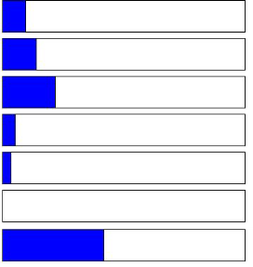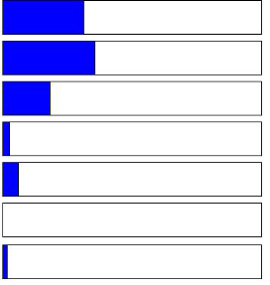**Online Registration**

**Registration Help Line**

|  |  |  |  |  |  |  |
| --- | --- | --- | --- | --- | --- | --- |
| **Response** | **Frequency** | **Percent** |  | **Response** | **Frequency** | **Percent** |
| Very Satisfied | 28 | 31.82 |  | Very Satisfied | 9 | 10.23 |
| Satisfied | 32 | 36.36 |  | Satisfied | 13 | 14.77 |
| Neutral | 17 | 19.32 |  | Neutral | 20 | 22.73 |
| Unsatisfied | 3 | 3.41 |  | Unsatisfied | 5 | 5.68 |
| Very Unsatisfied | 6 | 6.82 |  | Very Unsatisfied | 4 | 4.55 |
| Not Applicable | 0 | 0.00 |  | Not Applicable | 0 | 0.00 |
| **Missing** | 2 | 2.27 |  | **Missing** | 37 | 42.05 |
| **Repeating a Course Obtaining Information** | | | | | | |
| **Response** | **Frequency** | **Percent** |  | **Response** | **Frequency** | **Percent** |
| Very Satisfied | 5 | 5.68 |  | Very Satisfied | 14 | 15.91 |
| Satisfied | 10 | 11.36 |  | Satisfied | 27 | 30.68 |
| Neutral | 20 | 22.73 |  | Neutral | 15 | 17.05 |
| Unsatisfied | 5 | 5.68 |  | Unsatisfied | 13 | 14.77 |
| Very Unsatisfied | 2 | 2.27 |  | Very Unsatisfied | 5 | 5.68 |
| Not Applicable | 0 | 0.00 |  | Not Applicable | 0 | 0.00 |
| **Missing** | 46 | 52.27 |  | **Missing** | 14 | 15.91 |
| **Clearing Prerequisites Online Registration** | | | | | | |
| **Response** | **Frequency** | **Percent** |  | **Response** | **Frequency** | **Percent** |
| Very Satisfied | 12 | 13.64 |  | Very Easy | 30 | 34.09 |
| Satisfied | 21 | 23.86 |  | Easy | 21 | 23.86 |
| Neutral | 20 | 22.73 |  | Neutral | 26 | 29.55 |
| Unsatisfied | 7 | 7.95 |  | Difficult | 2 | 2.27 |
| Very Unsatisfied | 3 | 3.41 |  | Very Difficult | 4 | 4.55 |
| Not Applicable | 23 | 26.14 |  | Not Applicable | 0 | 0.00 |
| **Missing** | 2 | 2.27 |  | **Missing** | 5 | 5.68 |

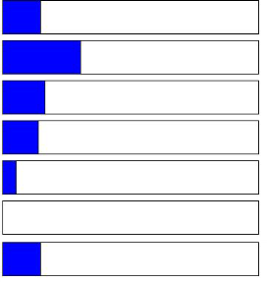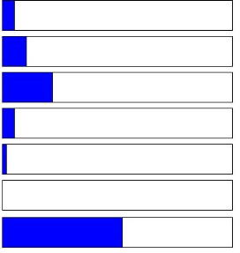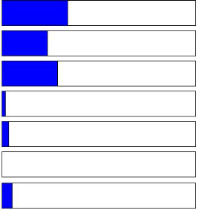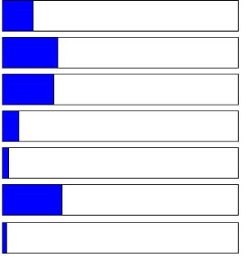Research & Planning

Page 2 3/9/2015

**Registration Help Line**

|  |  |  |  |  |  |  |
| --- | --- | --- | --- | --- | --- | --- |
| **Response** | **Frequency** | **Percent** |  | **Response** | **Frequency** | **Percent** |
| Very Easy | 8 | 9.09 |  | Very Easy | 5 | 5.68 |
| Easy | 14 | 15.91 |  | Easy | 7 | 7.95 |
| Neutral | 16 | 18.18 |  | Neutral | 26 | 29.55 |
| Difficult | 7 | 7.95 |  | Difficult | 2 | 2.27 |
| Very Difficult | 4 | 4.55 |  | Very Difficult | 1 | 1.14 |
| Not Applicable | 0 | 0.00 |  | Not Applicable | 0 | 0.00 |
| **Missing** | 39 | 44.32 |  | **Missing** | 47 | 53.41 |
| **Obtaining Information Clearing Prerequisites** | | | | | | |
| **Response** | **Frequency** | **Percent** |  | **Response** | **Frequency** | **Percent** |
| Very Easy | 15 | 17.05 |  | Very Easy | 13 | 14.77 |
| Easy | 19 | 21.59 |  | Easy | 12 | 13.64 |
| Neutral | 22 | 25.00 |  | Neutral | 24 | 27.27 |
| Difficult | 13 | 14.77 |  | Difficult | 6 | 6.82 |
| Very Difficult | 4 | 4.55 |  | Very Difficult | 4 | 4.55 |
| Not Applicable | 0 | 0.00 |  | Not Applicable | 24 | 27.27 |
| **Missing** | 15 | 17.05 |  | **Missing** | 5 | 5.68 |
| **Add/drop classes Check college email** | | | | | | |
| **Response** | **Frequency** | **Percent** |  | **Response** | **Frequency** | **Percent** |
| Frequently Used | 28 | 31.82 |  | Frequently Used | 45 | 51.14 |
| Occasionally Used | 40 | 45.45 |  | Occasionally Used | 15 | 17.05 |
| Rarely Used | 13 | 14.77 |  | Rarely Used | 19 | 21.59 |
| Never Used | 2 | 2.27 |  | Never Used | 3 | 3.41 |
| Expect Future Use | 2 | 2.27 |  | Expect Future Use | 2 | 2.27 |
| Not Applicable | 0 | 0.00 |  | Not Applicable | 0 | 0.00 |
| **Missing** | 3 | 3.41 |  | **Missing** | 4 | 4.55 |
| **Check educational plan Check for grades** | | | | | | |
| **Response** | **Frequency** | **Percent** |  | **Response** | **Frequency** | **Percent** |
| Frequently Used | 16 | 18.18 |  | Frequently Used | 34 | 38.64 |
| Occasionally Used | 18 | 20.45 |  | Occasionally Used | 29 | 32.95 |
| Rarely Used | 30 | 34.09 |  | Rarely Used | 12 | 13.64 |
| Never Used | 11 | 12.50 |  | Never Used | 4 | 4.55 |
| Expect Future Use | 4 | 4.55 |  | Expect Future Use | 3 | 3.41 |
| Not Applicable | 0 | 0.00 |  | Not Applicable | 0 | 0.00 |
| **Missing** | 9 | 10.23 |  | **Missing** | 6 | 6.82 |

Research & Planning

**Repeating a Course**

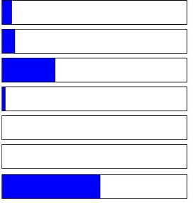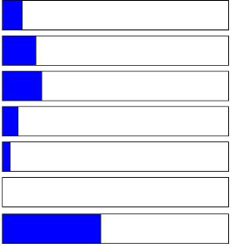

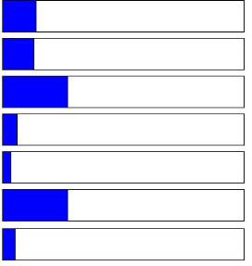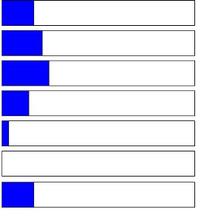





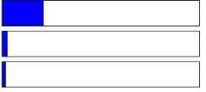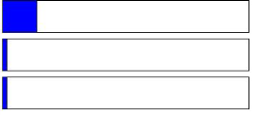

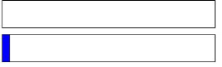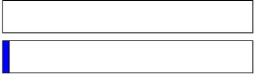





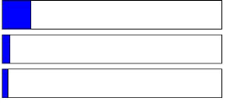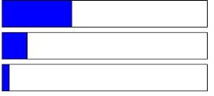

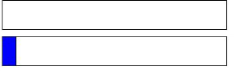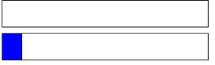

Page 3 3/9/2015

|  |  |  |  |  |  |  |
| --- | --- | --- | --- | --- | --- | --- |
| **Pay fees** |  |  |  | **Pay for parking** |  | |
| **Response** | **Frequency** | **Percent** |  | **Response** | **Frequency** | **Percent** |
| Frequently Used | 26 | 29.55 |  | Frequently Used | 20 | 22.73 |
| Occasionally Used | 34 | 38.64 |  | Occasionally Used | 19 | 21.59 |
| Rarely Used | 14 | 15.91 |  | Rarely Used | 12 | 13.64 |
| Never Used | 4 | 4.55 |  | Never Used | 15 | 17.05 |
| Expect Future Use | 3 | 3.41 |  | Expect Future Use | 7 | 7.95 |
| Not Applicable | 0 | 0.00 |  | Not Applicable | 0 | 0.00 |
| **Missing** | 7 | 7.95 |  | **Missing** | 15 | 17.05 |

**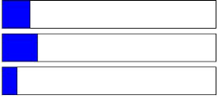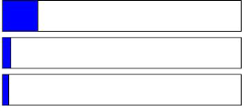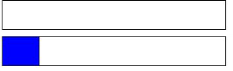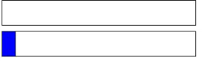****Retrieve class schedule**

**Retrieve unofficial transcript**

|  |  |  |  |  |  |  |
| --- | --- | --- | --- | --- | --- | --- |
| **Response** | **Frequency** | **Percent** |  | **Response** | **Frequency** | **Percent** |
| Frequently Used | 37 | 42.05 |  | Frequently Used | 19 | 21.59 |
| Occasionally Used | 25 | 28.41 |  | Occasionally Used | 20 | 22.73 |
| Rarely Used | 16 | 18.18 |  | Rarely Used | 16 | 18.18 |
| Never Used | 2 | 2.27 |  | Never Used | 16 | 18.18 |
| Expect Future Use | 3 | 3.41 |  | Expect Future Use | 4 | 4.55 |
| Not Applicable | 0 | 0.00 |  | Not Applicable | 0 | 0.00 |
| **Missing** | 5 | 5.68 |  | **Missing** | 13 | 14.77 |

**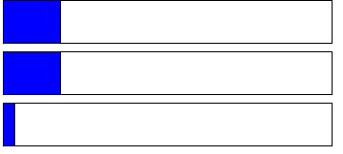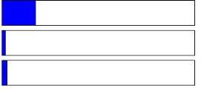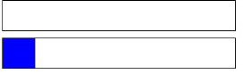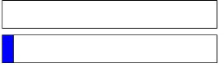****View registration appointment date and time**

|  |  |  |  |  |  |  |
| --- | --- | --- | --- | --- | --- | --- |
| **Response** | **Frequency** | **Percent** |  | **Response** | **Frequency** | **Percent** |
| Frequently Used | 35 | 39.77 |  | Frequently Used | 10 | 11.36 |
| Occasionally Used | 28 | 31.82 |  | Occasionally Used | 21 | 23.86 |
| Rarely Used | 10 | 11.36 |  | Rarely Used | 20 | 22.73 |
| Never Used | 4 | 4.55 |  | Never Used | 22 | 25.00 |
| Expect Future Use | 6 | 6.82 |  | Expect Future Use | 2 | 2.27 |
| Not Applicable | 0 | 0.00 |  | Not Applicable | 8 | 9.09 |
| **Missing** | 5 | 5.68 |  | **Missing** | 5 | 5.68 |





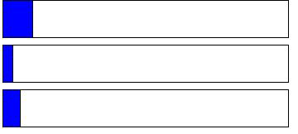



******Checking financial aid status**

**Online counseling appointment.**





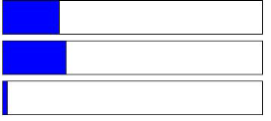

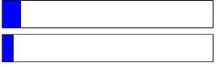

**Changing address.**

|  |  |  |  |  |  |  |
| --- | --- | --- | --- | --- | --- | --- |
| **Response** | **Frequency** | **Percent** |  | **Response** | **Frequency** | **Percent** |
| Frequently Used | 24 | 27.27 |  | Frequently Used | 5 | 5.68 |
| Occasionally Used | 23 | 26.14 |  | Occasionally Used | 7 | 7.95 |
| Rarely Used | 14 | 15.91 |  | Rarely Used | 21 | 23.86 |
| Never Used | 7 | 7.95 |  | Never Used | 23 | 26.14 |
| Expect Future Use | 2 | 2.27 |  | Expect Future Use | 3 | 3.41 |
| Not Applicable | 13 | 14.77 |  | Not Applicable | 24 | 27.27 |
| **Missing** | 5 | 5.68 |  | **Missing** | 5 | 5.68 |

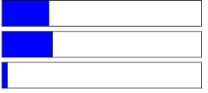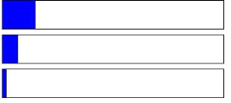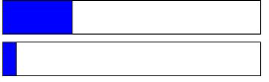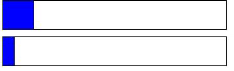Research & Planning

Page 4 3/9/2015

**Online Application for Admissions**

|  |  |  |  |  |  |  |
| --- | --- | --- | --- | --- | --- | --- |
| **Response** | **Frequency** | **Percent** |  | **Response** | **Frequency** | **Percent** |
| Completely Agree | 21 | 23.86 |  | Completely Agree | 24 | 27.27 |
| Agree | 30 | 34.09 |  | Agree | 40 | 45.45 |
| Neutral | 22 | 25.00 |  | Neutral | 11 | 12.50 |
| Disagree | 3 | 3.41 |  | Disagree | 2 | 2.27 |
| Completely Disagree | 3 | 3.41 |  | Completely Disagree | 3 | 3.41 |
| Not Applicable | 0 | 0.00 |  | Not Applicable | 3 | 3.41 |
| **Missing** | 9 | 10.23 |  | **Missing** | 5 | 5.68 |

**Residency Petitions/Appeals**

|  |  |  |  |  |  |  |
| --- | --- | --- | --- | --- | --- | --- |
| **Response** | **Frequency** | **Percent** |  | **Response** | **Frequency** | **Percent** |
| Completely Agree | 4 | 4.55 |  | Completely Agree | 15 | 17.05 |
| Agree | 12 | 13.64 |  | Agree | 21 | 23.86 |
| Neutral | 18 | 20.45 |  | Neutral | 18 | 20.45 |
| Disagree | 3 | 3.41 |  | Disagree | 5 | 5.68 |
| Completely Disagree | 3 | 3.41 |  | Completely Disagree | 3 | 3.41 |
| Not Applicable | 0 | 0.00 |  | Not Applicable | 0 | 0.00 |
| **Missing** | 48 | 54.55 |  | **Missing** | 26 | 29.55 |

**Student Petitions**

|  |  |  |  |  |  |  |
| --- | --- | --- | --- | --- | --- | --- |
| **Response** | **Frequency** | **Percent** |  | **Response** | **Frequency** | **Percent** |
| Completely Agree | 6 | 6.82 |  | Completely Agree | 5 | 5.68 |
| Agree | 11 | 12.50 |  | Agree | 6 | 6.82 |
| Neutral | 16 | 18.18 |  | Neutral | 19 | 21.59 |
| Disagree | 3 | 3.41 |  | Disagree | 3 | 3.41 |
| Completely Disagree | 2 | 2.27 |  | Completely Disagree | 2 | 2.27 |
| Not Applicable | 0 | 0.00 |  | Not Applicable | 0 | 0.00 |
| **Missing** | 50 | 56.82 |  | **Missing** | 53 | 60.23 |

**AB540 Process**

|  |  |  |  |  |  |  |
| --- | --- | --- | --- | --- | --- | --- |
| **Response** | **Frequency** | **Percent** |  | **Response** | **Frequency** | **Percent** |
| Completely Agree | 3 | 3.41 |  | Completely Agree | 15 | 17.05 |
| Agree | 6 | 6.82 |  | Agree | 21 | 23.86 |
| Neutral | 15 | 17.05 |  | Neutral | 21 | 23.86 |
| Disagree | 3 | 3.41 |  | Disagree | 10 | 11.36 |
| Completely Disagree | 1 | 1.14 |  | Completely Disagree | 6 | 6.82 |
| Not Applicable | 0 | 0.00 |  | Not Applicable | 0 | 0.00 |
| **Missing** | 60 | 68.18 |  | **Missing** | 15 | 17.05 |

Research & Planning

**Add/Drop classes**



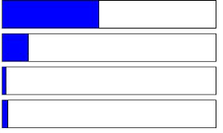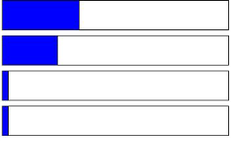

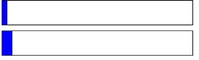

**Verification of Enrollment**



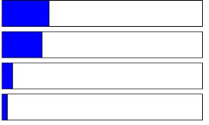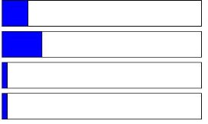

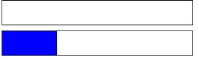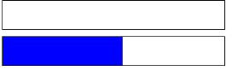

**High School Concurrent Enrollment**



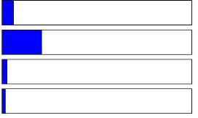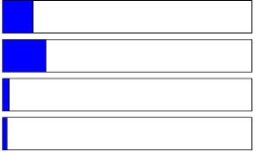

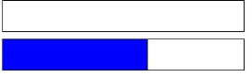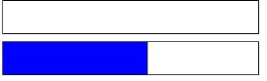

**Obtaining Information**



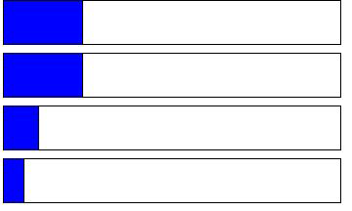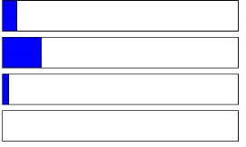

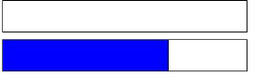

Page 5 3/9/2015

**Hours of Operation**

|  |  |  |  |  |  |  |
| --- | --- | --- | --- | --- | --- | --- |
| **Response** | **Frequency** | **Percent** |  | **Response** | **Frequency** | **Percent** |
| Completely Agree | 18 | 20.45 |  | Completely Agree | 17 | 19.32 |
| Agree | 22 | 25.00 |  | Agree | 22 | 25.00 |
| Neutral | 18 | 20.45 |  | Neutral | 26 | 29.55 |
| Disagree | 7 | 7.95 |  | Disagree | 4 | 4.55 |
| Completely Disagree | 4 | 4.55 |  | Completely Disagree | 1 | 1.14 |
| Not Applicable | 0 | 0.00 |  | Not Applicable | 0 | 0.00 |
| **Missing** | 19 | 21.59 |  | **Missing** | 18 | 20.45 |

**Overall Experience**

|  |  |  |  |  |  |  |
| --- | --- | --- | --- | --- | --- | --- |
| **Response** | **Frequency** | **Percent** |  | **Response** | **Frequency** | **Percent** |
| Completely Agree | 15 | 17.05 |  | Very Easy | 25 | 28.41 |
| Agree | 31 | 35.23 |  | Easy | 27 | 30.68 |
| Neutral | 22 | 25.00 |  | Neutral | 20 | 22.73 |
| Disagree | 8 | 9.09 |  | Difficult | 4 | 4.55 |
| Completely Disagree | 2 | 2.27 |  | Very Difficult | 4 | 4.55 |
| Not Applicable | 0 | 0.00 |  | Not Applicable | 0 | 0.00 |
| **Missing** | 10 | 11.36 |  | **Missing** | 8 | 9.09 |
| **Add/Drop classes Residency Petitions/Appeals** | | | | | | |
| **Response** | **Frequency** | **Percent** |  | **Response** | **Frequency** | **Percent** |
| Very Easy | 23 | 26.14 |  | Very Easy | 3 | 3.41 |
| Easy | 34 | 38.64 |  | Easy | 7 | 7.95 |
| Neutral | 18 | 20.45 |  | Neutral | 20 | 22.73 |
| Difficult | 0 | 0.00 |  | Difficult | 1 | 1.14 |
| Very Difficult | 4 | 4.55 |  | Very Difficult | 3 | 3.41 |
| Not Applicable | 2 | 2.27 |  | Not Applicable | 0 | 0.00 |
| **Missing** | 7 | 7.95 |  | **Missing** | 54 | 61.36 |
| **Verification of Enrollment Student Petitions** | | | | | | |
| **Response** | **Frequency** | **Percent** |  | **Response** | **Frequency** | **Percent** |
| Very Easy | 14 | 15.91 |  | Very Easy | 6 | 6.82 |
| Easy | 17 | 19.32 |  | Easy | 5 | 5.68 |
| Neutral | 21 | 23.86 |  | Neutral | 20 | 22.73 |
| Difficult | 2 | 2.27 |  | Difficult | 0 | 0.00 |
| Very Difficult | 5 | 5.68 |  | Very Difficult | 2 | 2.27 |
| Not Applicable | 0 | 0.00 |  | Not Applicable | 0 | 0.00 |
| **Missing** | 29 | 32.95 |  | **Missing** | 55 | 62.50 |

Research & Planning

**Facilities**



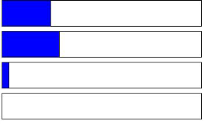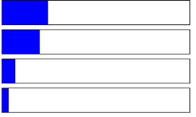

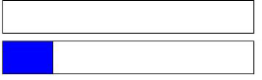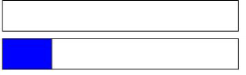

**Online Application for Admissions**



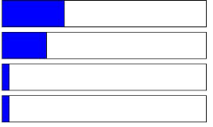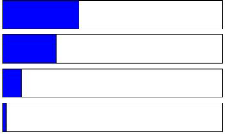

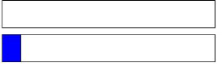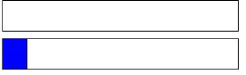

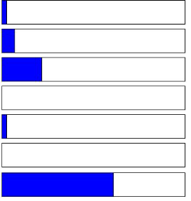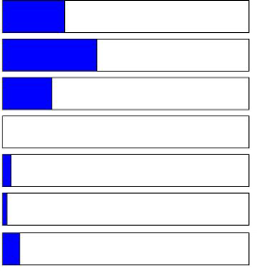

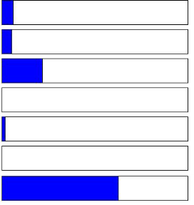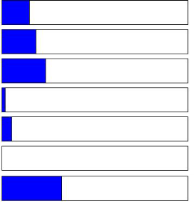

Page 6 3/9/2015

|  |  |  |  |  |  |  |
| --- | --- | --- | --- | --- | --- | --- |
| **High School Concurrent Enrollment AB540 Process** | | | | | | |
| **Response** | **Frequency** | **Percent** |  | **Response** | **Frequency** | **Percent** |
| Very Easy | 3 | 3.41 |  | Very Easy | 2 | 2.27 |
| Easy | 4 | 4.55 |  | Easy | 4 | 4.55 |
| Neutral | 19 | 21.59 |  | Neutral | 18 | 20.45 |
| Difficult | 1 | 1.14 |  | Difficult | 0 | 0.00 |
| Very Difficult | 2 | 2.27 |  | Very Difficult | 2 | 2.27 |
| Not Applicable | 0 | 0.00 |  | Not Applicable | 0 | 0.00 |
| **Missing** | 59 | 67.05 |  | **Missing** | 62 | 70.45 |
| **Obtaining Information Hours of Operation** | | | | | | |
| **Response** | **Frequency** | **Percent** |  | **Response** | **Frequency** | **Percent** |
| Very Easy | 13 | 14.77 |  | Very Easy | 18 | 20.45 |
| Easy | 19 | 21.59 |  | Easy | 22 | 25.00 |
| Neutral | 20 | 22.73 |  | Neutral | 21 | 23.86 |
| Difficult | 10 | 11.36 |  | Difficult | 4 | 4.55 |
| Very Difficult | 6 | 6.82 |  | Very Difficult | 3 | 3.41 |
| Not Applicable | 0 | 0.00 |  | Not Applicable | 0 | 0.00 |
| **Missing** | 20 | 22.73 |  | **Missing** | 20 | 22.73 |
| **Facilities Overall Experience** | | | | | | |
| **Response** | **Frequency** | **Percent** |  | **Response** | **Frequency** | **Percent** |
| Very Easy | 15 | 17.05 |  | Very Easy | 16 | 18.18 |
| Easy | 25 | 28.41 |  | Easy | 25 | 28.41 |
| Neutral | 22 | 25.00 |  | Neutral | 26 | 29.55 |
| Difficult | 1 | 1.14 |  | Difficult | 5 | 5.68 |
| Very Difficult | 3 | 3.41 |  | Very Difficult | 5 | 5.68 |
| Not Applicable | 0 | 0.00 |  | Not Applicable | 0 | 0.00 |
| **Missing** | 22 | 25.00 |  | **Missing** | 11 | 12.50 |
| **Online Application for Admissions Add/Drop classes** | | | | | | |
| **Response** | **Frequency** | **Percent** |  | **Response** | **Frequency** | **Percent** |
| Frequently Used | 17 | 19.32 |  | Frequently Used | 32 | 36.36 |
| Occasionally Used | 25 | 28.41 |  | Occasionally Used | 34 | 38.64 |
| Rarely Used | 28 | 31.82 |  | Rarely Used | 9 | 10.23 |
| Never Used | 2 | 2.27 |  | Never Used | 1 | 1.14 |
| Expect Future Use | 2 | 2.27 |  | Expect Future Use | 1 | 1.14 |
| Not Applicable | 0 | 0.00 |  | Not Applicable | 1 | 1.14 |
| **Missing** | 14 | 15.91 |  | **Missing** | 10 | 11.36 |

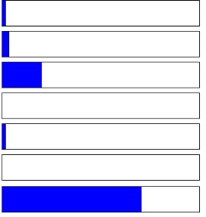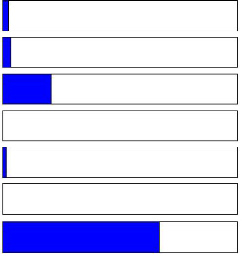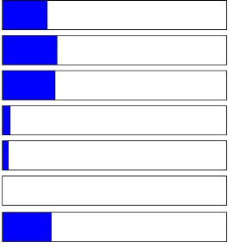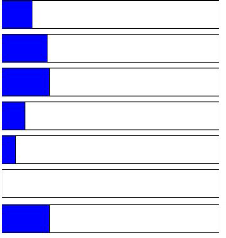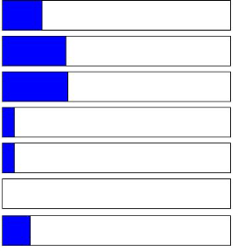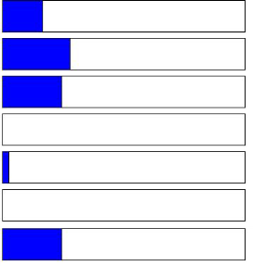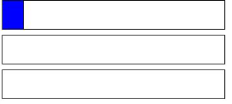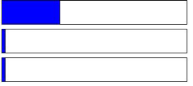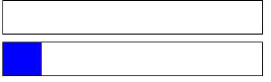Research & Planning

Page 7 3/9/2015

**Residency Petitions/Appeals**

|  |  |  |  |  |  |  |
| --- | --- | --- | --- | --- | --- | --- |
| **Response** | **Frequency** | **Percent** |  | **Response** | **Frequency** | **Percent** |
| Frequently Used | 4 | 4.55 |  | Frequently Used | 11 | 12.50 |
| Occasionally Used | 9 | 10.23 |  | Occasionally Used | 23 | 26.14 |
| Rarely Used | 20 | 22.73 |  | Rarely Used | 21 | 23.86 |
| Never Used | 13 | 14.77 |  | Never Used | 5 | 5.68 |
| Expect Future Use | 1 | 1.14 |  | Expect Future Use | 1 | 1.14 |
| Not Applicable | 0 | 0.00 |  | Not Applicable | 0 | 0.00 |
| **Missing** | 41 | 46.59 |  | **Missing** | 27 | 30.68 |

**Student Petitions**

|  |  |  |  |  |  |  |
| --- | --- | --- | --- | --- | --- | --- |
| **Response** | **Frequency** | **Percent** |  | **Response** | **Frequency** | **Percent** |
| Frequently Used | 4 | 4.55 |  | Frequently Used | 2 | 2.27 |
| Occasionally Used | 8 | 9.09 |  | Occasionally Used | 8 | 9.09 |
| Rarely Used | 16 | 18.18 |  | Rarely Used | 12 | 13.64 |
| Never Used | 13 | 14.77 |  | Never Used | 14 | 15.91 |
| Expect Future Use | 1 | 1.14 |  | Expect Future Use | 1 | 1.14 |
| Not Applicable | 0 | 0.00 |  | Not Applicable | 0 | 0.00 |
| **Missing** | 46 | 52.27 |  | **Missing** | 51 | 57.95 |

**AB540 Process**

|  |  |  |  |  |  |  |
| --- | --- | --- | --- | --- | --- | --- |
| **Response** | **Frequency** | **Percent** |  | **Response** | **Frequency** | **Percent** |
| Frequently Used | 2 | 2.27 |  | Frequently Used | 13 | 14.77 |
| Occasionally Used | 8 | 9.09 |  | Occasionally Used | 31 | 35.23 |
| Rarely Used | 12 | 13.64 |  | Rarely Used | 18 | 20.45 |
| Never Used | 15 | 17.05 |  | Never Used | 5 | 5.68 |
| Expect Future Use | 1 | 1.14 |  | Expect Future Use | 0 | 0.00 |
| Not Applicable | 0 | 0.00 |  | Not Applicable | 0 | 0.00 |
| **Missing** | 50 | 56.82 |  | **Missing** | 21 | 23.86 |

**Hours of Operation**

|  |  |  |  |  |  |  |
| --- | --- | --- | --- | --- | --- | --- |
| **Response** | **Frequency** | **Percent** |  | **Response** | **Frequency** | **Percent** |
| Frequently Used | 12 | 13.64 |  | Frequently Used | 13 | 14.77 |
| Occasionally Used | 30 | 34.09 |  | Occasionally Used | 27 | 30.68 |
| Rarely Used | 18 | 20.45 |  | Rarely Used | 20 | 22.73 |
| Never Used | 4 | 4.55 |  | Never Used | 5 | 5.68 |
| Expect Future Use | 1 | 1.14 |  | Expect Future Use | 1 | 1.14 |
| Not Applicable | 0 | 0.00 |  | Not Applicable | 0 | 0.00 |
| **Missing** | 23 | 26.14 |  | **Missing** | 22 | 25.00 |

Research & Planning

**Verification of Enrollment**





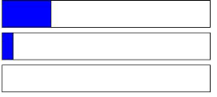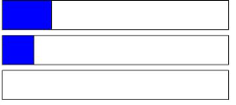

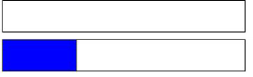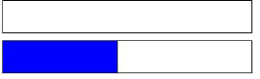

**High School Concurrent Enrollment**





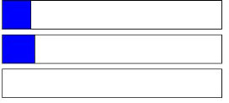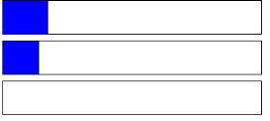

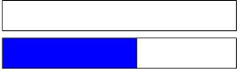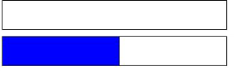

**Obtaining Information**





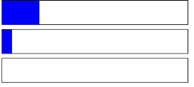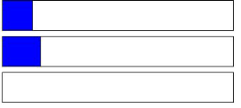

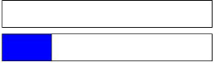

**Facilities**





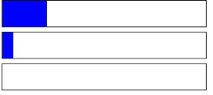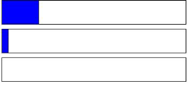

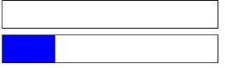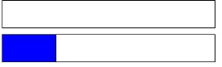

Page 8 3/9/2015

**Overall Experience**

|  |  |  |  |  |  |  |
| --- | --- | --- | --- | --- | --- | --- |
| **Response** | **Frequency** | **Percent** |  | **Response** | **Frequency** | **Percent** |
| Frequently Used | 19 | 21.59 |  | Very Satisfied | 19 | 21.59 |
| Occasionally Used | 31 | 35.23 |  | Satisfied | 15 | 17.05 |
| Rarely Used | 15 | 17.05 |  | Neutral | 15 | 17.05 |
| Never Used | 2 | 2.27 |  | Unsatisfied | 1 | 1.14 |
| Expect Future Use | 0 | 0.00 |  | Very Unsatisfied | 1 | 1.14 |
| Not Applicable | 0 | 0.00 |  | Not Applicable | 0 | 0.00 |
| **Missing** | 21 | 23.86 |  | **Missing** | 37 | 42.05 |

**In-Person/Mail Transcript Requests**

|  |  |  |  |  |  |  |
| --- | --- | --- | --- | --- | --- | --- |
| **Response** | **Frequency** | **Percent** |  | **Response** | **Frequency** | **Percent** |
| Very Satisfied | 10 | 11.36 |  | Very Satisfied | 4 | 4.55 |
| Satisfied | 11 | 12.50 |  | Satisfied | 8 | 9.09 |
| Neutral | 19 | 21.59 |  | Neutral | 15 | 17.05 |
| Unsatisfied | 2 | 2.27 |  | Unsatisfied | 2 | 2.27 |
| Very Unsatisfied | 1 | 1.14 |  | Very Unsatisfied | 1 | 1.14 |
| Not Applicable | 0 | 0.00 |  | Not Applicable | 0 | 0.00 |
| **Missing** | 45 | 51.14 |  | **Missing** | 58 | 65.91 |
| **Credit by Exam Academic Renewal** | | | | | | |
| **Response** | **Frequency** | **Percent** |  | **Response** | **Frequency** | **Percent** |
| Very Satisfied | 6 | 6.82 |  | Very Satisfied | 7 | 7.95 |
| Satisfied | 10 | 11.36 |  | Satisfied | 8 | 9.09 |
| Neutral | 15 | 17.05 |  | Neutral | 18 | 20.45 |
| Unsatisfied | 1 | 1.14 |  | Unsatisfied | 1 | 1.14 |
| Very Unsatisfied | 0 | 0.00 |  | Very Unsatisfied | 1 | 1.14 |
| Not Applicable | 0 | 0.00 |  | Not Applicable | 0 | 0.00 |
| **Missing** | 56 | 63.64 |  | **Missing** | 53 | 60.23 |
| **Obtaining Information Online Transcript Requests** | | | | | | |
| **Response** | **Frequency** | **Percent** |  | **Response** | **Frequency** | **Percent** |
| Very Satisfied | 17 | 19.32 |  | Very Easy | 19 | 21.59 |
| Satisfied | 19 | 21.59 |  | Easy | 14 | 15.91 |
| Neutral | 17 | 19.32 |  | Neutral | 17 | 19.32 |
| Unsatisfied | 9 | 10.23 |  | Difficult | 3 | 3.41 |
| Very Unsatisfied | 2 | 2.27 |  | Very Difficult | 1 | 1.14 |
| Not Applicable | 0 | 0.00 |  | Not Applicable | 0 | 0.00 |
| **Missing** | 24 | 27.27 |  | **Missing** | 34 | 38.64 |

Research & Planning

**Online Transcript Requests**





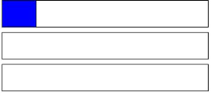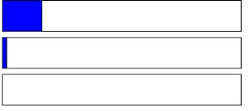

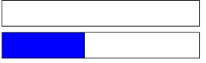

**Grade Change Petitions**

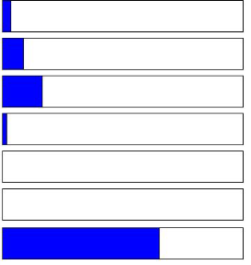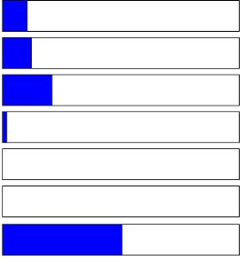

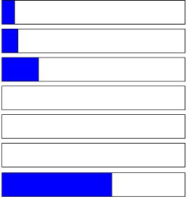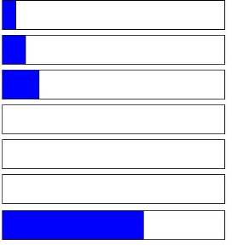

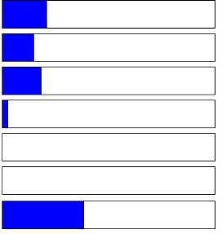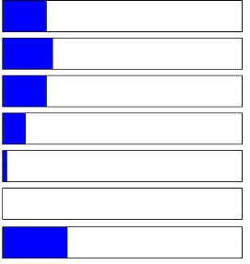

Page 9 3/9/2015

**In-Person/Mail Transcript Requests**

|  |  |  |  |  |  |  |
| --- | --- | --- | --- | --- | --- | --- |
| **Response** | **Frequency** | **Percent** |  | **Response** | **Frequency** | **Percent** |
| Very Easy | 10 | 11.36 |  | Very Easy | 3 | 3.41 |
| Easy | 8 | 9.09 |  | Easy | 5 | 5.68 |
| Neutral | 21 | 23.86 |  | Neutral | 19 | 21.59 |
| Difficult | 3 | 3.41 |  | Difficult | 3 | 3.41 |
| Very Difficult | 1 | 1.14 |  | Very Difficult | 0 | 0.00 |
| Not Applicable | 0 | 0.00 |  | Not Applicable | 0 | 0.00 |
| **Missing** | 45 | 51.14 |  | **Missing** | 58 | 65.91 |
| **Credit by Exam Academic Renewal** | | | | | | |
| **Response** | **Frequency** | **Percent** |  | **Response** | **Frequency** | **Percent** |
| Very Easy | 5 | 5.68 |  | Very Easy | 5 | 5.68 |
| Easy | 5 | 5.68 |  | Easy | 7 | 7.95 |
| Neutral | 18 | 20.45 |  | Neutral | 20 | 22.73 |
| Difficult | 2 | 2.27 |  | Difficult | 3 | 3.41 |
| Very Difficult | 0 | 0.00 |  | Very Difficult | 0 | 0.00 |
| Not Applicable | 0 | 0.00 |  | Not Applicable | 0 | 0.00 |
| **Missing** | 58 | 65.91 |  | **Missing** | 53 | 60.23 |
| **Obtaining Information** | | | | | | |
| **Response** | **Frequency** | **Percent** |  | | | |
| Very Easy | 18 | 20.45 |
| Easy | 15 | 17.05 |
| Neutral | 19 | 21.59 |
| Difficult | 7 | 7.95 |
| Very Difficult | 3 | 3.41 |
| Not Applicable | 0 | 0.00 |
| **Missing** | 26 | 29.55 |

Research & Planning

**Grade Change Petitions**

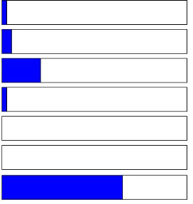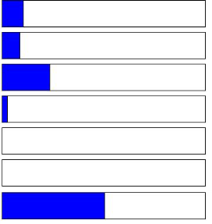

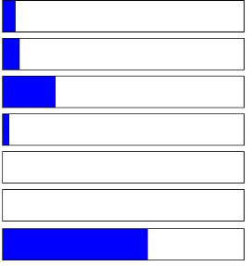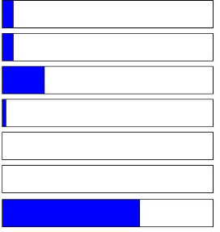

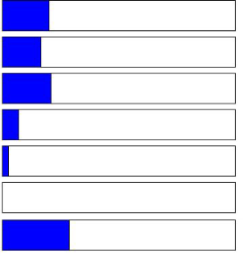

Page 10 3/9/2015

**Comments**

**Question: 2. If you did not register on the date of your registration appointment time, please indicate the reason**

**why.**

|  |
| --- |
| **Response** |
| the system said i was not allowed to register when my classmate already was |
| I didn't know my work schedule |
| I am in the Nursing Program and my assigned section number was not clear at time of registration. |
| the site STOPS WORKING or does not LOAD. |
| I am currently in the nursing program and enrollment in classes is dependent on passing the previous classes. |
| I am in a programe. |
| The myecc website became incompatible with my Mac computer. |
| I needed to take CDEV-104 for my permit application, but the course was always full since the last 2 semesters. |
| Classes were full and I had to wait to get ADD slips from teacher |
| I did not know where to find the appointment time |

**Question: What service or function in Admissions, Records, Registration and Evaluation would you most like to see improved? Why? Please provide suggestions for improvement.**

|  |
| --- |
| **Response** |
| The way of adding or registering for classes doesn't give everybody the chance to enroll in the class because too many students add the classes to their schedules and fill up the classes, who will end up dropping the class in the first two weeks. |
| The counseling department needs improvement, I walked in at 10am I was told that I could see a counselor at 11am so I booked that appt. I got there 5 mins early and waited to see the counselor for over 25 mins. When I finally saw the counselor she only saw me for 5 mins. I figure out the information on my own. She made the comment that she had been there for 17 years, I believe her; only people who have worked for an institution that long do not value other's people  time. The counselors do not value other people's time. They are very slow about receiving you even when the receptionist tell's them that they have an appt waiting. I doubt if I ever use the counseling service again. I'm happy that most of everything is done online now or at least you can begin with assist.org and wing it. |
| More classes. All classes fill before my registration date. I can never get the correct classes based off ed plan. |
| Everything is ok |
| If there was more help for students with financial needs, as well as more staff. Perhaps for petitions if there were less hoops to have to jump through and for students that don't qualify for eop not to be left out. |
| I would like to see registration to be improved. For instance, students who have never missed a fee deadline can register earlier. I had to register 3 weeks after registration was opened. |
| My first experience was not was I was expecting but , after all I did show up late and I did just got of work that day. Maybe it was my attitude , anyways after I had to get help for any other support in enrollment I just ask my instructor. After class and he was very helpful. ECC is a great college and I am glad I enrolled into it. |
| Financial aid |
| You eed some explanation of the parking permit. After I paid online, I had ZERO direction as to how I was to get the permit....would it be mailed? Passed out at a kiosk on campus? I even called campus police and they didn't know...ended up waiting in line at the cashiers office for 90 minutes...still never knowing if that is where I pick it up. Luckily it was |
| having older records available on the online transcript |
| residency petitions take too long to process and when you go to admissions and ask about the status they don't know how your process is going. speeding up the process would be great |
| I would like a more professional and nicer staff in both the admissions office and the quick drop by councillors. |
| If registration could be made online but from a mobile app that would help a lot. Make registration easier. |
| Online my ECC is a big issue on cell phones. Apple phones are not allowed to use Safari so you download Foxfire, on Foxfire it is not easy tip you great schedules etc.I would like to see improvement think you |
| Online is not a problem, if I need help, I ask in the campus. The admissions, records and registration need improvement in the campus not online. |

**Question: What service or function in Admissions, Records, Registration and Evaluation would you most like to**

**see improved? Why? Please provide suggestions for improvement.**

|  |
| --- |
| **Response** |
| Academic renewal... I was mislead on this process and would have waited until my last semester at ECC to do this because as it turned out from the misinformation I received, this hindered the success of the process making it a wasted effort. |
| It would be nice to know that a general requirements student applying for a program such as the nursing, x-ray, or respiratory therapy program doesn't need to submit a request for an official transcript if all of the classes have been taken at ECC, due to all of the information being accessible already. This may seem like common sense but, it is not.  Considering the students only have a limited number of free requests, (and a limited financial income), this would be good information as a bullet point on the request form. |
| The staff at ECC is Tier 1. |
| Shorter lines. More friendly staff. And some private booths with a chair for privacy and for those who are elderly. |
| There should be an explanation issued when your registration cannot be completed. It is often that you try to register before your registration date - but there is no clue of that during the process - it just doesn't go through. Why not post the registration date right at the top of MyEcc registration format? |
| These issues have cropped up in the last few years, and have yet to be fixed: Website functionality is buggy, and I often have to log in with different computers or browser to get it to work. User experience is confusing, feedback is nonexistent. I ended up with a ABS sticker that I did not want, and probably paid for, but there was no clear indication either way when I was signing up. Add/Drop functionality is deeply flawed: I am asked to search for a class by section number or department name, and if I didn't already know the name for either, I am stuck. In short, the entire user experience for adding and dropping classes need to be completely overhauled and debugged. |
| Proper maintenance of the system when registration opens. The site is extremely faulty. This semester for a class I was on the waitlist and when I checked it a few days before the class started it had listed 2 open seats in the class so I dropped the waitlist to enroll in those empty seats and it told me they were unavailable and that the waitlist was full which made no sense when I had literally dropped the class a few seconds prior. all week long leading up to the class it said the same thing 2 open seats waitlist full and I was unable to ensure a spot back in the class luckily by the 2nd week I was able to add it. |
| I would like to say that recently I petitioned a grade I also experienced racism from the instructor in at which I disclosed in the paperwork. I received a grade change denial card in the mail and no contact from the school to address the issues; very unprofessional. |
| I was never sent an email saying that I had been accepted in nor did I recieve a student ID number until 6 months later, after I had called about 5 times unable to reach anyone. I almost went to another school because of this. I'm not sure how you can improve this because it shouldn't really be an issue. |
| In general, the ECC website should be remade so it is much easier for the average student. Information displayed in MyECC can be very cluttered at times, making information hard to find. There are many dropdown menus also make accessing grades, adding classes, or paying on my account very tedious. |
| Clearing whether students meet prerequisites prior to the registration period. When I registered for this semester I had to contact the office due to the system not recognizing that I met the requirements for a class and it did not allow me to register until the admissions office manually input it. It was quickly dealt with but if there were to have only been one spot left I might have missed enrolling due to the issue. |
| To be more efficient with more people perhaps. It seriously takes such a long time to get to one person to the next. |
| i would like to see the unofficial transcript changed. There our times at home that it wont allow me to print, and there are times that it takes a long time to load and it just cancels |
| I am only enrolled in the "Band for older students" which is ZERO units. This requires me to apply for admission every semester. Why? I would like to not have to apply for admission every semester to be in the Community Band. |
| Obtaining information |
| My ECC Account is not securely locked now. I found this in this January.I am very concerned about it. I want to change my password at least, but I can't. It says "Server Error." I tried to "Chat online," but I don't want to write my important personal information, my birthdate or SS# on such unsecured site. What can I do?Which department or person can I contact to solve this problem? Thank you for your prompt reply in advance. |
| Admission office need to find a way to bring students attention that any federal or state financial aid. |
| I would like online counseling appointments to be made easier. It's very difficult for me to get an appointment made. |
| My ECC should be compatible with Mac. I didn't know I had to download chrome till later on I enroll, which cause to miss a lot of information such as my registration appointment date, financial aid award and registering fro classes. |

**Question: What service or function in Admissions, Records, Registration and Evaluation would you most like to**

**see offered in the future? Why would this be important to you?**

|  |
| --- |
| **Response** |
| I would ask for the in coming student's personal email and use it from day one. It is cumberson at best to use ECC to check email that is provided by the school. Everything regarding your classes, payments...anything should go directly to the student's personal email, chances are they are going to see that first. |
| Everything is ok |
| More help for students that don't qualify for eop. |
| Faster services.Or on time appointments |
| Counseling appointments |
| extended hours for evening and weekend |
| Make everything a little simpler |
| The availability to do what you do in the campus offices, be done online. |
| Grade change petition... I experienced a professor that I produced valid proof of medical hospitalization requesting to be dropped from the course; instead, I remained on roster, given an incomplete that was changed to a fail. No results from the grade change petition I submitted to change it from fail to "W". another course I received a fail in could not be repeated because it was no longer offered... once again that grade had no way to become a passing grade to be removed or replaced. |
| A "quick question" option would be nice. Sometimes only one question is needed or a small issue such as financial aid counseling appeal for one of the allied health programs to continue receiving financial aid after meeting the unit maximum is needed. It may not require the time and resource of a full appointment time, that could be better utilized by another student that really needs it. |
| N/A |
| How to: signs posted in the area. And giving your student number to you upon checking in. Why? So many times I wanted my number only. Compared to other community colleges? I find ECC lacks in many areas of the registration process and what to do next? Steps. Maybe a pilot program for a college who functions extremely? Would benefit ECC? |
| I am a community student (of the orchestra) and under current policies must reapply every semester. As a result I am last in registration date order, delayed in registering and thus getting a parking permit. Paying for a parking permit AND paying for parking is making everybody mad...you need to get the parking out on time. |
| Years ago, I attempted to get answers over the phone, and in person. Both of these experiences were frustrating, nearly useless, and complete waste of my time. (In one instance, a person outright told me the wrong information, then acted belligerent when I challenged her.) I resorted to using the website to do these basic functions of adding a class, dropping a class, getting a student ID, etc. Except, now the website is also buggy, prone to malfunction. If ECC is to be taken seriously as a means for academic advancement, these basic customer experiences issues must be addressed, and improved. Ironically, this survey is also somewhat flawed. The questions are a little repetitive, looking for nuanced answers by asking the same questions in slightly different ways, which is confusing. And one question asked "how satisfied" I was, and the choices were "Agree" to "Disagree." I guess I am agreeing to how satisfied, and disagreeing to how unsatisfied? A little confusing. Thank you for your time, and for listening. |
| N/A |
| No comment. |
| More service and efficiency. |
| In person or phone call counseling and improvement in student academic planning tab. Sometime the site is incompatible with Mac computers thus causing later sign up leading to missing registration dates. I have missed out on enrolling in classes because of the website not working. |
| I have a BA degree from a foreign country. My foreign credential needs to be evaluated. There are several evaluation companies, but I don't know which to apply for. Besides I got married and changed my last name after I got a graduation certificate and transcript from an university. The name in my credential is my maiden name. Translation costs a lot. I hope the process in this matter would be easier in the nearest future. Thank you. |