**El Camino Community College**

# 2020 CAREER EDUCATION (CE) SUPPLEMENTAL QUESTIONS

**ENTER DIVISION NAME HERE**

**ENTER PROGRAM NAME HERE**

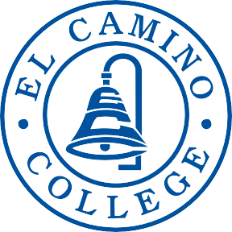

**DEAN:**

ENTER NAME OF DIVISION DEAN HERE

**CONTRIBUTOR(S):**

ENTER NAME(S) OF CONTRIBUTOR(S) HERE

*CE programs must conduct a full program review every 4 years. The comprehensive program review includes responses to the CE supplemental questions below. Every two years (once between full program reviews) these supplemental questions must be answered and submitted to Academic Affairs for posting on the College website.*

***Use labor market data, advisory committee input/feedback, and institutional and program-level data to respond to the following questions:***

**1. How strong is the occupational demand for the program?** In your response, describe any changes in demand over the past 5 years and discuss the occupational outlook for next 5 years. Provide applicable labor market data (e.g., US Bureau of Labor Statistics, Employment Development Department) that address state and local needs.

**2. How does the program address needs that are not met by similar programs in the region?** In your response, identify any distinctive components of the program (e.g., curriculum, facilities, resources) and/or describe any unique contributions the program or its students/graduates make to the community served.

**3. What are the completion, success, and employment rates for students in the program?** In your response, identify the standards set by the program and discuss any factors that may impact completion, success, and employment rates among students in the program. Describe the status of any action plans for maintaining/improving rates relative to such benchmarks.

**4. List any licensure/certification exam(s) required for entry into the workforce in the field of study and report the most recent pass rate(s) among program graduates.** In your response, identify any applicable performance benchmarks set by regulatory agencies and describe the status of any action plans for maintaining/improving pass rates relative to such benchmarks.

**5. Are the students satisfied with their preparation for employment? Are the employers in the field satisfied with the level of preparation of program graduates?** Use data from student surveys, employer surveys, and other sources of employment feedback to justify your response.

**6. Is the advisory committee satisfied with the level of preparation of program graduates? How has advisory committee input and feedback been used in the past two years to ensure employer needs are met by the program?** Describe the status and impact of any advisory committee recommendations.

California Education Code 78016 requires that the review process for CE programs includes the review and comments of a program’s advisory committee. **Provide the following information:**

a. Advisory committee membership list and credentials.

b. Meeting minutes or other documentation to demonstrate that the CE program review process has met the above Education Code requirement.