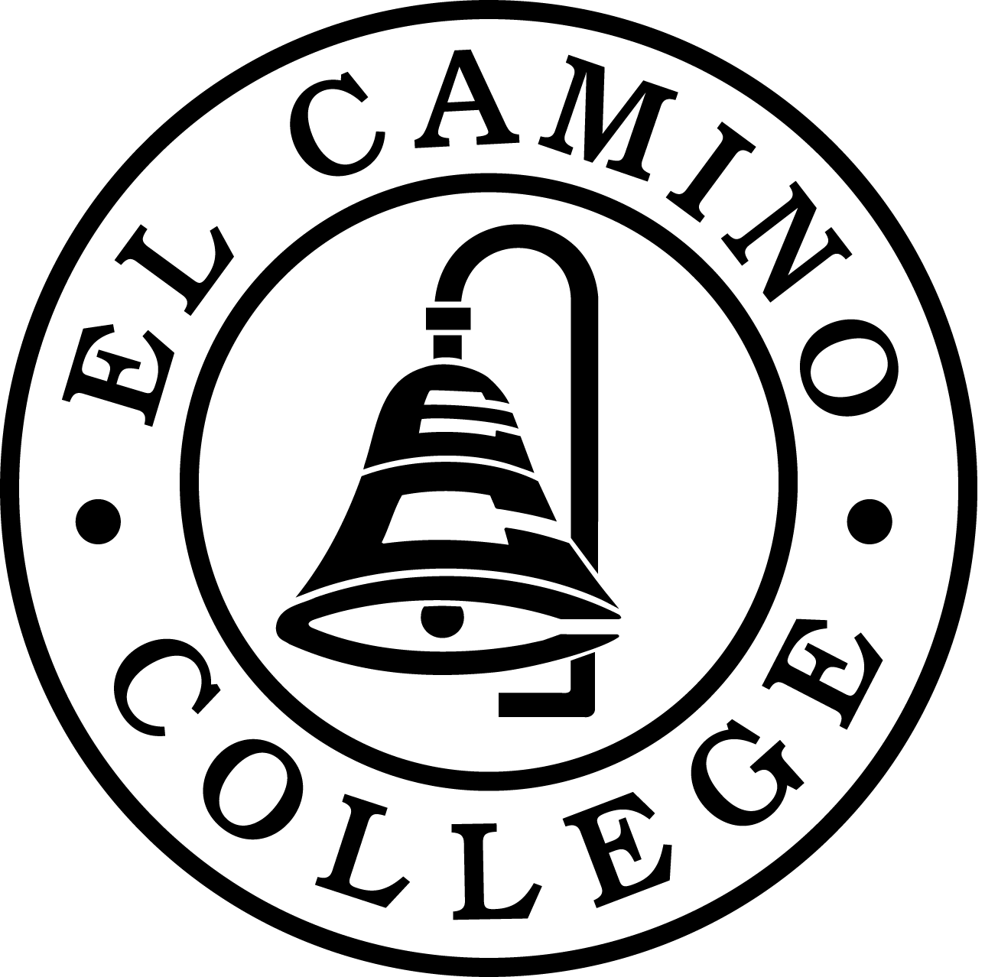 | Academic Senate of El Camino College 2016-17  16007 Crenshaw Blvd., Torrance CA 90506, (310) 532-3670 x3254  Office location: Schauerman Library, Room 273

El Camino College Academic Senate Statement of Support for All Students

The El Camino College Academic Senate remains committed to advocating for all of our students in order to create a safe and successful learning environment. We strongly endorse recent statements of support which affirm the mission of the community colleges to serve California’s diverse population.

We support California Community Colleges Interim Chancellor Erik Skinner's statement that “While the presidential election has been divisive and has sparked anxiety and uncertainty on our campuses, we will always embrace the values of inclusion and diversity and support all students who want to build better lives for themselves and their communities. No student should forgo the opportunity to apply for financial assistance at our colleges.”

In addition, we endorse the reassurances and reminders issued in the November 10, 2016 California Community College Chancellor's Office press release, including the statement that "In California, in-state enrollment fees and state financial aid -- including fee waivers, Cal Grant and privately funded institutional scholarships -- are available to certain undocumented students, or Dreamers. These benefits are protected by California law....Community college financial aid and student services professionals are available to support undocumented students…"

Finally, we strongly support El Camino College President Dena Maloney’s statement that "it is important for us to come together as a campus community and support each other and our students as we move forward. Inclusiveness has always been a strength of El Camino College, and is an integral part of our campus culture. Respect for diversity of views is one of our core values."

The El Camino College Academic Senate is steadfastly dedicated to the college’s mission to make a positive difference in the lives of all students while working in collaboration with our diverse communities.

Passed by the El Camino College Academic Senate 11.15.16

References:

Dena Maloney’s Nov. 10, 2016 Email
To: ECC Students, Faculty, Staff, Managers

With the 2016 election season now at a close, it is important for us to come together as a campus community and support each other and our students as we move forward. Inclusiveness has always been a strength of El Camino College, and is an integral part of our campus culture. Respect for diversity of views is one of our core values.

As always, El Camino College remains dedicated to our mission of providing excellent comprehensive educational programs and services that promote student learning and success in collaboration with our diverse communities.

CALIFORNIA COMMUNITY COLLEGES CHANCELLOR’S OFFICE

PRESS RELEASE November 10, 2016
Paige Marlatt Dorr
Office: 916.327.5356
Cell: 916.601.8005
Office E-mail: pdorr@cccco.edu
California Community Colleges Reaffirm Values of Inclusiveness and Diversity Following Presidential Election
SACRAMENTO, Calif. – As student government leaders from around the state gather in Sacramento for their general assembly, the California Community Colleges Chancellor’s Office on Thursday reminded students, including undocumented students, that financial aid remains available for them to pursue their educational goals.
“While the presidential election has been divisive and has sparked anxiety and uncertainty on our campuses, we will always embrace the values of inclusion and diversity and support all students who want to build better lives for themselves and their communities,” said Interim Chancellor Erik E. Skinner. “No student should forgo the opportunity to apply for financial assistance at our colleges.”
In California, in-state enrollment fees and state financial aid -- including fee waivers, Cal Grant and privately funded institutional scholarships -- are available to certain undocumented students, or Dreamers. These benefits are protected by California law, and more information can be found by clicking on the “Dream Act” link at icanaffordcollege.com.
Skinner also noted that community college financial aid and student services professionals are available to support undocumented students, and several colleges have on-campus Dream Centers.
“We look forward to joining the leaders of the Student Senate for the California Community Colleges this weekend to reaffirm our commitment that our colleges are welcoming and supportive for students of all backgrounds,” said Skinner, who added that the community college system will continue to work closely with the University of California and California State University systems on supporting all students.
The California Community Colleges is the largest system of higher education in the nation composed of 72 districts and 113 colleges serving 2.1 million students per year. Community colleges supply workforce training, basic skills education in English and math, and prepare students for transfer to four-year institutions. The Chancellor’s Office provides leadership, advocacy and support under the direction of the Board of Governors of the California Community Colleges. For more information about the community colleges, please visit http://californiacommunitycolleges.cccco.edu/, https://www.facebook.com/CACommColleges, or https://twitter.com/CalCommColleges.

